NAME : VARSHA APPASAB PATIL

USN : 2GI23CS174

**Assignment: 5**

**Problem Statement:** Program to implement simple calculator.

**1.Problem Definition:** Design and implement a console-based simple calculator program that can perform basic arithmetic operations: addition, subtraction, multiplication, and division.

**Algorithm :**

1. Start Program

2. Declare Variables:

* operator: to store the arithmetic operator.
* num1, num2: to store the two numbers for the operation.
* result: to store the result of the operation.

3. Display Introduction:

* Print the message: "Simple calculator perform addition, subtraction, multiplication and division".

4. Prompt User for Operator:

* Display message: "Select operation (+, -, *, /):"
* Read input and store it in operator.

5. Input the numbers

* Display message: "Enter first number:"
* Read input and store it in num1
* Display message: "Enter second number:"
* Read input and store it in num2.

6. Perform Operation Based on Operator:

* If operator is +, compute result = num1 + num2
* Else if operator is -, compute result = num1 - num2.
* Else if operator is *, compute result = num1 * num2.
* Else if operator is /, compute result = num1 / num2.

If num2 is not zero, compute result = num1 / num2.

Else, display error message: "Error! Division is not possible."

Else, display error message: "You have entered the Invalid operator!"

8. Display Result:

* Print the result in the format: "num1 operator num2 = result".

9. End Program

**Flowchart**

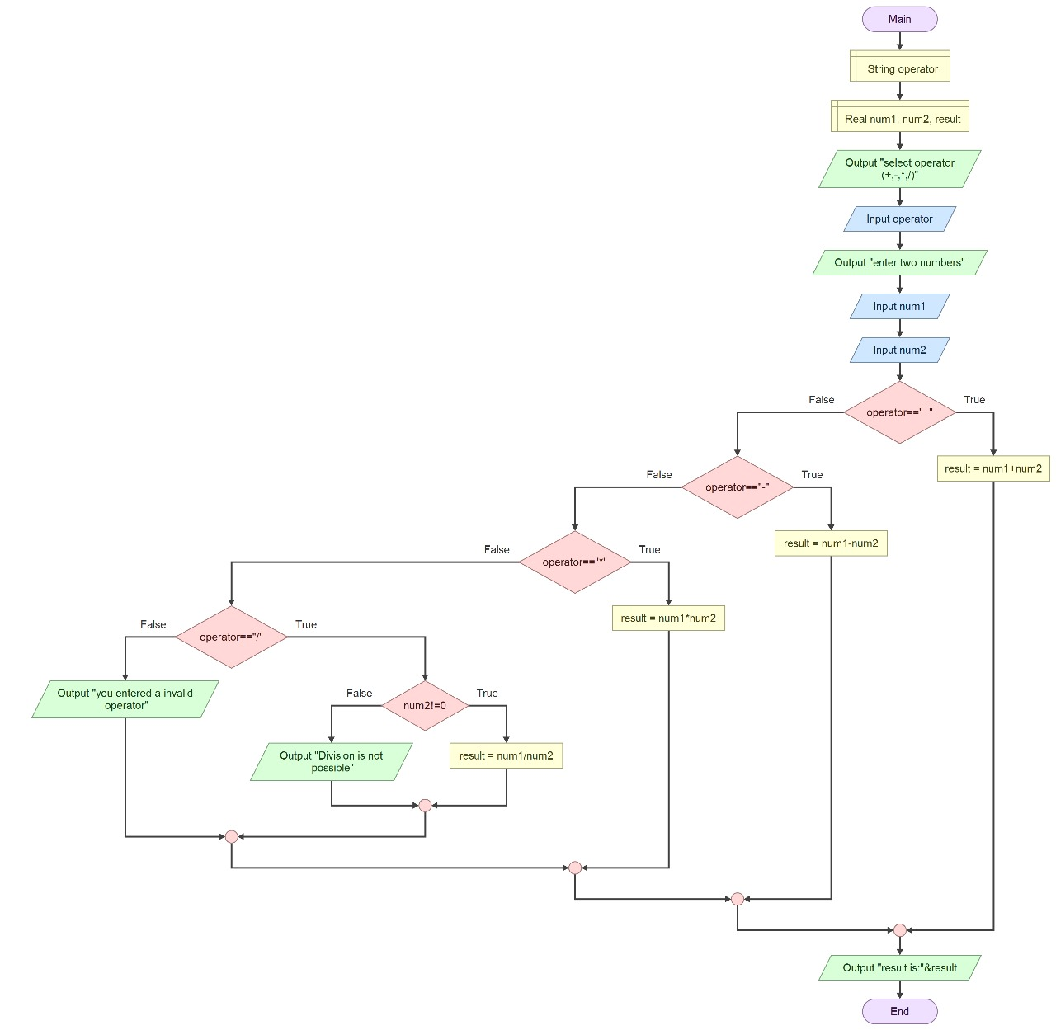

**Implementation of Logic Expression**

1.Include Required Libraries:

* The program starts by including the standard input/output library using #include <stdio.h>. This allows the use of functions like printf and scanf.

2. Define the Main Function:

* The program execution begins in the main function, which serves as the entry point.

3. Operator Selection:

* The user selects an operation by entering one of the characters: +, -, *, or /.
* The program checks which operation was chosen using conditional statements.
* Perform arithmetic operation
* Addition:

If the operator is +, the program calculates the sum of num1 and num2:

result = num1 + num2;

* Subtraction:

If the operator is -, the program calculates the difference:

result = num1 - num2;

* Multiplication:

If the operator is *, the program calculates the product:

result = num1 * num2

* Division:

If the operator is /, the program checks if num2 is not zero:

If num2 != 0, it computes the quotient:

result = num1 / num2

If num2 is zero, it outputs an error message to avoid division by zero.

4. Invalid Operator Handling:

If the input operator does not match any of the expected characters, it prints an "Invalid operator!" message.

5. Output:

Finally, the program prints the result of the operation, formatted as "num1 operator num2 = result".

Key Logic Expressions:

Conditional Statements: Used to determine which arithmetic operation to perform based on the user's input.

Error Handling: Specifically for division, to ensure the program does not attempt to divide by zero, which is undefined in mathematics.

**Source code:(C Program)**

#include <stdio.h>

int main()

{

char operator;

float num1, num2, result;

printf ("Simple calculator perform addition, subtraction, multiplication and division");

printf("Select operation (+, -, *, /): ");

scanf(" %c", &operator);

printf("Enter first number: ");

scanf("%f", &num1);

printf("Enter second number: ");

scanf("%f", &num2);

if(operator=='+')

result = num1 + num2;

else if(operator=='-')

result = num1 - num2;

else if(operator=='*')

result = num1 * num2;

else if(operator=='/')

if (num2 != 0) {

result = num1 / num2;}

else

{printf("Error! Division by zero is not possible.\n");}

else

printf("You have entered Invalid operator!\n");

printf("%f %c%f = %f\n", num1, operator,num2, result);

return 0;

}

**6.Sample input and output:**

Case 1:

Select operation (+, -, *, /): +

Enter first number: 67

Enter second number: 31

67+31 = 98

Case 2:

Select operation (+, -, *, /): -

Enter first number: 97

Enter second number: 29

97 -29 = 68

Case 3:

Select operation (+, -, *, /): *

Enter first number: 51

Enter second number: 4

51*4= 204

Case 4:

Select operation (+, -, *, /): /

Enter first number: 55

Enter second number: 0

Error! Division by zero is not possible.

Case 5:

Select operation (+, -, *, /): /

Enter first number: 276

Enter second number: 6

276/6= 46

Case 6:

Select operation (+, -, *, /): _

You have entered the Invalid operator!