## Consider the following schema for a Library Database:

**BOOK (*Book_id, Title, Publisher_Name, Pub_Year*) BOOK_AUTHORS (Book_id, Author_*Name*) PUBLISHER (*Name, Address, Phone*) BOOK_COPIES (*Book_id, Branch_id, No-of_Copies*)**

**BOOK_LENDING (*Book_id, Branch_id, Card_No, Date_Out, Due_Date*) LIBRARY_BRANCH (*Branch_id, Branch_Name, Address*)**

## Write SQL queries to

1. Retrieve details of all books in the library – id, title, name of publisher, authors, number of copies in each branch, etc.

## Get the particulars of borrowers who have borrowed more than 3 books, but from Jan 2017 to Jun 2017

1. Delete a book in BOOK table. Update the contents of other tables to reflect this data manipulation operation.

## Partition the BOOK table based on year of publication. Demonstrate its working with a simple query.

1. Create a view of all books and its number of copies that are currently available in the Library.

**ER Diagram:**

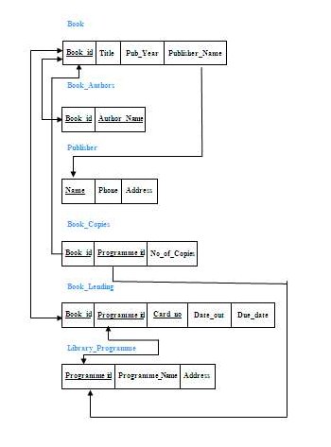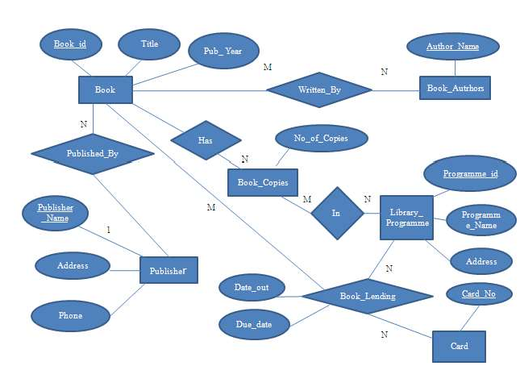**Schema Diagram:**

**Table Creation**

2

CREATE TABLE BOOK ( BOOK_ID NUMBER(10)PRIMARY KEY, TITLE VARCHAR(20),

PUB_YEAR VARCHAR(20),

PUBLISHER_NAME VARCHAR(20),

FOREIGN KEY(PUBLISHER_NAME) REFERENCES PUBLISHER(NAME) ON DELETE CASCADE);

3

CREATE TABLE BOOK_AUTHORS ( AUTHOR_NAME VARCHA(20),

BOOK_ID NUMBER(10),

PRIMARY KEY(BOOK_ID, AUTHOR_NAME),

FOREIGN KEY(BOOK_ID) REFERENCES BOOK (BOOK_ID) ON DELETE CASCADE);

CREATE TABLE PUBLISHER (

1

NAME VARCHAR(20) PRIMARY KEY, PHONE NUMBER(20),

ADDRESS VARCHAR(100));

7

CREATE TABLE BOOK_COPIES ( NO_OF_COPIES NUMBER(5),

BOOK_ID NUMBER(10),

BRANCH_ID NUMBER(10),

PRIMARY KEY(BOOK_ID, BRANCH_ID),

FOREIGN KEY(BOOK_ID) REFERENCES BOOK(BOOK_ID) ON DELETE CASCADE, FOREIGN KEY(BRANCH_ID) REFERENCES LIBRARY_BRANCH (BRANCH_ID) ON DELETE CASCADE);

5

CREATE TABLE BOOK_LENDING ( DATE_OUT DATE,

DUE_DATE DATE, BOOK_ID NUMBER(10),

BRANCH_ID NUMBER(10),

CARD_NO NUMBER(10),

PRIMARY KEY(BOOK_ID,BRANCH_ID, CARD_NO),

FOREIGN KEY(BOOK_ID) REFERENCES BOOK(BOOK_ID) ON DELETE CASCADE, FOREIGN KEY(BRANCH_ID) REFERENCES LIBRARY_BRANCH(BRANCH_ID) ON DELETE CASCADE,

FOREIGN KEY(CARD_NO) REFERENCES CARD(CARD_NO) ON DELETE CASCADE);

6

CREATE TABLE CARD

(CARD_NO NUMBER(10) PRIMARY KEY);

CREATE TABLE LIBRARY_BRANCH (

BRANCH_ID NUMBER(10) PRIMARY KEY, BRANCH_NAME VARCHAR(50),

4

ADDRESS VARCHAR(100));

#### Table Descriptions

DESC BOOK;

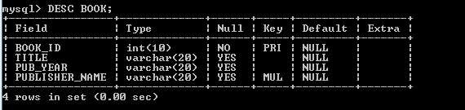

DESC BOOK_AUTHORS;

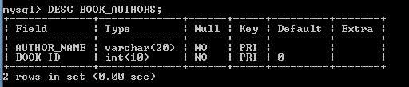

DESC PUBLISHER;

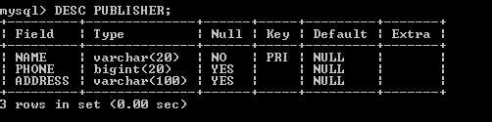

DESC BOOK_COPIES;

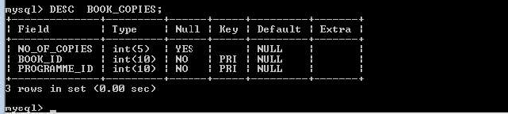

DESC BOOK_LENDING;

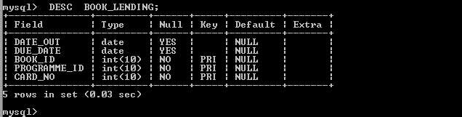

DESC CARD;

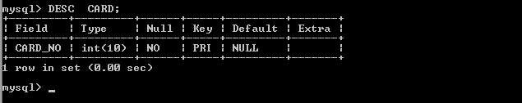

DESC LIBRARY_PROGRAMME

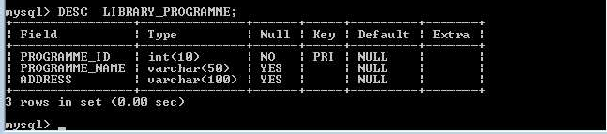

#### Insertion of Values to Tables

INSERT NUMBERO BOOK VALUES (1, 'DBMS','JAN-2017', 'MCGRAW-HILL');

INSERT NUMBERO BOOK VALUES (2,'ADBMS','JUN-2016','MCGRAW-HILL');

INSERT NUMBERO BOOK VALUES (3, 'CD','SEP-2016','PEARSON');

INSERT NUMBERO BOOK VALUES (4,' ALGORITHMS ','SEP-2015',' MIT'); INSERT NUMBERO BOOK VALUES (5,'OS','MAY-2016','PEARSON');

INSERT NUMBERO BOOK_AUTHORS VALUES ('NAVATHE', 1); INSERT NUMBERO BOOK_AUTHORS VALUES ('NAVATHE', 2); INSERT NUMBERO BOOK_AUTHORS VALUES ('ULLMAN',3); INSERT NUMBERO BOOK_AUTHORS VALUES ('CHARLES', 4); INSERT NUMBERO BOOK_AUTHORS VALUES('GALVIN', 5);

INSERT NUMBERO PUBLISHER VALUES ('MCGRAW-HILL', 9989076587,'BANGALORE'); INSERT NUMBERO PUBLISHER VALUES ('PEARSON', 9889076565,'NEWDELHI');

INSERT NUMBERO PUBLISHER VALUES ('PRENTICE HALL', 7455679345,'HYEDRABAD'); INSERT NUMBERO PUBLISHER VALUES ('WILEY', 8970862340,'CHENNAI');

INSERT NUMBERO PUBLISHER VALUES ('MIT',7756120238,'BANGALORE');

INSERT NUMBERO BOOK_COPIES VALUES (10, 1, 10);

INSERT NUMBERO BOOK_COPIES VALUES (5, 1, 11);

INSERT NUMBERO BOOK_COPIES VALUES (2, 2, 12);

INSERT NUMBERO BOOK_COPIES VALUES (5, 2, 13);

INSERT NUMBERO BOOK_COPIES VALUES (7, 3, 14);

INSERT NUMBERO BOOK_COPIES VALUES (1, 5, 10);

INSERT NUMBERO BOOK_COPIES VALUES (3, 4, 11);

INSERT NUMBERO BOOK_LENDING VALUES ('2017-01-01','2017-06-01', 1, 10, 101);

INSERT NUMBERO BOOK_LENDING VALUES ('2017-01-11 ','2017-03-11', 3, 14, 101);

INSERT NUMBERO BOOK_LENDING VALUES ('2017-02-21','2017-04-21', 2, 13, 101);

INSERT NUMBERO BOOK_LENDING VALUES ('2017-03-15 ','2017-07-15', 4, 11, 101);

INSERT NUMBERO BOOK_LENDING VALUES ('2017-04-12','2017-05-12', 1, 11, 104);

INSERT NUMBERO CARD VALUES (100); INSERT NUMBERO CARD VALUES (101); INSERT NUMBERO CARD VALUES (102); INSERT NUMBERO CARD VALUES (103); INSERT NUMBERO CARD VALUES (104);

INSERT NUMBERO LIBRARY_BRANCH VALUES (10,'VIJAY NAGAR','MYSURU');

INSERT NUMBERO LIBRARY_ BRANCH VALUES (11,'VIDYANAGAR','HUBLI');

INSERT NUMBERO LIBRARY_ BRANCH VALUES(12,'KUVEMPUNAGAR','MYSURU'); INSERT NUMBERO LIBRARY_ BRANCH VALUE(13,'RAJAJINAGAR','BANGALORE'); INSERT NUMBERO LIBRARY_ BRANCH VALUES (14,'MANIPAL','UDUPI');

SELECT * FROM BOOK;

|  |  |  |  |
| --- | --- | --- | --- |
| **BOOK_ID** | **TITLE** | **PUB_YEAR** | **PUBLISHER_NAME** |
| 1 | DBMS | Jan-2017 | MCGRAW-HILL |
| 2 | ADBMS | Jun-2017 | MCGRAW-HILL |
| 3 | CD | Sep-2016 | PEARSON |
| 4 | ALGORITHMS | Sep-2015 | MIT |
| 5 | OS | May-2016 | PEARSON |

SELECT * FROM BOOK_AUTHORS;

|  |  |
| --- | --- |
| **AUTHOR_NAME** | **BOOK_ID** |
| NAVATHE | 1 |
| NAVATHE | 2 |
| ULLMAN | 3 |
| CHARLES | 4 |
| GALVIN | 5 |

SELECT * FROM PUBLISHER;

|  |  |  |
| --- | --- | --- |
| **NAME** | **PHONE** | **ADDRESS** |
| MCGRAW-HILL | 9989076587 | BANGALORE |
| MIT | 7756120238 | BANGALORE |
| PEARSON | 9889076565 | NEWDELHI |
| PRENTICE HALL | 7455679345 | HYEDRABAD |
| WILEY | 8970862340 | CHENNAI |

SELECT * FROM BOOK_COPIES;

|  |  |  |
| --- | --- | --- |
| **NO_OF_COPIES** | **BOOK_ID** | **BRANCH _ID** |
| 10 | 1 | 10 |
| 5 | 1 | 11 |
| 2 | 2 | 12 |
| 5 | 2 | 13 |
| 7 | 3 | 14 |
| 1 | 5 | 10 |
| 3 | 4 | 11 |

SELECT * FROM BOOK_LENDING;

|  |  |  |  |  |
| --- | --- | --- | --- | --- |
| **DATEOUT** | **DUEDATE** | **BOOKID** | **BRANCH _ID** | **CARD_NO** |
| 2017-01-01 | 2017-06-01 | 1 | 10 |  |
| 2017-01-11 | 2017-03-11 | 3 | 4 | 101 |
| 2017-02-21 | 2017-04-21 | 2 | 13 | 101 |
| 2017-03-15 | 2017-07-15 | 4 | 11 | 101 |
| 2017-04-12 | 2017-05-12 | 1 | 11 | 104 |

SELECT * FROM CARD;

|  |
| --- |
| **CARDNO** |
| 101 |
| 102 |
| 103 |
| 104 |
| 105 |

SELECT * FROM LIBRARY_BRANCH;

|  |  |  |
| --- | --- | --- |
| **BRANCH _ID** | **BRANCH _NAME** | **ADDRESS** |
| 10 | VIJAY NAGAR | MYSURU |
| 11 | VIDYANAGAR | HUBLI |
| 12 | KUVEMPUNAGAR | MYSURU |
| 13 | RAJAJINAGAR | BANGALORE |
| 14 | MANIPAL | UDUPI |

#### Queries:

1. **Retrieve details of all books in the library id, title, name of publisher, authors, number of copies in each branch, etc.**

SELECT B.BOOK_ID, B.TITLE, B.PUBLISHER_NAME, A.AUTHOR_NAME, C.NO_OF_COPIES, L.PROGRAMME_ID

FROM BOOK B, BOOK_AUTHORS A, BOOK_COPIES C, LIBRARY_ BRANCH L

WHERE B.BOOK_ID=A.BOOK_ID AND B.BOOK_ID=C.BOOK_ID AND

L. BRANCH _ID=C.PROGRAMME_ID;

|  |  |  |  |  |  |
| --- | --- | --- | --- | --- | --- |
| **BOOK_ ID** | **TITLE** | **PUBLISHER_ NAME** | **AUTHOR_ NAME** | **NO_ OF_COPIES** | **BRANCH _ID** |
| 1 | DBMS | MCGRAW-HILL | NAVATHE | 10 | 10 |
| 1 | DBMS | MCGRAW-HILL | NAVATHE | 5 | 11 |
| 2 | ADBMS | MCGRAW-HILL | NAVATHE | 2 | 12 |
| 2 | ADBMS | MCGRAW-HILL | NAVATHE | 5 | 13 |
| 3 | CD | PEARSON | ULLMAN | 7 | 14 |
| 4 | ALGORITHMS | MIT | CHARLES | 1 | 11 |
| 5 | OS | PEARSON | GALVIN | 3 | 10 |

#### Get the particulars of borrowers who have borrowed more than 3 books, but from Jan 2017 to Jun 2017.

SELECT CARD_NO

FROM BOOK_LENDING

WHERE DATE_OUT

BETWEEN '2017-01-01'AND '2017-07-01'

GROUP BY CARD_NO HAVING COUNT(*)>3;

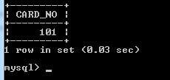

#### Delete a book in BOOK table. Update the contents of other tables to reflect this data manipulation operation.

DELETE FROM BOOK WHERE BOOK_ID=3;

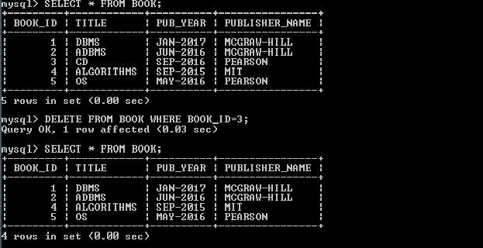

#### Partition the BOOK table based on year of publication. Demonstrate its working with a simple query.

CREATE VIEW VW_PUBLICATION AS

SELECT PUB_YEAR

FROM BOOK;

SELECT * FROM VW_PUBLICATION

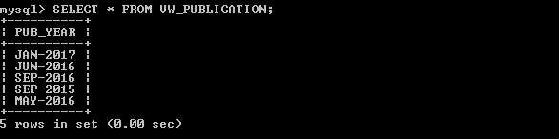

#### Create a view of all books and its number of copies that are currently available in the Library.

CREATE VIEW VW_BOOKS AS

SELECT B.BOOK_ID, B.TITLE, C.NO_OF_COPIES

FROM BOOK B, BOOK_COPIES C, LIBRARY_ BRANCH L

WHERE B.BOOK_ID=C.BOOK_ID

AND C. BRANCH _ID=L. BRANCH _ID;

SELECT * FROM VW_BOOKS;

