**PROJECT REPORT**

**on**

# Image encryption and decryption

**(CSE** V **Semester Mini project PCS-504) 2020-2021**



**Submitted to: Submitted by:**

Mr. Saumitro Varsha Saini

(CC-CSE-G- V-Sem) Roll.No: 1918796

**Guided by:** CSE-G- V -Sem

Dr. Indrajeet Session: 2020-2021

(Resource Person)

**DEPARTMENT OF COMPUTER SCIENCE AND INFORMATION TECHNOLOGY**

**GRAPHIC ERA HILL UNIVERSITY, DEHRADUN**

**CERTIFICATE**

**Certified that Miss VARSHA SAINI (Roll No.- 1918796) has developed mini project on “**Image encryption and decryption**” for the CS 5th  Semester Mini Project Lab  in Graphic Era Hill University, Dehradun. The project carried out by Students is their own work as best of my knowledge.**

 Date:15-Dec-2021

(Mr. Saumitro sir ) **Project Guide**

**Project Co-ordinator**          Mr. Saumitro

**CC-CSE-G-5th -Sem**    (CSE Department)

(CSE Department ) GEHU Dehradun

**ACKNOWLEDGMENT**

We would like to express our gratitude to The Almighty Mr. Saumitro , the most Beneficent and the most Merciful, for completion of project.

We wish to thank our parents for their continuing support and encouragement. We also wish to thank them for providing us with the opportunity to reach this far in our studies.

We would like to thank particularly our project Co-ordinator Mr. Saumitro and our Project Guide Mr. Sandeep kumar for his patience, support and encouragement throughout the completion of this project and having faith in us.

 We also acknowledge to teachers like Mr. Sushant and Mr. Saumitro who help us in developing the project.

At last but not the least We greatly indebted to all other persons who directly or indirectly helped us during this work.

**Varsha Saini**

**Roll No.- 1918796**

**CSE-G-5th-Sem**

**Session: 2020-2021**

**GEHU, Dehradun**

## TABLE OF CONTENTS

**CHAPTER NO. TITLE**

1. **INTRODUCTION** 
   1. Abstract
   2. About project

### **PROJECT**

* 1. Requirement Analysis
  2. Software Specification

### **3. SNAPSHOT OF PROJECT**

* 1. encryption of a image
  2. after encryption
  3. decryption of a image
  4. after decryption

1. **CONCLUSION**

1. **REFERENCES**
2. **CHAPTER**

**INTRODUCTION**

## Abstract

This is a project dealing with securing images over a network. Image is a delicate piece of information shared between clients across the world. Cryptography plays a huge role during secure connections.

This project is very secure because another person can not decrypt our image until he did not get correct key.

### **ABOUT PROJECT**

Image encryption works on the innovative idea of taking the consecutive or random pixel bits of an image and collectively worked and modified with logic, thereby leading to a complete set of new of pixel, which is typical from the original bits. Hence, giving rise to a new mode of information transfer. A further complication can be added to the malignant attacker, by incorporating the CBC (Cipher Block Chaining) method by which the plain text is monumentally embedded in the encrypted image, thereby making the data transfer very secure. A further addition of a key in the process makes the image tight/closed from any external agency.

.

## MOTIVATION

The security of encryption lies in the ability of an algorithm to generate ciphertext (encrypted text) that is not easily reverted back to its original plaintext. The use of keys adds another level of security to methods of protecting our information. A key is a piece of information that allows only those that hold it to encode and decode a message.

## CHAPTER

**PROJECT**

#### **REQUIREMENT ANALYSIS**

The application has been developed in Java using different packages and libraries. Application has nine buttons in its homepage where each of the button performs a specific task it has been assigned with. With the click of the user, application executes the request for further processing. With each of the request, application asks for the input file and processes them using openSSL instructions to execute the output.

Cryptographic libraries are based on command line tools and are difficult to be used. It requires sequential instruction to be provided manually through DOS. This application will make the use of crypto function (openSSL) easy through interface.

To configure any basic encryption scheme securely, it's very important that all of these parameters (at the minimum) are configured correctly:

1. Choosing the correct algorithm
2. Choosing the right mode of operation
3. Choosing the right padding scheme
4. Choosing the right keys and their sizes
5. Correct IV initialization with cryptographically secure CSPRNG
   1. **SOFTWARE SPECIFICATION**

* Java using swing and awt packages
* OpenSSL crypto libraries
* Support for FIPS 140 label 2 * complying crypto tokens.
* Windows: This project can easily be configured on windows OS. For running this project on windows, you will have to install JDK or eclipse.

# CHAPTER

**SNAPSHOT OF PROJECT**

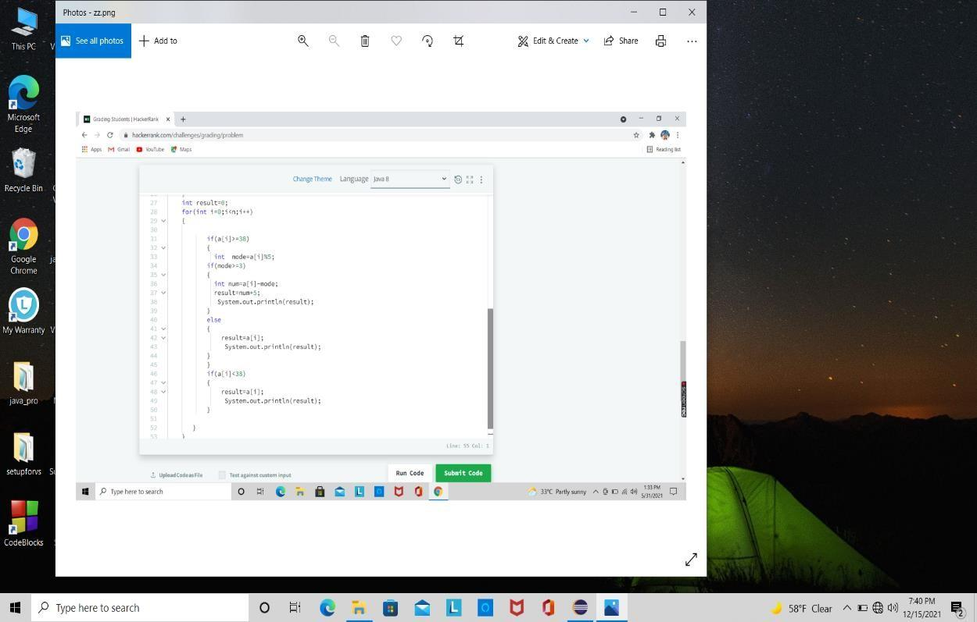

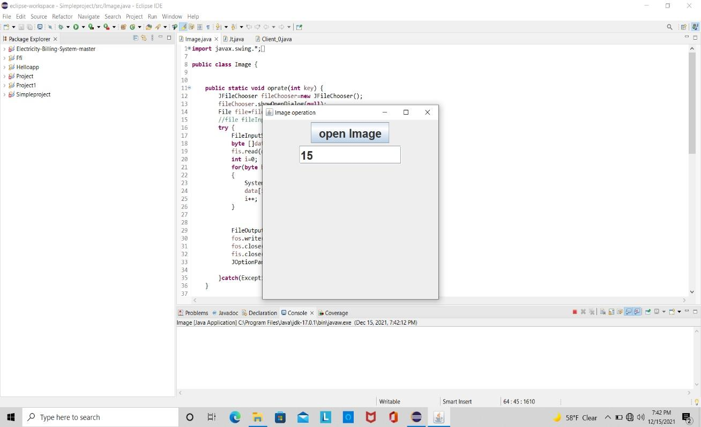

### **encryption of a image**

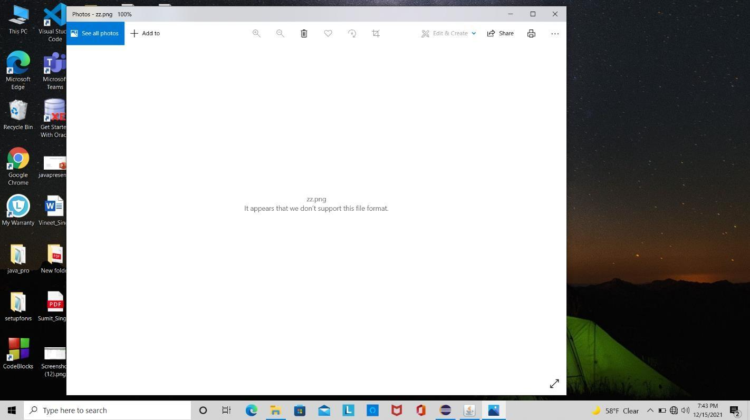

* **decryption of a image**

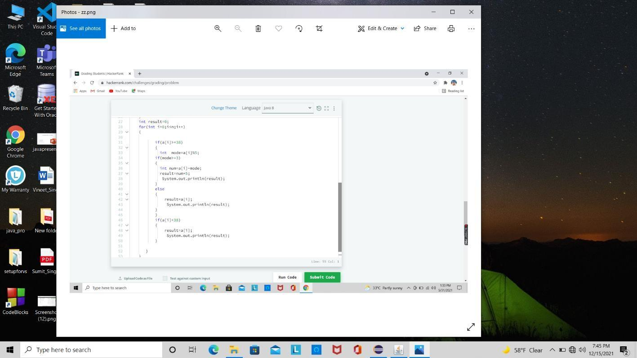

# CHAPTER

# CONCLUSION

In the field of information security, growth plays a main concern, growth means change, change starts when we think an innovative concept. In this study, we introduce one in the field of information security under image encryption topic. Image encryption can be defined in such a way that it is the process of encoding secret image with the help of some encryption algorithm in such a way that unauthorized users can’t access it. This process, though sounds complicated, is very effective and easy implementation is the added feather to the advantage crown of image encryption with CBC incorporation. Though, the image through data encryption is completely distorted or unclear, the ultimate output i.e., the cipher text can be extra modified with the help of the key in picturing a more aesthetic image for the hacker which, when deeply checked, will not leave a single trace of the randomization that has been introduced to the image. Analytical results show that this proposal brags about its creation having improved security and complexity.

# CHAPTER

### **References**

1. Cryptology,History([http://www.faqs.org/espionage/CouDe/Cryptology-](http://www.faqs.org/espionage/Cou-De/Cryptology-) History)

1. C. K. Huang, H. H. Nien, S. K. Changchien, and H. W. Shieh, “Image encryption with chaotic random codes by grey relational grade and Taguchi method,” Optics Communications, vol. 280, no. 2, pp. 300–310, 2004.
2. G. Chen, Y. Mao, and C. K. Chui, “A symmetric image encryption scheme based on 3D chaotic cat maps,” Chaos, Solitons and Fractals, vol. 21, no. 3, pp. 749–761, 2014.
3. Q. Guo, Z. Liu, and S. Liu, “Color image encryption by using Arnold and discrete fractional random transforms in IHS space,” Optics and Lasers in Engineering, vol. 48, no. 12, pp. 1174–1181, 2010.
4. Z.-L. Zhu, W. Zhang, K.-W. Wong, and H. Yu, “A chaos-based symmetric image encryption scheme using a bit-level permutation,” Information Sciences, vol. 181, no. 6, pp. 1171– 1186, 2011.