SOFTWARE ENGINEERING

# 1.Difference between service base and product base company?

|  |  |
| --- | --- |
| Product based company | Service based company |
| 1. A Product based company is one that has its own product to sell to consumers through the market. | 1. A Service based company is an enterprise offers services to its clients. |
| 2. Quality is main. | 2. Client is main. |
| 3. They hire only a limited no of candidates from top colleges around the world. | 3. They recruit a large no of candidates during the campus placements. |
| 4. Job security is high. | 4. Job security is low. |

## 2. List out some companies under service based and product based companies?

Product based companies:- Google, Microsoft, Amazon, Oracle, IBM, Intel.

Service based companies:- Infosys, TCS, Wipro, Cognizant, Capgemini, NIT DATA.

## **3. What is the current most popular model using by the companies?**

Waterfall model-All stages of development are sequential.

Agile

V-model

Spiral model

## 4. List out the testing tools and its purpose?

**Software testing tools:-**

**Test Complete:-** It is developed by smart bear software it ensures the quality of the application without sacrificing quality or agility.

**Lambda test:-** It is a cross browser testing tool. It helps to streamline software testing process.

**Test rail:-** It is a test management tool. It helps to streamline software testing process.

**X-Ray:-** It is a test management app for jira. It helps to plan, execute and track quality assurance.

**Zephyr Scale:-** It is a test time management provides a smarter & more structured way to plan, manage and measure tests.

## **Test project:-** It is a test automation tool that allows users to create automated tested for mobile and web applications.

## 5. List out the companies works on cyber securities?

**Software Engineering:-** Build & develop systems companies cyber security.

Cisco, Sophos, Google, IBM(International Business Machine), Microsoft, Goudstrike, EMC, Dark Trace,

**Fortinet, Symantec.**

## ****6. What are the Standalone applications and dynamic applications?****

**Standalone applications:- Stand alone applications are a type of software program that is designed to run on a single computer or local machine of the user, does not need for a server or internet connection. This application provides a no of benefits, such as offline capabilities, and greater customization(the action of modifying something to suit a particular individual or task).**

Example: Notepad, Calculator, Microsoft word, Adobe photo shop.

**Dynamic applications:-** A Dynamic web application is a type of application that can change its content, appearance, and functionality in response to user input, system events, and information. Dynamic web applications may make use of features such as load-time data-driven forms, AIAX, databases, or other services that respond to external events.

Example: Youtube’s website content has dynamically updated in response to your input.

## 7. What is a client and server and their examples.

|  |  |  |
| --- | --- | --- |
| **Characteristics** | **Client** | **Server** |
| Defination | A Computer device which asks a server for services is known as a customer.  The customer is the front end element in client and server architecture which communicate, with the user and sends requests to the server. | A Server offers services to other devices connected to network.  A server primary functions include accepting and completing customer requests as well as storing and managing data. |
| Support of login | Login of single users. | Multiple users login. |
| Examples | Laptops, desktops. | Web servers, database severs and file servers. |
| Performance | The client performance is less when we compare it with the server. | The Server performance is high when we compare it with the client. |
| Functionality | It completely depends on the services of server because the server generates the services requested by the client. | It sends the requested services to the client based on their requirements. |

## 8. What are the jobs available on databases and their companies?

**Jobs Available:-** Oracle DBA, Oracle database Administration Application Lead, Senior SQL DBA, Consultant Oracle DBA, Senior Database Administrator.

**Companies:-** Airtels, Exl, Accenture, Swiggy, Oracle, firebird, SQ life, My SQL, SCV, Mango ,Texadata.

## 9. Where are the google servers located?

| **Continent** | **Location** | **Geo** | **Products Location** | **Cloud Location** | **Timeline** | **Description** |
| --- | --- | --- | --- | --- | --- | --- |
| North America | [Arcola (VA), USA](https://en.wikipedia.org/wiki/Arcola,_Virginia) | https://upload.wikimedia.org/wikipedia/commons/thumb/5/55/WMA_button2b.png/17px-WMA_button2b.png[38°56′35.99″N 77°31′27.61″W](https://geohack.toolforge.org/geohack.php?pagename=Google_data_centers&params=38_56_35.99_N_77_31_27.61_W_scale:5000_region:US) | [Loudoun County](https://www.google.com/about/datacenters/locations/loudoun-county/) | N. Virginia (us-east4) | 2017 - announced[[4]](https://en.wikipedia.org/wiki/Google_data_centers#cite_note-:1-4)[[5]](https://en.wikipedia.org/wiki/Google_data_centers#cite_note-:2-5) |  |
| North America | [Atlanta (GA), USA](https://en.wikipedia.org/wiki/Atlanta) | https://upload.wikimedia.org/wikipedia/commons/thumb/5/55/WMA_button2b.png/17px-WMA_button2b.png[33°44′59.04″N 84°35′5.33″W](https://geohack.toolforge.org/geohack.php?pagename=Google_data_centers&params=33_44_59.04_N_84_35_5.33_W_scale:5000_region:US) | [Douglas County](https://www.google.com/about/datacenters/locations/douglas-county/) | - | 2003 - launched | 350 employees |
| South America | [Cerrillos, Santiago, Chile](https://en.wikipedia.org/wiki/Cerrillos,_Chile) | https://upload.wikimedia.org/wikipedia/commons/thumb/5/55/WMA_button2b.png/17px-WMA_button2b.png[33°31′14″S 70°43′18″W](https://geohack.toolforge.org/geohack.php?pagename=Google_data_centers&params=33.520515_S_70.721695_W_)[[6]](https://en.wikipedia.org/wiki/Google_data_centers#cite_note-6) | - | Santiago (southamerica-west1) | 2020 - announced[[7]](https://en.wikipedia.org/wiki/Google_data_centers#cite_note-7)  2021 - launched[[8]](https://en.wikipedia.org/wiki/Google_data_centers#cite_note-8) |  |
| Asia | [Changhua County, Taiwan](https://en.wikipedia.org/wiki/Changhua_County) | https://upload.wikimedia.org/wikipedia/commons/thumb/5/55/WMA_button2b.png/17px-WMA_button2b.png[24°08′18.6″N 120°25′32.6″E](https://geohack.toolforge.org/geohack.php?pagename=Google_data_centers&params=24_08_18.6_N_120_25_32.6_E_scale:5000) | [Changhua County](https://www.google.com/about/datacenters/locations/changhua-county/) | Taiwan  (asia-east1) | 2011 - announced  2013 - launched | 60 employees |
| North America | [Clarksville (TN), USA](https://en.wikipedia.org/wiki/Clarksville,_Tennessee) | https://upload.wikimedia.org/wikipedia/commons/thumb/5/55/WMA_button2b.png/17px-WMA_button2b.png[36°37′16″N 87°15′47″W](https://geohack.toolforge.org/geohack.php?pagename=Google_data_centers&params=36.6211599_N_87.2630735_W_) | [Montgomery County](https://www.google.com/about/datacenters/locations/montgomery-county/) | - | 2015 - announced |  |
| North America | [Columbus (OH), USA](https://en.wikipedia.org/wiki/Columbus,_Ohio) |  | - | Columbus (us-east5) | 2022 - launched[[9]](https://en.wikipedia.org/wiki/Google_data_centers#cite_note-9) |  |
| North America | [Council Bluffs (IA), USA](https://en.wikipedia.org/wiki/Council_Bluffs,_Iowa) | https://upload.wikimedia.org/wikipedia/commons/thumb/5/55/WMA_button2b.png/17px-WMA_button2b.png[41°13′17.7″N 95°51′49.92″W](https://geohack.toolforge.org/geohack.php?pagename=Google_data_centers&params=41_13_17.7_N_95_51_49.92_W_scale:5000_region:US) | [Council Bluffs](https://www.google.com/about/datacenters/locations/council-bluffs/) |  | 2007 - announced  2009 - completed first phase completed  2012 and 2015 - expanded | 130 employees |

## 10. What are the different versions of Android?

Nougat

Oreo

ICECREAM Sandwich

Android 5 Lollipop

Android 11

Android honeycomb honeycomb

Android eclair eclair

Android 13

Froyo

Gingerbread

Jelly Bean

Lollipop

Marshmallow

Android 9 Pie

Android q beta features

Android versions pie

Cupcake

Eclair

Honeycomb

Alpha

KitKat

Android 10

Android 12

## 11. What are the characteristics of software?

## Top Characteristics of Software

The quality of a software product is determined by what it offers and how easily it can be used. Software is judged by different people on different grounds. Customers, for instance, want software that meets their specific needs. Similarly, developers engaged in designing, coding, and maintaining the software determine the quality of the software by assessing its internal characteristics. Let’s check them out…

### 1. Functionality

The functionality of software refers to its ability to perform and function according to design specifications. In simple terms, software systems should function correctly, i.e. perform all the functions for which they are designed.

The functions refer to the features that the end user, as well as the business, expect as basic facilities from the system. All these functions must be integrated into the system. Many software applications out there are designed for simplicity, but ultimately, the purpose of the software is to provide its users with the desired functionality.  In order to look like the best software product, it must have a clear appearance, components, and functions. However, there are also those products out there that can provide a great deal of value for your money.

### 2. Usability (User-friendly)

The user-friendliness of the software is characterized by its ease of use. In other words, learning how to use the software should require less effort or time. Navigating the software is extremely important since it helps determine the journey the user takes within the software.  This is imperative to ensure visitors remain on your website and have a positive experience, which leads to an increase in sales and brand loyalty.

An important indicator of a good piece of software is its user interface, i.e., the smooth flow of its design. A product with a great UI (User Interface) design is more likely to get noticed than one without. If a software program isn’t user-friendly, users may have trouble navigating the software and using some of its features. Software should require less time or effort to learn. Ideally, software should be easy to use even by people with no IT experience.

### 3. Efficiency

Essentially, it refers to the software’s ability to utilize human and system resources such as time, effort, CPU, memory, computation power, network bandwidth, files, databases, etc., as effectively and efficiently as possible. For a software project to succeed, efficiency is crucial. In addition to meeting the needs for which the software was made, it must also provide excellent features designed to assist users in completing their tasks faster. Software should make efficient use of storage space and execute commands according to timing requirements.

In order to be efficient, software must offer users proper value in terms of their time and cash. The market is filled with products that cater to various industries, but only a handful of products are efficient enough to benefit individuals and businesses. The medical billing software that Open Practice Solutions provides, for instance, makes billing processes much more efficient for clients than those offered by other companies.

4. Flexibility

Software Flexibility refers to the ability of the software solution to adapt to potential or future changes in its requirements. When evaluating the flexibility of software, look at how simple it is to add, modify, or remove features without interfering with the current operation.

It is essential to keep up with rapidly changing markets, technologies, and customer needs. In software development, change is inevitable; it can arise during the development process itself or as the result of future requirements. Flexibility is therefore highly valued. Consequently, any software product must be scalable, flexible, and easily adaptable to future technology. When designing or building a software product, be sure to plan for these changes that are inevitably going to occur. Loose coupling of components is the key to creating highly flexible systems.

## 12. What is metaphors 3?

Metaphors are used by software developers to explain abstract or unfamiliar concepts in more concrete terms that customers & users can more easily understand.

**Common metaphors:-** viruses, bugs, crashes, fatal errors etc., Icons area great way to aid the process of understanding symbols are to assist users to grasp concepts more quickly.

## 13. Encryption:-

Adaptive Software Development has been proposed by Jim Highsmith as a technique for building complex software and system. The philosophical underpinnings of ASD focus. On human collaboration and team self organization.

## 14. What is Chartering?

Chartering is an activity within the shipping industry whereby a shipowner hires out the use of their vessel to a charterer. The contract between the parties is called a charterparty. The three main types of charter are: demise charter, voyage charter, and time charter.

## 15. What is volatile requirements?

Volatile requirements These are requirements that are likely to change during the system development process or after the system has been become operational. Examples of volatile requirements are requirements resulting from government health-care policies or healthcare charging mechanisms.

## 16. Draw the UseCase diagram for ATM machine?[UML Use Case Diagram]

## 17. What is UML?

**UML:-**

**1. Unified Modeling Language.**

**2. UML is a way to visually represent the architecture design & implementation of complex software systems.**

**3. There are to main categories – Structure diagram, behavioral diagram.**

**4. Structure diagrams show the things in the modeled system. They show different objects in a system.**

**5. Behavioral diagram show what would happen in a system. They describe how the objects interact with each other to create a system**

**6.** Structure diagrams **– Class diagram, Component diagram, Deployment diagram, Object package profile diagram.**

**7.** Behavioral diagrams **– Use-Case diagram, Activity state machine sequence, Communication diagram etc.,**

**8. UML is way of visualizing software program using a collection of diagram.**

18.Abbrevation of CASE and examples of CASE tools?

 Computer-aided software engineering (CASE) is the implementation of computer-facilitated tools and methods in software development.

There are three types of CASE tools: upper-CASE, lower-CASE, and integrated CASE tools.

## 19. What is role of software engineering in development of web apps?

Application software engineers build websites and applications for end-users. You help build new features and functionality as well as update and improve existing code to keep the product running smoothly. Engineers may write front-end or back-end code — some write both. Programmer, developer, coder. These are all terms sometimes used to refer to a software engineer. Put simply, a software engineer is someone who creates computer software. But a more accurate way to think about the role is that you apply engineering principles to the software development process — designing, developing, and maintaining software. Great software engineers are exceptional problem solvers and essential partners in the [product development](https://www.aha.io/roadmapping/guide/what-is-product-development) process. While product managers lead the [product vision](https://www.aha.io/roadmapping/guide/product-strategy/what-is-product-vision) (focusing on "why" and "what" to build), software engineers bring that vision to life. You deliver the technical "how" and help set the timeline that answers "when." The field of software engineering is constantly evolving, making it an exciting and dynamic career choice. And software engineers are in high demand. In fact, the U.S. Bureau of Labor Statistics projects employment opportunities for software engineers will grow by [22 percent](https://www.bls.gov/emp/tables/occupations-most-job-growth.htm) in the decade leading up to 2030.

## 20. What are the Automated estimated tools for software project cost?

Estimation mistake

Parametric estimating

Analogous estimating

Expert judgment

Estimation techniques

Builder trend

Contractor Foreman

Cost of quality

Stack

Use case points

## 21. What are the tools used for scheduling task sets?

Gantt chart

Wrike

Monday. pricing

Asana

Hive

Trello

Critical path method

ProofHub

Calendar

https://encrypted-tbn0.gstatic.com/licensed-image?q=tbn:ANd9GcRcEhyTIpRTI2eD5xwl099Xa2SsUpvHYkQqscLU64zvjS7zOh_ET6Kz8vkrWzFZycbLvTib&s=19

Fast tracking

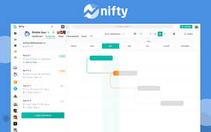

Nifty

https://encrypted-tbn0.gstatic.com/images?q=tbn:ANd9GcRXHIaUUtBKIcB4Ek4iTCemleBOdG7A-XhqFlN0-e6uGidoW3RQw7rTFg&s=0

ClickUp

GanttPRO

Hub Planner

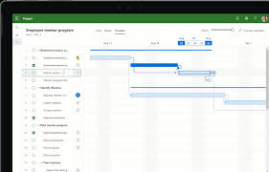

Microsoft Project

https://encrypted-tbn0.gstatic.com/images?q=tbn:ANd9GcSgRbGU9FzNHY3NtjMLlmU1LnE-aqsxlOsoK9txbWfmx4y8J7e2tRS_Hg&s=0

Simulation

SmartTask

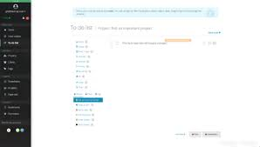

Task dependencies

https://encrypted-tbn0.gstatic.com/images?q=tbn:ANd9GcQOgEmCyeCICC_2j0T1TehJfmwvsxTmao8X5jmIq52xo2WjU7k_MtW9AA&s=0

Zoho Projects

Task list

Duration compression

Program Evaluation and Review Technique

ProjectManager

Resource leveling

## 22. What are the tools used to track the progress of project?

Gantt chart

Dashboard

Jira

Time tracker

Asana

ClickUp

Monday

Todoist

Trello

Wrikehttps://encrypted-tbn0.gstatic.com/images?q=tbn:ANd9GcTTfd8UCYZHt94Ix48JcQe58WypsdRNvdRTVEpjula7PSW3usUydRqe0g&s=0

https://encrypted-tbn0.gstatic.com/images?q=tbn:ANd9GcTHB7y8l8WP0s1_0W2Jk4i2Pjk6sQbGC5kG3uRNp8u5-GBKCOadFkRgT78&s=0

Critical path analysis

https://encrypted-tbn0.gstatic.com/images?q=tbn:ANd9GcTKvUIHmHlqj5_XwYNYPfO7pRGGDjqofDW4-OwcGBxDd33UHWiefrWZtg&s=0

Microsoft

https://encrypted-tbn0.gstatic.com/images?q=tbn:ANd9GcTfXTBmMUBWUN5mrUALI-K1D6y4JNkGa7o57Z5Ix_AzYK4oJ8e86FSZZN4&s=0

Tasks

https://encrypted-tbn0.gstatic.com/images?q=tbn:ANd9GcRWjl4C5pVOLlvXKv3eKFS1teGlQRNRHx1r4W_yvjbQ1267SxEnxnkdoQ&s=0

Work breakdown structure

https://encrypted-tbn0.gstatic.com/images?q=tbn:ANd9GcT3DQEgj6X2YHr-sHlyv_DSZ9myjh8FFxhEFoPaJC5-tyTpiW4bx-oc6g&s=0

Reporting

https://encrypted-tbn0.gstatic.com/images?q=tbn:ANd9GcRELi1EQ4sz3zfqQFAxGBggajbLTv0DCHWg-XjhZtSiSraBhoP0ObOycQ&s=0

Timesheets

Backlog

https://encrypted-tbn0.gstatic.com/images?q=tbn:ANd9GcSOSFyrXq38tSLTCQ9gS0_UX_C0ykpM8MoLQoEqdt2SYOePaqbyUOhd6g&s=0

Basecamp

Evaluation metrics

Project management

Kanban

Project reports

Project tracking

Agile project management

## 23. What is BCWP and BCWS?

**BCWP** = Budgeted Cost of Work Performed = % Complete x BAC, the value of the work or $ accomplished to date in terms of the baseline schedule, otherwise known as earned value.

**BCWS** = Budgeted Cost of Work Scheduled is the work or $ that should have been accomplished to date according to the baseline plan.

BCWP is compared to BCWS to determine if the project is behind or ahead of where is projected to be.

## 24. What are the latest versions of Python.r?

**Active Phython releases:-**

3.13 prerelease 2024-10-01 (planned) 2029-10 PEP 719.

3.12 bugfix 2023-10-02 2028-10 PEP 693.

3.11 bugfix 2022-10-24 2027-10 PEP 664.

3.10 security 2021-10-04 2026-10 PEP 619.

3.9 security 2020-10-05 2025-10 PEP 596.

3.8 security 2019-10-14 2024-10 PEP 569.

## 25. What are the available software configuration management tools?

Ansible

Puppet

Chef

Salt

CFEngine

Rudder

Terraform

Juju

Octopus Deploy

https://encrypted-tbn0.gstatic.com/images?q=tbn:ANd9GcSC4I3ISjkUDYmhSBotJqBkeeAU-LLSZaqMouFeiZp5iHqdiHLcaUY77Q&s=0

Vagrant

github

## 26. Extensions for real time functions?

The Realtime extension incorporates the ANSI/IEEE standards POSIX 1003.1b-1993 and POSIX 1003.1i-1995.

The Realtime extension is organized as a Feature Group within the UNIX specification, denoted by the symbol _XOPEN_REALTIME.

## 27. What are the various file systems?

NTFS

FAT

Ext4

FAT32

exFAT

UFS

Third Extended Filesystem

Ext2

XFS

https://encrypted-tbn0.gstatic.com/images?q=tbn:ANd9GcT1kcXT5RLTWZfkyPPkhLnd-MfH6zo6D6z1hUECyZfTe6mvtPL4iJSeiQ&s=0

HFS Plus

https://encrypted-tbn0.gstatic.com/images?q=tbn:ANd9GcSV0RMXS8MplKecdggLB0HRK3wGiqV1l4iLp1wj5dczM_vtjQlTw-76A0c&s=0

Unix

https://encrypted-tbn0.gstatic.com/images?q=tbn:ANd9GcQvDhh_hAKPvfuV5zkOilHXYo7nAcQrKJ460o0Ba_SWMbpT-kEd22lAhQ&s=0

Hard disk drive

https://encrypted-tbn0.gstatic.com/images?q=tbn:ANd9GcRl30jD_fSsF0s8qrFrFZF1jwZtiwYAMEQZTS5jhYP7jZI8CxGZCihOWw&s=0

Extended file system

VxFS

Hierarchical File System

## 28. Tools used to develop the website template?

WordPress. ...

Squarespace. ...

InVision Studio. ...

Figma. ...

Photoshop. ...

ProofHub. ...

Sketch. ...

Adobe Dreamweaver.

## 29. Draw a class diagram of ATM?

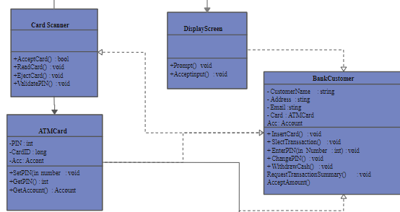

## 30.What are the architectures description languages?

Architectural description languages (ADLs) are specialized languages used to describe the structure and behavior of software systems, hardware systems, or even entire enterprises. They essentially provide a way to formally model and document complex systems, making them easier to understand, analyze, and communicate.

ADLs come in various forms, from text-based languages like AADL (Architecture Analysis and Design Language) to graphical languages like ArchiMate. They typically allow you to specify:

* Components: The building blocks of the system, such as software modules, hardware units, or business units.
* Connectors: How components interact with each other, such as data flows, control flows, or physical connections.
* Constraints: Rules that the system must obey, such as performance requirements, safety properties, or security limitations.

Here are some of the benefits of using ADLs:

* Improved communication: ADLs provide a clear and unambiguous way to document system architecture, which can help prevent misunderstandings between stakeholders.
* Early analysis: By capturing the system's architecture in a formal model, it becomes possible to perform automated analysis to identify potential problems early in the development process.
* Enhanced maintainability: ADLs can make it easier to understand and modify complex systems, which can lead to lower maintenance costs.
* Reuse: ADL models can be reused in different contexts, which can save time and effort.

Some popular ADLs include:

* AADL: A text-based language commonly used in the aerospace and defense industries.
* SysML: A graphical language with a strong focus on systems engineering.
* ArchiMate: A graphical language for enterprise architecture.
* DoD/DoDAF: A standard architectural framework used by the US Department of Defense.
* MARTE: A UML profile for real-time and embedded systems.

[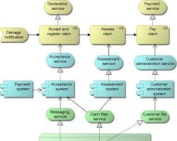](https://en.wikipedia.org/wiki/ArchiMate)

ArchiMate Architecture Description Language

Ultimately, the choice of ADL depends on the specific needs of your project. There are many ADLs available, each with its own strengths and weaknesses. It's important to consider factors such as the type of system you're developing, the size and complexity of the project, and the skills and experience of your team.

## ****31.Tools for Testing Interface?****

**Here are some of the most popular and effective tools for testing interfaces, along with their key features and visual examples:**

**API Testing Tools:**

* **Postman**:
  + User-friendly interface for crafting and executing REST API requests
  + Collaboration features for sharing collections and working in team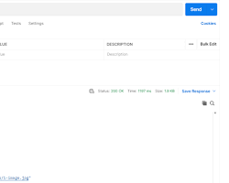

Postman interface for API testing

* **SoapUI** (:
  + Supports both REST and SOAP APIs
  + Comprehensive testing capabilities, including functional, security, and load testing

[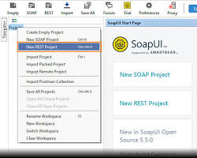](https://www.soapui.org/getting-started/rest-testing/)

SoapUI interface for API testing

* **JMeter** :
  + Open-source tool primarily known for load testing, but also capable of API testing
  + Highly customizable and scalable

[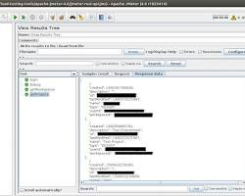](https://octoperf.com/blog/2018/04/23/jmeter-rest-api-testing/)

JMeter interface for API testing

**Web UI Testing Tools:**

* **Selenium**:
  + Widely used open-source tool that supports multiple browsers and platforms
  + Can be used with various programming languages

[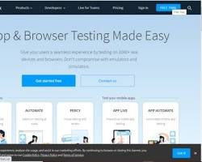](https://www.browserstack.com/guide/ui-testing-with-selenium)

Selenium WebDriver interface for web UI testing

* **Cypress**:
  + Modern, JavaScript-based tool focused on speed and ease of use
  + Built-in features for visual testing and debugging

[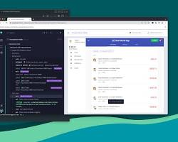](https://totalperform.com/cypress-an-end-to-end-automation-testing-tool/)

Cypress interface for web UI testing

* **Testsigma**:
  + Cloud-based tool with AI-powered capabilities
  + Low-code approach for creating tests

[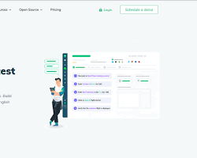](https://testsigma.com/user-interface-testing-tools)

Testsigma interface for web UI testing

**Mobile UI Testing Tools:**

* **Appium**:
  + Open-source tool for testing native, hybrid, and web apps on iOS and Android devices
  + Supports multiple programming languages

[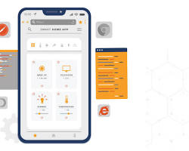](https://www.headspin.io/blog/using-appium-for-testing-mobile-web-apps)

Appium interface for mobile UI testing

* **Espresso**:
  + Android-specific testing framework for native apps
  + Provides a concise way to write UI tests

[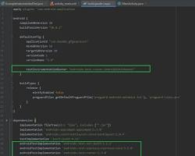](https://www.geeksforgeeks.org/ui-testing-with-espresso-in-android-studio/)

Espresso interface for Android UI testing

* **XCUITest** :
  + Apple's native UI testing framework for iOS apps
  + Integrated with Xcode

[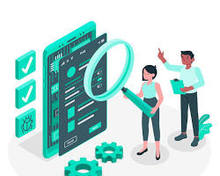](https://medium.com/trendyol-tech/how-to-make-ios-ui-testing-fast-and-reliable-6f572a0955f2)

XCUITest interface for iOS UI testing

**Visual Testing Tools:**

* **Applitools**:
  + Uses AI to compare screenshots and identify visual differences
  + Integrates with various testing frameworks

[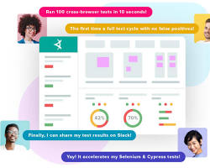](https://applitools.com/)

Applitools interface for visual UI testing

* **Percy**:
  + Another visual testing tool with a focus on collaboration and integration

[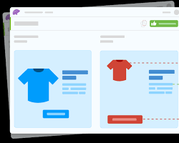](https://www.browserstack.com/guide/visual-testing-beginners-guide)

Percy interface for visual UI testing

**Choosing the right tool depends on your specific testing needs, the types of interfaces you're testing, and your team's skills and preferences.**