1. **CREATE TABLE pet (name VARCHAR(20), owner VARCHAR(20),**

**species VARCHAR(20), sex CHAR(1), birth DATE, death DATE);**

1. **DESCRIBE pet;**

+---------+-------------+------+-----+---------+-------+

| Field | Type | Null | Key | Default | Extra |

+---------+-------------+------+-----+---------+-------+

| name | varchar(20) | YES | | NULL | |

| owner | varchar(20) | YES | | NULL | |

| species | varchar(20) | YES | | NULL | |

| sex | char(1) | YES | | NULL | |

| birth | date | YES | | NULL | |

| death | date | YES | | NULL | |

+---------+-------------+------+-----+---------+-------+

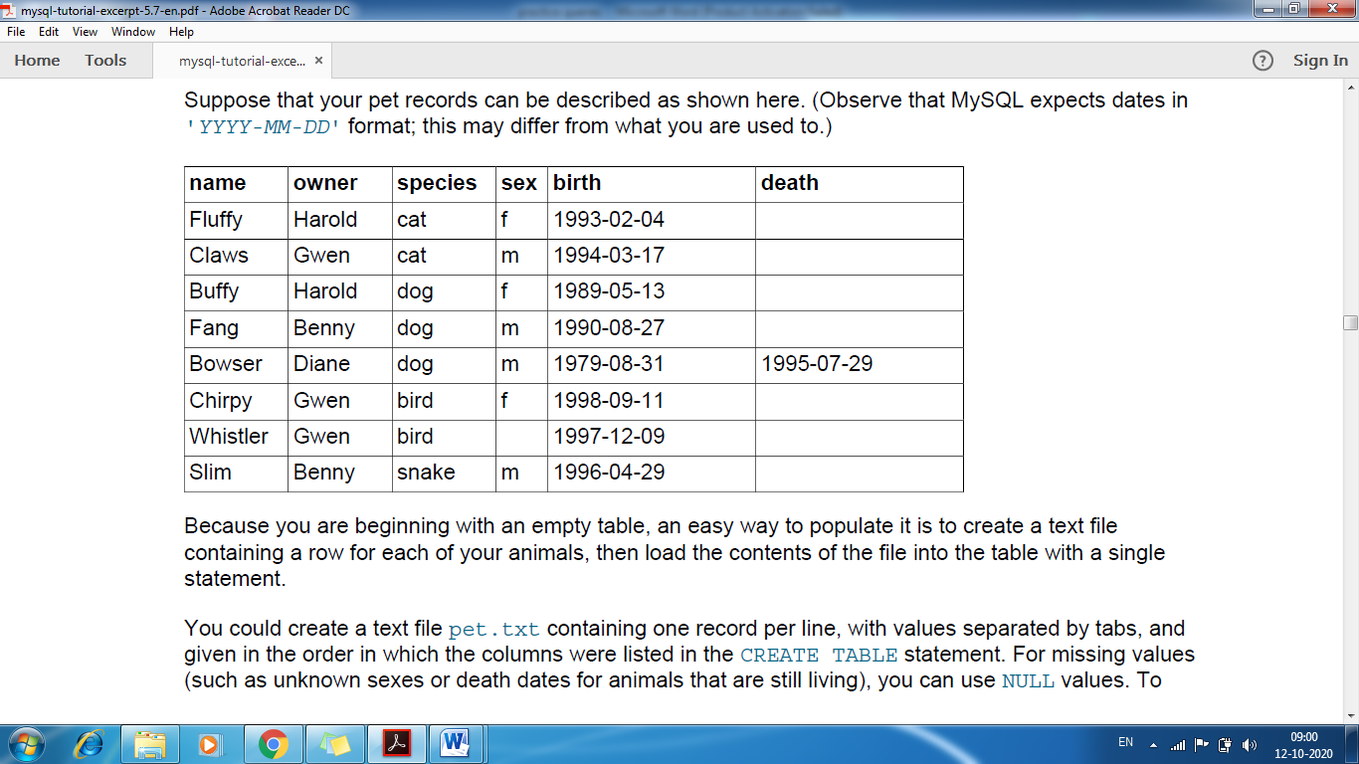

**3. INSERT INTO petVALUES('Puffball','Diane','hamster','f','1999-03-30',NULL);**

**Selecting All Data**

1. **SELECT * FROM pet;**
2. **UPDATE pet SET birth = '1989-08-31' WHERE name = 'Bowser';**
3. **SELECT * FROM pet WHERE name = 'Bowser';**

+--------+-------+---------+------+------------+------------+

| name | owner | species | sex | birth | death |

+--------+-------+---------+------+------------+------------+

| Bowser | Diane | dog | m | 1989-08-31 | 1995-07-29 |

+--------+-------+---------+------+------------+------------+

1. **SELECT * FROM pet WHERE birth >= '1998-1-1';**

name | owner | species | sex | birth | death |

+----------+-------+---------+------+------------+-------+

| Chirpy | Gwen | bird | f | 1998-09-11 | NULL |

| Puffball | Diane | hamster | f | 1999-03-30 | NULL |

+----------+-------+---------+------+------------+-------+

**Selecting Particular Columns**

1. **SELECT name, birth FROM pet;**

+----------+------------+

| name | birth |

+----------+------------+

| Fluffy | 1993-02-04 |

| Claws | 1994-03-17 |

| Buffy | 1989-05-13 |

| Fang | 1990-08-27 |

| Bowser | 1989-08-31 |

| Chirpy | 1998-09-11 |

| Whistler | 1997-12-09 |

| Slim | 1996-04-29 |

| Puffball | 1999-03-30 |

+----------+------------+

**Sorting Rows**

You may have noticed in the preceding examples that the result rows are displayed in no particular order. It

is often easier to examine query output when the rows are sorted in some meaningful way. To sort a result,

use an ORDER BY clause.

1. **SELECT name, birth FROM pet ORDER BY birth;**

+----------+------------+

| name | birth |

+----------+------------+

| Buffy | 1989-05-13 |

| Bowser | 1989-08-31 |

| Fang | 1990-08-27 |

| Fluffy | 1993-02-04 |

| Claws | 1994-03-17 |

| Slim | 1996-04-29 |

| Whistler | 1997-12-09 |

| Chirpy | 1998-09-11 |

| Puffball | 1999-03-30 |

+----------+------------+

The default sort order is ascending, with smallest values first. To sort in reverse (descending) order, add

theDESC keyword to the name of the column you are sorting by:

mysql>**SELECT name, birth FROM pet ORDER BY birth DESC;**

+----------+------------+

| name | birth |

+----------+------------+

| Puffball | 1999-03-30 |

| Chirpy | 1998-09-11 |

| Whistler | 1997-12-09 |

| Slim | 1996-04-29 |

| Claws | 1994-03-17 |

| Fluffy | 1993-02-04 |

| Fang | 1990-08-27 |

| Bowser | 1989-08-31 |

| Buffy | 1989-05-13 |

+----------+------------+