Github introduction:

1. Git is a version control system
2. Git is a distributed version control system(VCS)
3. Central version control system: SVN is an example of central VCS

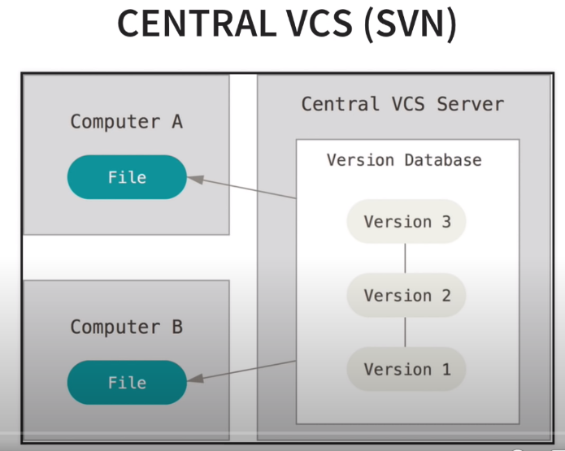

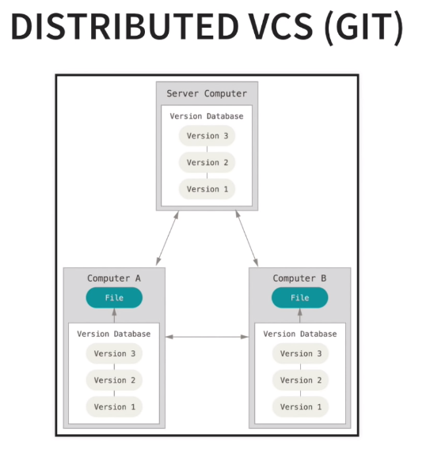

Install git from the website

* git --VERSION

Set config values

* git config --global user.name “VarshaVinay”
* git config --global user.email “lalapura.varsha@gmail.com”
* git config --list

Commands:

ls

ls -la

mkdir Local-Repo

ls

ls -la

mkdir .personal

touch calc.py

touch sample1.pyc

touch sample2.pyc

git init —----------------> shows .git dir

rm -rf .git —-------------> removes .git

git init(tract the project using git)

ls -la —------------------> shows .git dir inside the Local-Repo dir, hence we now tracking this project called Local-Repo using git

We have not committed anything using git yet

1. Before the first commit:

touch .gitignore —-----> create a .ignore file

getid .gitignore —------>

.personal

*.pyc

git status —---------------> on branch master

no commits yet, untracked files .gitignore, calc.py

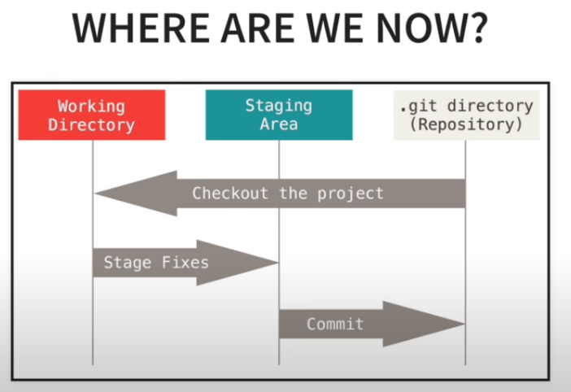

our git working area has .gitignore and cal.py files

Q) How to know what are the files in the git working dir?

A- command: git status

1. Adding files to the staging area

git add .gitignore

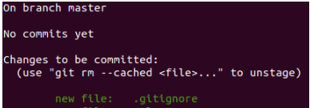

or add every thing from the working area to the staging area,

git add -A

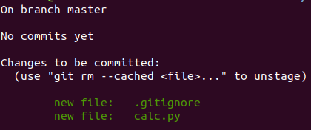

1. Remove files from the staging area:

git reset calc.py

git status

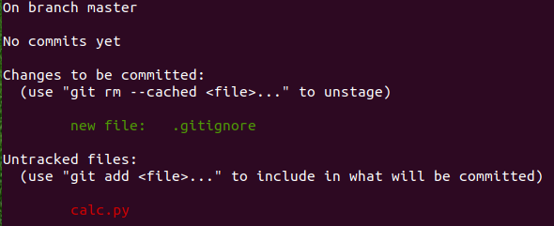

Now remove all files from staging area

git reset

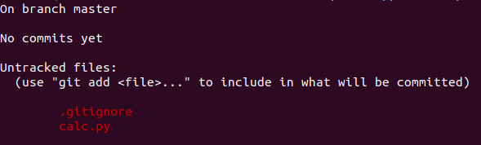

git add -A

git status

1. Our first commit

For initial commit

git commit -m “Initial Commit”

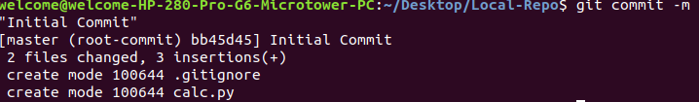

git status



git log : to see the commit we just made, gives the hash number, author name and date information, commit message

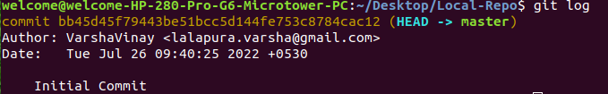

1. Cloning a remote repo:

First make an empty directory called Cloned-Repo outside the existing Local-repo directory.

cd into the Cloned-Repo

now do a git clone

syntax: git clone <url> <where to clone>

example: git clone <https://github.com/CoreyMSchafer/remote_repo.git> .

Here I got stuck,

github user : VarshaVinay

password: typed my correct password,

But github has a new procedure to authenticate:

Followed this link for my ubuntu machine:

<https://stackoverflow.com/questions/68775869/message-support-for-password-authentication-was-removed-please-use-a-personal> upto git pull -v

copied the authentication password, it is in .personal file

I dint understand much, but I am still proceeding with Corey Sir’s video now.

remote_repo not found tried this instead

git clone https://github.com/CoreyMSchafer/Sample-Repo.git .

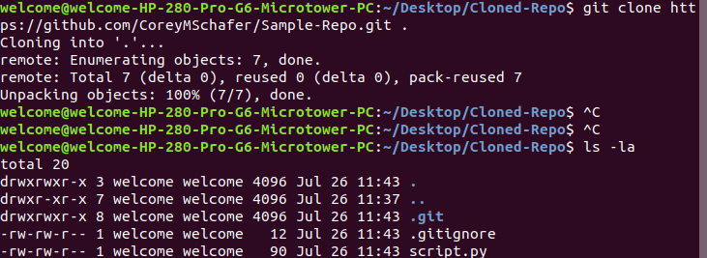

1. Viewing information about the remote repository:

command: git remote -v 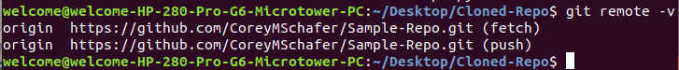

command: git branch -a



Instead of calc.py file, we have a script.py file from this Cloned_Repo directory

Q) Now how to reflect the changes made in the Cloned-repo directory present remotely somewhere?

1. Commit the changes locally before pushing it to the remote location

Steps:

Make changes in the script.py file and check the difference between original and made changes now using command git diff

command : git diff

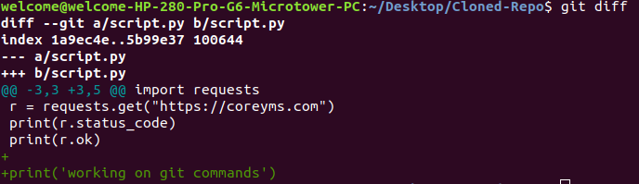

next : git status

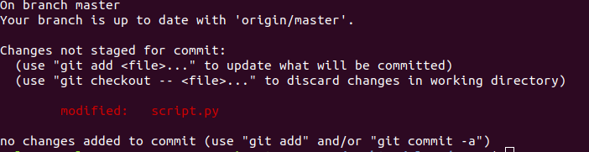

add the modified file to the staging directory:

git add -A (A for all the changes)

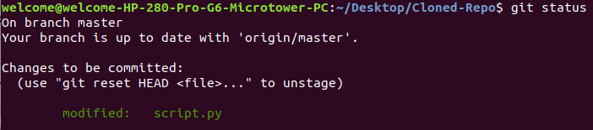

now commit the changes locally:

git commit -m “print statement in the end”

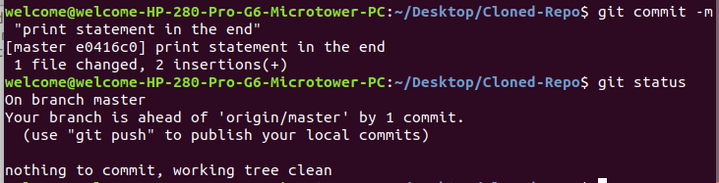

now push the changes to the remote repository:

before that pull changes the very last time a change was made in the repository

command: git pull origin master

(origin is the repository name, master is the branch name)



git push origin master

