**CLOUD COMPUTING LAB**

**CAT – 2**

**TEAM MEMBERS:**

1934045 – SNEKA P

1934052 – TANUJA A

1934055 – VARSHA B

**AIM:**

To dockerize a web application and deploy it in the kubernetes cluster.

**APPLICATION:**

CIT REGISTRATION WEBSITE

**PROBLEM STATEMENT:**

This is to deploy ancit registration web portal for students know about the college infrastructure and brochure and to register for their interested courses.

**DOCKER FILE:**

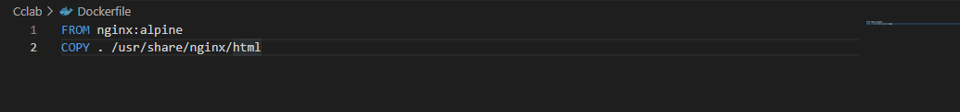

**BUILDING DOCKER IMAGE:**

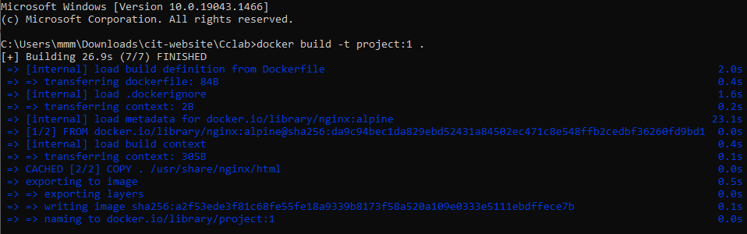

**RUNNING DOCKER IMAGE:**



**IMAGE CACHING:**



**LAYER CACHING:**

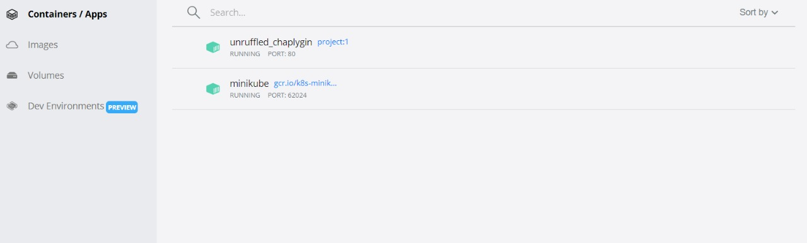

**CONTAINER SERVICE EXPOSURE:**



**CONTAINER LOG FETCHING:**

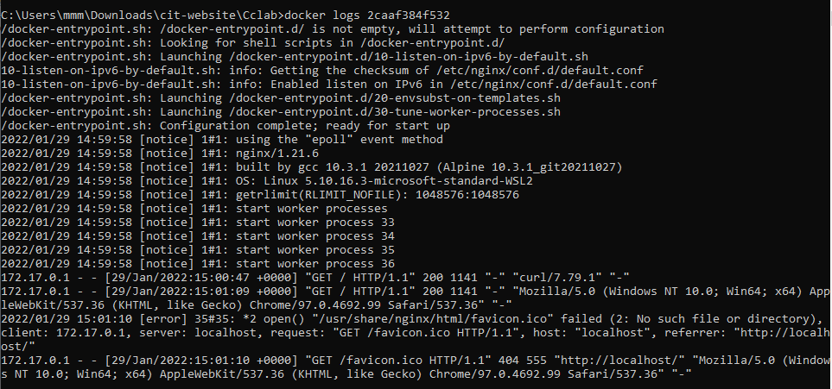

**EXECUTING INTO DOCKER:**

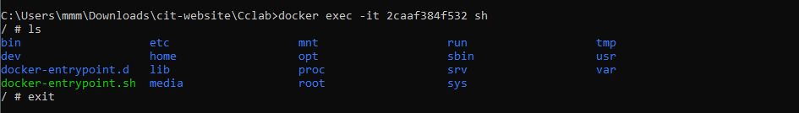

**KUBERNETES:**

**STARTING MINIKUBE:**

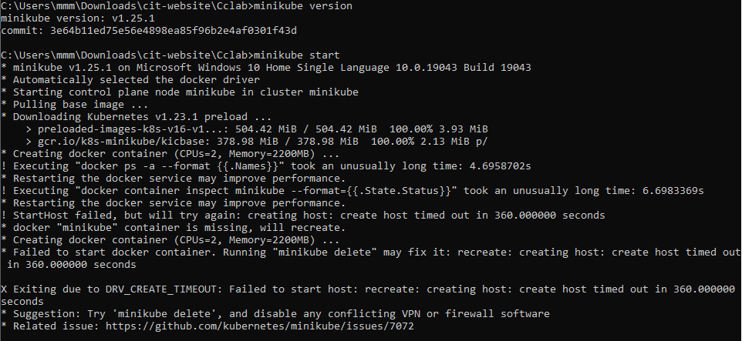

**CREATING NAMESPACE:**

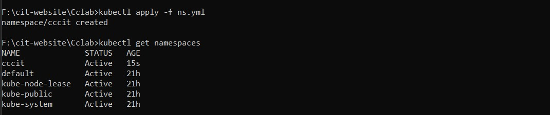

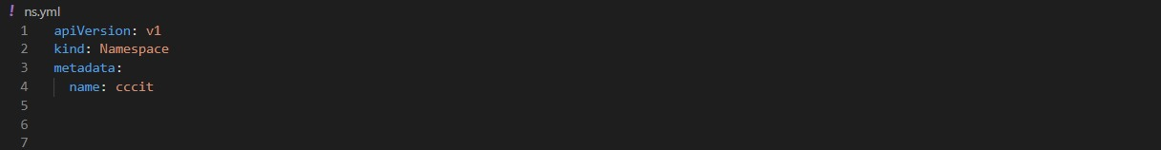

**CREATING POD IN THE NAME SPACE :**

**WhatsApp Image 2022-01-30 at 3.54.18 PM.jpeg**

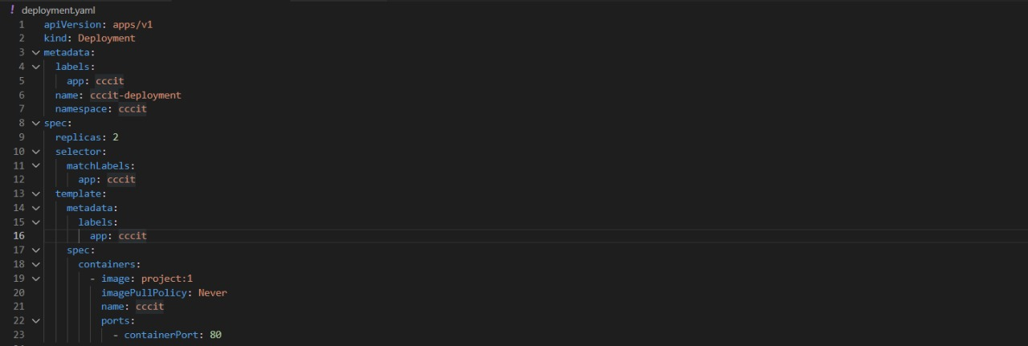

**CONFIGURING DEPLOYMENT POD WITH 2 REPLICAS :**

**WhatsApp Image 2022-01-30 at 4.07.37 PM.jpeg**

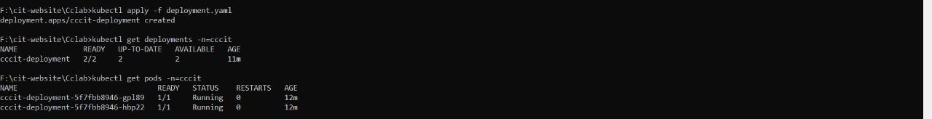

**SERVICE EXPOSURE(v1):**

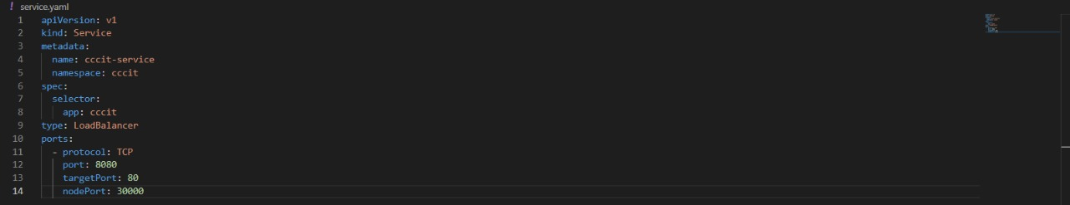

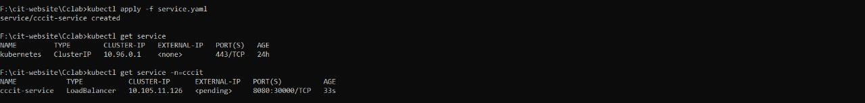

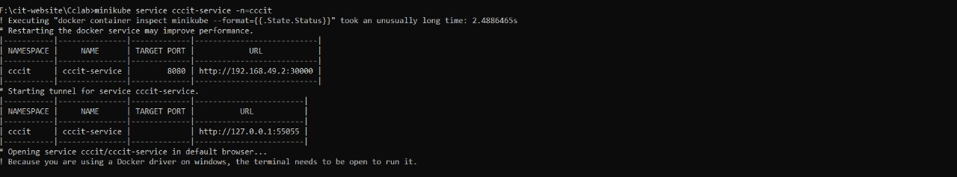

**HOSTED WEBPAGE :**



**RESOURCE LIMITATION :**

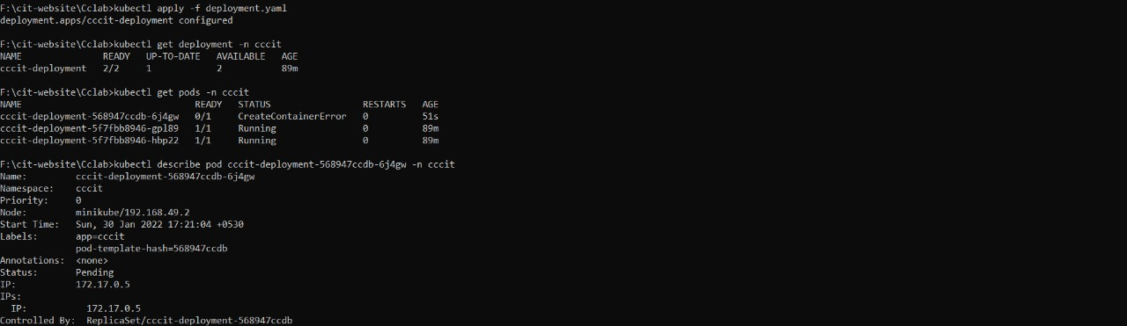

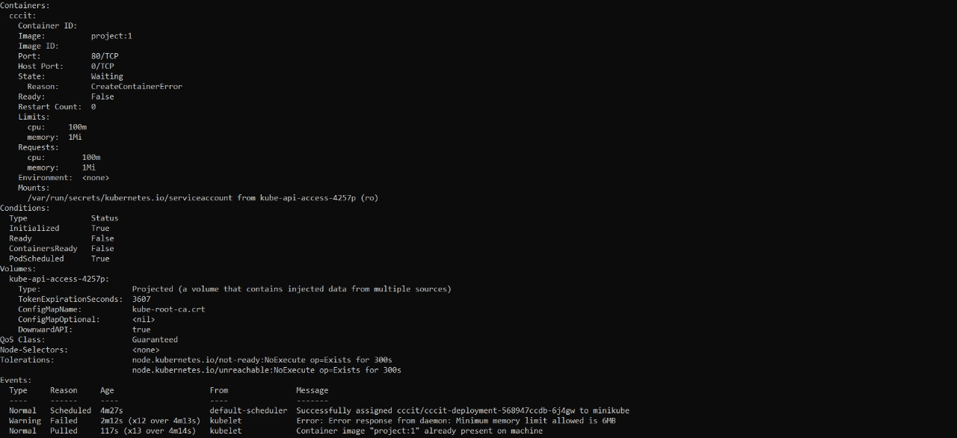

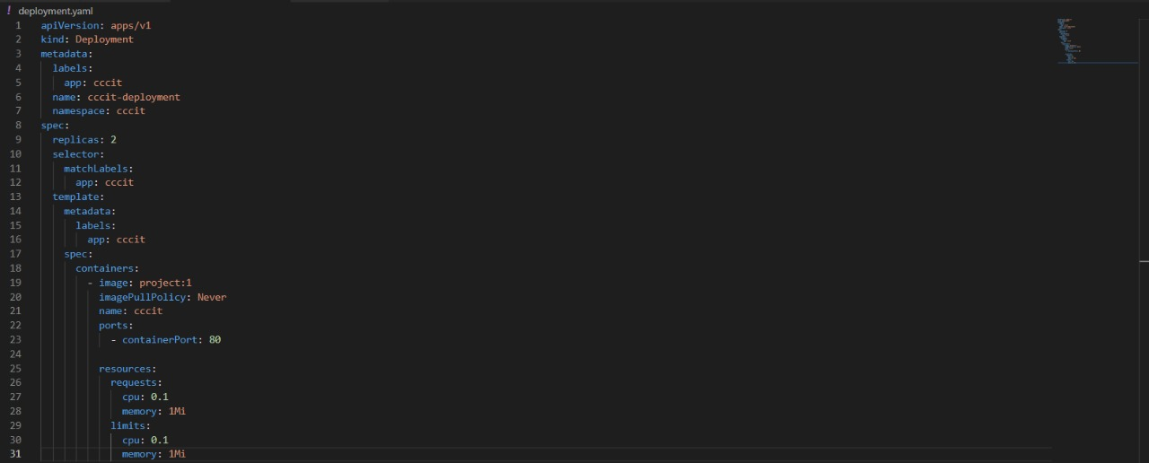

**ROLLBACK STRATEGY**

**VERSION 2 :**



