|  |  |  |
| --- | --- | --- |
| **Ex.No.: 3** | | **WRITING BASIC SQL SELECT STATEMENTS** |
| **Date:** | 6/8/24 |

# Find the Solution for the following:

**True OR False**

1. The following statement executes successfully.

# Identify the Errors

SELECT employee_id, last_name sal*12 ANNUAL SALARY

FROM employees;

False ->Corrected Query and Output

Select employee_id,last_name,salary*12 AS "Annual Salary" from Employees;

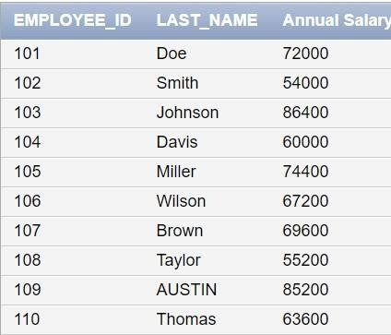

1. Show the structure of departments the table. Select all the data from it.

DESC department;

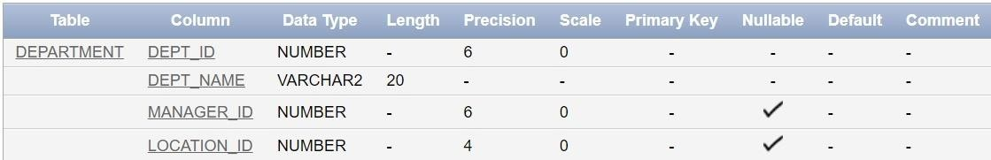

Select * from Department;

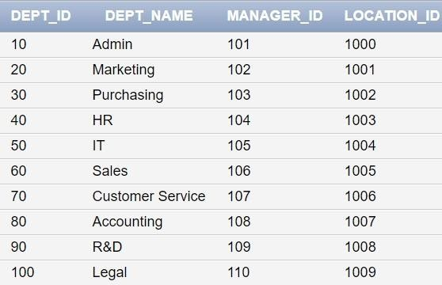

1. Create a query to display the last name, job code, hire date, and employee number for each employee, with employee number appearing first.

SELECT employee_id, last_name, job_id, hire_date FROM employees;

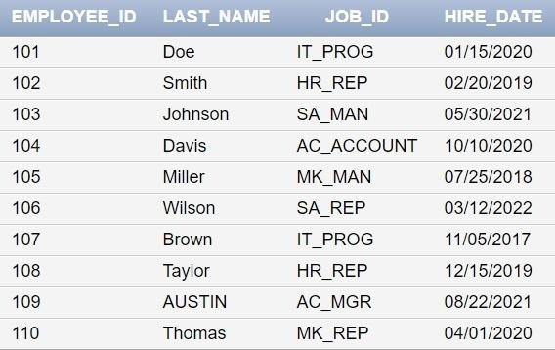

1. Provide an alias STARTDATE for the hire date.

SELECT employee_id, last_name, job_id, hire_date AS STARTDATE FROM employees;

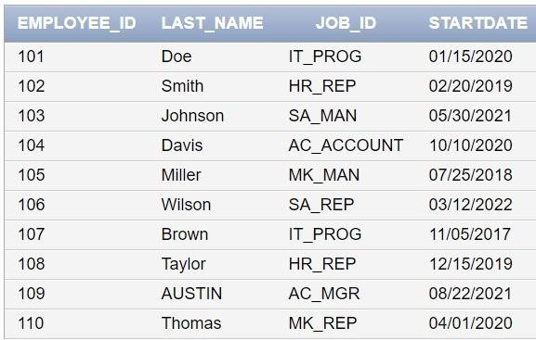

1. Create a query to display unique job codes from the employee table.

SELECT DISTINCT job_id FROM employees;

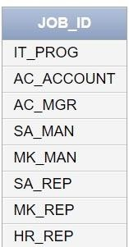

1. Display the last name concatenated with the job ID , separated by a comma and space, and name the column EMPLOYEE and TITLE.

SELECT last_name || ', ' || job_id AS "EMPLOYEE and TITLE" FROM employees;

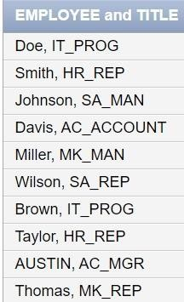

1. Create a query to display all the data from the employees table. Separate each column by a comma. Name the column THE_OUTPUT.

SELECT employee_id || ', ' || last_name || ', ' || job_id || ', ' || hire_date AS THE_OUTPUT FROM employees;

