**“QR-SITE”**

***Dissertation Submitted in Partial fulfillment***

***of the Requirement for the Award of the Degree of***

***Master of Technology***

***(M.Tech.(IT)(5Yrs))***

***Session July-December, 2023***

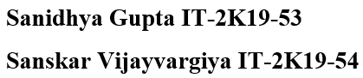**Under the guidance of Submitted By**

**Dr. Nitin Nagar**

**International Institute of Professional Studies**

**Devi Ahilya Vishwavidyalaya, Indore, M.P.**

**2023**