1) Total Revenue
select SUM(total_price) as TotalRevenue from pizza_sales as Totalprice
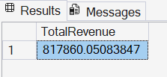
2) Average Order Value
select SUM(total_price)/COUNT(DISTINCT order_id) as Average_OrderValue from pizza_sales
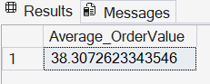
3) Total Pizza Sold

select SUM(quantity) as Total_PizzaSold from pizza_sales

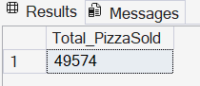

4)Total Orders Placed

select COUNT(distinct order_id) as Total_orders from pizza_sales

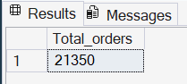
5)Average pizzas per order
select cast(cast(sum(quantity)as decimal (10,2))/ cast(count(distinct order_id)as decimal(10,2)) as decimal(10,2)) as AveragePizza from pizza_sales
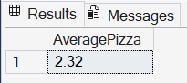

6)Daily trend for total orders-Daywise
select DATENAME(dw,order_date)as order_day,count(distinct order_id) as Total_orders
from pizza_sales
group by datename(dw,order_date)
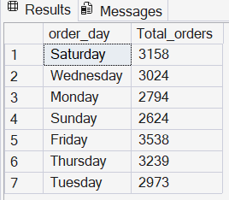
7)Monthly trend
select DATENAME(MONTH, order_date) as Month_name , COUNT(distinct order_id) as Total_Orders from pizza_sales
group by DATENAME(MONTH, order_date) order by Total_orders desc
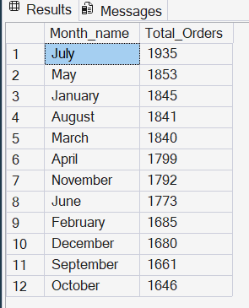

8)Percentage of sales by pizza category:
select pizza_category, sum(total_price) * 100 / (select sum(total_price) from pizza_sales) as PercentageOfSales from pizza_sales group by pizza_category

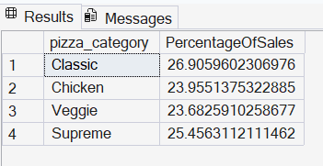

9)Percentage of Sales by pizza Size
select pizza_size, sum(total_price) * 100 / (select sum(total_price) from pizza_sales) as PercentageOfSalesbySIZEfrom pizza_sales group by pizza_size
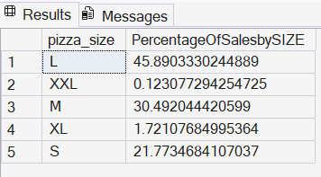
10)Top 5 BEST sellers by Revenue

select top 5 pizza_name,sum(total_price) as Total_Revenue from pizza_sales
group by pizza_name order by Total_Revenue desc
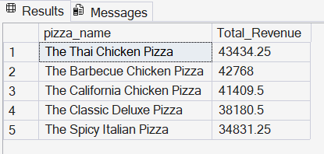
11)Bottom 5 sellers by Revenue

select top 5 pizza_name,sum(total_price) as Total_Revenue from pizza_sales
group by pizza_name order by Total_Revenue
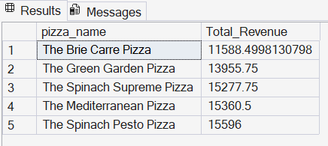

12)Top 5 Best sellers by Quantity

select top 5 pizza_name,sum(quantity) as Total_Quantity from pizza_sales
group by pizza_name order by Total_Quantity desc
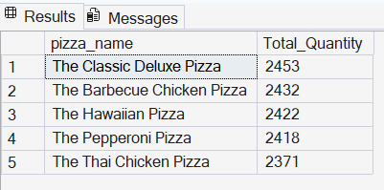
13)Bottom 5 by Quantity

select top 5 pizza_name,sum(quantity) as Total_Quantity from pizza_sales
group by pizza_name order by Total_Quantity
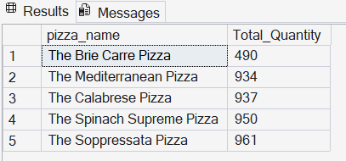
14)Top 5 by order ID

select top 5 pizza_name,count(distinct order_id) as Total_Orders from pizza_sales
group by pizza_name order by Total_Orders desc
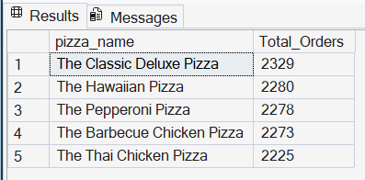

15)Bottom 5 by order ID

select top 5 pizza_name,count(distinct order_id) as Total_Orders from pizza_sales
group by pizza_name order by Total_Orders

