Assignment 1: Chatbot Development
UniGuide: Intelligent College Campus Chatbot with Python Flask & Gemini AI
Author: Student
Date: May 22, 2026
Architecture: Python Flask Backend & Gemini AI integration

1. Executive Summary & Project Objective
Chatbots have emerged as an essential interface in modern web systems, facilitating instant support and reducing administrative workload. This project, titled UniGuide, is a smart campus assistant chatbot built with a Python Flask server backend and optional Google Gemini AI integration. The chatbot is designed to guide students, prospective applicants, and parents through admissions procedures, tuition structures, academic calendars, campus geography, and support tickets.
Key objectives of the UniGuide chatbot include:
- • 24/7 Information Access: Instantly answering common student questions regarding tuition fees and term dates.
- • Dual AI Processing: Leveraging Google Gemini LLM API for natural language understanding while using a robust offline rule-based regex fallback.
- • Admissions Streamlining: Helping new applicants understand application steps and deadlines.
- • Live Support Integration: Enabling users to raise troubleshooting tickets, gathering email data, and generating confirmation IDs via stateful sessions.

2. Conversation Flow Design
To deliver a robust conversational user experience, UniGuide uses a rule-based state-machine design. The logic splits interactions into predefined, structured flows: Welcome Greeting, Admission Flow, Navigation Flow, Ticketing Form Flow, and Fallback/Error state.

Detailed Conversation Node Structure
1. Welcome Node: Greets the user, details the bot's abilities, and suggests quick-reply buttons (Admissions, Fees, Map, Exams, Raise Ticket).
2. Admissions Node: Triggers on keywords like 'apply', 'admission', 'enrol'. Displays steps, deadlines, and links to the Application portal.
3. Navigation Node: Triggers on map-related keywords. Displays a simulated graphical map and popular landmarks.
4. Support Ticket State: Collects student email, validates formatting, prompts for issue details, submits to HELP-DESK queue, and returns confirmation IDs.
5. Fallback Error Node: Triggers on unmatched queries. Suggests search alternatives and displays hotkeys to return to known topics.

3. Technical Implementation & UI Design
UniGuide is built as a highly responsive Python Flask application to guarantee server-side security, live API connectivity, and a premium look-and-feel. It uses native web APIs and complies with modern aesthetic guidelines.
- • Backend Architecture (Python Flask): Configures session state memory to store support ticket fields. Exposes routing for landing pages ('/') and API chat processing endpoints ('/api/chat'). Loads the Google Generative AI (Gemini) SDK for intelligent reasoning.
- • Structure (HTML5/Templates): Rendered dynamically by Flask. Organizes the application into a split layout, showing stats cards in the sidebar and chat messages on the main viewport.
- • Design & Style (Vanilla CSS3): Uses glassmorphism (frosted borders, backdrop filters) to blend components nicely in dark and light modes. Incorporates smooth transit keyframes for message bubble entries.
- • Client Script (Vanilla JS): Manages frontend elements, triggers typing status indicators, interacts with the backend `/api/chat` API using Fetch, and plays sound effects.

4. Chatbot Screens & Output Analysis
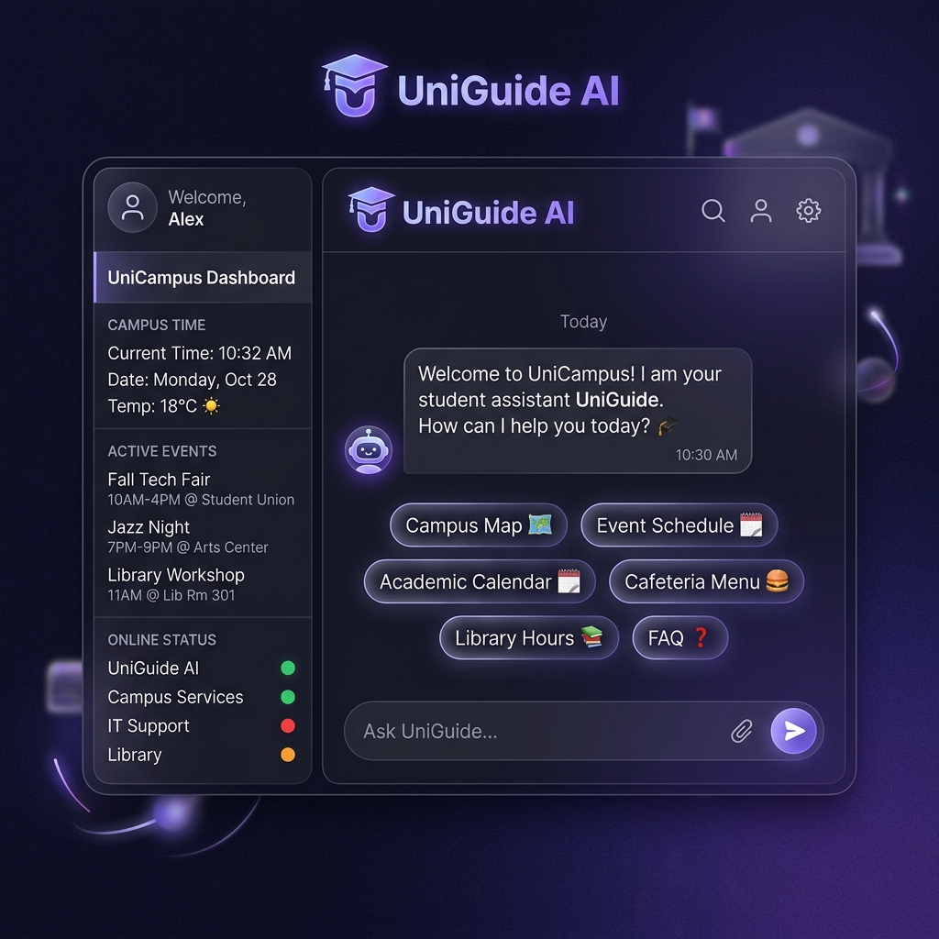
Figure 1: UniGuide Welcome Interface & Common Topics Panel

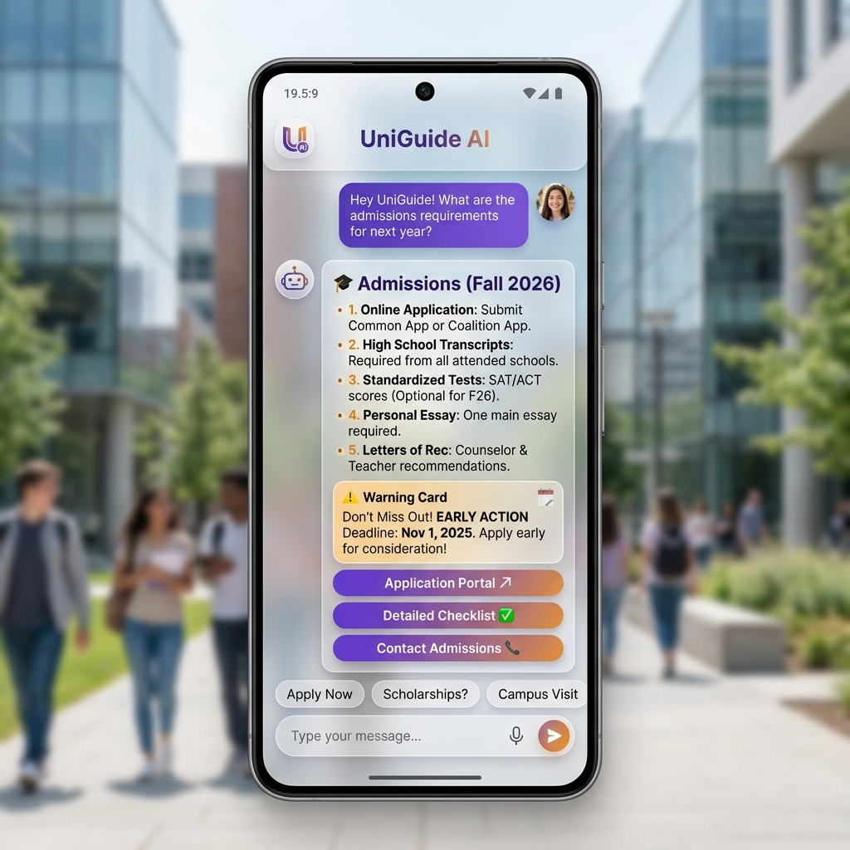
Figure 2: Admissions Requirements & Fees Inquiry Interface

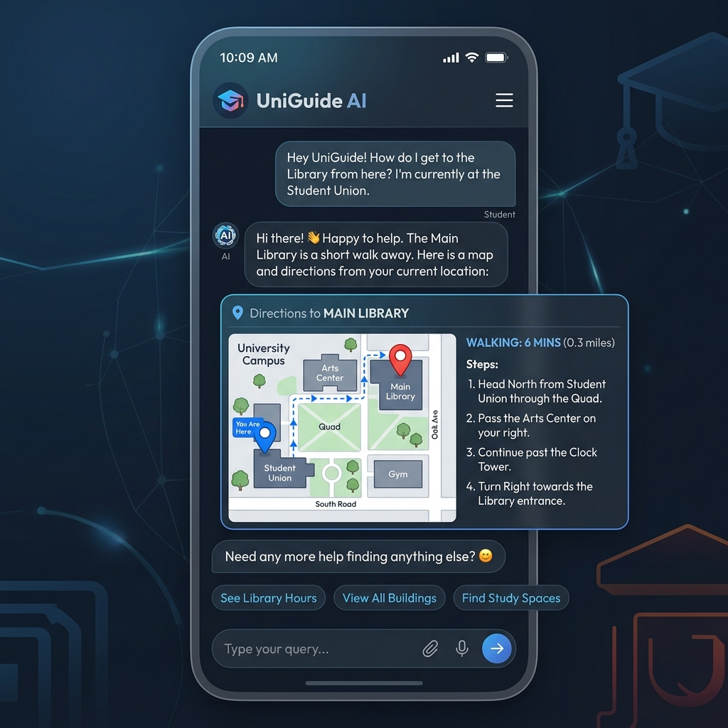
Figure 3: Interactive Campus Maps and Directions

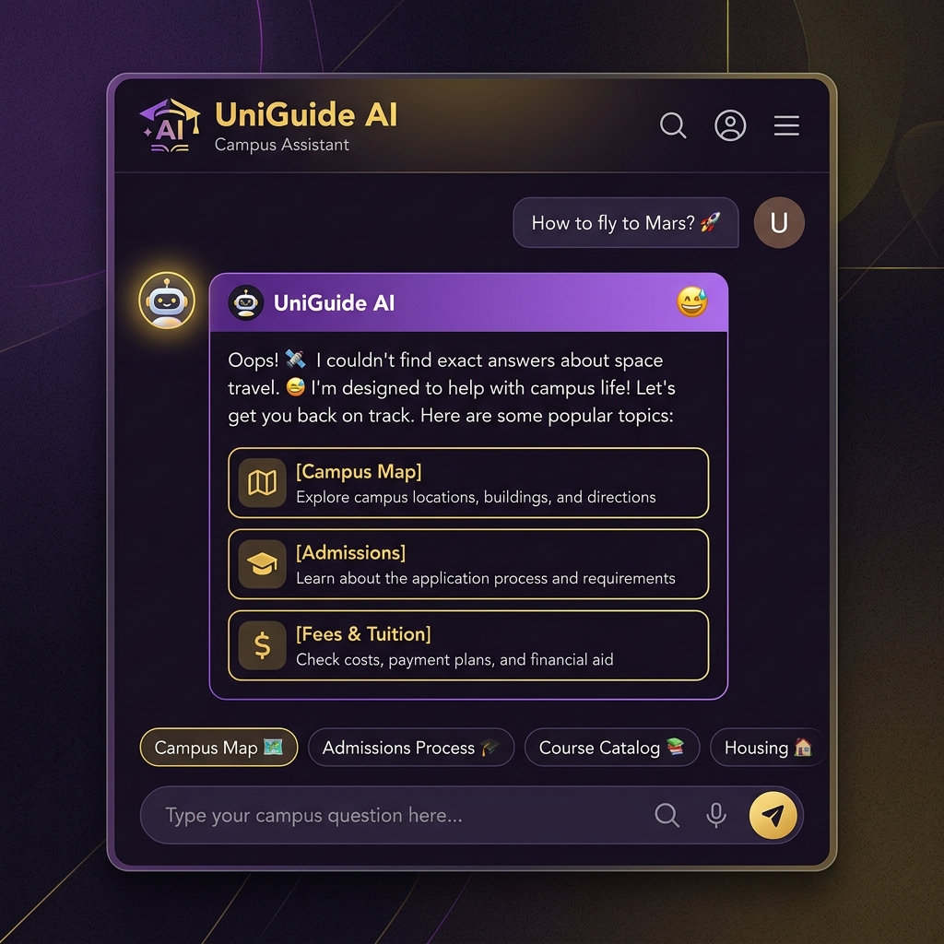
Figure 4: Robust Fallback Error Handling for Unrecognized Queries

Project Working Directory & Links
• Local Source Directory: file:///C:/Users/Asus/.gemini/antigravity/scratch/UniGuide-Chatbot
• Flask Entry Script: file:///C:/Users/Asus/.gemini/antigravity/scratch/UniGuide-Chatbot/app.py
• Local Dev Server Port: http://localhost:5000

Conversation Interaction Mapping
User Intent / Input | Pattern Matching Rule | Bot Action & Output
admission requirements | Keyword matches: 'admission', 'apply' | Displays application portal link, deadlines, and criteria list.
tuition fees | Keyword matches: 'fees', 'cost', 'tuition' | Displays cost comparison list (in-state vs out-of-state) and scholarship links.
campus map library | Keyword matches: 'map', 'directions', 'library' | Draws simulated campus map box with dynamic locator pulsing.
raise ticket | Keyword matches: 'ticket', 'support', 'help' | Initiates stateful ticket form. Prompts for student email address, then prompt for issue description, returning ID.
fly to Mars | No matches (Fallback triggers) | Returns friendly error notification card containing popular recommended buttons.

5. Conclusion & Future Scopes
UniGuide successfully models a premium Flask chatbot interface capable of answering basic college student and parent inquiries. By merging server-side python control with beautiful frontend UX elements and Gemini LLM integration, the bot delivers a highly robust interactive experience. Future enhancements will involve linking with live student databases via SQL libraries, supporting multi-language speech outputs, and fine-tuning models to automatically answer campus-specific curriculum documents.

