**Arc Face: Additive Angular Margin Loss for Deep Face Recognition**

**Team Members**

**1. Bobba Shruti**

**2. Varsha Reddy Chinthalapudi**

**Project Description:**

This project entails the development of a sophisticated face recognition system with a multi-faceted approach. It commences with the use of the MTCNN (Multi-task Cascaded Convolutional Networks) for precise face detection and subsequent annotation, thereby enhancing data quality. The annotated images are organized into a structured dataset for training and evaluation. Deep learning techniques are then harnessed, featuring an embedding model to extract critical facial features and an Arc Face loss function to heighten feature discrimination, ultimately improving recognition accuracy.

To ensure robustness, the dataset is thoughtfully divided into training, validation, and test sets, allowing for rigorous performance assessment. The model is systematically fine-tuned, considering hyperparameters, architecture, and training dynamics, to optimize recognition results. This holistic approach seamlessly integrates computer vision and deep learning, yielding a powerful face recognition system applicable to security, access control, and numerous other fields, characterized by its accuracy and adaptability.

**Dataset:**

The dataset is structured within a 'data' directory, which further contains a 'raw' directory. Inside the 'raw' directory, subdirectories are organized, each bearing the name of an individual ('name1,' 'name2,' etc.). Within these subdirectories, a collection of photos ('photo1.jpg,' 'photo2.jpg,' etc.) is stored for each individual. This dataset is tailored for the task of face recognition, with each individual's photos grouped together for training and evaluation. Accurate annotations associate these images with their respective person, making it a valuable resource for supervised learning. The dataset encompasses a diverse range of individuals, capturing variations in facial features, expressions, and orientations, providing a robust foundation for training and assessing face recognition models.



**Annotations:**

Annotations play a crucial role in this project's dataset. Each image in the dataset is associated with precise annotations that provide essential information about the images, primarily facilitating face recognition. These annotations typically include:

1. **Bounding Boxes:** For each image, a bounding box is drawn around the detected face. This spatial information defines the location and size of the face within the image, making it easier for the model to recognize and process.
2. **Labels:** Each image is labeled with a unique identifier, often corresponding to the individual whose face is depicted in the image. These labels enable the model to associate specific images with the respective person, forming the basis for supervised learning.
3. **dataset_labels.csv:** The dataset is further organized and enriched by the creation of a dataset_labels.csv file. This file records the image paths and their associated labels, providing an efficient means of linking images to individuals for training and evaluation. The dataset_labels.csv file acts as a central reference, enhancing the dataset's manageability and facilitating seamless integration into the model, contributing significantly to the success of the face recognition project. The dataset_labels.csv file is an essential bridge between the dataset and the model, facilitating data loading and organization during the training and evaluation phases. It ensures that the model can accurately recognize and differentiate individuals based on their images, contributing to the project's success in face recognition.

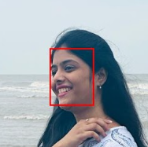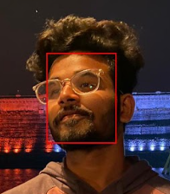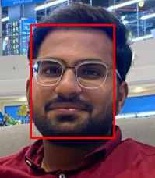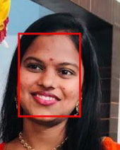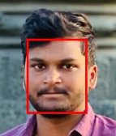

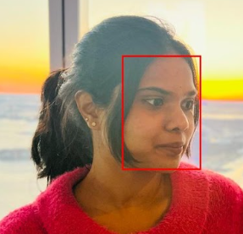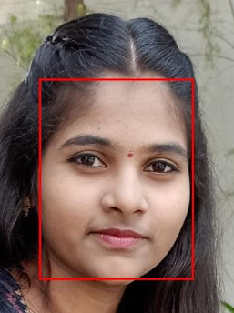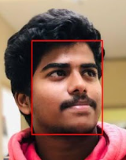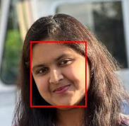

**Partitioning:**

The dataset partitioning in this project is meticulously designed to ensure comprehensive model training and evaluation, with the following percentages:

* Training Set (90%): The majority of the dataset, accounting for 90%, is allocated for training and testing. This substantial portion is essential for the model's learning process and evaluating its real-world performance.
* Training Data (88% of 90%): Within the training set, approximately 88% is exclusively dedicated to model training. This core training data is where the model learns to recognize and differentiate between individuals based on their facial features.
* Validation Data (12% of 90%): A smaller yet vital subset, constituting around 12% of the training set, is set aside for validation. This validation data is instrumental in fine-tuning hyperparameters, optimizing the model's architecture, and ensuring it generalizes well to unseen data.
* Test Set (10%): The final 10% of the dataset is reserved for testing. This portion is entirely independent of the training and validation phases, providing a reliable evaluation of the model's real-world performance.

Overall, this partitioning strategy allows for comprehensive model development. It balances extensive training with rigorous validation and unbiased testing, ensuring the model's proficiency in recognizing faces accurately and reliably across various scenarios and facial variations.

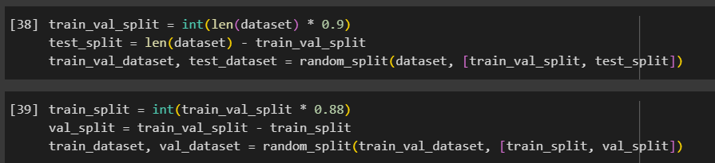

**Transformation:**

Transformation is a vital part of your data preprocessing pipeline, encompassing both normalization and augmentation techniques to enhance the robustness and performance of your face recognition model.

1. **Normalization:**

Normalization is a crucial preprocessing step in your code, implemented using PyTorch's transforms.Normalize. It involves scaling the pixel values of images to a standardized distribution. The specified mean and std values, [0.485, 0.456, 0.406] and [0.229, 0.224, 0.225], respectively, center the data around these values and scale it by the standard deviation. This process aligns pixel values, ensuring that they have a consistent range and mitigating variations in lighting, contrast, and exposure. Normalization enhances model stability, aids convergence during training, improves generalization, and prevents issues like vanishing gradients, ultimately leading to a more effective face recognition model.

1. **Augmentation:**

Data augmentation, another critical preprocessing step in your code, diversifies the training data to improve the model's robustness. It comprises three key transformations:

* **Resize:** Images are resized to a uniform 224x224 pixel size, a common practice in deep learning, ensuring consistent input dimensions.
* **Random Horizontal Flip:** With a 50% probability, images are horizontally flipped, introducing orientation variety and aiding the model in generalizing across different head angles.
* **Random Rotation**: Images are randomly rotated by up to 10 degrees, simulating head pose variations. This augmentation makes the model more resilient to different facial orientations, enhancing its real-world performance. These transformations collectively prepare the input data for effective training, making the model robust and capable of recognizing faces accurately under diverse real-world conditions.

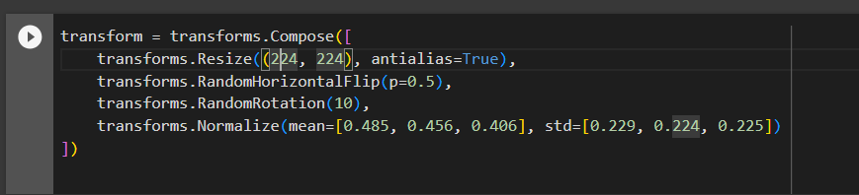

**Optimization:**

Optimization, a pivotal process in model training, involves iteratively adjusting a model's parameters to minimize the loss and enhance performance. In this code, the Stochastic Gradient Descent (SGD) optimizer was chosen to drive this process. SGD continuously updates the model's parameters by calculating gradients of the loss and refining the model's weights. The ultimate goal of optimization is to minimize the loss, guiding the model towards accurate face recognition.

The result of this optimization is an improved model with enhanced capabilities. It fine-tunes its parameters, ultimately leading to more accurate classifications and precise identification of individuals based on their facial features. This optimization process significantly enhances the model's effectiveness in real-world scenarios.

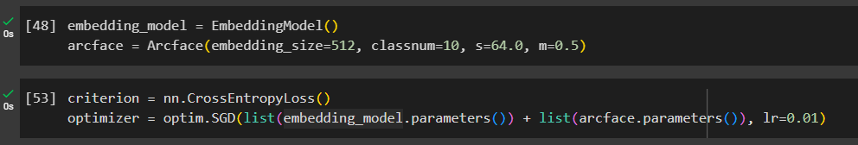

**Loss:**

Loss is a pivotal metric that quantifies the disparity between the model's predicted class labels and the actual labels in the training data. In this code, cross-entropy loss was chosen for its effectiveness in classification tasks. The loss value (reported as 35) reflects how far the model's predictions deviate from the true labels. Lower loss values indicate more accurate predictions. The primary purpose of loss calculation is to guide the optimization process by offering a quantitative measure of the model's performance. As optimization progresses, the loss diminishes, signaling the model's improved capability to achieve precise face recognition. This reduction in loss mirrors the model's ability to refine its predictions and enhance its accuracy, ultimately resulting in a more adept face recognition model.

