Multilingual Document Summarization

Report

**Yasaswi Nallamothu, Sruthi Bobba, Varsha Reddy Chinthalapudi**

# Introduction:

# The "Multilingual Document Summarization" project uses advanced technology to summarize long texts in different languages. Its goal is to make it easier for people around the world to understand and access important information, benefiting fields like education and business. This project is a big step forward in language technology, showing how we can better understand and share information across languages.

# Methodology:

# Language Models:  For English  and Arabic, we use sophisticated  language models, such  as BERT based  models.  Accurate  language representation  and  understanding  are  made  easier  by these  approaches.

# Topic identification: It is accomplished by using Latent Dirichlet Allocation (LDA). This method of  unsupervised  machine  learning  assists  in  identifying  important  subjects  within  the  corpus  of  documents.

# Sentence Selection: To improve the caliber and applicability of the final summary, we develop a  technique to choose instructive statements for summarization.

# Data  Preprocessing:  To  clean  and  organize  the  text  data,  we  carry  out  data  preprocessing  techniques such text tokenization, lemmatization, and stop-word removal.

# Evaluation  Metrics:  We  use  metrics  like  ROUGE  and  BERT  Score  to evaluate  the quality  of  the summaries.

# Crosslingual  Capabilities:  To  increase  its  adaptability,  our system is built to  process  papers  in  several languages.

# Our  goal  is to  efficiently  automate  multidocument text summary using these  models,  algorithms,  and tools, and to provide excellent summaries in Arabic and English.

# Approach:

The steps that we are going to follow in our project are as mentioned below:

* Install Dependencies
* Read Data files
* Remove empty lines
* Remove stop words
* Remove punctuation
* Detect Language
* English Language Model
* Arabic Language Model
* Calculate sentence importance
* Summarization
* LDA Approach

# Network Architecture:

# The neural network architecture consists of encoder-decoder structures, where the encoder processes the input document, and the decoder generates the summary. Attention mechanisms are implemented to enable the model to focus on relevant parts of the document during both encoding and decoding phases. The network is designed to handle the intricacies of Arabic grammar and semantics.

# Evaluation Metrics:

# To assess the performance of the summarization model, multiple evaluation metrics are employed, including ROUGE (Recall-Oriented Understudy for Gisting Evaluation), BLEU (Bilingual Evaluation Understudy), and METEOR (Metric for Evaluation of Translation with Explicit ORdering).

# Challenges and Future Work:

# Challenges in this project include handling linguistic variations in Arabic, ensuring accurate translation, and addressing domain-specific terminology. Future work may involve enhancing the model's capabilities for handling different Arabic dialects, exploring transfer learning techniques, and extending the system to support summarization for other languages.

**Implementation:**

**Task 1: Install Dependencies**

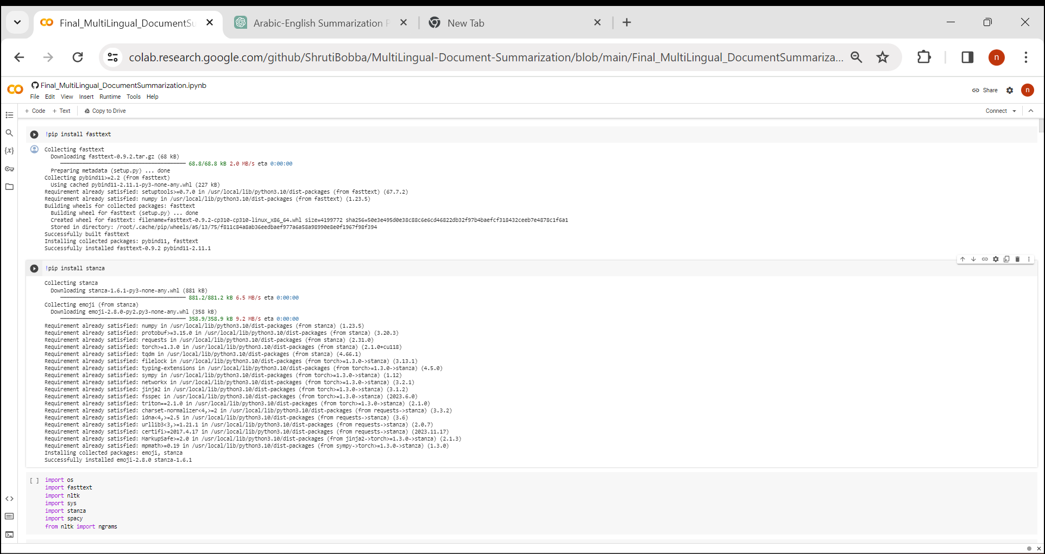

**Task 2: Read Data files**

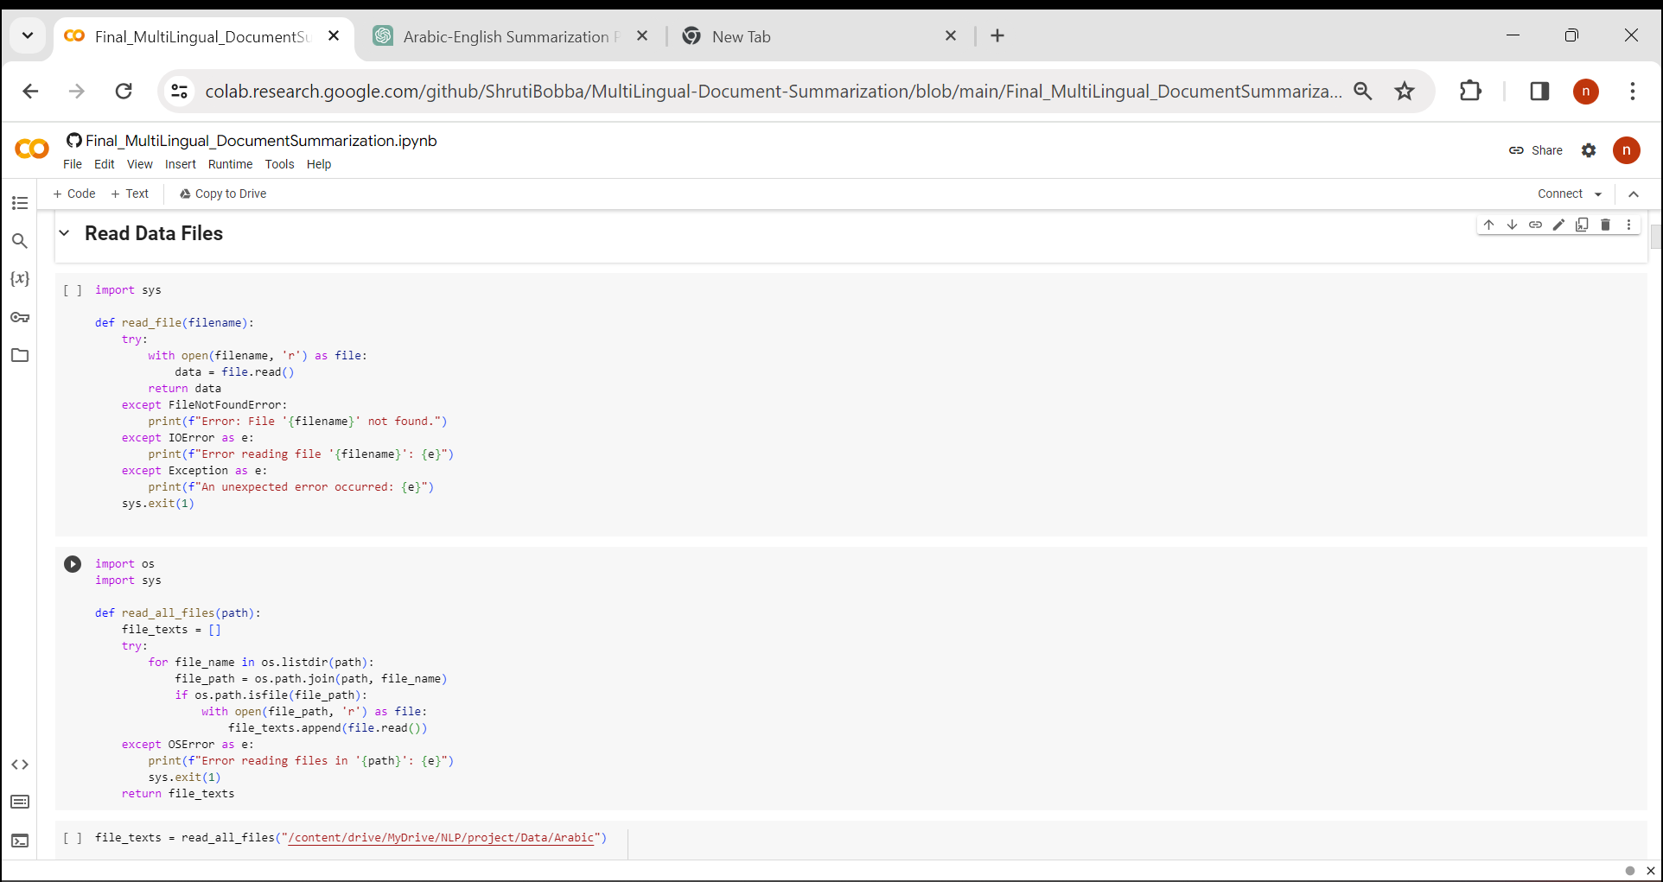

**Task 3: Remove empty lines**

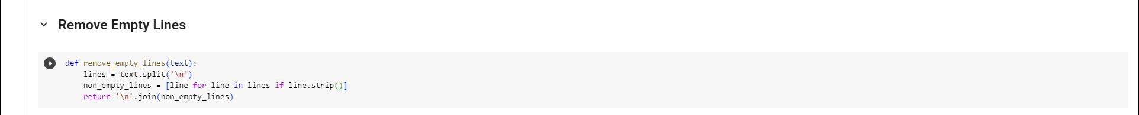

**Task 4: Remove stop words**

**Task 5: Remove punctuation**

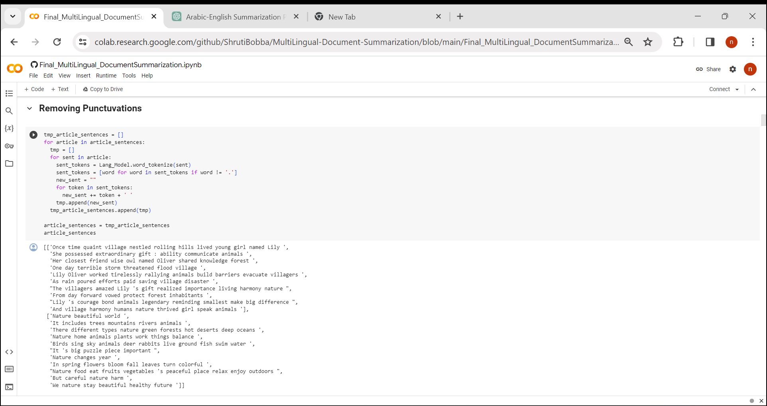

**Task 6: Detect Language**

**Task 7: English Language Model**

**Task 8: Arabic Language Model**

**Task 9: Calculate sentence importance**

**Task 10: Summarization**

**Task 11: LDA Approach**

**Conclusion and Results:**

**References:**

# 