B. M. S. COLLEGE OF ENGINEERING
Autonomous Institute, Affiliated to VTU, Belagavi

DEPARTMENT OF MACHINE LEARNING
Program: B.E. In Artificial Intelligence and Machine Learning

Academic Year: 2026 - 27, Session: July 2026 - December 2026
Time Series Analysis
(24AM7PCTSA)
LAB AAT – DOMAIN-BASED TIME SERIES FORECASTING
AAT Report
Title: Day-Ahead Electricity Price Forecasting with Volatility and Prediction Intervals Using SARIMA-GARCH and Quantile Gradient Boosting
Application Domain: Smart City (Energy Systems)
SDG addressed: SDG 7: Affordable and Clean Energy
Submitted by

Sl. No. | Student Name | USN | Student Signature
1 | Shreyashree C R | 1BM23AI180
2 | Sinchana K | 1BM23AI183
3 | Varsha Tolani | 1BM23AI206
4 | Sahana K Sonni | 1BM23AI163
Semester & Section:

Valuation Report
(to be filled by faculty)
Score: |  | Faculty In-charge:
Comments: |  | Faculty Signature with date:

TABLE OF CONTENTS
1. ABSTRACT
2. INTRODUCTION AND PROBLEM IDENTIFICATION
2.1 Application Domain
2.2 Problem Statement
2.3 Need for Forecasting
2.4 Objectives
2.5 Scope of the Study
3. LITERATURE REVIEW AND RESEARCH GAP
3.1 Review of Existing Research
3.2 Research Gap
3.3 Proposed Approach
4. DATASET DESCRIPTION AND EXPLORATORY DATA ANALYSIS
4.1 Dataset Source
4.2 Variables and Data Description
4.3 Data Preparation
4.4 Exploratory Data Analysis
5. BASELINE FORECASTING MODEL
5.1 Model Selection
5.2 Model Methodology
5.3 Implementation
5.4 Baseline Results
6. PROPOSED MODEL AND ENHANCEMENT
6.1 Motivation for Improvement
6.2 Proposed Enhancement
6.3 Methodology and Implementation
6.4 Expected Advantage
6.5 Proposed Model Results
7. PERFORMANCE EVALUATION AND COMPARISON
7.1 Evaluation Measures
7.2 Comparative Results
7.3 Interpretation of Results
8. CONCLUSION AND FUTURE SCOPE
8.1 Conclusion
8.2 Future Scope
8.3 SDG Addressed
9. REFERENCES
10. TEAM CONTRIBUTION

1. ABSTRACT
Day-ahead electricity prices show daily patterns, price spikes, negative values, and changing uncertainty. This project forecasts hourly DE-LU prices from the public Energy-Charts/SMARD dataset, covering 1 October 2024 to 31 August 2026. Existing research uses autoregressive price models, volatility models, and probabilistic forecasting, but comparisons can be difficult when markets, test periods, and evaluation procedures differ. This study compares a seasonal SARIMA-GARCH baseline with quantile gradient boosting on the same chronological rolling day-ahead test. The first 180 days initialize training; the following 520 days provide 12,480 held-out hourly forecasts. SARIMA models the conditional mean and GARCH models changing residual variance. Three gradient-boosting models directly estimate the 10th, 50th, and 90th conditional price quantiles. SARIMA-GARCH achieved MAE 23.28 EUR/MWh; quantile boosting achieved 25.11 EUR/MWh. Their 80% interval coverages were 82.9% and 79.8%, respectively. The results show the value of reporting both point accuracy and uncertainty, but apply only to this zone, data window, and feature set. An interactive dashboard supports test-day, model, history, and display-unit exploration. Currency conversion changes displayed values only; INR remains a converted DE-LU price, not an Indian-market forecast.

2. INTRODUCTION AND PROBLEM IDENTIFICATION

2.1 Application Domain
The application domain is smart-city energy systems and electricity markets. Day-ahead prices guide electricity procurement and inform decisions by suppliers, consumers, storage operators, and grid planners. Prediction intervals add a practical view of price risk.

2.2 Problem Statement
Using hourly DE-LU day-ahead prices available before a delivery day, forecast all 24 hourly prices for that day and provide uncertainty intervals. Forecasts must be evaluated against actual held-out prices without using those prices to construct that day's prediction.

2.3 Need for Forecasting
A day-ahead estimate helps plan bids, energy purchases, flexible demand, and storage schedules. Lower and upper bounds help decision makers consider adverse and favorable price outcomes rather than relying on a single estimate.

2.4 Objectives
1. Obtain and validate an attributed market-price dataset.
2. Explore trend, hourly seasonality, negative values, and price variation.
3. Implement a SARIMA-GARCH baseline.
4. Implement 10th/50th/90th quantile gradient boosting.
5. Compare both models using chronological out-of-sample point and interval metrics.

2.5 Scope of the Study
The study covers one DE-LU hourly UTC price series from 2024-10-01 through 2026-08-31. The first 180 days initialize the models; the next 520 complete days are evaluated as rolling 24-hour forecasts. No weather, load, generation, fuel, or neighboring market inputs are used. UTC days do not exactly match local market days at daylight-saving changes. The dashboard date selector is limited to this stored held-out period; it does not produce forecasts for arbitrary historical or future dates. Currency and MWh/kWh selections change display values only. INR is a converted DE-LU price, not a forecast for India.

3. LITERATURE REVIEW AND RESEARCH GAP

3.1 Review of Existing Research
Problem / Dataset | Method Used | Evaluation Measures | Key Findings | Limitations | Link of the paper
Paper 1 — Garcia et al. (2005). Problem: next-day spot-price prediction. Data: deregulated mainland Spain and California electricity markets. | GARCH-based day-ahead price forecasting, modelling conditional heteroskedasticity. | Empirical day-ahead price-forecast results are reported for both markets. The accessible bibliographic abstract does not name a specific error statistic. | Shows that GARCH methods can be applied to electricity-market price forecasting, where uncertainty changes over time. | Older market regimes and two market datasets; historical results may not generalize to current market design or other zones. | doi.org/10.1109/TPWRS.2005.846044
Paper 2 — Ziel (2016). Problem: next-day electricity spot-price forecasting with intraday dependence. Data: German/Austrian EPEX prices; out-of-sample period 969 days. | Twenty-four LASSO linear regressions with autoregressive and intraday price features. | Out-of-sample MAE and RMSE; both are appropriate when prices can be negative. | LASSO can select useful lag effects while shrinking parameters; the paper reports benefits against two popular approaches. | A point-forecast method; it does not directly provide calibrated prediction intervals. | doi.org/10.1109/TPWRS.2016.2521545
Paper 3 — Nowotarski & Weron (2018). Problem: estimating probabilistic electricity-price forecasts. Data: review of published markets and studies; no single common dataset. | Review and taxonomy of probabilistic forecasting methods, including quantile, interval, and density forecasts. | Reviews probabilistic forecast evaluation and the need to assess both calibration and sharpness; measures depend on the studies. | Explains why distributions or prediction intervals add useful risk information beyond a single point forecast. | A literature review rather than one controlled model experiment; underlying studies differ in data and test design. | doi.org/10.1016/j.rser.2017.05.234
Paper 4 — Uniejewski, Weron & Ziel (2018). Problem: price spikes and changing variance, including near-zero or negative prices. Data: 12 datasets from diverse power markets. | Sixteen variance-stabilizing transformations tested with regression and neural-network model classes. | Comparative forecasting study across datasets and model classes; the article compares out-of-sample forecast accuracy. | The probability-integral transform combined with a standard Gaussian distribution performed best among the tested transforms. | Transformation performance depends on the data and fitted distribution; the study does not compare the exact two-model pipeline used here. | doi.org/10.1109/TPWRS.2017.2734563
Paper 5 — Lago et al. (2021). Problem: reproducible, rigorous comparison of day-ahead forecasting methods. Data: multi-year, multi-market public benchmark datasets. | Literature survey, comparison of statistical and deep-learning methods, and an open-access benchmark/toolbox. | Discusses MAE, RMSE, and MAPE for point forecasts and recommends consistent test periods, benchmarks, and statistical testing. | Identifies common weaknesses in electricity-price comparisons and supplies datasets, forecasts, and tools for reproducible benchmarking. | Benchmark coverage is limited to its included markets and periods; results do not guarantee performance under later market regimes. | doi.org/10.1016/j.apenergy.2021.116983

3.2 Research Gap
Research demonstrates that price lags, changing volatility, and probabilistic forecasts matter [1-5]. Published comparisons may use different markets, time periods, benchmarks, and error measures, making results hard to compare. This project addresses a bounded classroom gap: evaluate a seasonal SARIMA-GARCH interval and a direct quantile-boosting interval on the same long chronological DE-LU holdout, and report both point error and interval quality. It does not claim that this model comparison has never been studied.

3.3 Proposed Approach
Use one public price series; aggregate to hourly UTC; reserve the first 180 days for initialization; issue rolling next-day forecasts for the remaining complete days; compare SARIMA-GARCH with three quantile-boosting models using the same actual prices and evaluation measures.
Public DE-LU  prices | → | Hourly UTC  cleaning | → | 180-day initial  training | → | Rolling 24-hour  forecasts | → | SARIMA-GARCH  vs. quantile GB | → | Error and interval  evaluation

4. DATASET DESCRIPTION AND EXPLORATORY DATA ANALYSIS

4.1 Dataset Source
Energy-Charts public price API, DE-LU bidding zone; API attribution to Bundesnetzagentur / SMARD. License: CC BY 4.0. The supplied reproducible CSV contains 16,800 hourly observations, from 2024-10-01 00:00 UTC through 2026-08-31 23:00 UTC.

4.2 Variables and Data Description
timestamp_utc is the observation timestamp in UTC. price_eur_mwh is the market price in EUR/MWh. Descriptive statistics: mean 95.89, median 98.41, standard deviation 58.67, minimum -499.00, and maximum 936.28 EUR/MWh. The series includes 1052 negative-price hours and 96 zero-price hours.

4.3 Data Preparation
Convert API epoch timestamps to UTC; retain valid price values; restrict the request to the documented date range; average the source's 15-minute observations to hourly means; check a continuous hourly index; and retain negative prices. Lag and rolling features for a forecast are shifted so only prices available at least 24 hours before the target are used. No random train/test split is used.

4.4 Exploratory Data Analysis
The daily average-price plot shows broad level changes and occasional large movements. The median-by-UTC-hour plot shows an intraday pattern. Extreme and negative observations are genuine market values, not removed outliers. These observations motivate a 24-hour seasonal SARIMA component, lagged/calendar features, and explicit conditional-uncertainty estimates.
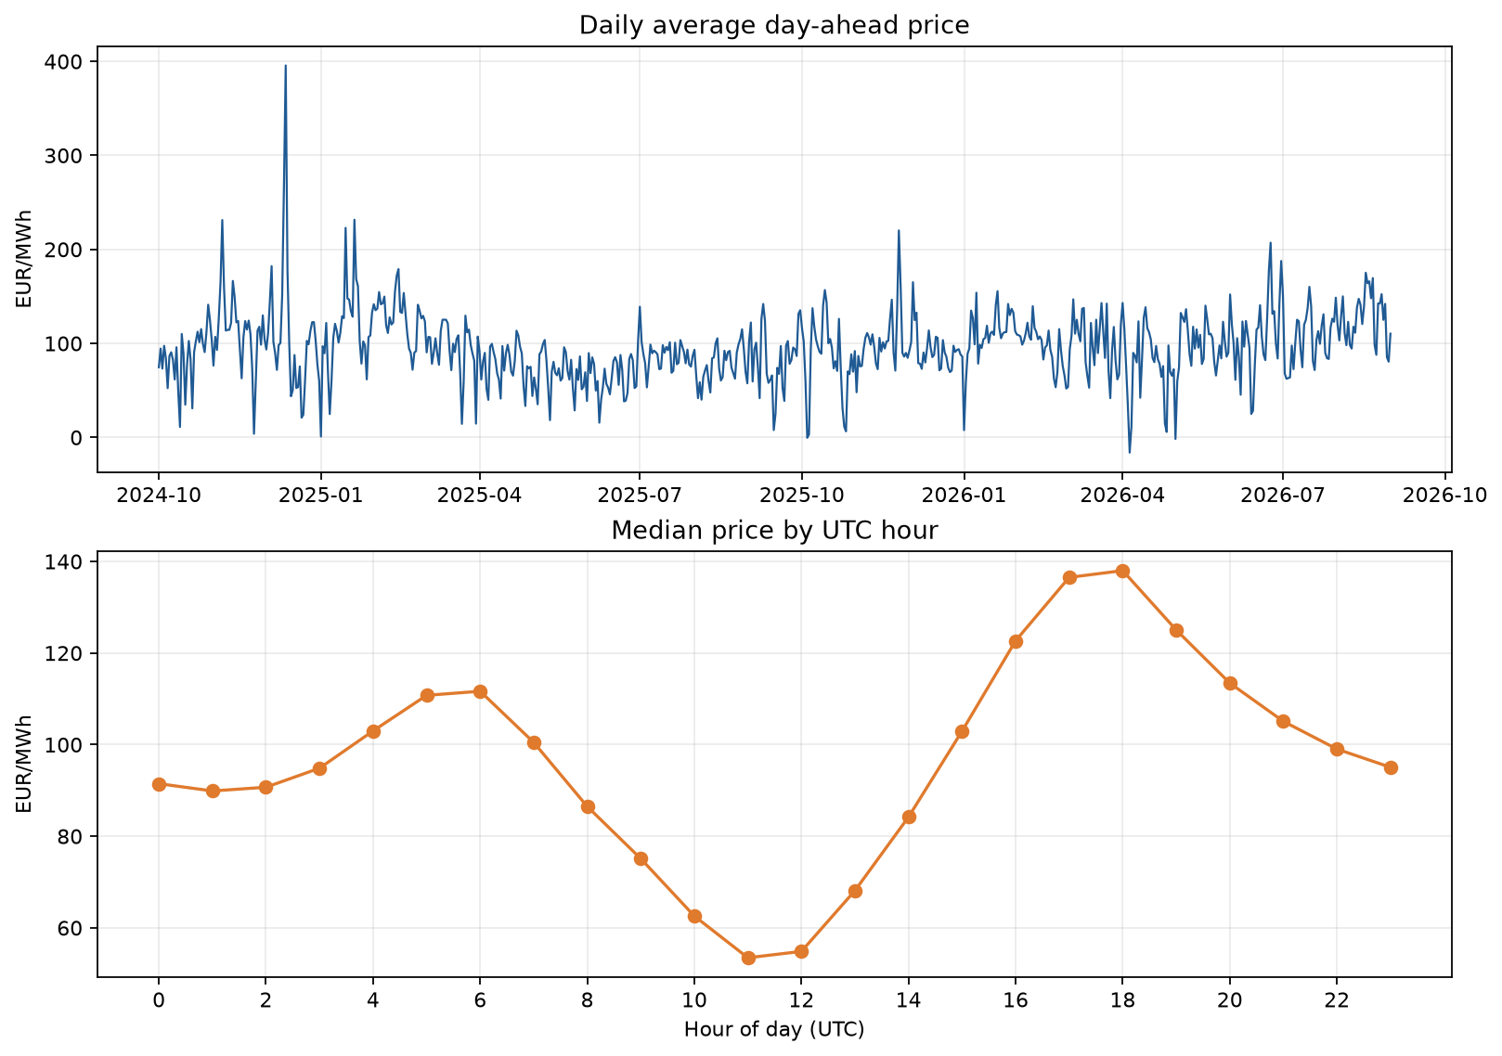
Figure 1. Daily average prices and median price by UTC hour.

5. BASELINE FORECASTING MODEL

5.1 Model Selection
SARIMA provides an interpretable statistical baseline for serial dependence and daily seasonality. GARCH is added to model time-varying variance in the baseline's forecast residuals. This directly addresses volatility while keeping the mean model compact.

5.2 Model Methodology
The baseline is SARIMA(1,0,1)x(1,0,1,24), estimated on the most recent 180 pre-test days. In lag notation, phi(B)Phi(B^24)(y_t-c)=theta(B)Theta(B^24)epsilon_t. Standardized SARIMA residuals are modelled by GARCH(1,1): epsilon_t=sigma_t z_t and sigma_t^2=omega+alpha epsilon_(t-1)^2+beta sigma_(t-1)^2. The nominal 80% interval is forecast mean +/- 1.645 forecast standard deviations. This interval assumes approximately normal standardized innovations; the test coverage checks that assumption empirically.

5.3 Implementation
Fit SARIMAX and GARCH using only initial training data. Generate the next 24-hour mean and variance forecast. After the whole day-ahead forecast is recorded, extend the state-space model with that day's actual prices without re-estimating parameters, and update GARCH variance from resulting residuals. Repeat for each test day. Full implementation: src/forecasting.py; execution: main.py. The Streamlit dashboard lets users select a held-out UTC test date, chart window, models, actual-price visibility, interval visibility, line or step charts, and linear or symmetric-log axes. Its scorecard and history explorer offer selectable metrics, hourly/daily/weekly aggregation, rolling averages, typical UTC-hour views, price distributions, and CSV downloads. Users can select display currency and MWh/kWh. Available currencies use published ECB reference rates through Frankfurter; users may enter a positive manual rate for another three-letter currency code, while EUR remains available offline. These conversions affect displayed price-valued results and downloads only; source EUR/MWh data, model fitting, stored forecasts, interval coverage, and percentage metrics remain unchanged.
sarima = SARIMAX(
train.tail(180 * 24),
order=(1, 0, 1),
seasonal_order=(1, 0, 1, 24),
trend="c",
enforce_stationarity=False,
enforce_invertibility=False,
).fit(disp=False)
forecast_24h = sarima.get_forecast(steps=24).predicted_mean
residuals = sarima.resid.dropna()
scale = residuals.std()
garch = arch_model(
residuals / scale, mean="Zero", vol="GARCH",
p=1, q=1, rescale=False
).fit(disp="off")

5.4 Baseline Results
Over 520 test days (12,480 hours), SARIMA-GARCH obtained MAE 23.28 EUR/MWh, RMSE 36.38 EUR/MWh, sMAPE 83.34%, 80% interval coverage 82.9%, and mean interval width 83.25 EUR/MWh. See the forecast plot and comparative table.
Baseline results and model comparison:
Model | MAE  EUR/MWh | RMSE  EUR/MWh | sMAPE | 80% coverage | Mean width  EUR/MWh | 10% pinball | 90% pinball
SARIMA-GARCH | 23.28 | 36.38 | 83.34% | 82.9% | 83.25 | 6.43 | 6.30
Quantile Gradient Boosting | 25.11 | 38.27 | 86.53% | 79.8% | 81.90 | 6.77 | 6.09
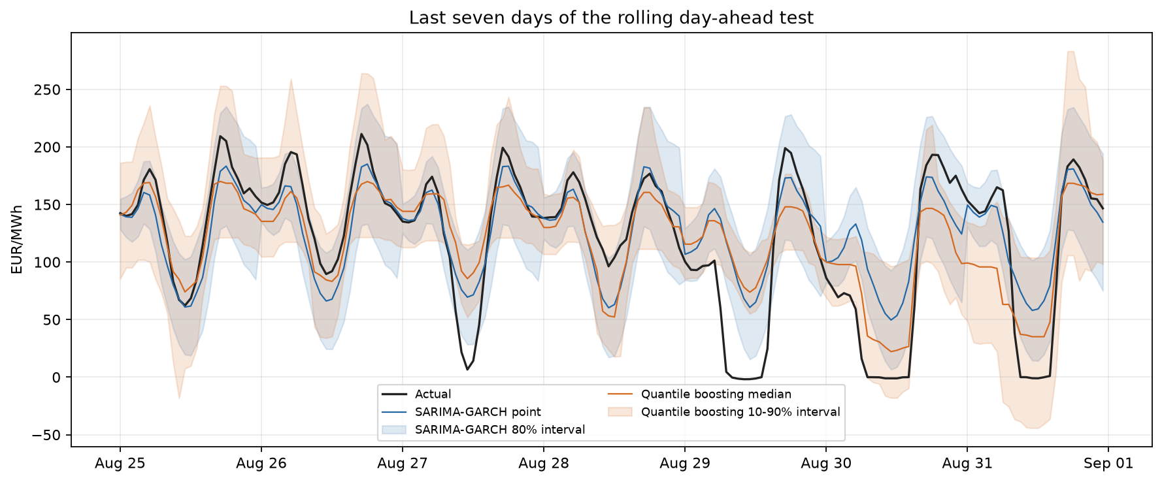
Figure 2. Forecasts and nominal 80% prediction intervals over the final seven test days.

6. PROPOSED MODEL AND ENHANCEMENT

6.1 Motivation for Improvement
The SARIMA-GARCH interval uses a symmetric parametric construction around the mean and assumes a standardized innovation distribution. Electricity-price errors can be asymmetric and affected by spikes, so direct estimation of conditional quantiles provides a useful alternative for comparison.

6.2 Proposed Enhancement
Fit three separate GradientBoostingRegressor models with quantile loss at tau=0.10, 0.50, and 0.90. The 50th percentile is the point forecast; the 10th and 90th percentiles define a nominal 80% prediction interval.

6.3 Methodology and Implementation
Features include 24-, 48-, and 168-hour lagged prices; the mean and standard deviation of the preceding 24 prices available at the forecast origin; the mean of the preceding 168 available prices; and cyclical hour, weekday, and month features. Each model uses 150 estimators, learning rate 0.05, depth 2, minimum leaf size 15, subsample 0.8, and random seed 42. The quantile objective is rho_tau(u)=u(tau-I[u<0]), where u=y-yhat. Quantile outputs are ordered to prevent crossing. Complete code: src/forecasting.py.
models = {}
for tau in (0.10, 0.50, 0.90):
models[tau] = GradientBoostingRegressor(
loss="quantile", alpha=tau,
n_estimators=150, learning_rate=0.05,
max_depth=2, min_samples_leaf=15,
subsample=0.8, random_state=42,
).fit(X_train, y_train)
q10, q50, q90 = (models[q].predict(X_day)
for q in (0.10, 0.50, 0.90))

6.4 Expected Advantage
Direct quantile loss does not require the lower and upper bounds to be symmetric around a point forecast. Calendar and weekly-lag features represent effects not explicitly encoded by a single 24-hour seasonal term. These are expected advantages, not a guarantee of lower errors; the common test set determines the observed result.

6.5 Proposed Model Results
Quantile boosting obtained MAE 25.11 EUR/MWh, RMSE 38.27 EUR/MWh, sMAPE 86.53%, 80% interval coverage 79.8%, and mean interval width 81.90 EUR/MWh. The orange quantile interval and median are shown in the forecast comparison plot.
Model | MAE  EUR/MWh | RMSE  EUR/MWh | sMAPE | 80% coverage | Mean width  EUR/MWh | 10% pinball | 90% pinball
SARIMA-GARCH | 23.28 | 36.38 | 83.34% | 82.9% | 83.25 | 6.43 | 6.30
Quantile Gradient Boosting | 25.11 | 38.27 | 86.53% | 79.8% | 81.90 | 6.77 | 6.09

7. PERFORMANCE EVALUATION AND COMPARISON

7.1 Evaluation Measures
MAE=(1/n)sum|y-yhat| is interpretable in EUR/MWh. RMSE=sqrt((1/n)sum(y-yhat)^2) penalizes large errors. MAPE is not used because electricity prices may be zero or negative; sMAPE=(200/n)sum(|y-yhat|/(|y|+|yhat|)) is reported instead. For the nominal 80% interval, coverage is the fraction of actual prices between lower and upper bounds, and mean width measures interval sharpness. Pinball loss evaluates the 10th and 90th quantile forecasts.

7.2 Comparative Results
Both models are evaluated on the same 12,480 held-out hourly prices across 520 days. The table compares point error, 80% interval coverage and width, and the 10th- and 90th-quantile pinball losses. SARIMA-GARCH has lower MAE and RMSE; quantile boosting has coverage closer to the nominal 80% and a slightly narrower interval.
Model | MAE  EUR/MWh | RMSE  EUR/MWh | sMAPE | 80% coverage | Mean width  EUR/MWh | 10% pinball | 90% pinball
SARIMA-GARCH | 23.28 | 36.38 | 83.34% | 82.9% | 83.25 | 6.43 | 6.30
Quantile Gradient Boosting | 25.11 | 38.27 | 86.53% | 79.8% | 81.90 | 6.77 | 6.09

Model | 10th-percentile pinball loss | 90th-percentile pinball loss
SARIMA-GARCH | 6.43 | 6.30
Quantile Gradient Boosting | 6.77 | 6.09

7.3 Interpretation of Results
SARIMA-GARCH has lower MAE (23.28 vs. 25.11 EUR/MWh) and RMSE (36.38 vs. 38.27 EUR/MWh) on this 520-day test. Quantile boosting coverage (79.8%) is close to the nominal 80%; SARIMA-GARCH coverage is 82.9%. The quantile interval is slightly narrower. Coverage alone is not sufficient, so width and pinball losses are also reported. This single-zone backtest does not establish a universal winner.

8. CONCLUSION AND FUTURE SCOPE

8.1 Conclusion
The project addressed next-day DE-LU hourly price prediction using a rolling 24-hour evaluation. The seasonal SARIMA-GARCH baseline had the lower point errors; quantile boosting produced coverage near its nominal 80% target with a slightly narrower interval. Forecasts and intervals can support procurement, flexible-demand, and storage planning, but are not guarantees of savings. Findings are limited to this zone, input series, model settings, and test period. The dashboard makes the held-out input-to-output comparison explorable; currency and energy-unit selections are display conversions and do not change either model's forecasts. An INR display is still DE-LU market data.

8.2 Future Scope
Test across additional zones and seasons; include load, weather, renewable generation, fuel, and neighboring-market variables; calibrate intervals; handle local-market daylight-saving hours explicitly; compare persistence and more forecasting baselines; and test value in a defined operational decision.

8.3 SDG Addressed
SDG 7 (Affordable and Clean Energy) is relevant because reliable price forecasts can support efficient electricity use, flexible demand, and storage scheduling. SDG 13 (Climate Action) is a secondary connection through energy-system planning in renewable-rich markets. A forecast alone does not ensure either SDG outcome.

9. REFERENCES
[1] Garcia, R. C., Contreras, J., van Akkeren, M., & Garcia, J. B. C. (2005). A GARCH forecasting model to predict day-ahead electricity prices. IEEE Transactions on Power Systems, 20(2), 867-874. https://doi.org/10.1109/TPWRS.2005.846044
[2] Ziel, F. (2016). Forecasting electricity spot prices using Lasso: On capturing the autoregressive intraday structure. IEEE Transactions on Power Systems, 31(6), 4977-4987. https://doi.org/10.1109/TPWRS.2016.2521545
[3] Nowotarski, J., & Weron, R. (2018). Recent advances in electricity price forecasting: A review of probabilistic forecasting. Renewable and Sustainable Energy Reviews, 81, 1548-1568. https://doi.org/10.1016/j.rser.2017.05.234
[4] Uniejewski, B., Weron, R., & Ziel, F. (2018). Variance stabilizing transformations for electricity spot price forecasting. IEEE Transactions on Power Systems, 33(2), 2219-2229. https://doi.org/10.1109/TPWRS.2017.2734563
[5] Lago, J., Marcjasz, G., De Schutter, B., & Weron, R. (2021). Forecasting day-ahead electricity prices: A review of state-of-the-art algorithms, best practices and an open-access benchmark. Applied Energy, 293, 116983. https://doi.org/10.1016/j.apenergy.2021.116983
[6] Bundesnetzagentur / SMARD. Energy-Charts price API, DE-LU bidding zone. Data supplied under CC BY 4.0. https://api.energy-charts.info/
[7] Statsmodels. SARIMAX documentation. https://www.statsmodels.org/stable/generated/statsmodels.tsa.statespace.sarimax.SARIMAX.html
[8] ARCH. arch_model documentation. https://arch.readthedocs.io/
[9] Scikit-learn. GradientBoostingRegressor documentation. https://scikit-learn.org/stable/modules/generated/sklearn.ensemble.GradientBoostingRegressor.html

10. TEAM CONTRIBUTION
Sl. No. | Name | USN | Contribution
1 | Shreyashree C R | 1BM23AI180 | Dataset sourcing from the Energy-Charts/SMARD API, data preparation (hourly aggregation, timestamp and continuity checks) and exploratory data analysis including Figure 1.
2 | Sinchana K | 1BM23AI183 | Literature review of the five reference papers, identification of the research gap, and drafting of the problem statement, objectives and scope.
3 | Varsha Tolani | 1BM23AI206 | Implementation of the SARIMA-GARCH baseline model and the rolling day-ahead forecasting pipeline, along with baseline result analysis.
4 | Sahana K Sonni | 1BM23AI163 | Implementation of the quantile gradient boosting models, evaluation metrics (MAE, RMSE, sMAPE, coverage, pinball loss), comparison plots and final report compilation.

