B.M.S. COLLEGE OF ENGINEERING, BENGALURU
DEPARTMENT OF MACHINE LEARNING
Academic Activity Task (AAT)

TRUTHLENS AI
A Comparative Study of Traditional and Transformer-Based NLP Models
for Explainable Fake News Detection

Course / Activity: NLP - Topic Exploration, Implementation, Validation and Presentation
Student 1: [Name / USN]
Student 2: [Name / USN]
Class / Semester: [Insert class and semester]
Faculty: [Insert faculty name]
Academic Year: 2026-27

1. AAT Requirement Mapping
The activity sheet asks the team to select an NLP topic, study its real-world application and architecture, implement the technique, evaluate the model, compare approaches where applicable, and submit a report and presentation. TruthLens AI is designed around each of these requirements.
Activity requirement | TruthLens implementation | Evidence in project
Choose an NLP topic | Fake news text classification | Problem statement and literature review
Real-time application / API | News screening interface + REST API | Streamlit app and FastAPI endpoint
Study architecture / workflow | TF-IDF baseline and DistilBERT pipeline | Architecture and workflow figures
Implement selected NLP model | Fine-tuned DistilBERT | train_transformer.py
Pre-processing and evaluation | Cleaning, deduplication, stratified split, metrics | preprocess.py and evaluate.py
Compare approaches | TF-IDF + Logistic Regression vs DistilBERT | metrics.csv + comparison graph
Interpret results | LIME local explanations | explain.py + HTML output
Report and presentation | DOCX report and PPT | docs/

2. Abstract
TruthLens AI is an NLP-based research prototype for classifying news articles into two labels, FAKE and REAL, using a labelled news corpus. The study compares a traditional TF-IDF plus Logistic Regression approach with a fine-tuned DistilBERT transformer. The work covers data cleaning, duplicate removal, stratified train/validation/test splitting, model training, evaluation using accuracy, precision, recall and F1-score, confusion-matrix analysis, and local model interpretation using LIME. A Streamlit interface and FastAPI endpoint demonstrate how the classifier could be used as a first-pass screening tool in a newsroom, moderation workflow, or information triage system.
The model is intentionally described as a classification system rather than as a universal fact-checker. Its prediction is learned from the label distribution and writing patterns in the training corpus, so independent verification from trusted sources would be required before any high-stakes decision.

3. Problem Statement
Large volumes of online news and social content make manual screening difficult. The goal of this project is to build a reproducible NLP pipeline that can classify article text using both a conventional feature-based model and a transformer model, then provide a human-readable explanation for an individual prediction.

3.1 Objectives
- Understand a practical NLP text-classification problem and its real-world use.
- Clean and prepare a public labelled news dataset for supervised learning.
- Create a traditional TF-IDF + Logistic Regression baseline.
- Fine-tune a DistilBERT transformer for the same binary classification task.
- Evaluate both models on an untouched test set using multiple metrics.
- Use LIME to inspect local evidence behind individual predictions.
- Package the final pipeline in a simple web application and REST API.

4. Real-World Application
A practical use case is first-pass screening of article text before publication, moderation, or manual review. A newsroom or content platform could submit an article to an internal service, receive a model score, and route uncertain examples to a human reviewer. The output should be treated as a screening signal rather than as a final factual decision.

4.1 User Workflow
A user pastes an article into the interface. The application checks whether enough text is available, sends the text to the trained model, displays the predicted class and confidence, and exposes probability information. The same prediction logic can be accessed programmatically through the FastAPI endpoint.

5. Literature Review
Reference | Work | Relevance to project
Devlin et al. (2019) | BERT: Pre-training of Deep Bidirectional Transformers for Language Understanding | Introduced the BERT pre-training approach and established transformer encoders as a strong foundation for language understanding tasks.
Sanh et al. (2019) | DistilBERT: A Distilled Version of BERT | Presented a smaller distilled transformer designed to retain much of BERT’s language understanding ability with lower computational cost.
Shu et al. (2017) | Fake News Detection on Social Media: A Data Mining Perspective | Discussed fake-news detection as a broader data-mining problem and highlighted the role of content and contextual signals.
Ribeiro et al. (2016) | Why Should I Trust You? Explaining the Predictions of Any Classifier | Introduced LIME, a model-agnostic approach for producing local explanations around individual predictions.
The literature supports the design choice of using a conventional baseline for comparison, a compact transformer for contextual language representation, and a local explainability method for inspection of individual predictions.

6. Dataset
The project uses the ISOT Fake News Dataset provided by the Information Security and Object Technology Research Group at the University of Victoria. The dataset is distributed as separate True.csv and Fake.csv files. The project keeps only the article text and the binary label for the primary experiment.
The original dataset is not a generic measure of truth on the open web. Its labels are tied to how the source corpus was assembled, so model performance can be influenced by publisher, time-period, topic and writing-style differences. This is addressed as a major limitation in the discussion.

6.1 Data Preparation
- Remove missing article text.
- Remove URLs from article text.
- Remove obvious Reuters prefix artifacts where present.
- Normalize repeated whitespace.
- Remove duplicate articles.
- Sample the same number of articles from each class for the primary experiment.
- Perform a stratified 70/15/15 train, validation and test split using seed 42.
The default experiment uses 5,000 articles from each class, for 10,000 articles total before splitting. This keeps the project substantial while reducing training time for the academic prototype.

7. System Architecture
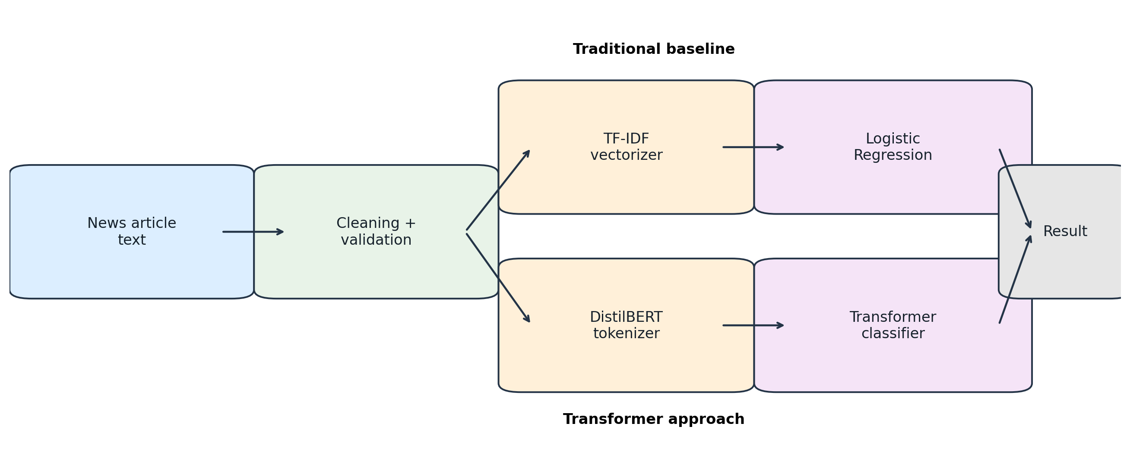
Figure 1. Two-branch NLP architecture. The same cleaned article text is sent through a traditional TF-IDF baseline and a transformer-based DistilBERT branch. Both branches produce a binary prediction for comparison.
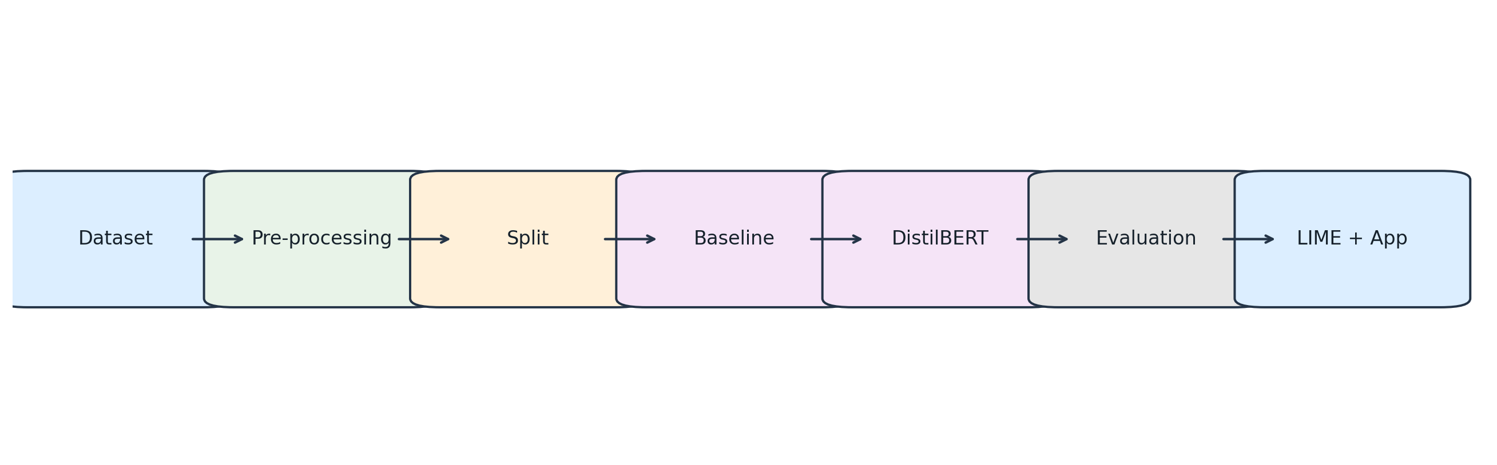
Figure 2. End-to-end workflow from dataset ingestion to evaluation, explainability and application.

8. Baseline Model: TF-IDF + Logistic Regression
The baseline uses a TF-IDF vectorizer with unigram and bigram features, English stop-word removal, sublinear TF scaling and a capped vocabulary of 20,000 features. Logistic Regression then learns a binary decision boundary over the sparse TF-IDF representation. This baseline is intentionally simple, fast, and useful for comparison.

8.1 Why keep the baseline?
- It establishes a reference point for the transformer.
- It provides an inexpensive model for debugging the data pipeline.
- It makes the comparison more informative than reporting only one model.
- Its feature representation is easier to inspect than a deep transformer.

9. Transformer Model: DistilBERT
The second model is DistilBERT, a compact transformer encoder. The project uses the pretrained distilbert-base-uncased checkpoint as the language representation and replaces the final task head with a two-class classification layer. The model is fine-tuned on the labelled training split.

9.1 Data Flow
- Raw article text enters the tokenizer.
- The tokenizer converts text into subword token IDs and attention masks.
- The transformer encoder produces contextual hidden representations.
- The sequence representation is passed to the classification head.
- Softmax produces the two class probabilities.
- The class with the larger probability is returned as the prediction.

9.2 Training Setup
Setting | Value
Base checkpoint | distilbert-base-uncased
Maximum sequence length | 256 tokens
Batch size | 8
Learning rate | 2e-5
Epochs | 2
Optimizer | AdamW
Gradient clipping | 1.0
Random seed | 42

10. Experimental Design
The dataset is split once using a fixed seed and the same partitions are reused by both models. The training split is used for parameter fitting, the validation split is used during transformer development and checkpoint selection, and the test split is held back for final comparison.

10.1 Evaluation Metrics
- Accuracy = correct predictions divided by all predictions.
- Precision = proportion of predicted positive examples that are positive.
- Recall = proportion of actual positive examples that are recovered.
- F1-score = harmonic mean of precision and recall.

11. Results
The table below is generated from the actual saved test predictions. The placeholders must be replaced by the pipeline after the full experiment has been run.
Model | Accuracy | Precision | Recall | F1 | Test size
TF-IDF + Logistic Regression | 97.40% | 96.47% | 98.40% | 97.43% | 1500
DistilBERT | 99.33% | 99.20% | 99.47% | 99.33% | 1500
The most important comparison is not simply the highest accuracy. Precision, recall and F1 should be interpreted together, and the limitations of the dataset must be considered before drawing broad conclusions about real-world misinformation.

12. Explainability with LIME
LIME creates a local explanation around one prediction by perturbing the text and fitting a simple surrogate model to approximate the classifier in that local neighbourhood. In TruthLens AI, the explanation is displayed as an inspection aid for a single article.
The explanation is not presented as causal evidence that a particular word makes an article false. It only shows which parts of the input were influential for the trained model in that local example.

12.1 Example Interpretation
During the demonstration, choose one held-out article, run explain.py, open results/lime_example.html, and discuss several highlighted words. Compare the explanation with the model class and confidence. The exact highlighted terms should be taken from the actual generated explanation rather than invented in the report.

13. Application Prototype
The Streamlit interface exposes a small front end for the trained model. It accepts article text, performs tokenization, returns the predicted class and confidence, and displays the class probabilities. A FastAPI service exposes the same prediction logic through a POST /predict endpoint for integration into another application.

13.1 Example API Request
{"text": "Paste a sufficiently long article here"}

13.2 Example API Response
{"label": "REAL", "confidence": 0.xx, "probabilities": {"FAKE": 0.xx, "REAL": 0.xx}, "model": "DistilBERT"}

14. Limitations and Responsible Use
- The label source reflects the construction of the ISOT corpus rather than a universal truth database.
- Publisher, writing style, time period and topic can create shortcuts that are not equivalent to factual reasoning.
- The maximum sequence length truncates long articles, so information outside the first 256 tokens can be lost.
- LIME explanations are local and approximate rather than a proof of causation.
- A production system should add evidence retrieval, source verification, calibration and an explicit human-review path.

15. Conclusion
TruthLens AI provides a complete NLP activity pipeline from data preparation through modelling, comparison, interpretation and application. The study demonstrates why a baseline remains useful when introducing a transformer model, and why evaluation and limitations are as important as the classifier itself. The project is intentionally reproducible: all data processing, training, evaluation and application steps are stored in one folder and can be repeated in Google Colab or a local Python environment.

16. References
- Devlin, J., Chang, M.-W., Lee, K., and Toutanova, K. (2019). BERT: Pre-training of Deep Bidirectional Transformers for Language Understanding. NAACL-HLT.
- Sanh, V., Debut, L., Chaumond, J., and Wolf, T. (2019). DistilBERT, a distilled version of BERT: smaller, faster, cheaper and lighter. arXiv:1910.01108.
- Shu, K., Sliva, A., Wang, S., Tang, J., and Liu, H. (2017). Fake News Detection on Social Media: A Data Mining Perspective. SIGKDD Explorations.
- Ribeiro, M. T., Singh, S., and Guestrin, C. (2016). Why Should I Trust You? Explaining the Predictions of Any Classifier. KDD.
- ISOT Research Lab, University of Victoria. Fake News Detection Dataset. https://onlineacademiccommunity.uvic.ca/isot/2022/11/27/fake-news-detection-datasets/

Appendix A. Project File Map
app.py - Streamlit front end
api.py - FastAPI service
src/preprocess.py - data cleaning and split creation
src/train_baseline.py - TF-IDF + Logistic Regression
src/train_transformer.py - DistilBERT fine-tuning
src/evaluate.py - held-out test evaluation
src/explain.py - LIME explanation
scripts/download_data.py - official dataset downloader
scripts/smoke_test.py - local baseline smoke test
scripts/build_submission_docs.py - metric placeholder replacement

11.1 Evaluation Figures

11.1.1 Confusion Matrix
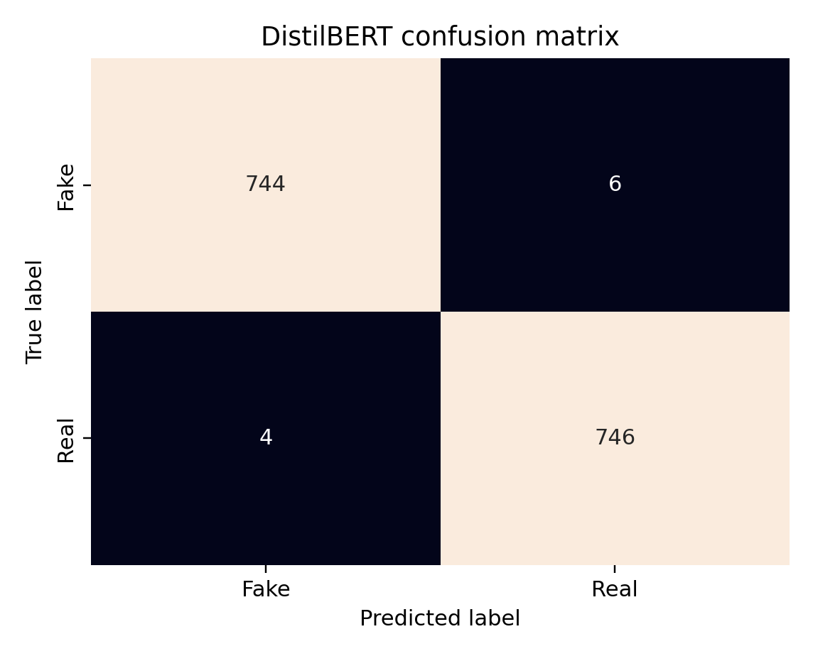

11.1.2 Model Comparison
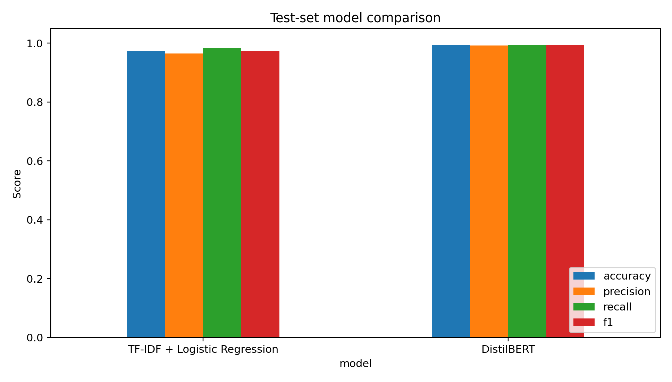

11.1.3 Training Curves
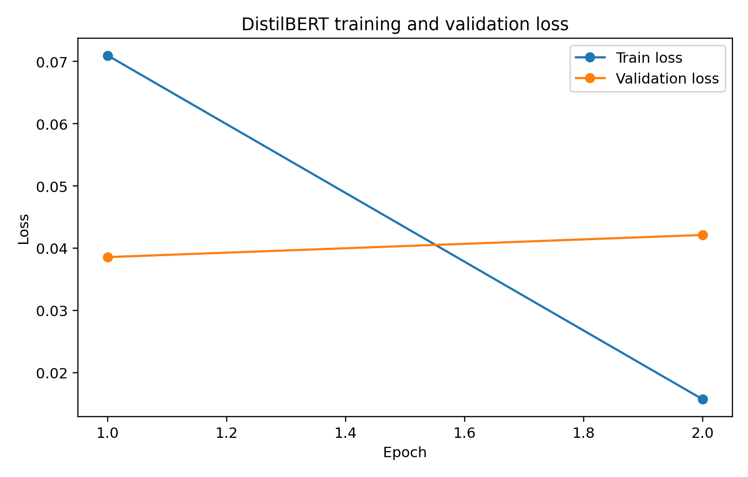

11.1.4 LIME Explanation
