## TW-1 (Message Queue)

### Writer

#include <sys/ipc.h>

#include <sys/msg.h>

#include <stdio.h>

#include <stdlib.h>

#define MAX 50

struct msg_buffer {

long mesg_type;

char mesg_text[100];

}message;

int main() {

key_t key;

int msgid;

key = ftok("progfile", 65);

msgid = msgget(key, 0666 | IPC_CREAT);

message.mesg_type = 1;

printf("Write data: \n");

fgets(message.mesg_text, MAX, stdin);

msgsnd(msgid, &message, sizeof(message), 0);

printf("Data sent is : %s\n", message.mesg_text);

return 0;

}

### 

### Reader

#include <sys/ipc.h>

#include <sys/msg.h>

#include <stdio.h>

#include <stdlib.h>

#define MAX 50

struct msg_buffer {

long mesg_type;

char mesg_text[100];

}message;

int main() {

key_t key;

int msgid;

key = ftok("progfile", 65);

msgid = msgget(key, 0666 | IPC_CREAT);

msgrcv(msgid, &message, sizeof(message), 1, 0);

printf("Data read is: %s\n", message.mesg_text);

msgctl(msgid, IPC_RMID, NULL);

return 0;

}

## Output

### Writer

lab2@lab2-virtual-machine:~/Aniket_NP-Lab/TW-1$ gcc TW-1_writer.c

lab2@lab2-virtual-machine:~/Aniket_NP-Lab/TW-1$ ./a.out

Write data: Hello World

Data sent is : Hello World

### Reader

lab2@lab2-virtual-machine:~/Aniket_NP-Lab/TW-1$ gcc TW-1_reader.c

lab2@lab2-virtual-machine:~/Aniket_NP-Lab/TW-1$ ./a.out

Data read is: Hello World

## 

## TW-1 (Pipe)

#include <unistd.h>

#include <stdio.h>

#include <sys/types.h>

#include <sys/wait.h>

int main() {

int fd[2], n;

char buffer[100];

pid_t p;

pipe(fd);

p = fork();

if (p > 0) {

printf("Parent process pid: %d\n", getppid());

printf("Child process pid: %d\n", p);

printf("Passing value child\n");

write(fd[1], "Hello World!\n", 13);

}

else {

printf("Child process pid: %d\n", getpid());

printf("Parent process pid: %d\n", getppid());

n = read(fd[0], buffer, 100);

printf("Data received by child process: \n");

write(1, buffer, n);

}

return 0;

}

## Output

lab2@lab2-virtual-machine:~/Aniket_NP-Lab/TW-1/pipe$ gcc TW-1.c

lab2@lab2-virtual-machine:~/Aniket_NP-Lab/TW-1/pipe$ ./a.out

Parent process pid: 7437

Child process pid: 7618

Passing value child

lab2@lab2-virtual-machine:~/Aniket_NP-Lab/TW-1/pipe$ Child process pid: 7618

Parent process pid: 1511

Data received by child process:

Hello World!

## TW-2

### Server

#include <sys/socket.h>

#include <netinet/in.h>

#include <arpa/inet.h>

#include <stdio.h>

#include <stdlib.h>

#include <strings.h>

#include <string.h>

#define PORT 4444

int main() {

int listenfd, connfd;

struct sockaddr_in servAddr, cliAddr;

socklen_t clilen;

char buffer[1024];

listenfd = socket(AF_INET, SOCK_STREAM, 0);

printf("[+] Server socket created successfully\n");

bzero(&servAddr, sizeof(servAddr));

servAddr.sin_family = AF_INET;

servAddr.sin_port = htons(PORT);

servAddr.sin_addr.s_addr = inet_addr("127.0.0.1");

bind(listenfd, (struct sockaddr *) &servAddr, sizeof(servAddr));

printf("[+] Bind to PORT %d successful\n", PORT);

listen(listenfd, 5);

printf("[+] Listening...\n");

connfd = accept(listenfd, (struct sockaddr *) &cliAddr, &clilen);

strcpy(buffer, "Hello World!");

send(connfd, buffer, strlen(buffer), 0);

printf("[+] Data sent to client: %s\n", buffer);

printf("[+] Closing the connection\n");

return 0;

}

### Client

#include <stdio.h>

#include <stdlib.h>

#include <strings.h>

#include <string.h>

#include <sys/socket.h>

#include <sys/types.h>

#include <netinet/in.h>

#include <arpa/inet.h>

#define PORT 4444

int main() {

int sockfd;

struct sockaddr_in servAddr;

char buffer[1024];

sockfd = socket(AF_INET, SOCK_STREAM, 0);

printf("[+] Client socket created successfully\n");

bzero(&servAddr, sizeof(servAddr));

servAddr.sin_family = AF_INET;

servAddr.sin_port = htons(PORT);

servAddr.sin_addr.s_addr = inet_addr("127.0.0.1");

connect(sockfd, (struct sockaddr *) &servAddr, sizeof(servAddr));

printf("[+] Connected to server\n");

recv(sockfd, buffer, 1024, 0);

printf("[+] Data received from server: %s\n", buffer);

printf("[+] Closing the connection\n");

return 0;

}

## 

## Output

### Server

lab2@lab2-virtual-machine:~/Aniket_NP-Lab/TW-2$ cc server.c

lab2@lab2-virtual-machine:~/Aniket_NP-Lab/TW-2$ ./a.out

[+]Server socket created successfully.

[+]Bind to port number 4444.

[+]Listening...

[+]Data sent to client: Hello.

[+]Closing the connection

### Client

lab2@lab2-virtual-machine:~/Aniket_NP-Lab/TW-2$ cc client.c

lab2@lab2-virtual-machine:~/Aniket_NP-Lab/TW-2$ ./a.out

[+]Client socket created successfully.

[+]Connected to server.

[+]Data received: Hello

[+]Closing the connection.

## TW-3

#include <stdio.h>

#define NODES 10

#define NO_ROUTE 999

#define NO_HOP 1000

int no;

struct node {

int a[NODES][4];

}router[NODES];

void init(int r) {

int i;

for (i = 1; i <= no; i++) {

router[r].a[i][1] = i;

router[r].a[i][2] = NO_ROUTE;

router[r].a[i][3] = NO_HOP;

}

router[r].a[r][2] = 0;

router[r].a[r][3] = r;

}

void inp(int r) {

int i;

printf("\nEnter distance from node %d to other nodes\n", r);

printf("Enter 999 if there is no direct route\n");

for (i = 1; i <= no; i++) {

if (i != r) {

printf("Enter distance to node %d: ", i);

scanf("%d", &router[r].a[i][2]);

router[r].a[i][3] = i;

}

}

}

void display(int r) {

int i;

printf("\nThe routing table for node %d is as follows", r);

for (i = 1; i <= no; i++) {

if (router[r].a[i][2] == 999)

printf("\n%d \t no link \t no hop", router[r].a[i][1]);

else

printf("\n%d \t %d \t %d", router[r].a[i][1], router[r].a[i][2], router[r].a[i][3]);

}

}

void dv_algo(int r) {

int i, j, z;

for (i = 1; i <= no; i++) {

// r → source router

// i → step taken (via which router to reach the dest router)

// j → destination router

// cannot jump from the source router or to a router which is not reachable or from the source router

if (router[r].a[i][2] != 999 && router[r].a[i][2] != 0) {

for (j = 1; j <= no; j++) {

z = router[r].a[i][2] + router[i].a[j][2];

if (z < router[r].a[j][2]) {

router[r].a[j][2] = z;

router[r].a[j][3] = i;

}

}

}

}

}

int main() {

int i, j, x, y;

char choice = 'y';

printf("Enter the number of nodes: ");

scanf("%d", &no);

for (i = 1; i <= no; i++) {

init(i);

inp(i);

}

printf("\nThe routing tables of nodes after initialization is as follows");

for (i = 1; i <= no; i++)

display(i);

printf("\n\nComputing shortest paths...\n");

for (i = 1; i <= no; i++)

dv_algo(i);

printf("\nThe routing tables of nodes after computation of shortest paths is as follows");

for (i = 1; i <= no; i++)

display(i);

printf("\n");

while (choice != 'n'){

printf("\nEnter the nodes between which shortest distance is to be found: ");

scanf("%d %d", &x, &y);

getchar();

printf("The length of the shortest path between nodes %d and %d is %d\n", x, y, router[x].a[y][2]);

printf("Continue? (y/n): ");

scanf("%c", &choice);

}

return 0;

}

## Output

aniket@aniket-Lenovo-IdeaPad-S540-15IML-D:~/NP-Lab/TW-3$ gcc dvalgo.c

aniket@aniket-Lenovo-IdeaPad-S540-15IML-D:~/NP-Lab/TW-3$ ./a.out

Enter the number of nodes: 5

Enter distance from node 1 to other nodes

Enter 999 if there is no direct route

Enter distance to node 2: 1

Enter distance to node 3: 999

Enter distance to node 4: 999

Enter distance to node 5: 999

Enter distance from node 2 to other nodes

Enter 999 if there is no direct route

Enter distance to node 1: 1

Enter distance to node 3: 3

Enter distance to node 4: 4

Enter distance to node 5: 5

Enter distance from node 3 to other nodes

Enter 999 if there is no direct route

Enter distance to node 1: 999

Enter distance to node 2: 2

Enter distance to node 4: 3

Enter distance to node 5: 999

Enter distance from node 4 to other nodes

Enter 999 if there is no direct route

Enter distance to node 1: 999

Enter distance to node 2: 4

Enter distance to node 3: 3

Enter distance to node 5: 999

Enter distance from node 5 to other nodes

Enter 999 if there is no direct route

Enter distance to node 1: 999

Enter distance to node 2: 5

Enter distance to node 3: 999

Enter distance to node 4: 999

The routing tables of nodes after initialization is as follows

The routing table for node 1 is as follows

1 0 1

2 1 2

3 no link no hop

4 no link no hop

5 no link no hop

The routing table for node 2 is as follows

1 1 1

2 0 2

3 3 3

4 4 4

5 5 5

The routing table for node 3 is as follows

1 no link no hop

2 2 2

3 0 3

4 3 4

5 no link no hop

The routing table for node 4 is as follows

1 no link no hop

2 4 2

3 3 3

4 0 4

5 no link no hop

The routing table for node 5 is as follows

1 no link no hop

2 5 2

3 no link no hop

4 no link no hop

5 0 5

Computing shortest paths...

The routing tables of nodes after computation of shortest paths is as follows

The routing table for node 1 is as follows

1 0 1

2 1 2

3 4 2

4 5 2

5 6 2

The routing table for node 2 is as follows

1 1 1

2 0 2

3 3 3

4 4 4

5 5 5

The routing table for node 3 is as follows

1 3 2

2 2 2

3 0 3

4 3 4

5 7 2

The routing table for node 4 is as follows

1 5 2

2 4 2

3 3 3

4 0 4

5 9 2

The routing table for node 5 is as follows

1 6 2

2 5 2

3 8 2

4 9 2

5 0 5

Enter the nodes between which shortest distance is to be found: 1 5

The length of the shortest path between nodes 1 and 5 is 6

Continue? (y/n): y

Enter the nodes between which shortest distance is to be found: 1 4

The length of the shortest path between nodes 1 and 4 is 5

Continue? (y/n): n

## TW-4

### UDP Program execution steps

1. Open Wireshark and double click on any-interface to start the packet capture process.
2. Open the browser and enter any website’s fully qualified domain name in the browser address bar and hit enter.
3. After the site is fully loaded, stop the capturing process in Wireshark, goto edit in the menu bar and select find packet option or just press Ctrl+F.
4. In the Find Packet menu bar, select the String option in the display filter drop-down menu and enter the name of the website in the next box and click on find.
5. The arrow pointing towards the packet is the request packet, and the arrow coming out from the packet is the response packet.
6. Click on any request or response DNS packet and examine the UDP packet.

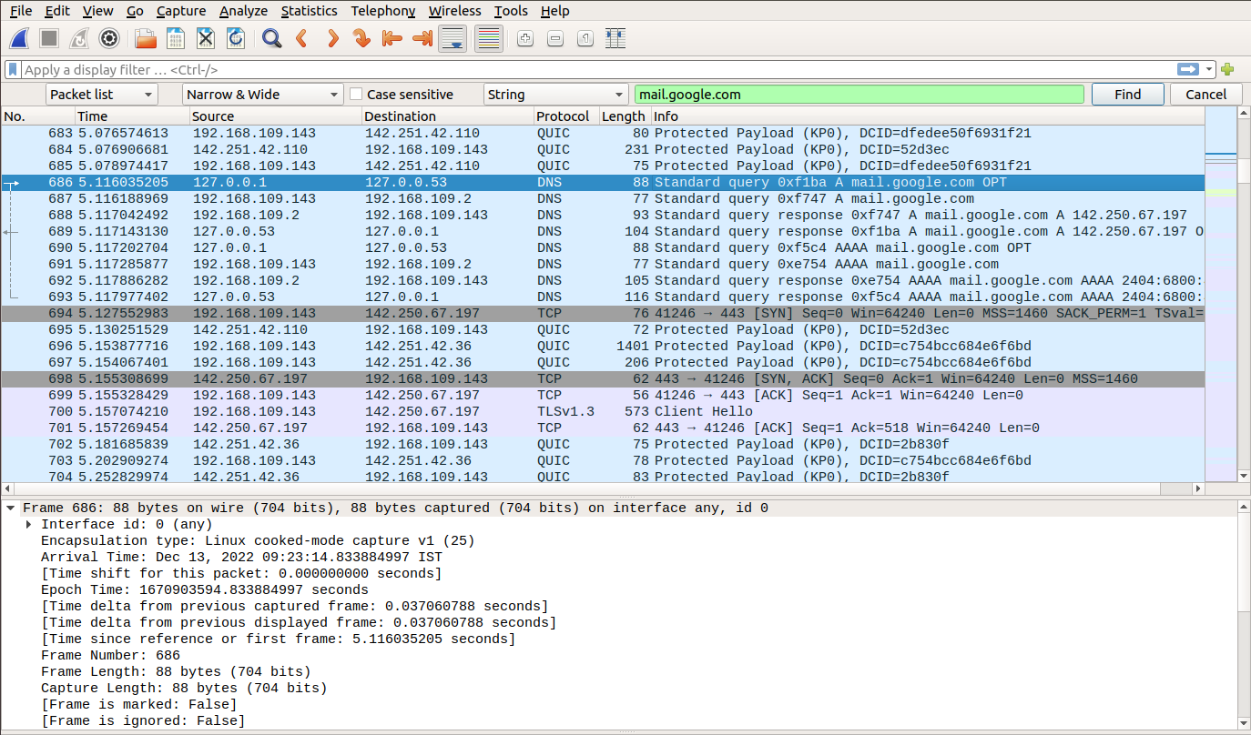

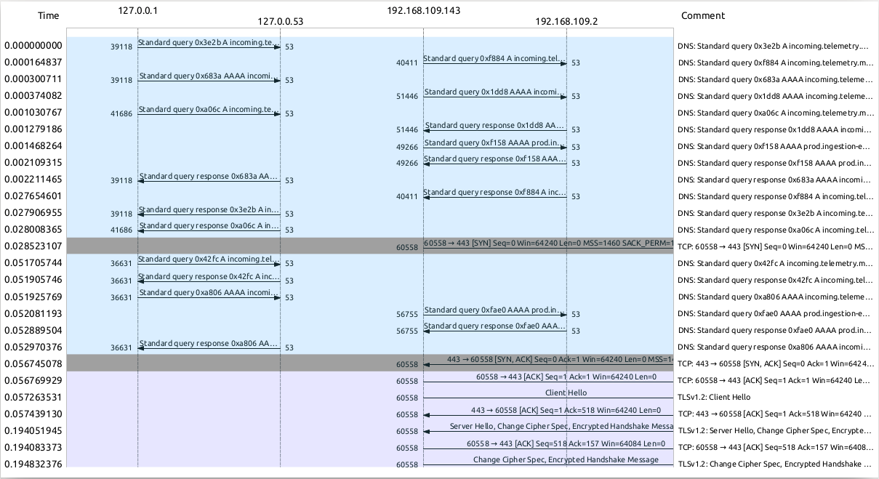

## TW-5

### TCP Program execution steps

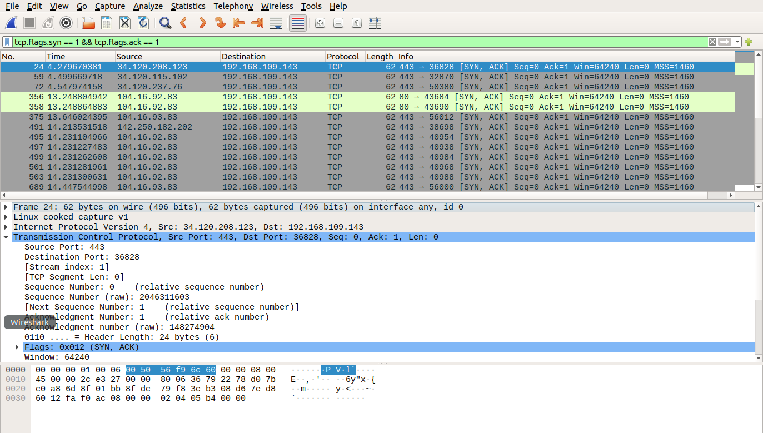

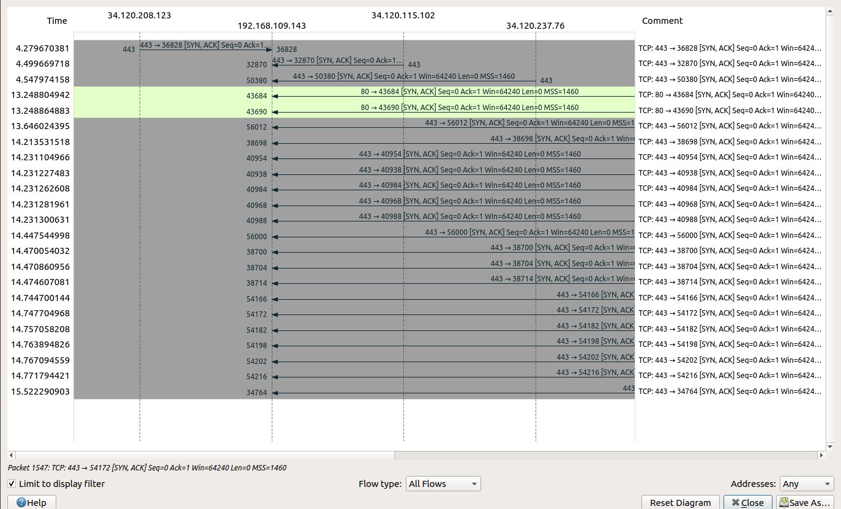

## TW-6

Load for

First.cc → TW6

Second.cc → TW7

Third.cc → TW8

***IMPORTANT - Load **NS3-WORKING** virtual machine***

1. Copy the required TW file from examples/tutorial folder to scratch folder
2. Add the below four lines at the end of the program before “Simulator::Run()”

#include "ns3/netanim-module.h"

AnimationInterface anim("first, xml");

AsciiTraceHelper ascii;

pointToPoint.EnableAsciiAll(ascii.CreateFileStream("first.tr"));

pointToPoint.EnablePcapAll("first");

1. Open terminal in **ns-3.28** and run command **./waf build**
2. Run command **./waf --run scratch/[first/second/third]**
3. **cd .. (to move back a folder)**
4. Change directory to **netanim-3.1** and run the command **./NetAnim** to run the network animator
5. Load the XML file **[first.xml /second.xml / third.xml ]** and run it

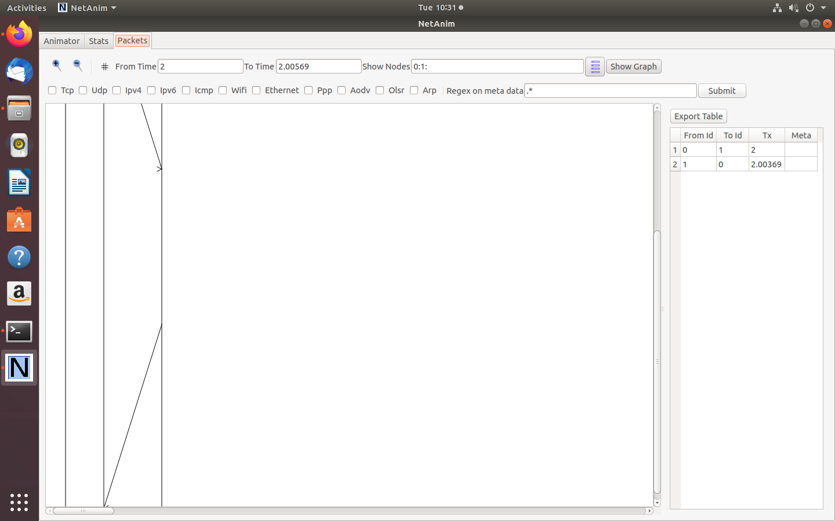

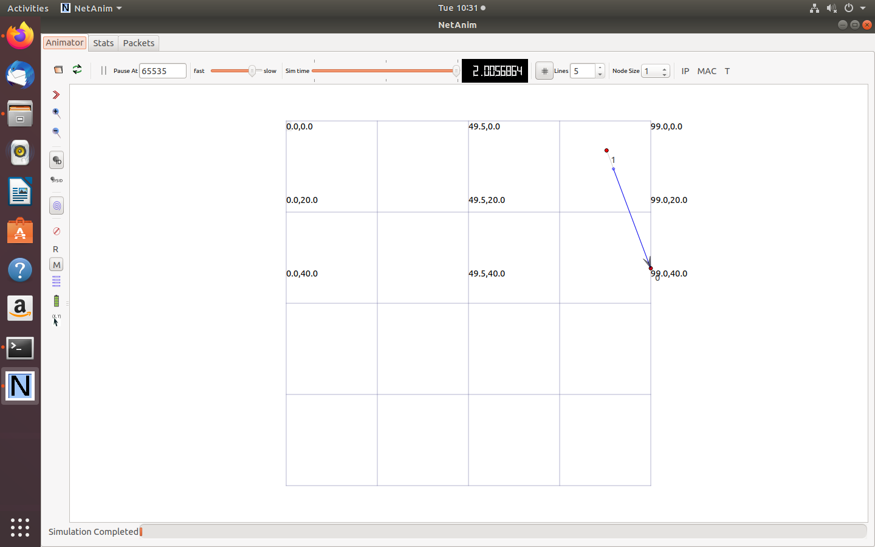

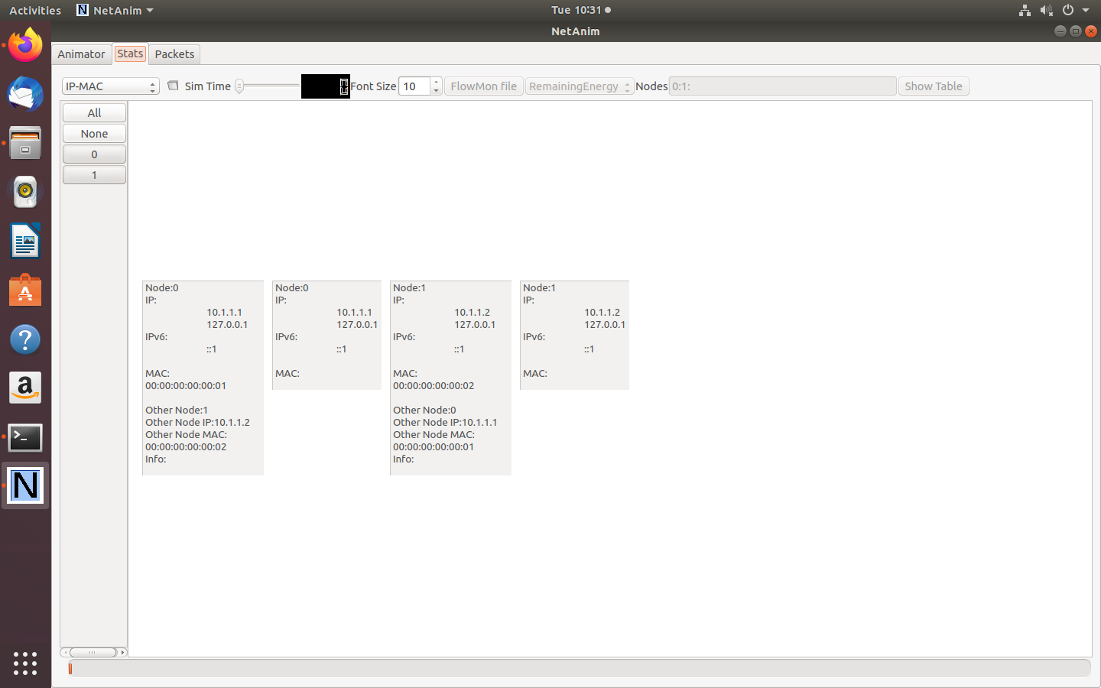

## TW-7

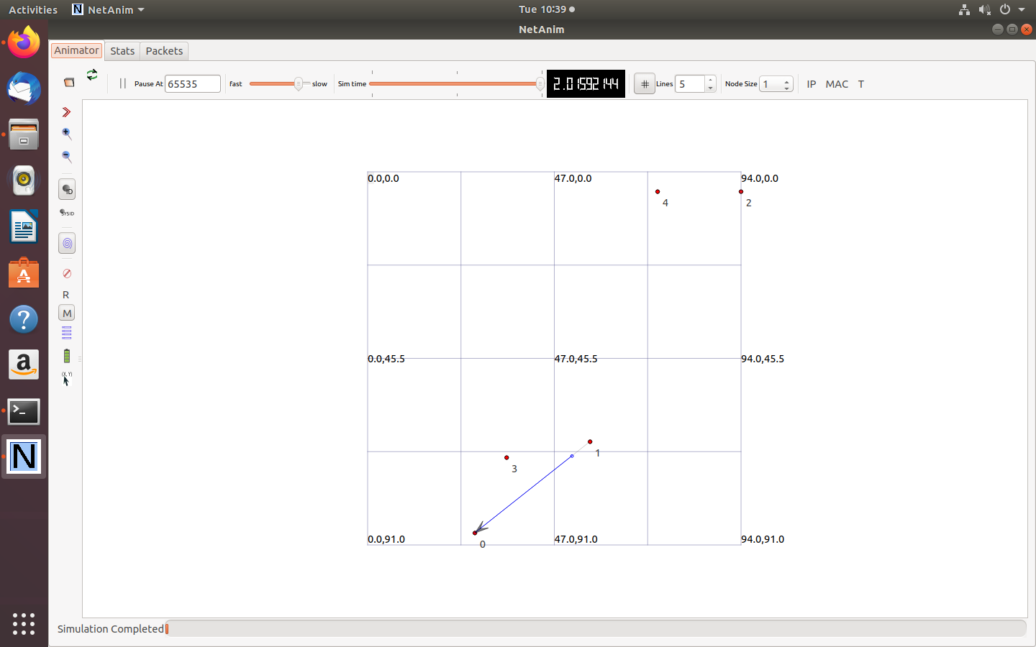

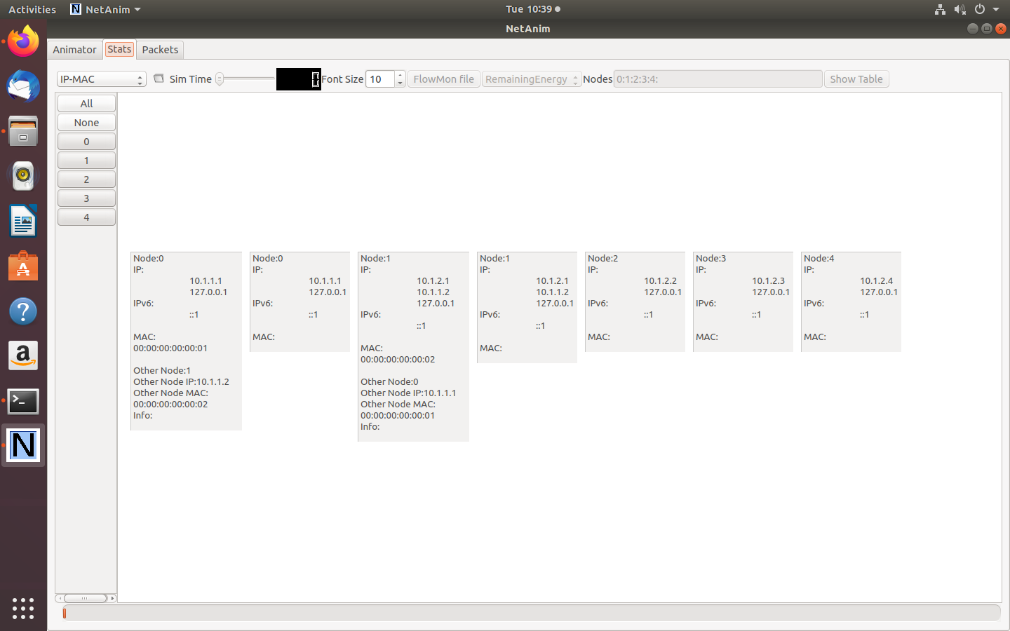

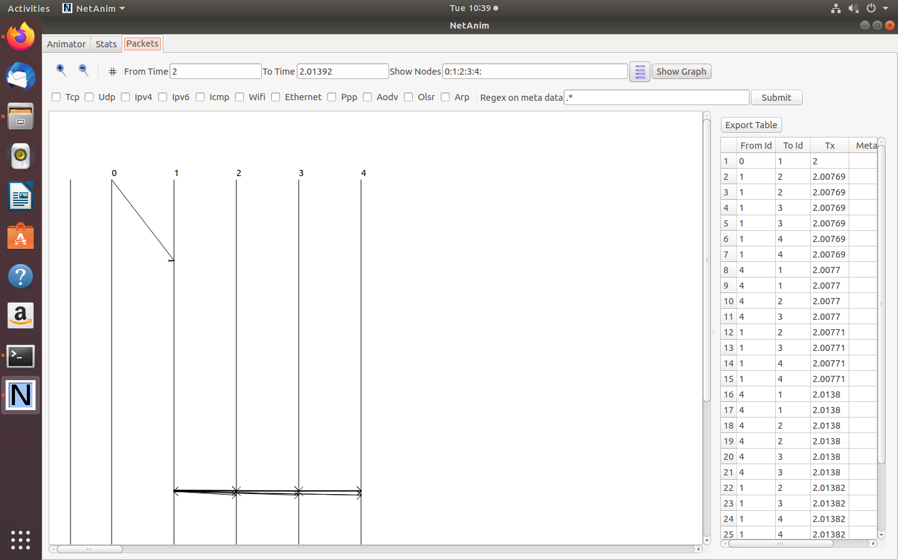

## TW-8

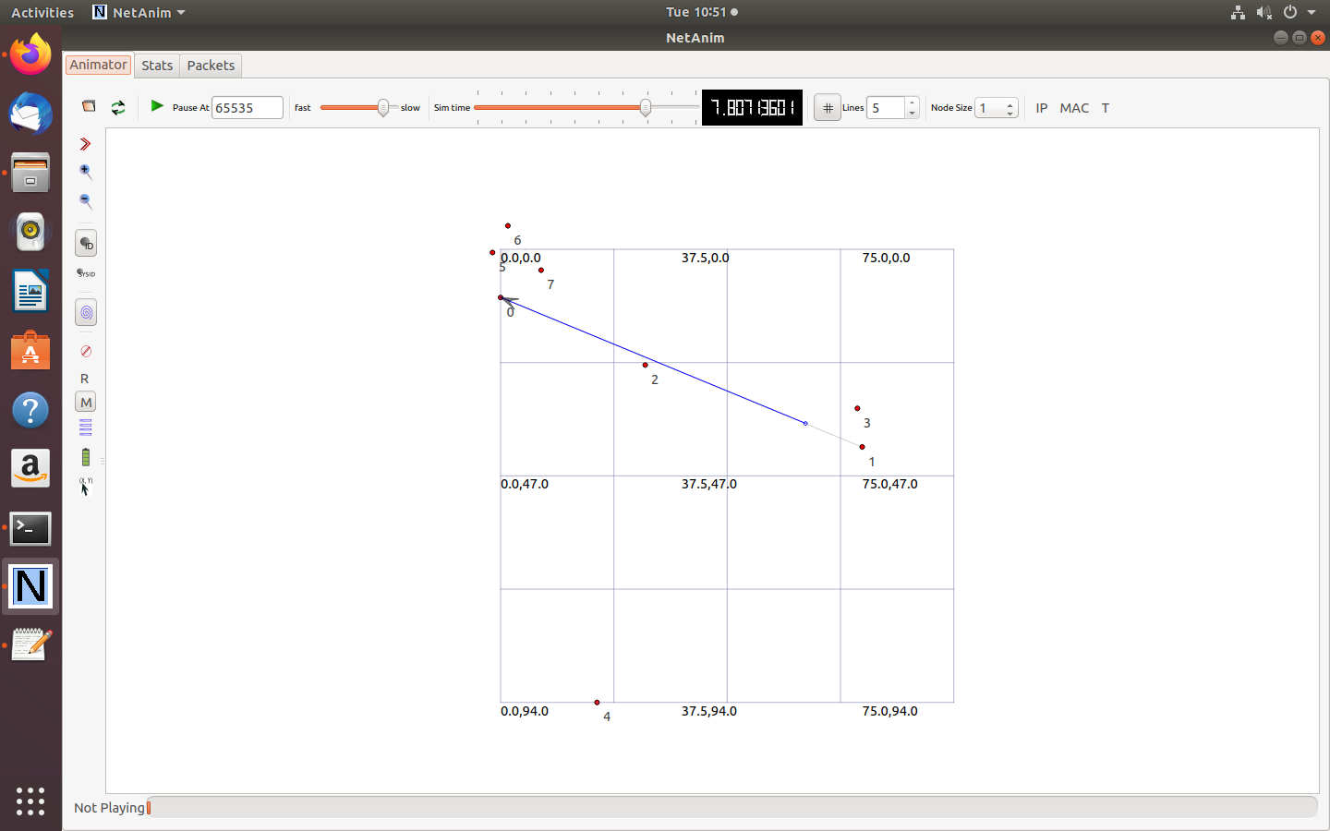

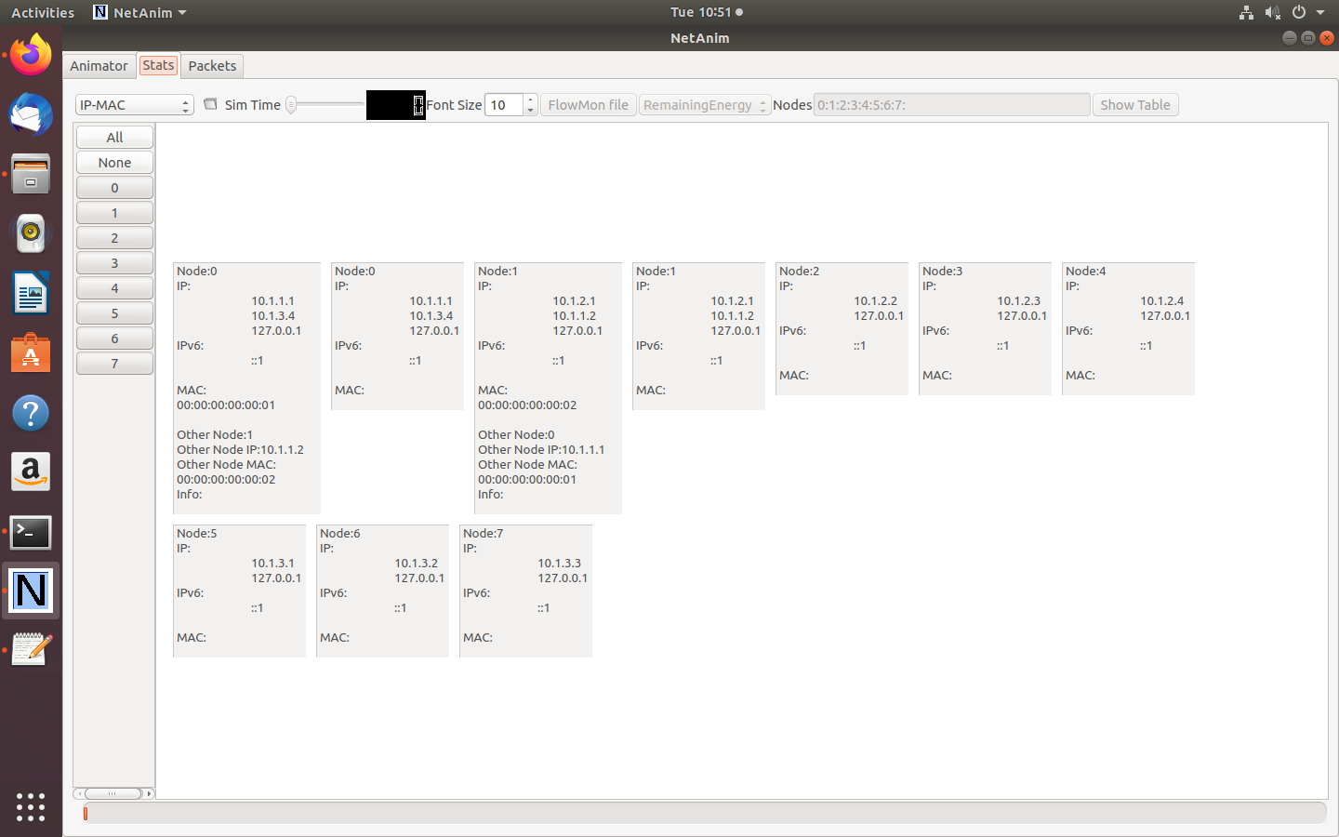

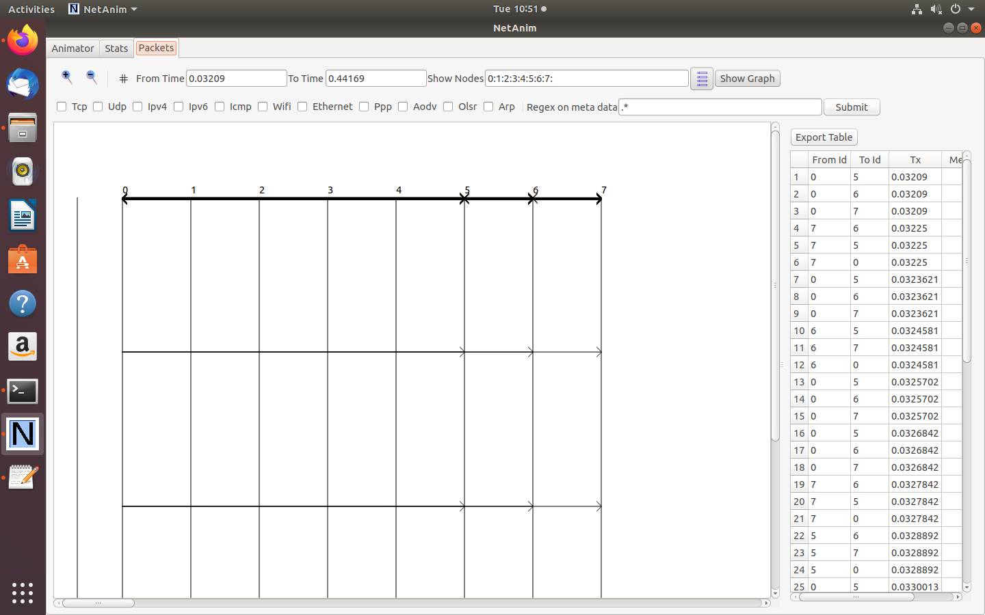

## TW-9

#### Steps to open the cooja simulator

1. Goto root directory
2. cd contiki-ng
3. cd tools
4. cd cooja
5. ant run

#### Steps to create motes and configure them as server and client

1. Goto File -> New Simulation
2. Name the simulation and click on create
3. Click on Motes -> Add motes -> Create a new mote type -> Sky mote
4. Click on Browse and select ipv6-hooks.c (/contiki-ng/examples/libs/ipv6-hooks)
5. Click on open and then on compile and then on create
6. Enter the number of motes as 4 and click on Add motes
7. Place all motes close to each other such that the coverage is 100% for each of them
8. Right click on mote 1 and then click More tools for Sky 1 and then on Serial Socket (SERVER). Mote 1 has been configured as Server.
9. Similarly, configure motes 2, 3 and 4 as clients.
10. Copy the server’s listening port number and paste it as the port number for all clients.
11. Start the server and connect the client to the server.
12. Run the simulation by clicking on Simulation -> Run Simulation

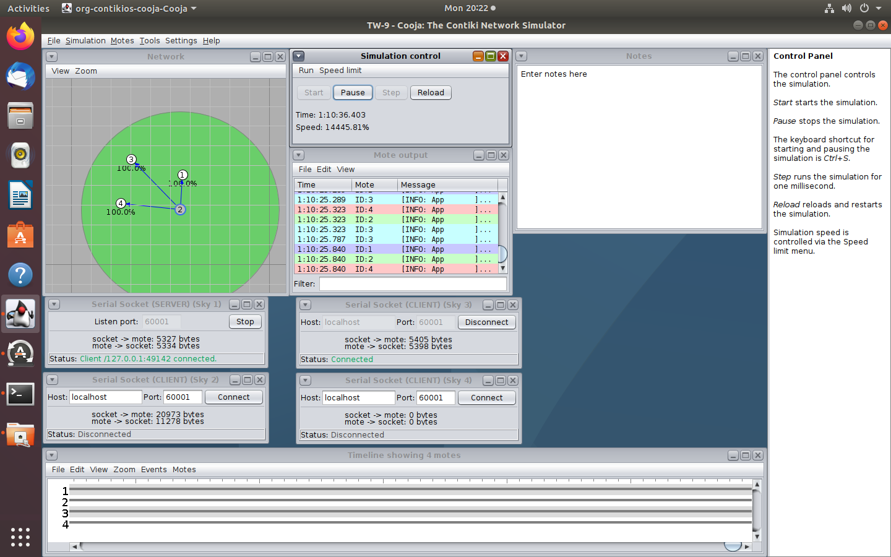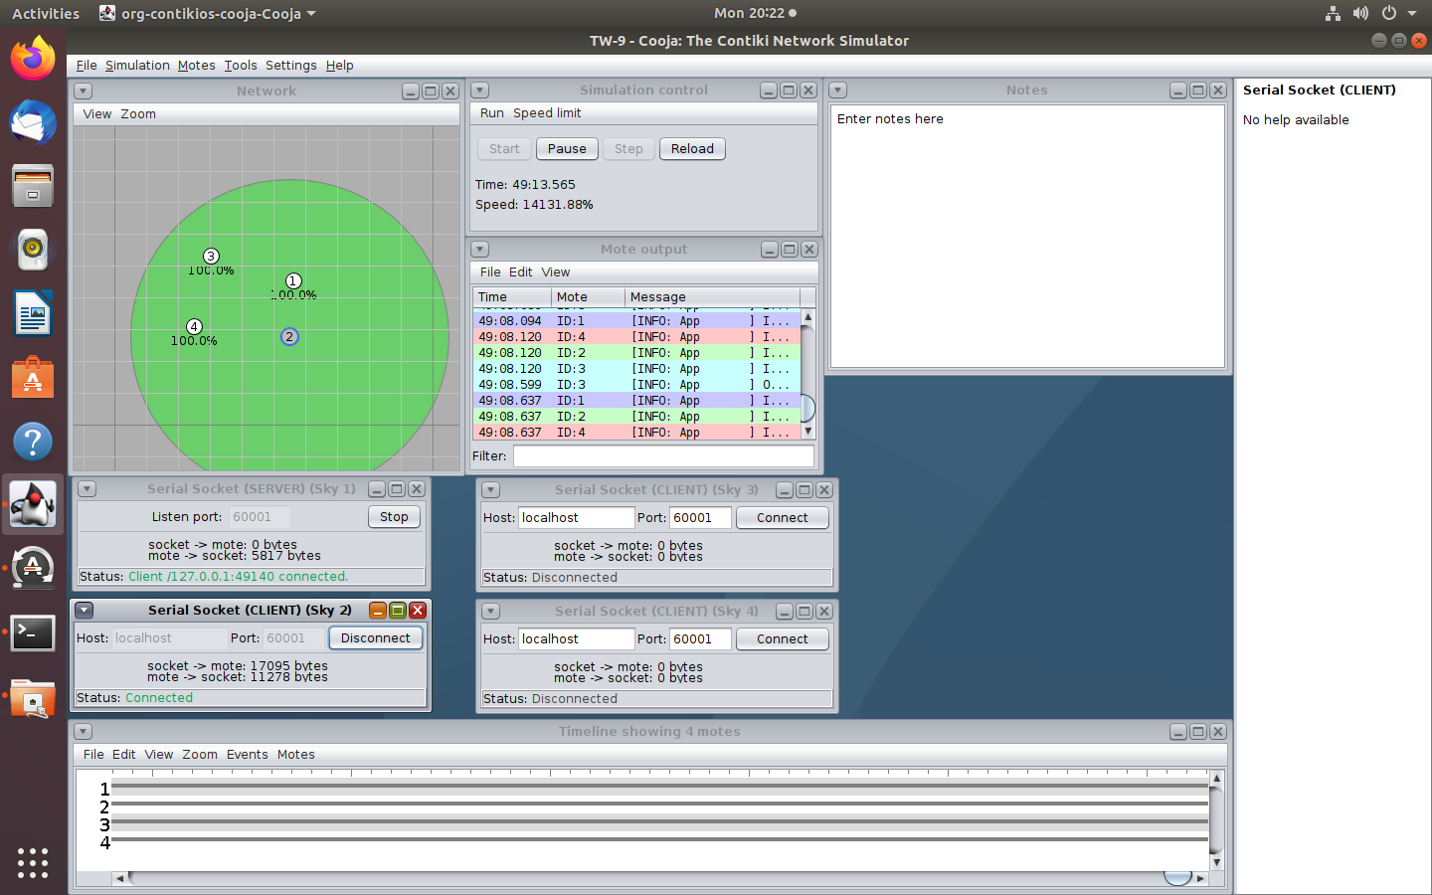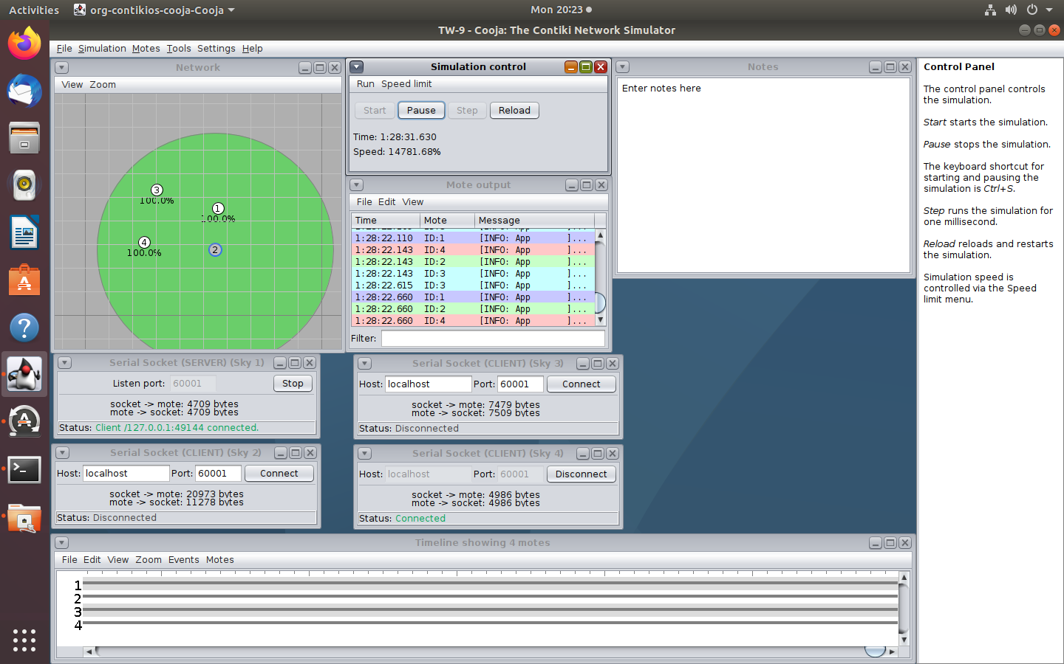

## TW-10

Follow the exact same steps to create 2 motes (client and server).

1. Click on Browse and select rpl-udp(/contiki-ng/examples/libs/rpl-udp)
2. Create udp-server.c and add 1 mote by clicking Motes -> Add new Mote -> Browse
3. Create udp-client.c and add 1 mote
4. Place both the motes close to each other
5. Configure 1 as server and 2 as client
6. Copy the server’s port number to the client.
7. Start the server and connect the client.
8. Run the simulation.

