Industrial Internship Report on
” Prediction of Agriculture Crop Production in India”
Prepared by
KOMMURI VARSHITHA

Executive Summary
This report presents the work completed during the Industrial Internship conducted by upskill Campus in collaboration with UniConverge Technologies Pvt. Ltd. The project, titled Prediction of Agriculture Crop Production in India, focuses on analyzing agricultural crop production data using Python. The dataset was cleaned, processed, and analyzed using Pandas, while Matplotlib was used to visualize production trends through graphs. The project helps identify crop production patterns across different years and provides meaningful insights from agricultural data. This internship improved my technical knowledge in Python, data analysis, visualization, and project documentation while giving me practical exposure to solving real-world data problems.

TABLE OF CONTENTS
1 Preface 3
2 Introduction 4
2.1 About UniConverge Technologies Pvt Ltd 4
2.2 About upskill Campus 8
2.3 Objective 10
2.4 Reference 10
2.5 Glossary 10
3 Problem Statement 11
4 Existing and Proposed solution 11
5 Proposed Design/ Model 12
5.1 High Level Diagram (if applicable) 12
5.2 Low Level Diagram (if applicable) 13
5.3 Interfaces (if applicable) 14-15
6 Performance Test 16
6.1 Test Plan/ Test Cases 16
6.2 Test Procedure 16
6.3 Performance Outcome 16
7 My learnings 17
8 Future work scope 17

Preface

The six-week industrial internship provided me with an opportunity to gain practical knowledge in Machine Learning and Data Analysis. During this internship, I worked on the project Prediction of Agriculture Crop Production in India, where I learned how to collect, clean, analyze, and visualize agricultural data using Python. I also gained hands-on experience with libraries such as Pandas and Matplotlib.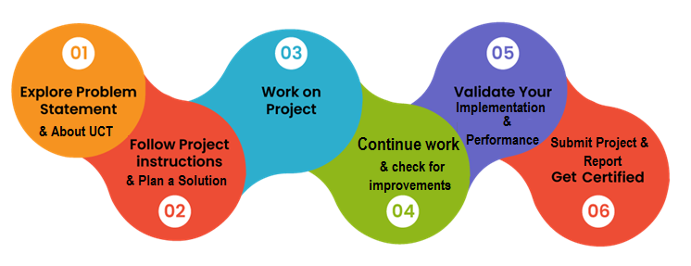
The internship enhanced my problem-solving ability, analytical thinking, and programming skills. It also improved my understanding of data preprocessing, visualization techniques, and project documentation.

I sincerely thank upskill Campus, UniConverge Technologies Pvt. Ltd., my college faculty, and everyone who supported me throughout this internship. This experience has increased my confidence and motivated me to continue learning advanced Machine Learning concepts in the future.

Introduction

About UniConverge Technologies Pvt Ltd
A company established in 2013 and working in Digital Transformation domain and providing Industrial solutions with prime focus on sustainability and RoI.
For developing its products and solutions it is leveraging various Cutting Edge Technologies e.g. Internet of Things (IoT), Cyber Security, Cloud computing (AWS, Azure), Machine Learning, Communication Technologies (4G/5G/LoRaWAN), Java Full Stack, Python, Front end etc.
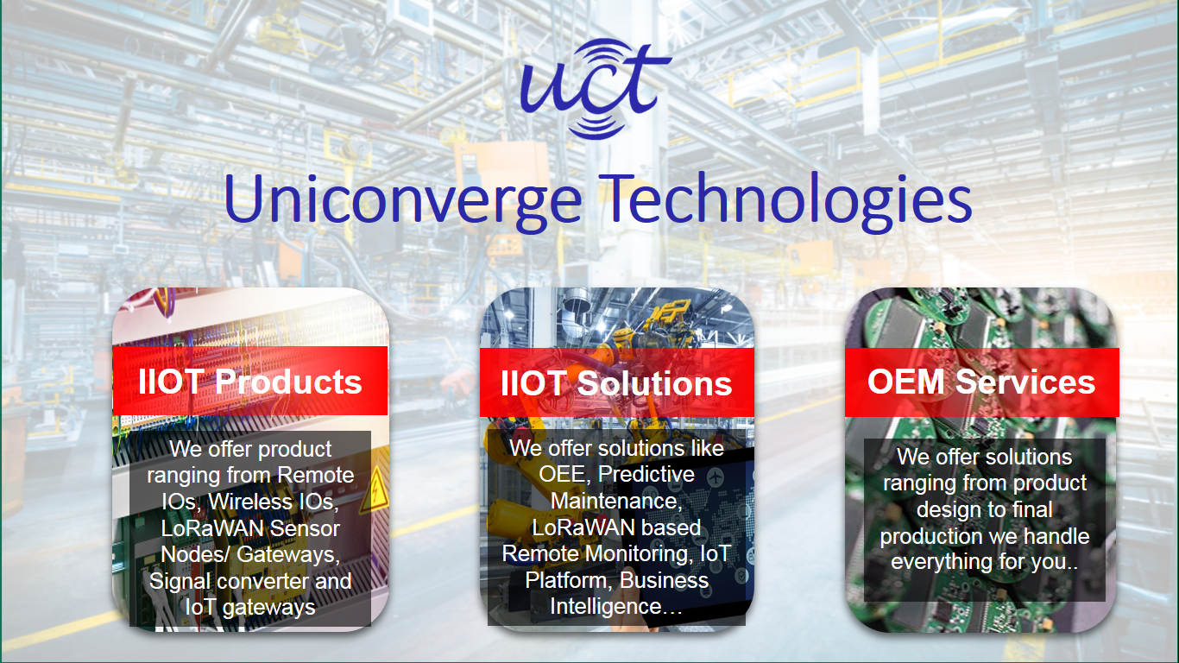
- UCT IoT Platform ()
UCT Insight is an IOT platform designed for quick deployment of IOT applications on the same time providing valuable “insight” for your process/business. It has been built in Java for backend and ReactJS for Front end. It has support for MySQL and various NoSql Databases.
- It enables device connectivity via industry standard IoT protocols - MQTT, CoAP, HTTP, Modbus TCP, OPC UA
- It supports both cloud and on-premises deployments.
It has features to
• Build Your own dashboard
• Analytics and Reporting
• Alert and Notification
• Integration with third party application(Power BI, SAP, ERP)
• Rule Engine

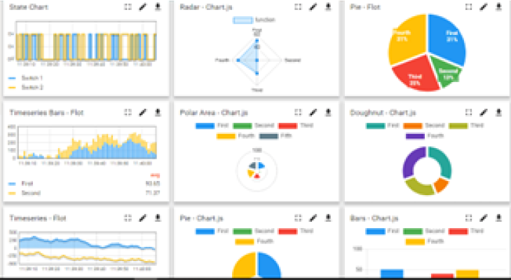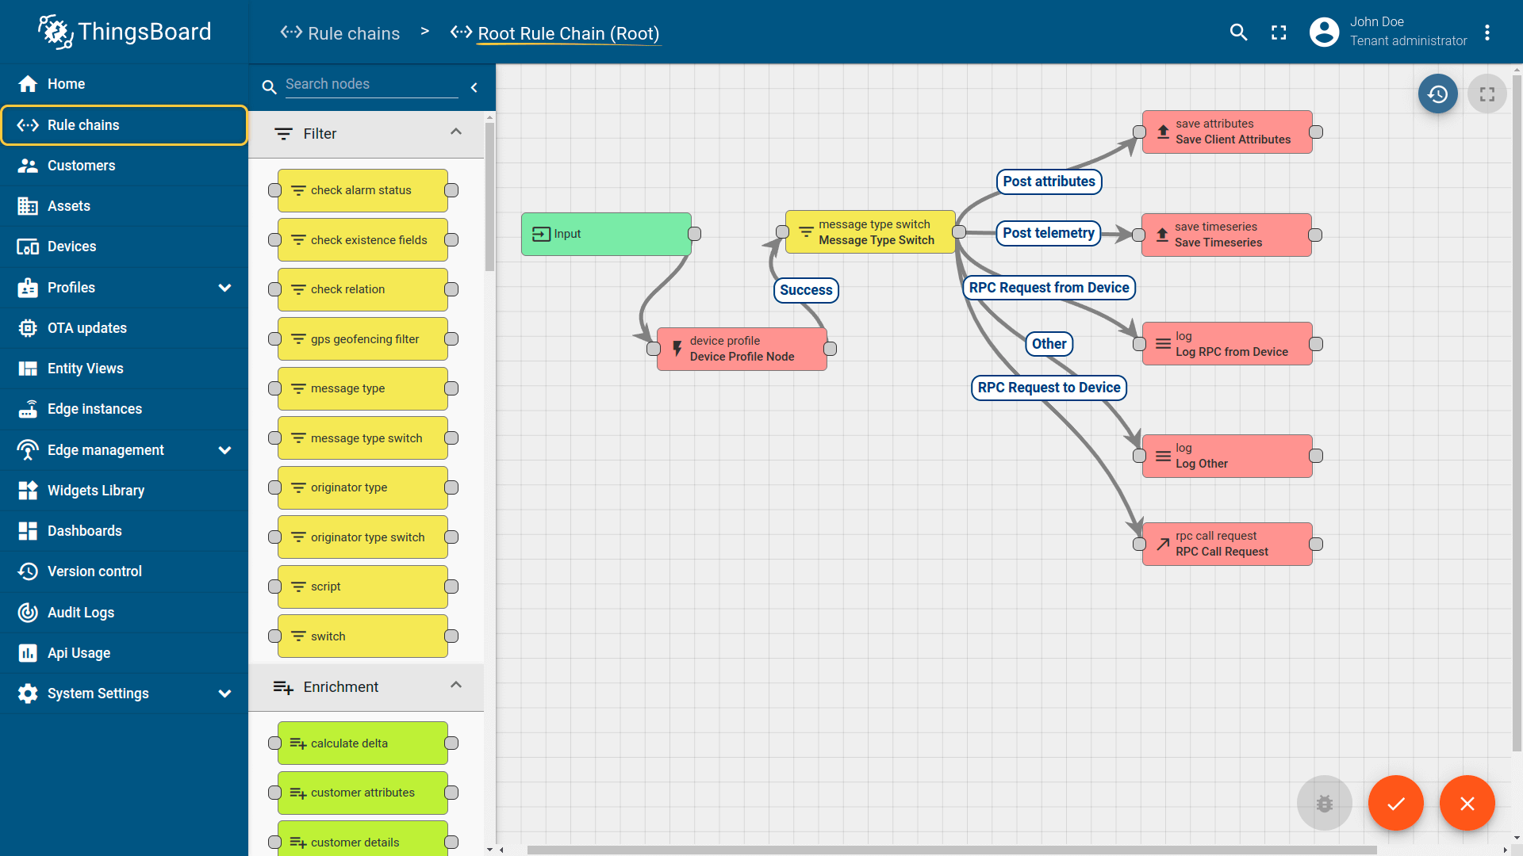

- Smart Factory Platform ()
Factory watch is a platform for smart factory needs.
It provides Users/ Factory
- with a scalable solution for their Production and asset monitoring
- OEE and predictive maintenance solution scaling up to digital twin for your assets.
- to unleased the true potential of the data that their machines are generating and helps to identify the KPIs and also improve them.
- A modular architecture that allows users to choose the service that they what to start and then can scale to more complex solutions as per their demands.
Its unique SaaS model helps users to save time, cost and money.
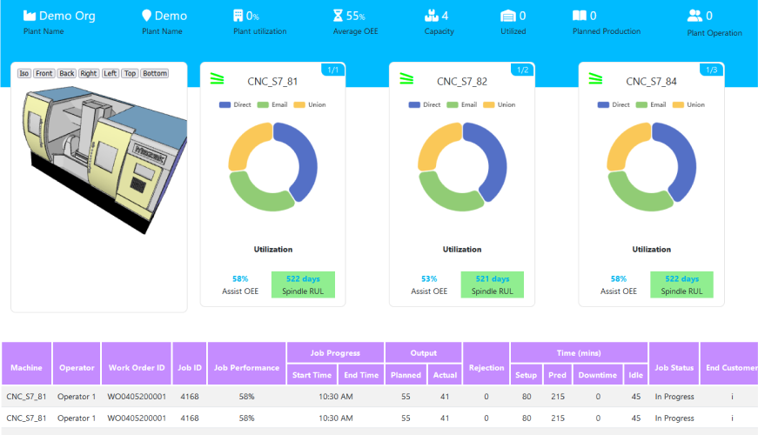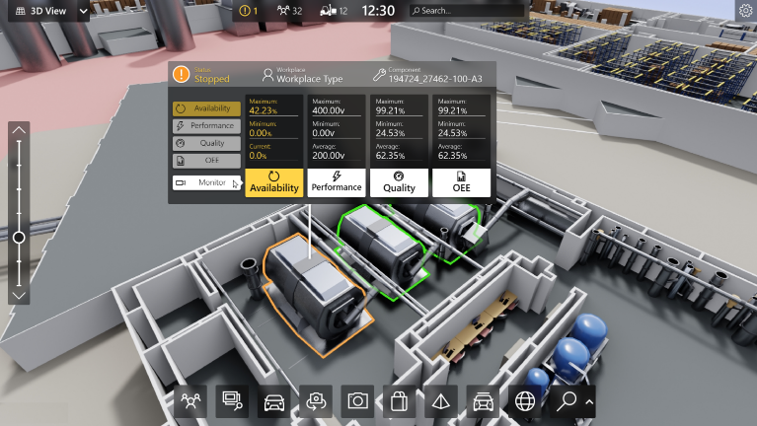

- 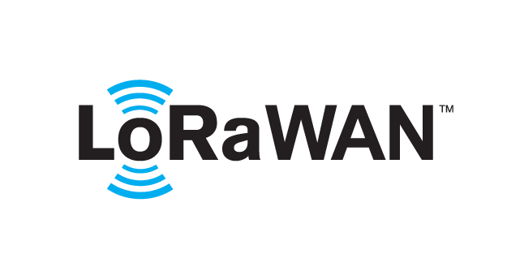 based Solution
UCT is one of the early adopters of LoRAWAN teschnology and providing solution in Agritech, Smart cities, Industrial Monitoring, Smart Street Light, Smart Water/ Gas/ Electricity metering solutions etc.
- Predictive Maintenance
UCT is providing Industrial Machine health monitoring and Predictive maintenance solution leveraging Embedded system, Industrial IoT and Machine Learning Technologies by finding Remaining useful life time of various Machines used in production process.
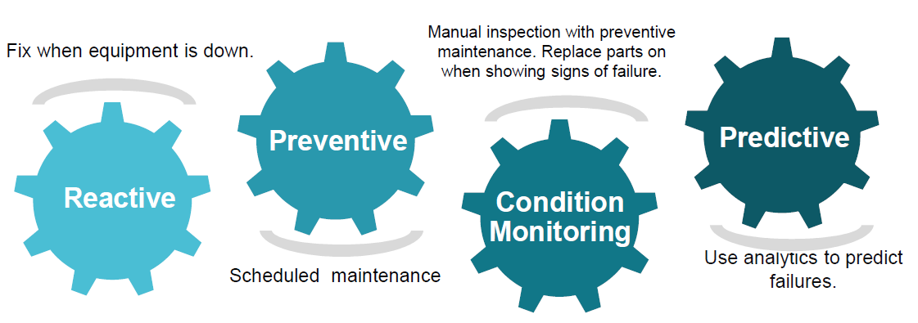

About upskill Campus (USC)
upskill Campus along with The IoT Academy and in association with Uniconverge technologies has facilitated the smooth execution of the complete internship process.
USC is a career development platform that delivers personalized executive coaching in a more affordable, scalable and measurable way.




Seeing need of upskilling in self paced manner along-with additional support services e.g. Internship, projects, interaction with Industry experts, Career growth Services
https://www.upskillcampus.com/
upSkill Campus aiming to upskill 1 million learners in next 5 year

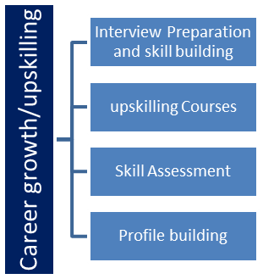
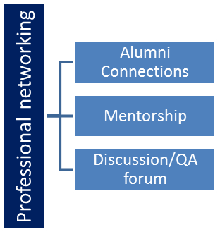
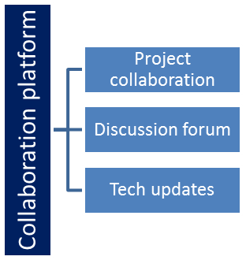
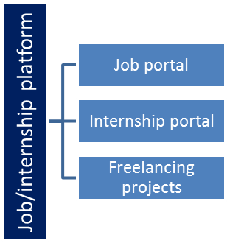

The IoT Academy
The IoT academy is EdTech Division of UCT that is running long executive certification programs in collaboration with EICT Academy, IITK, IITR and IITG in multiple domains.

Objectives of this Internship program
The objective for this internship program was to
☛ To analyze agriculture crop production data.
☛ To clean and preprocess the dataset.
☛ To visualize crop production trends using graphs.
☛ To understand agricultural production patterns.
☛ To improve Python and data analysis skills.
☛ To gain practical experience in Machine Learning and Data Analysis.

Reference
[1] Python Software Foundation. Python Documentation. https://docs.python.org⁠
[2] Pandas Development Team. Pandas Documentation. https://pandas.pydata.org⁠
[3] Matplotlib Development Team. Matplotlib Documentation. https://matplotlib.org

Glossary
Terms | Acronym
ML | Machine Learning
CSV | Comma Separated Values
Pandas | Python library used for data analysis
Dataset | Collection of structured data
Data Analysis | Process of examining and interpreting data

Problem Statement
Agricultural production data is available in large quantities, but understanding production trends from raw data is difficult. Farmers, researchers, and policymakers require meaningful insights from this data for better decision-making.

The objective of this project is to analyze agriculture crop production data, clean the dataset, perform exploratory analysis, and visualize production trends using Python. The generated graphs help users understand crop production patterns across different years in a simple and effective manner.

Existing and Proposed solution

Most agricultural datasets are available only as raw tables, making it difficult to identify production trends quickly. Manual analysis consumes time and may lead to inaccurate conclusions.

The proposed solution uses Python with Pandas and Matplotlib to preprocess the data, remove missing values, analyze crop production, and generate meaningful visualizations such as bar charts and line graphs. This approach provides a simple and efficient way to understand agricultural production patterns.

Code submission (Github link)
https://github.com/Varshi-1215/upskillcampus/blob/main/Prediction_of_Agriculture_Crop_Production_in_India%20(1).ipynb

Report submission (Github link) :
hhttps://github.com/Varshi-1215/upskillcampus/blob/main/PredictionofAgricultureCropproductioninindia_Varshitha_USC_UCT.docx

Proposed Design/ Model

The proposed system is designed to analyze agriculture crop production data using Python. The dataset is first imported into Google Colab, where preprocessing techniques are applied to clean the data and remove missing values. After preprocessing, the data is analyzed using the Pandas library to identify crop production trends across different years.
The processed data is then visualized using Matplotlib through bar charts and line graphs, making it easier to compare crop production and understand agricultural patterns. Finally, the results are interpreted to provide meaningful insights into crop production in India.

High Level Diagram (if applicable)
Agriculture Crop Dataset
Data Collection

Data Preprocessing
Data Analysis
Data Visualization

Prediction & Result

Figure 1: HIGH LEVEL DIAGRAM OF THE SYSTEM

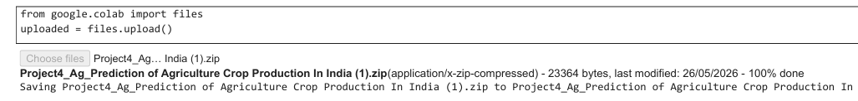
Low Level Diagram (if applicable)
Start

Import CSV Dataset

Load Data into Google colab

Data Cleaning & Preprocessing
Handle Missing Values

Analyze Data using Pandas

Generate Bar Chart & Line Graph

Prediction / Trend Analysis

Display Final Result

End

Figure 2: LOW LEVEL DIAGRAM OF THE SYSTEM

Interfaces (if applicable)



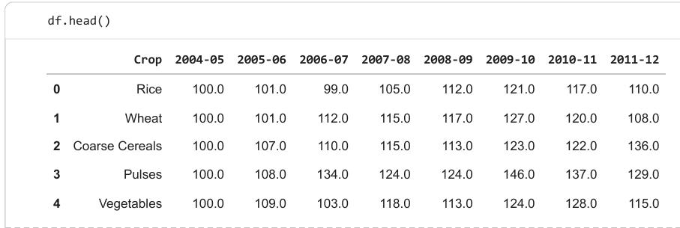
The dataset is uploaded into Google Colab using the files.upload() function. This allows the user to select the dataset file from the local system and load it into the notebook environment.

Dataset preview displaying first few records of crop production data
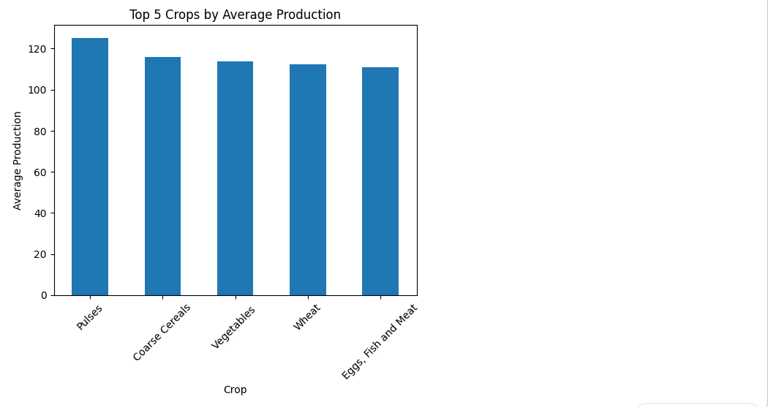

Bar chart showing top 5 crops based on average production.

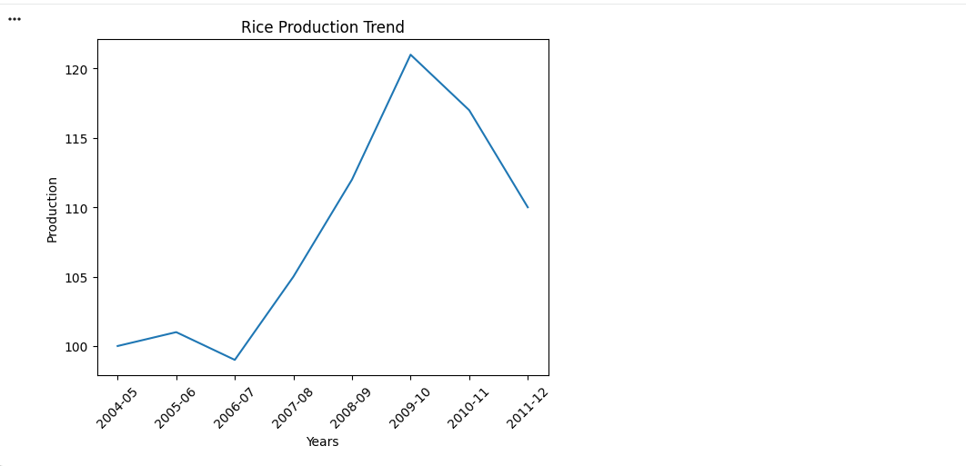

Line graph showing production trend of crops over years.

Performance Test

Performance testing was conducted to evaluate the efficiency and accuracy of the Prediction of Agriculture Crop Production in India project. The system was tested using the available agricultural crop production dataset in Google Colab. The objective of the testing process was to verify whether the dataset could be imported successfully, cleaned properly, analyzed accurately, and visualized without any errors. Different test cases were performed to ensure that each stage of the project functioned correctly. The performance results confirmed that the system generated accurate visualizations and meaningful insights from the agricultural data, meeting the objectives of the project successfully.

Test Plan/ Test Cases
The project was tested using the agriculture crop production dataset. The main objective was to verify whether the dataset could be successfully imported, cleaned, analyzed, and visualized. The following test cases were considered:
* Verify successful dataset import into Google Colab.
* Check whether missing values are handled correctly.
* Verify successful data analysis using Pandas.
* Ensure bar charts and line graphs are generated without errors.
* Validate that the final output provides meaningful insights into crop production trends.

Test Procedure
The dataset was uploaded into Google Colab and processed using Python. Initially, the dataset was cleaned by handling missing values and checking data quality. After preprocessing, the data was analyzed using the Pandas library. Visualization techniques such as bar charts and line graphs were created using Matplotlib. Finally, the outputs were verified to ensure that the analysis was accurate and the graphs correctly represented crop production trends.

Performance Outcome
The project successfully completed all the planned test cases. The dataset was processed without major errors, and the generated visualizations clearly represented crop production trends. The final output was accurate, easy to understand, and met the objectives of the project. Overall, the system performed efficiently and provided meaningful insights into agriculture crop production in India.

My learnings

This internship helped me improve my programming skills in Python and strengthened my understanding of data analysis concepts. I learned how to clean datasets, analyze data using Pandas, and create visualizations using Matplotlib. I also gained experience in project documentation, problem-solving, and presenting technical work in a professional manner. This internship increased my confidence and prepared me for future opportunities in Machine Learning and Data Science.

Future work scope

This project can be further enhanced by integrating Machine Learning algorithms to predict future crop production. Larger and more recent datasets can be used to improve analysis accuracy. Interactive dashboards can also be developed using modern visualization tools to provide real-time insights. Future improvements may include weather data integration and predictive analytics to support agricultural planning and decision-making.

