Rising Waters: A Machine Learning Approach to Flood Prediction

Project Documentation

Submitted By:

Tavisala Varshitha Reddy (Team Lead)

Tamadapalli Chandu

Desetty Revathi

P Rahul

Shaik Sameer Buddubhai Gari

G.Pullaiah College Of Engineering And Technology

Submitted To:

Skill Wallet

Project Domain:

Machine Learning using Python, Flask and IBM Cloud

Academic Year:

2025-2026

Acknowledgement

I express my sincere gratitude to Skill Wallet for providing the
opportunity to work on the project titled "Rising Waters: A
Machine Learning Approach to Flood Prediction." This project
helped me gain practical knowledge in Machine Learning, Data
Analysis, Data Preprocessing, Model Building, Flask Web
Development, and GitHub.
I also thank my mentors and faculty members for their valuable
guidance and continuous support throughout the project. Their
suggestions and encouragement helped me complete every
phase successfully.
Finally, I would like to thank my family and friends for their
motivation and support during the completion of this project.

Abstract

Floods are among the most devastating natural disasters, causing loss of
life, damage to infrastructure, and economic disruption every year.
Accurate and timely flood prediction plays an important role in disaster
preparedness and emergency response.
This project, "Rising Waters: A Machine Learning Approach to Flood
Prediction," aims to predict the possibility of flood occurrence using
historical weather and rainfall data. The project uses Machine Learning
classification algorithms including Decision Tree, Random Forest,
K-Nearest Neighbors (KNN), and XGBoost to analyze meteorological
parameters such as temperature, humidity, cloud cover, annual rainfall, and
seasonal rainfall.
After comparing the performance of all models, the best-performing model
is selected and integrated into a Flask-based web application. Users can
enter weather values through a simple web interface and instantly receive a
prediction indicating whether flood conditions are likely or not.
This system demonstrates how Machine Learning can support disaster
management authorities by providing faster and more reliable flood risk
predictions.
Introduction

Floods are one of the most common natural disasters affecting millions of
people around the world. Heavy rainfall, overflowing rivers, poor drainage
systems, and climate change increase the frequency and intensity of
floods. Early prediction of floods allows authorities to take preventive
measures such as evacuation planning, resource allocation, and
emergency response.
Machine Learning has become an effective technology for analysing large
datasets and identifying patterns that are difficult to detect using traditional
methods. By training classification algorithms on historical weather data, it
is possible to predict flood risk with improved accuracy.
In this project, a Machine Learning model is trained using weather-related
features such as temperature, humidity, cloud cover, annual rainfall, and
seasonal rainfall. The best-performing model is deployed using Flask to
create a simple web application that provides flood predictions based on
user input.

Problem Statement

Flood prediction using traditional methods is often time-consuming and less

accurate due to the complexity of weather conditions. Delayed predictions

reduce the time available for authorities to respond, increasing the risk of

damage and loss of life. There is a need for an intelligent, automated

system capable of providing faster and more accurate flood predictions.

Objectives

- Develop a Machine Learning model for flood prediction.

- Analyse historical weather and rainfall data.

- Compare multiple classification algorithms.

- Select the best-performing model.

- Deploy the trained model using Flask.

- Provide a user-friendly web interface.

- Support early warning and disaster preparedness.

Technologies Used

The Flood Prediction System is developed using Python and Machine
Learning technologies. The project involves data analysis, model training, web
application development, and deployment. The following technologies and
libraries were used throughout the project.

Table:

Technology / Tool | Purpose
Python | Programming Language
Jupyter Notebook | Data Analysis and Model Development
Pandas | Data Manipulation
NumPy | Numerical Computation
Matplotlib | Data Visualization
Seaborn | Statistical Visualization
Scikit-learn | Machine Learning Algorithms
XGBoost | Advanced Classification Model
Flask | Web Application Framework
Joblib | Saving and Loading ML Models
HTML | Web Page Structure
CSS | User Interface Styling
Git | Version Control
GitHub | Source Code Repository
IBM Cloud | Cloud Deployment Platform
System Requirements

Hardware Requirements

- Processor: Intel Core i3 or above
- RAM: 4 GB or above
- Storage: 10 GB Free Space
- Internet Connection

Software Requirements

Software | Version
Windows 10 / 11 | Operating System
Python | 3.10 or above
Anaconda Navigator | Latest
Jupyter Notebook | Latest
Flask | Latest
Git | Latest
GitHub Account | Required
Web Browser | Chrome / Edge

System Architecture
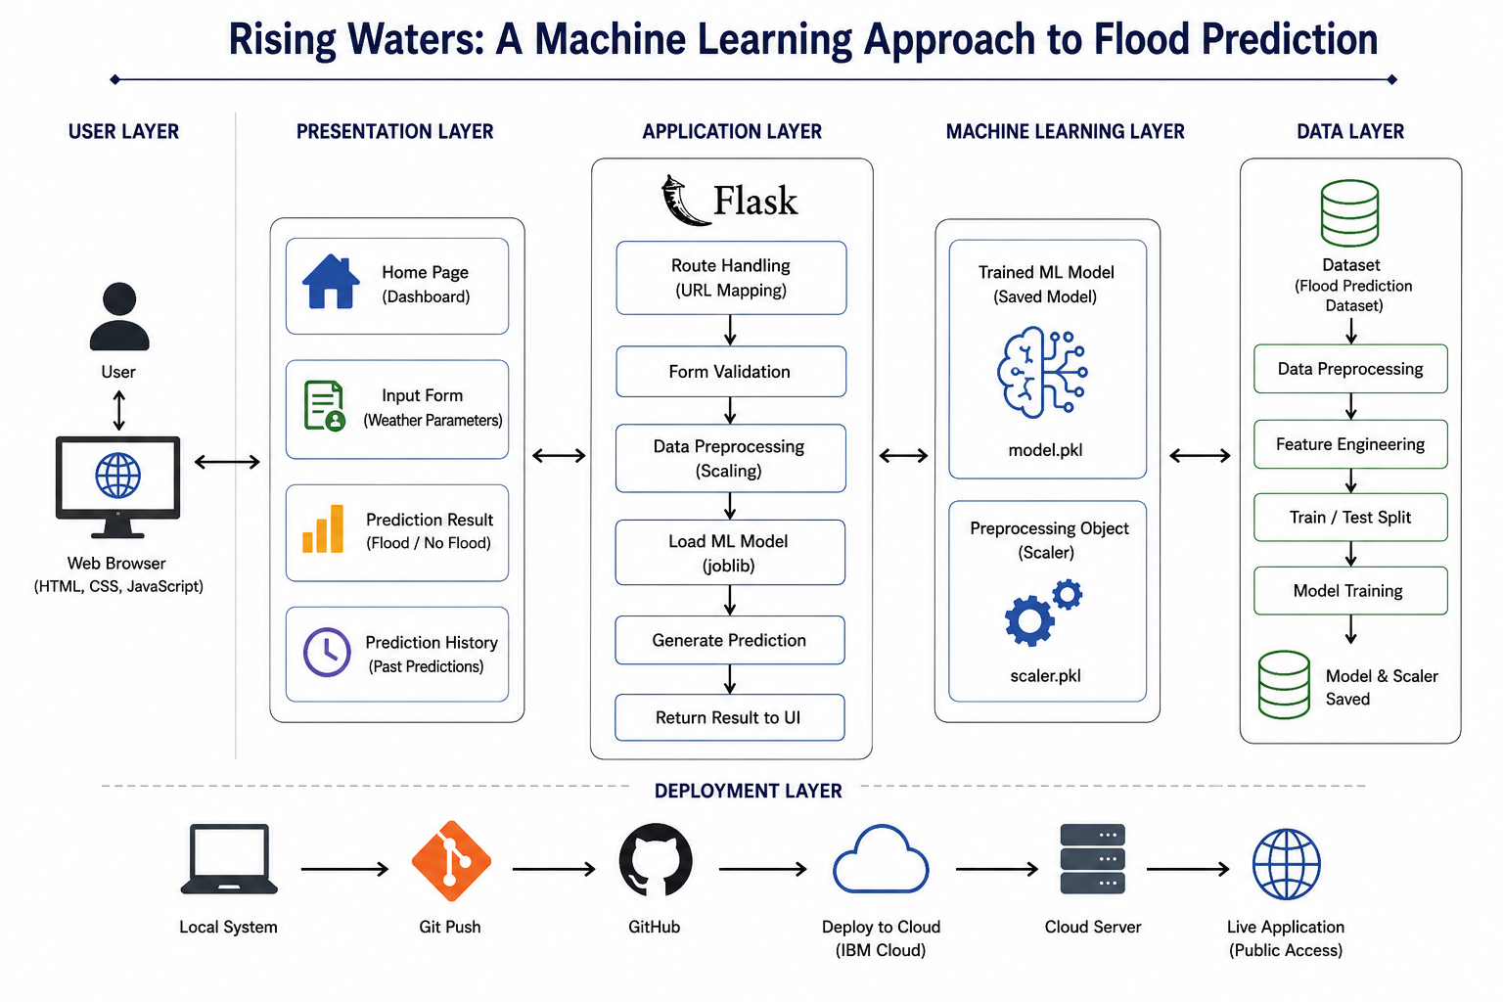

The system architecture consists of six major layers.
User Layer
The user accesses the application through a web browser and enters weather-related information.
Presentation Layer
The presentation layer contains the Home Page, Prediction Form, Prediction Result Page, and Prediction History.
Application Layer
The Flask application handles routing, input validation, preprocessing, model loading, and prediction generation.
Machine Learning Layer
The trained XGBoost model and scaler are loaded to predict flood risk.
Data Layer
Historical flood datasets undergo preprocessing, feature engineering, train-test splitting, and model training.
Deployment Layer
The application is deployed using GitHub and IBM Cloud, making it accessible through the web.
Entity Relationship Diagram

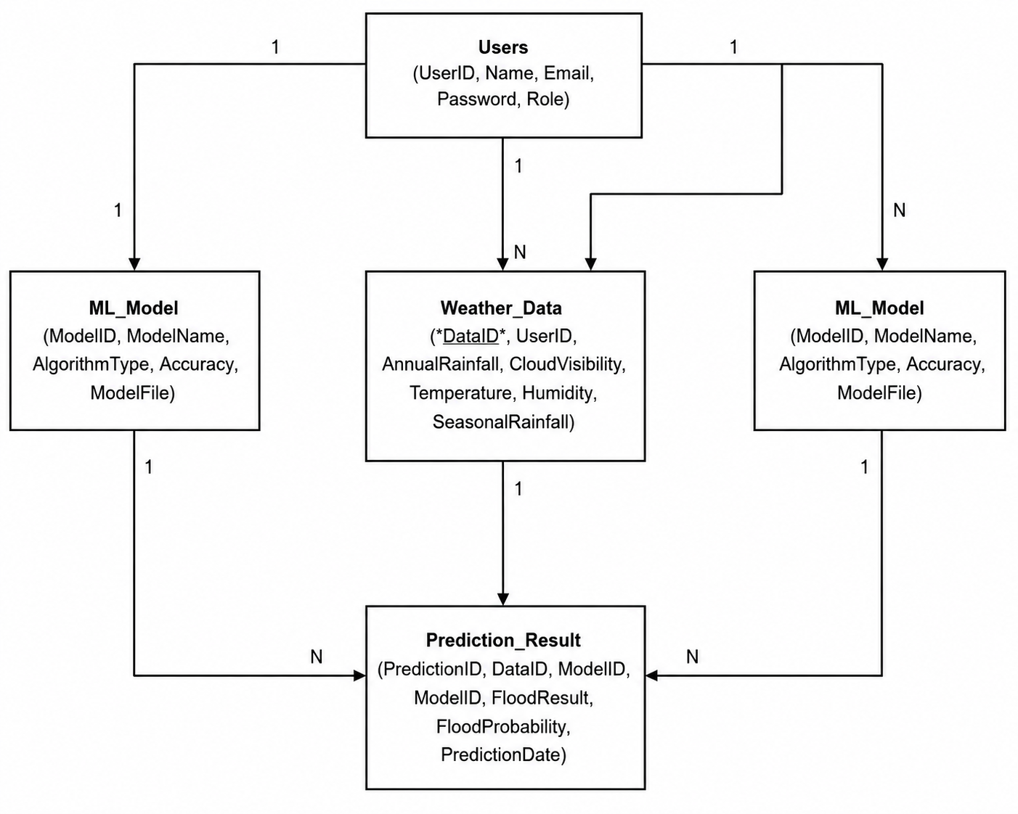

The Entity Relationship Diagram represents the relationship between the
User and Prediction entities. Each prediction is generated based on
weather parameters entered by the user. The prediction result indicates
whether flood conditions are likely or not.

Dataset Description
The flood prediction dataset used in this project was collected from Kaggle. It contains historical weather-related information and a target variable indicating flood occurrence.
The dataset includes the following features:
- Temperature
- Humidity
- Cloud Cover
- Annual Rainfall
- January–February Rainfall
- March–May Rainfall
- June–September Rainfall
- October–December Rainfall
- Average June Rainfall
- Sub Rainfall
- Flood (Target Variable)
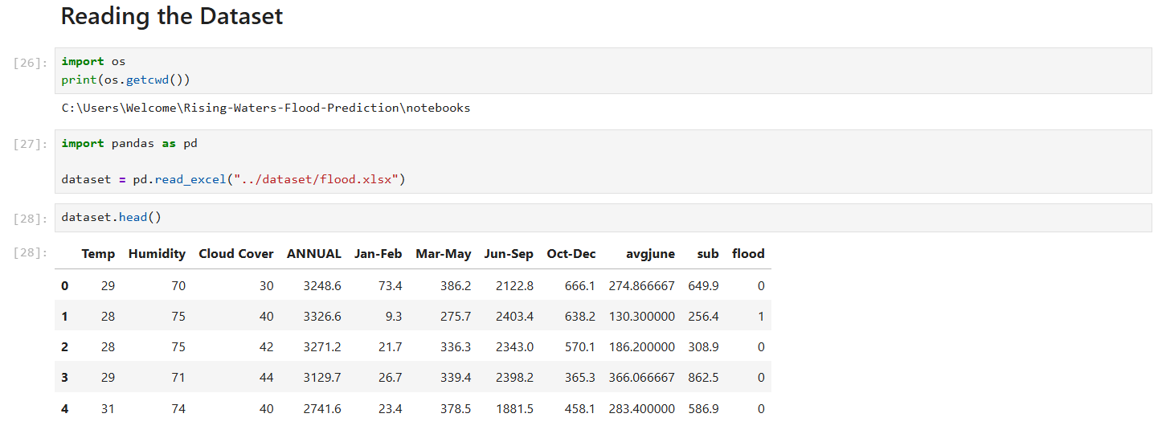
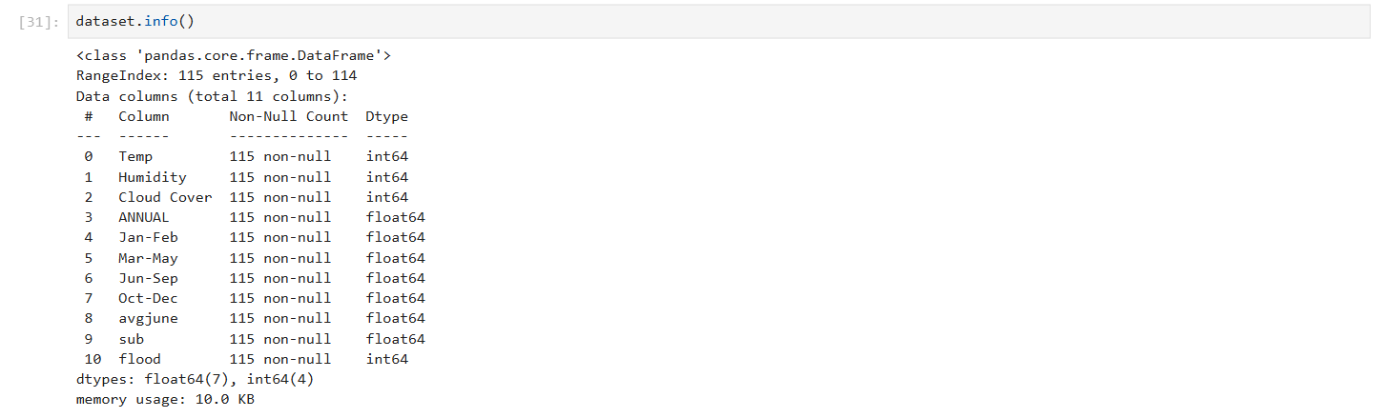
Data Analysis
Before training the Machine Learning models, the dataset was analysed to
understand feature distributions, identify patterns, and examine relationships
among variables.
The following techniques were used:
- Descriptive Statistics
- Univariate Analysis
- Multivariate Analysis
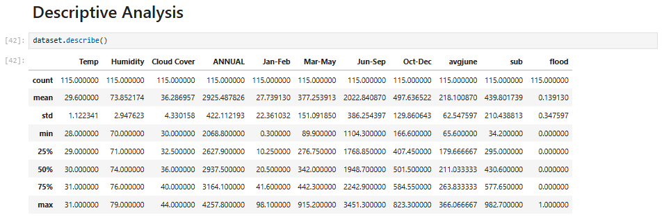
Descriptive analysis provides statistical information such as mean,
standard deviation, minimum, and maximum values.

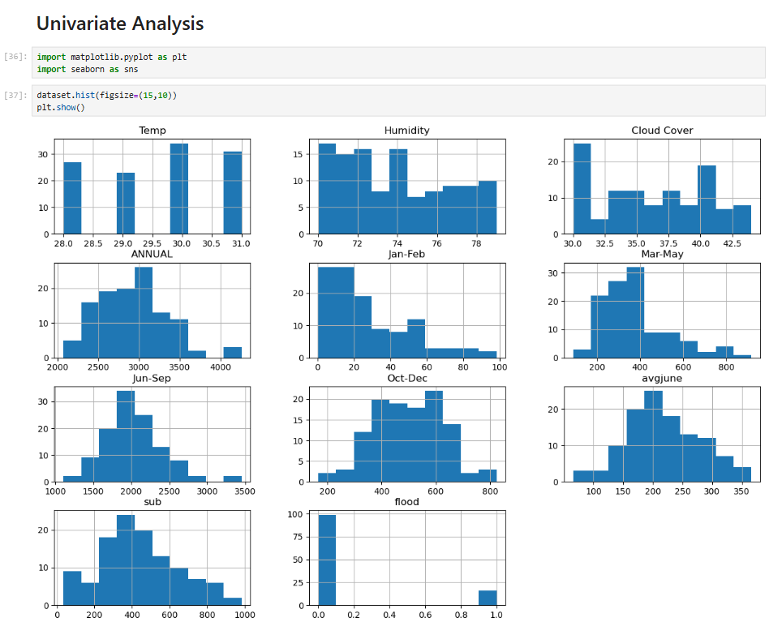
Univariate analysis helps understand the distribution of individual features, while

multivariate analysis reveals relationships between different variables using correlation

analysis.

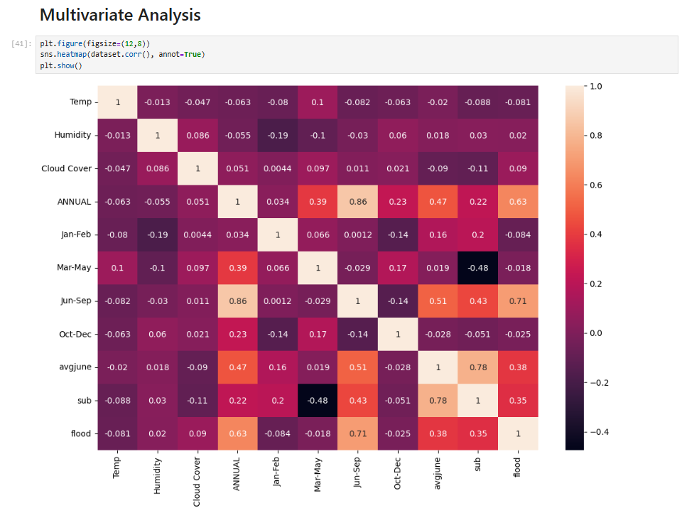
Data Preprocessing
Data preprocessing is one of the most important stages in Machine Learning. It prepares the dataset for training by cleaning and transforming the data.
The preprocessing steps performed in this project include:
- Handling Missing Values
- Handling Outliers
- Handling Categorical Values
- Train-Test Split
- Feature Scaling
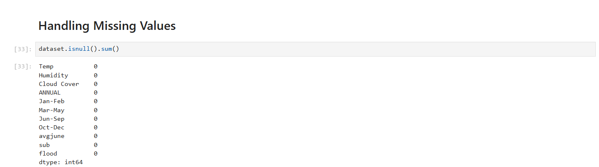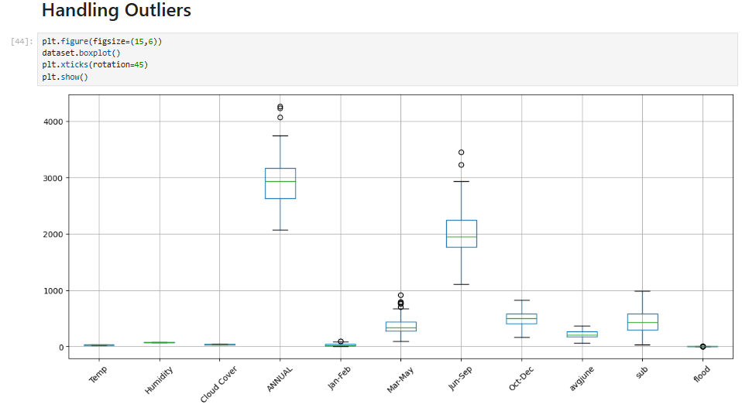

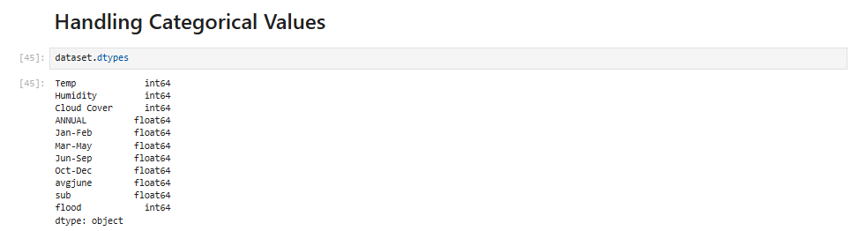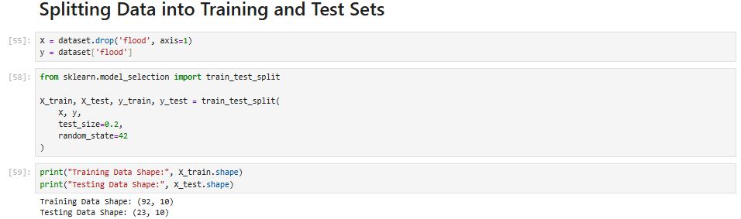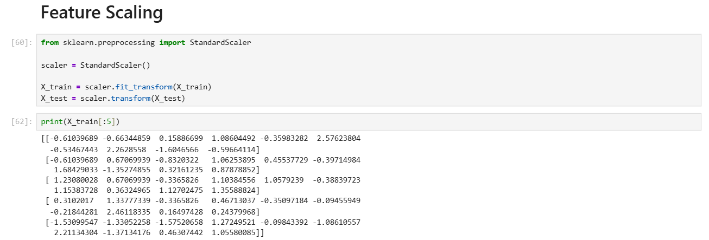

Model Building

After completing data preprocessing, the dataset was used to train multiple Machine Learning classification models. The objective was to identify the model that provides the highest prediction accuracy for flood occurrence.
The dataset was divided into training and testing sets using an 80:20 ratio. Four Machine Learning algorithms were implemented and evaluated.

Decision Tree
The Decision Tree classifier builds a tree-like structure by splitting the dataset based on feature values. It is simple to understand and suitable for classification problems.
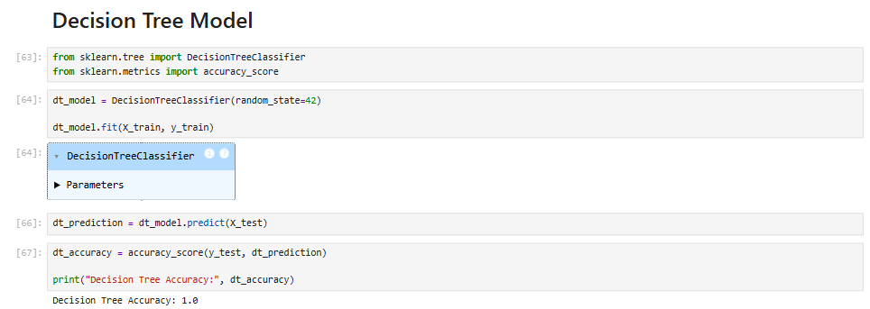

Random Forest
Random Forest combines multiple decision trees to improve prediction accuracy and reduce overfitting. It generally performs better than a single decision tree.
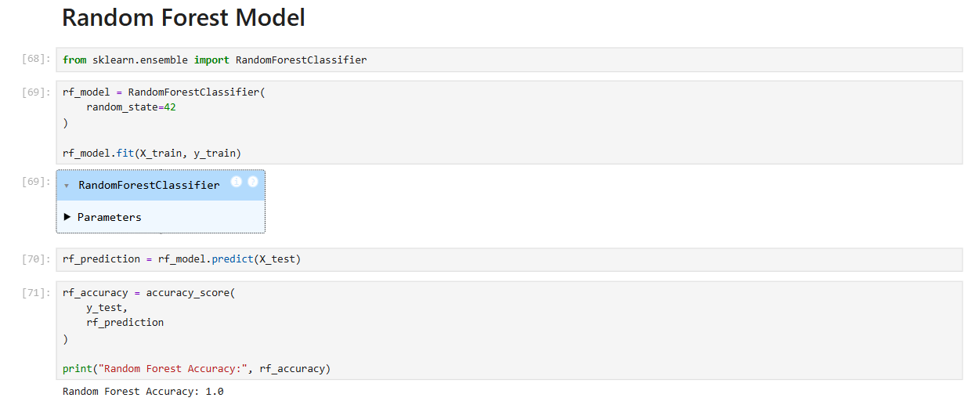

K-Nearest Neighbors (KNN)

The KNN algorithm predicts the output by finding the nearest neighboring data points based on distance.

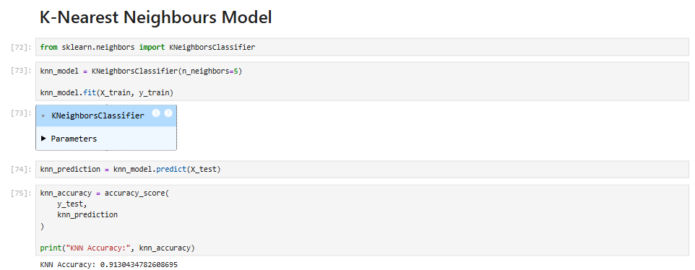

XGBoost
XGBoost is an advanced gradient boosting algorithm that provides high prediction accuracy and efficient model training. It achieved the best performance among all the models used in this project.
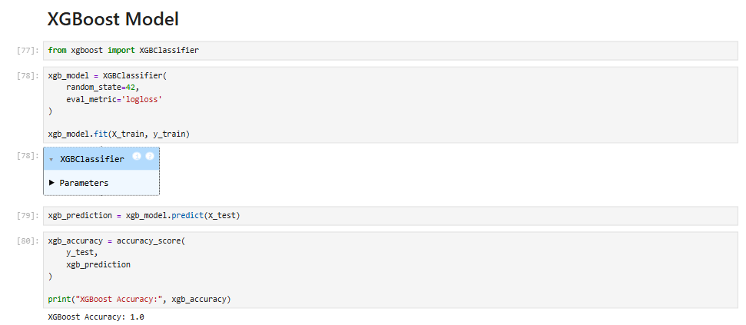

Model Comparison and Evaluation

The performance of all Machine Learning models was compared using accuracy score, confusion matrix, and classification report. The comparison helped identify the most suitable model for deployment.

Model Comparison

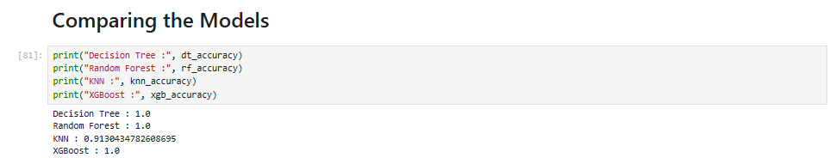

Among all the implemented algorithms, XGBoost achieved the highest prediction accuracy. Therefore, it was selected as the final model for deployment in the Flask web application.
Model Evaluation
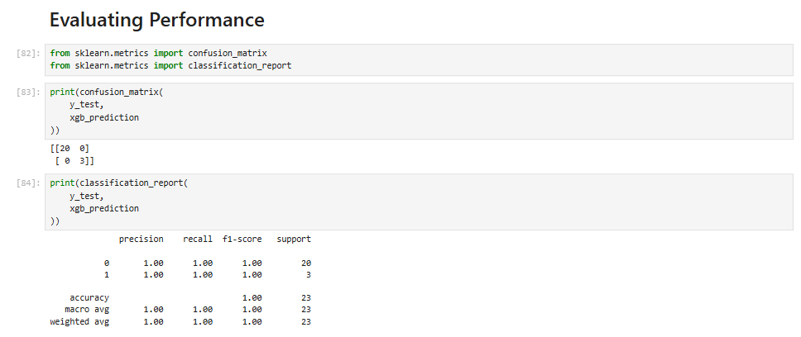
The confusion matrix provides detailed information about correct and incorrect classifications, while the classification report includes precision, recall, F1-score, and overall accuracy. These evaluation metrics confirm that the trained model performs effectively on unseen test data.

Saving the Model

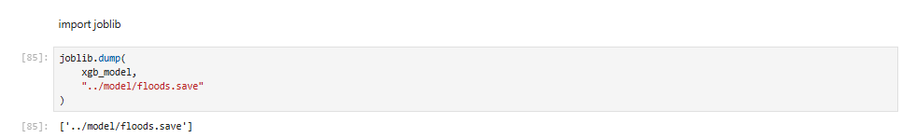

The trained XGBoost model and feature scaler were saved using the Joblib library. These saved files are loaded by the Flask application during prediction.

Flask Web Application
A Flask web application was developed to provide an easy-to-use interface for flood prediction. Users enter weather-related parameters through a web form, and the trained Machine Learning model predicts whether flood conditions are likely.
The application consists of the following files:
- app.py
- index.html
- result.html
- flood.html
- noflood.html
- style.css

Home Page
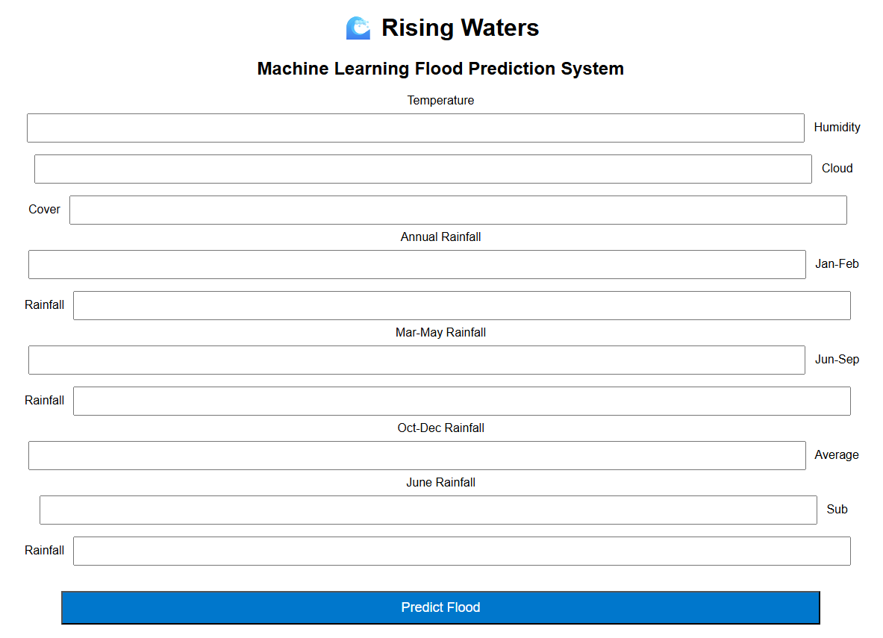
The Home Page allows users to enter all required weather parameters for flood prediction.

Prediction Form
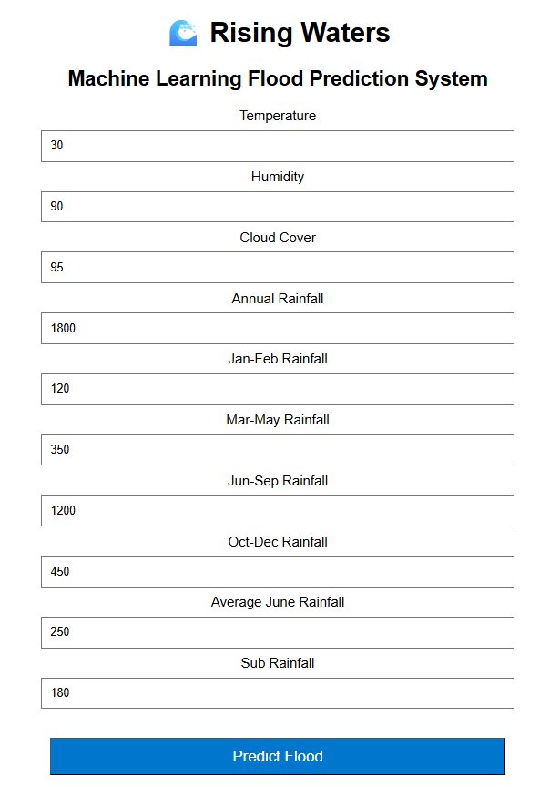

The Prediction Form contains input fields for temperature, humidity, cloud cover, annual rainfall, seasonal rainfall, average June rainfall, and sub rainfall.
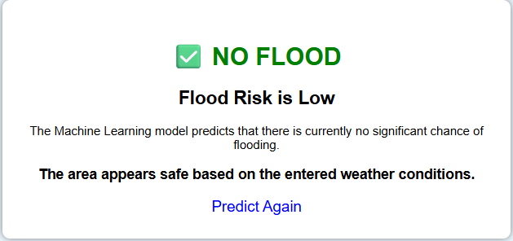

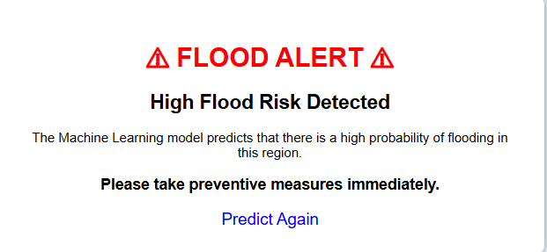

After entering the weather values, the application displays the prediction result

indicating whether flood conditions are expected.

GitHub Repository
GitHub was used to maintain and organize all project files. The repository includes the source code, Machine Learning models, documentation, screenshots, datasets, HTML templates, CSS files, and notebooks.
The GitHub repository ensures proper version control and allows the project to be shared and accessed easily.
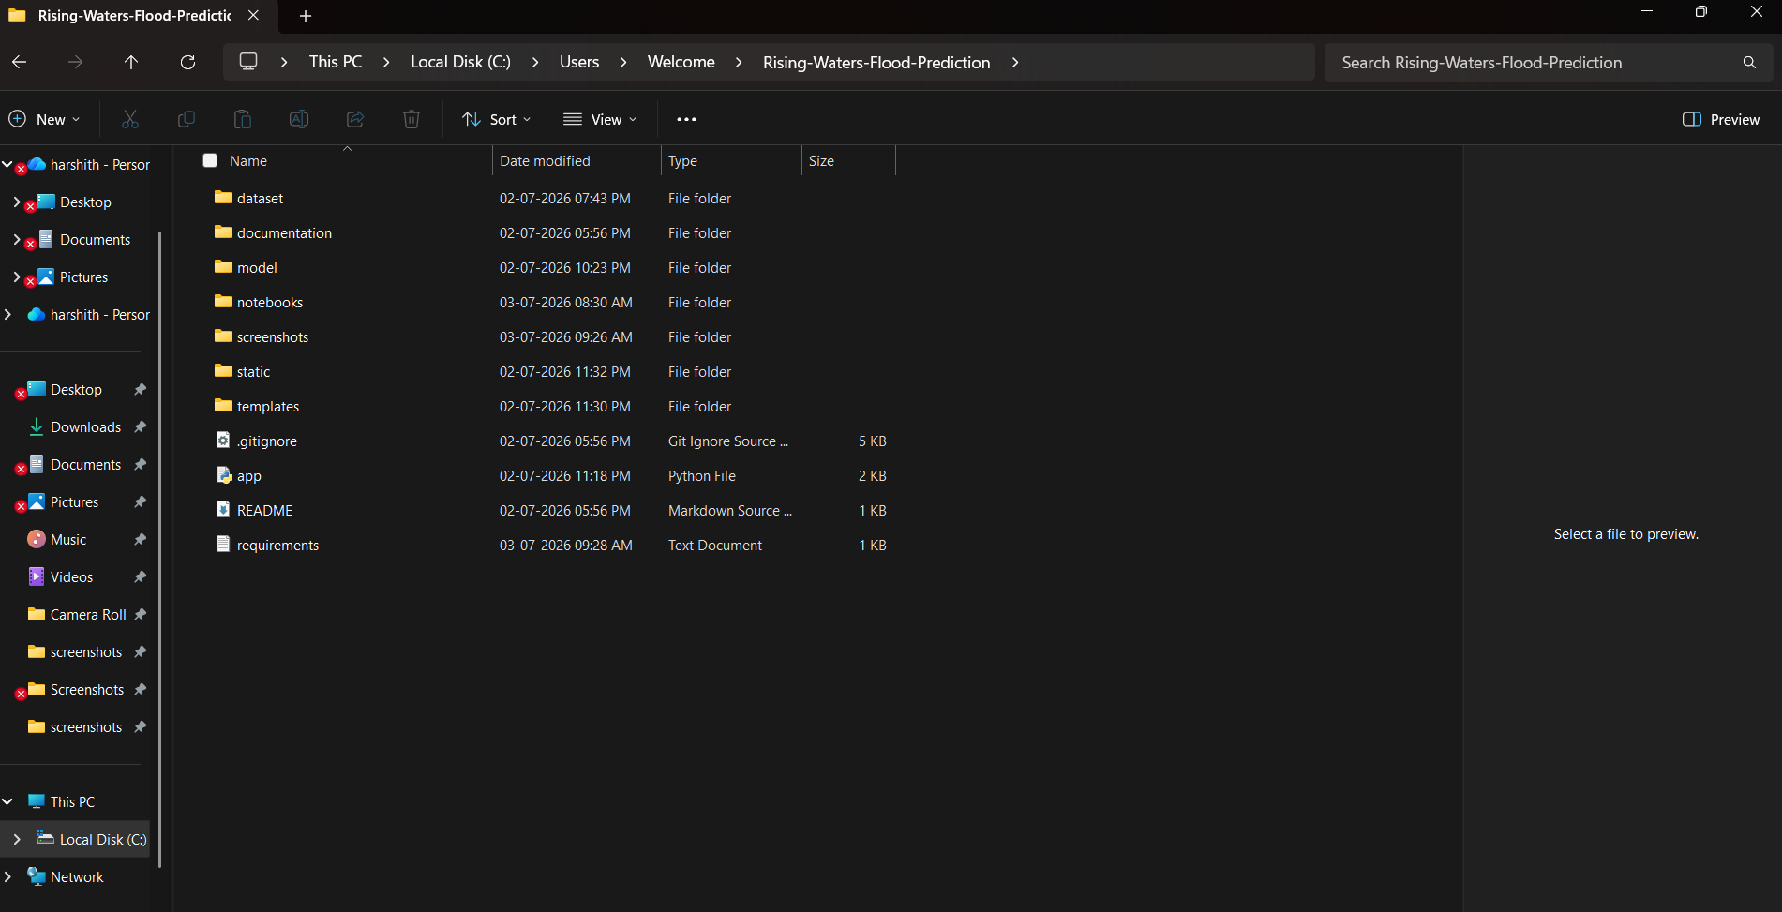

Results
The Flood Prediction System successfully predicts flood risk using Machine
Learning algorithms. After comparing multiple classification models, XGBoost
achieved the best overall performance and was selected as the final model.
The Flask web application provides an intuitive interface where users can enter
weather data and receive immediate flood predictions. The application
demonstrates how Machine Learning can support disaster preparedness and
improve decision-making.
Future Scope
The project can be enhanced in several ways to improve prediction accuracy and usability:
- Integrate live weather data from APIs.
- Deploy the application on IBM Cloud or another cloud platform.
- Develop a mobile application for easy access.
- Include GPS-based regional flood prediction.
- Use Deep Learning techniques for improved performance.
- Send SMS or email alerts to users during high flood risk.
- Visualize flood-prone regions on an interactive map.

Conclusion
The project "Rising Waters: A Machine Learning Approach to Flood Prediction" successfully demonstrates the application of Machine Learning in disaster management.
Multiple classification algorithms were trained and evaluated using historical weather data. XGBoost achieved the best performance and was integrated into a Flask web application, allowing users to predict flood risk through a simple interface.
The project highlights the importance of Machine Learning in supporting early warning systems, improving emergency response, and helping authorities make informed decisions.
References
- Kaggle – Flood Prediction Dataset
- Python Documentation – https://docs.python.org
- Pandas Documentation – https://pandas.pydata.org
- NumPy Documentation – https://numpy.org
- Scikit-learn Documentation – https://scikit-learn.org
- XGBoost Documentation – https://xgboost.readthedocs.io
- Flask Documentation – https://flask.palletsprojects.com
- Matplotlib Documentation – https://matplotlib.org
- Seaborn Documentation – https://seaborn.pydata.org
- IBM Cloud Documentation – https://cloud.ibm.com/docs

