**15IT304J-WEB PROGRAMMING**

**RA1711003011496-WEEK5 REPORT**

**PROJECT: Hostel Mess Management**

**Aim: To create a simple servlet program that displays the content written in servlet program.**

**Code:**

import java.io.IOException;

import java.io.PrintWriter;

import javax.servlet.ServletException;

import javax.servlet.http.HttpServlet;

import javax.servlet.http.HttpServletRequest;

import javax.servlet.http.HttpServletResponse;

public class Hello extends HttpServlet {

private static final long serialVersionUID = 1L;

public Hello() {}

protected void doGet(HttpServletRequest request, HttpServletResponse response) throws ServletException, IOException {

response.setContentType("text/html");

PrintWriter out=response.getWriter();

out.print("<html><body>");

out.print("<h3>Hello harika</h3>");

out.print("</body></html>");

}

}

**Output:**

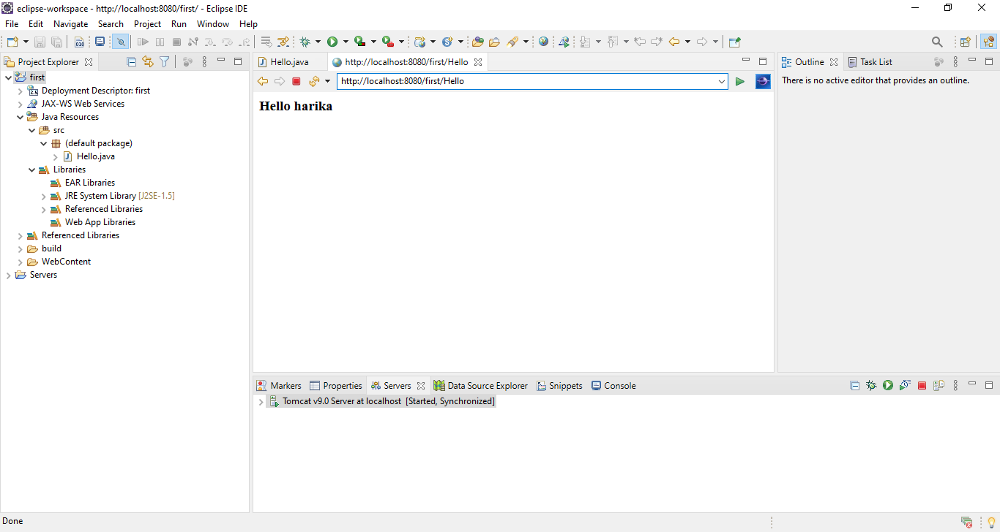

**Result: The experiment was completed successfully.**