**WEB DEVELOPMENT LAB**

**REG NO: RA1711003011213**

**WEEK-1**

**Aim: To prepare the resume using html tags**

**Code:**

|  |
| --- |
| <html> |
|  | <head lang="en-US"> |
|  | <title>Myresume</title> |
|  |  |
|  | <style> |
|  | .tab5 { |
|  | tab-size: 8; |
|  | } |
|  | </style> |
|  | </head> |
|  |  |
|  | <body> |
|  | <h3><strong>NAGASARAPU SAI DURGA VARSHINI </strong></h3> |
|  | <pre class="tab5"> |
|  | <img src="varshini213.jpg" alt="Not found" width="150" height="150"> |
|  | </pre> |
|  | <p> varshini.nagasarapu@gmail.com <br> 8897210895 </p> |
|  | <h3><strong>EDUCATION</strong></h3> |
|  | <style> |
|  | table,th,td{ |
|  | border:1px solid black; |
|  | border-collapse:collapse; |
|  | } |
|  | tab4 { |
|  | tab-size: 8; |
|  | } |
|  | </style> |
|  | <table> |
|  | <tr> |
|  | <th> YEAR </th> |
|  | <th> COLLEGE/INSTITUTE</th> |
|  | </tr> |
|  | <tr> |
|  | <td> 2017-2021 </td> |
|  | <td> SRM institute of Science and Technology, Chennai <br> Percentage- 86% </td> |
|  | </tr> |
|  | <tr> |
|  | <td> 2015-2017 </td> |
|  | <td> SRI CHAITANYA COLLEGE <br> Percentage- 96.2%</td> |
|  | </tr> |
|  | <tr> |
|  | <td> 2014-2015 </td> |
|  | <td> Sri Chaitanya School <br> Percentage -95% </td> |
|  | </tr> |
|  | </table> |
|  | <h3><strong>INTERSHIP</strong></h3> |
|  | <p> </p> |
|  | <a>Software Intern,IDC Technologies in Hyderabad (TOPIC : WEB DEVELOPMENT) </a> |
|  | <h3><strong> TECHNICAL SKILLS </strong> </h3> |
|  | <p></p> |
|  | <a> Languages Learnt :<br> C,C++,JAVA Programming Languages |
|  | <h3> <strong> ELECTIVES </strong></h3> |
|  | <p></p> |
|  | <a> Big Data Analytics <br> Networking <br> Machine Learning </a> |
|  | <h3> <strong> CERTIFICATIONS </strong></h3> |
|  | <p></p> |
|  | <a> |
|  | 1.Machine Learning by Stanford University on Courseera.<br> |
|  | 2.Committee Member at AARUUSH,SRMIST. |
|  | </a> |
|  | <h3><strong> PERSONAL PROFILE </strong></h3> |
|  | <p></p> |
|  | <a> Data of birth : 04/11/1999 <br> |
|  | Gender : Female<br> |
|  | Age : 20 <br> |
|  | Nationality : Indian<br> |
|  | Languages Known : English,Telugu </a> |
|  | <p> </p> |
|  | <p></p> |
|  | <a><h3><strong>DATE : </strong></h3> 9th-Aug-2020</a> |
|  | <m><h3><strong>PLACE : </strong></h3> Kattankulatur <pre class="tab4"><h3><strong> SIGNATURE</h3></strong></pre> |
|  | </body> |
|  | </html> |

**Output:**

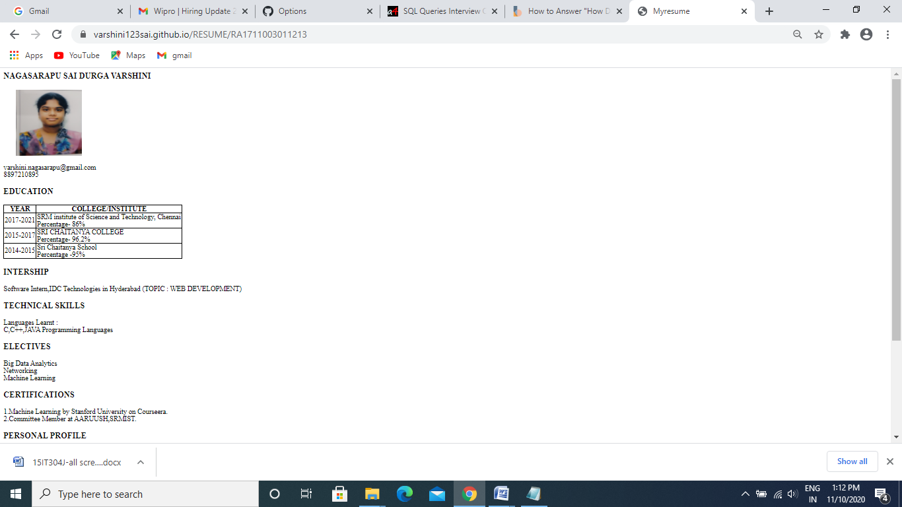

**Can refer github link :** **https://varshini123sai.github.io/RESUME/RA1711003011213**