**15IT304J-WEB PROGRAMMING**

**RA1711003011303-WEEK3 REPORT**

**PROJECT: Hostel Mess Management**

**Aim: To add semantic and multimedia tags to the home page.**

**Tags used:**

<script>

Semantic tags:

* <aside>
* <details>
* <figure>
* <footer>
* <header>
* <main>
* <mark>
* <nav>
* <section>

Multimedia Tags:

* <vedio>

**Code:**

<div class="footer" align="center">

  <footer>

  <h2>Connect To Us</h2>

  <!-- Add font awesome icons -->

  <a href="#" class="fa fa-facebook"></a>

  <a href="#" class="fa fa-twitter"></a>

  <a href="#" class="fa fa-google"></a>

  <a href="#" class="fa fa-instagram"></a>

  </div>

<section align="center">

  <h2>TAKE A TOUR!!</h2>

  <video width="900" height="350" controls autoplay>

  <source src="SRM UNIVERSITY,CHENNAI Mess Menu FOR 1ST YEAR B.TECH STUDENTS !!!!!.mp4" type="video/mp4">

  Your browser does not support the video tag.

  </video>

  </section>

<script>

        var slideIndex = 0;

        showSlides();

        function showSlides() {

          var i;

          var slides = document.getElementsByClassName("mySlides");

          var dots = document.getElementsByClassName("dot");

          for (i = 0; i < slides.length; i++) {

            slides[i].style.display = "none";

          }

          slideIndex++;

          if (slideIndex > slides.length) {slideIndex = 1}

          for (i = 0; i < dots.length; i++) {

            dots[i].className = dots[i].className.replace(" active", "");

          }

          slides[slideIndex-1].style.display = "block";

          dots[slideIndex-1].className += " active";

          setTimeout(showSlides, 2000); // Change image every 2 seconds

        }

        </script>

<aside>

      <div style="float:right;">

          <table>

            <tr>

         <b>   <ul align="left">

             CAMPUSES<br>

              <hr>

              <li align="left">NCR<BR>

              <li align="left">VADAPALANI<BR>

              <li align="left">RAMAPURAM<BR>

              <li>KATTANKULATHUR

            </ul></b>

            </tr>

          </table>

      </div>

          </aside>

**Ouput:**

**aside tag:**

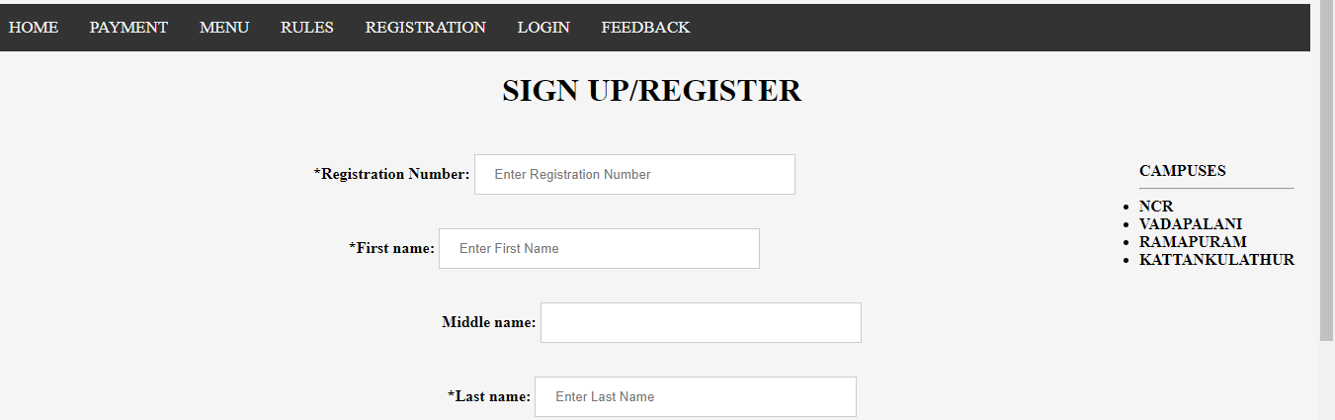

**script tag:**



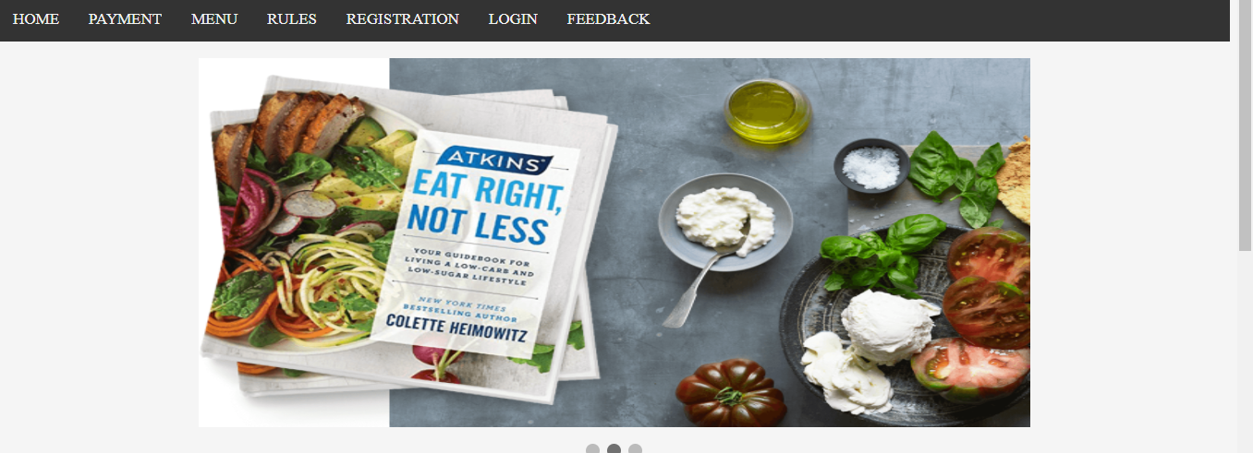

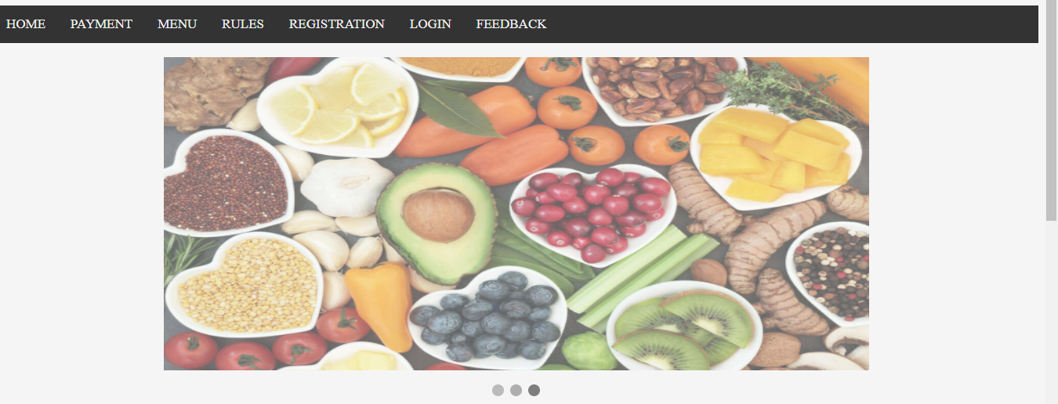

**Vedio tag:**

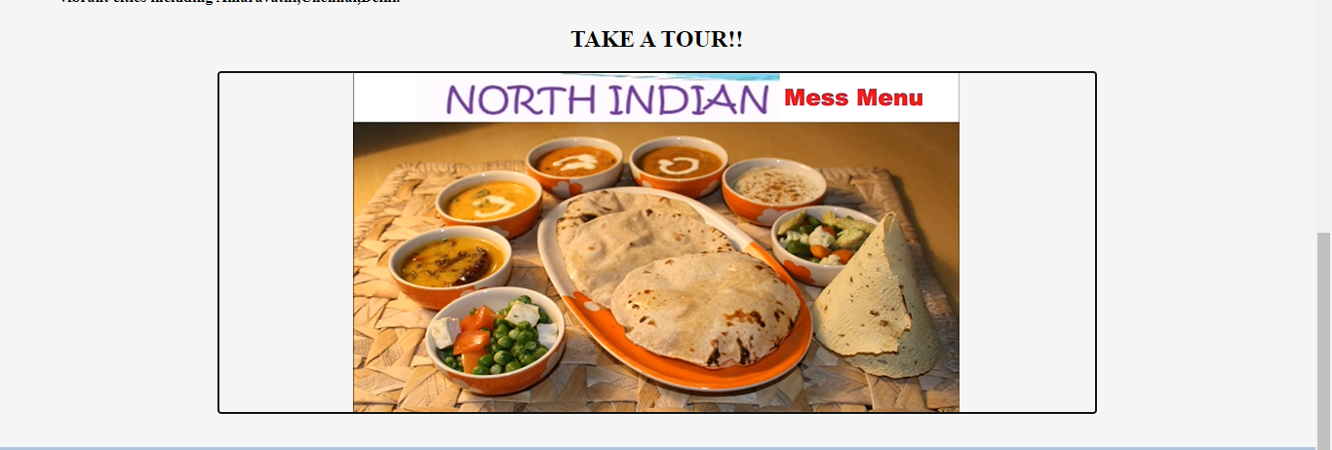

**Footer tag:**

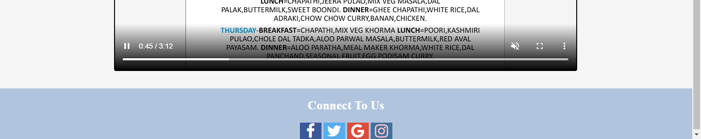

**Result: The experiment was successfully completed.**