**15IT304J-WEB PROGRAMMING**

**RA1711003011303-WEEK6 REPORT**

**PROJECT: Hostel Mess Management**

**Aim: To create a simple jsp program that displays current date and time in the system.**

**Code:**

<%@ page import=*"java.io.*,java.util.*,javax.servlet.*"*%>

<!DOCTYPE html>

<html>

<head>

<meta charset=*"ISO-8859-1"*>

<title>Display Current Date and Time</title>

</head>

<body>

<h1>Display current date and time:</h1>

<%

Date date=**new** Date();

out.print(date.toString());

%>

</body>

</html>

**Output:**

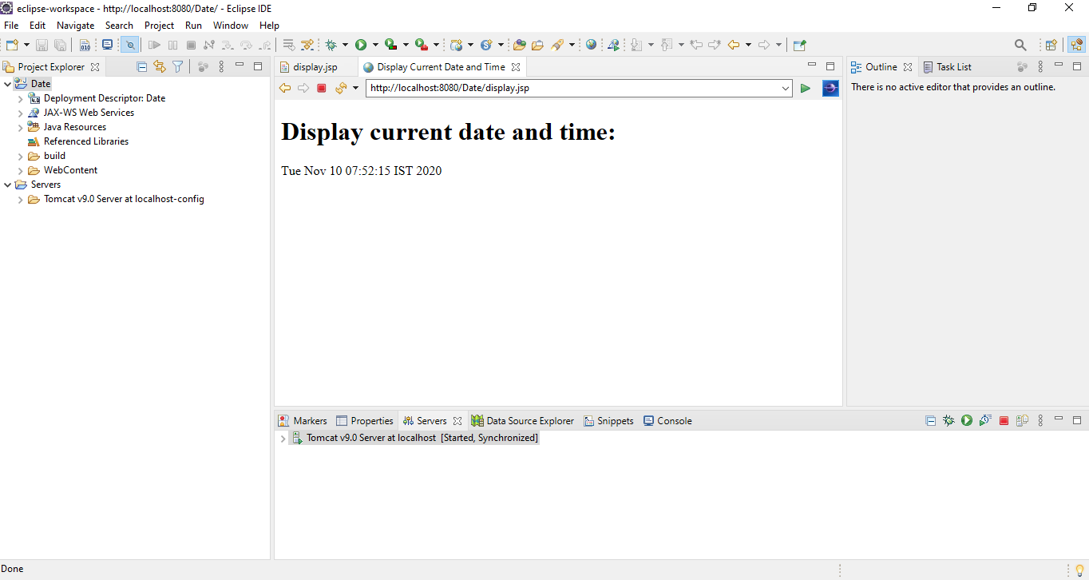

**Result: The experiment was successfully completed.**