**15IT304J-WEB PROGRAMMING**

**RA1711003011303-WEEK7 REPORT**

**PROJECT: Hostel Mess Management**

**Aim: To create a simple xml program that displays student record linking it with Css stylesheet.**

**Code:**

**Xml Code:**

<?xml version="1.0" encoding="UTF-8"?>

<?xml-stylesheet type="text/css" href="h.css"?>

<record>

    <heading>STUDENTS RECORD</heading>

    <student>

        <Regno>Registration Number : RA1711003011303</Regno>

        <Name>Name : Harika Kakumani</Name>

        <sid>Student ID : 1000A</sid>

        <dept>Department : CSE </dept>

        <branch>Branch : KTR </branch>

    </student>

    <student>

        <Regno>Registration Number : RA1711003011213</Regno>

          <Name>Name : Varshini</Name>

        <sid>Student ID : 1000B</sid>

        <dept>Department : CSE </dept>

        <branch>Branch : KTR </branch>

    </student>

    <student>

        <Regno>Registration Number : RA1711003091812</Regno>

        <Name>Name : Rahul</Name>

        <sid>Student ID : 1000C</sid>

        <dept>Department : CSE </dept>

        <branch>Branch : MODI </branch>

    </student>

    <student>

        <Regno>Registration Number : RA1711003015091</Regno>

        <Name>Name : Sreeja</Name>

        <sid>Student ID : 1000D</sid>

        <dept>Department : EEE </dept>

        <branch>Branch : RMP </branch>

    </student>

     <student>

        <Regno>Registration Number : RA1711003016134</Regno>

         <Name>Name : Harshitha</Name>

        <sid>Student ID : 1000E</sid>

        <dept>Department : MECH </dept>

        <branch>Branch : MODI </branch>

    </student>

</record>

**Css Code:**

body{

    text-align: center;

}

record {

    color:black;

    background-color:greenyellow;

    width: 100%;

}

heading {

    color:green;

    font-size : 40px;

    background-color:lightskyblue;

}

heading, Name, Regno, sid, dept, branch{

    display : block;

}

Regno {

    font-size : 25px;

    font-weight : bold;

}

**Output:**

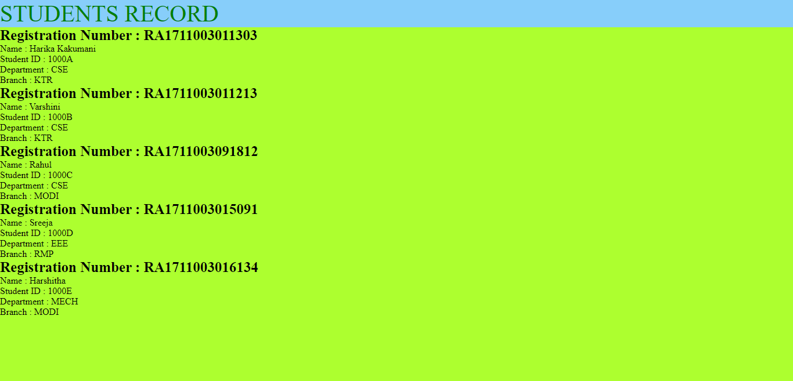

**Result: The experiment was successfully completed.**