**15IT304J-WEB PROGRAMMING**

**RA1711003011303-WEEK8 REPORT**

**PROJECT: Hostel Mess Management**

**Aim: To create a simple ajax program that displays student details linking it with Xml file.**

**Code:**

<!DOCTYPE html>

<html>

<style>

table,th,td {

  border : 1px solid black;

  border-collapse: collapse;

}

th,td {

  padding: 5px;

}

</style>

<body>

<button type="button" onclick="loadDoc()">Get my student record</button>

<br><br>

<table id="demo"></table>

<script>

function loadDoc() {

  var xhttp = new XMLHttpRequest();

  xhttp.onreadystatechange = function() {

    if (xhttp.readyState == 4 && xhttp.status == 200) {

      myFunction(xhttp);

    }

  };

  xhttp.open("GET", "x.xml", true);

  xhttp.send();

}

function myFunction(xml) {

  var i;

  var xmlDoc = xml.responseXML;

  var table="<tr><th>Registration number</th><th>Name</th></tr>";

  var x = xmlDoc.getElementsByTagName("student");

  for (i = 0; i <x.length; i++) {

    table += "<tr><td>" +

    x[i].getElementsByTagName("Regno")[0].childNodes[0].nodeValue +

    "</td><td>" +

    x[i].getElementsByTagName("Name")[0].childNodes[0].nodeValue +

    "</td></tr>";

  }

  document.getElementById("demo").innerHTML = table;

}

</script>

</body>

</html>

**Output:**

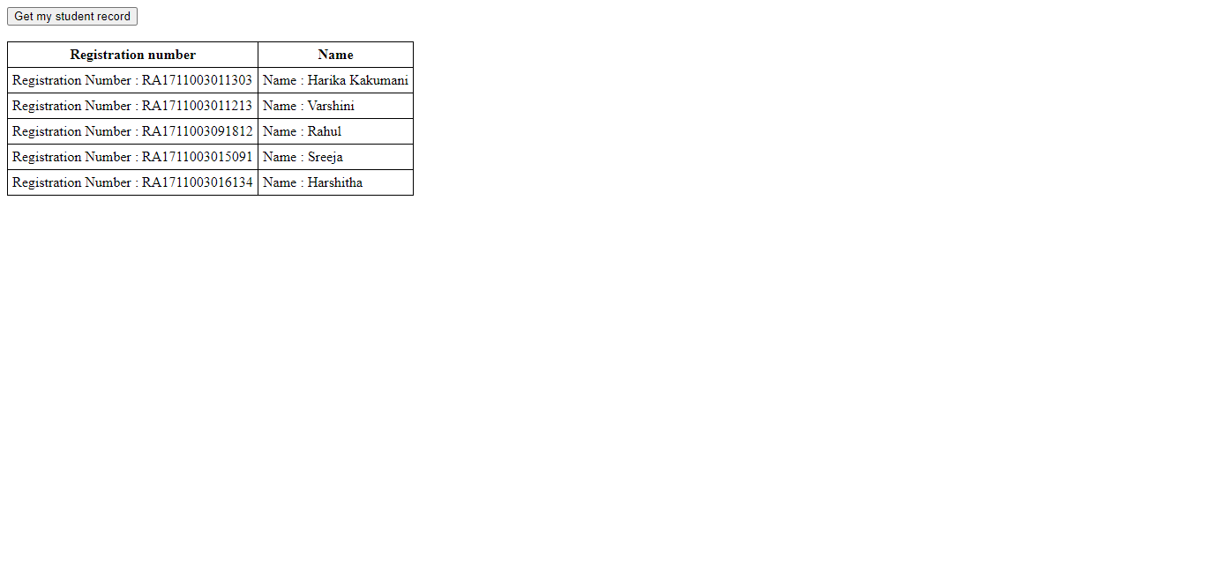

**Result: The experiment was successfully completed.**