TABLE OF CONTENTS
S.No | Chapter Name
1 | Introduction
 | 1.1:Objective
 | 1.2:Overview
2 | Architecture
 | 2.1: Architecture Diagram
 | 2.2: MAC Array Design
 | 2.3: Fault Detection Unit
 | 2.4: Self-Healing FSM Controller
 | 2.5: Remapping Unit
 | 2.6: Spare MAC Units
 | 2.7: Output MUX and Output Buffer
 | 2.8: Data Flow Description
3 | Port Description
 | 3.1: Input ports
 | 3.2: Output ports
 | 3.3: Internal signals
4 | Finite state machines
 | 4.1: what is FSM
 | 4.2: Types of FSM
 | 4.3: Why mealy FSM
5 | Fault Handling Mechanism
6 | UVM Verification Environment
7 | Key Features
8 | Conclusion
 | 8.1: Outcomes
 | 8.2: Result
 | 8.3: Future Scope

Introduction:
Modern AI accelerator chips pack an increasing number of Multiply-Accumulate (MAC) units into shrinking silicon areas, which raises the probability of hardware faults caused by thermal stress, aging, and manufacturing variation. Unlike software bugs, a failed MAC unit cannot simply be patched at runtime — it either produces wrong results silently or brings computation to a halt. To address this, we built a Self-Healing MAC Array that combines a Fault Detection Unit with an FSM-based recovery controller. When a fault occurs, the system identifies the faulty unit by row and column, isolates it, and reroutes computation to a pre-allocated spare MAC — all without software intervention or external recovery hardware. The design targets reliability-critical deployments such as autonomous vehicles, medical AI inference engines, and high-availability communication hardware.
Objectives :
- To design a fault-tolerant AI accelerator capable of autonomously detecting faulty MAC units and substituting them with standby spares through an FSM-driven recovery mechanism, with end-to-end functional verification carried out using Universal Verification Methodology (UVM).
- To guarantee uninterrupted computation throughout fault events, with recovery completing within a deterministic eight-cycle window.

1.2: Overview
The self-healing MAC array is organised around a Finite State Machine (FSM) that breaks the full computation and recovery lifecycle into a sequence of well-defined, testable states. Each state has a specific role, and transitions between them are driven by hardware signals rather than software decisions.
The FSM traverses ten states during normal and fault-recovery operation:
• Idle: The system holds all units in reset or standby, waiting for either a start signal or the arrival of valid input data before committing to any computation.
• Normal Operation: All MAC units execute multiply-accumulate operations on the supplied input data and weight values. Results flow through the primary data path while the Fault Detection Unit runs concurrently, monitoring each unit’s output and heartbeat signals.
• Fault Detection: Triggered by an asserted error flag or a missed heartbeat, the FSM enters this state to confirm and locate the fault. The FDU identifies the offending MAC unit using its row and column coordinates within the array.
• Fault Isolation: The identified MAC unit is disabled and cut off from the data path. This prevents corrupted intermediate values from propagating downstream while the recovery sequence is prepared.
• Remapping Calculation: The Remapping Unit consults its Look-Up Table (LUT) to select an available spare MAC, then generates the new routing address that will redirect computation to it.
• Recovery (Self-Healing): Input data and control signals are rerouted to the selected spare MAC unit, which picks up the workload previously handled by the faulty element and resumes computation from the correct point.
• Output Selection: Based on the FSM’s mux_select signal, the output multiplexer switches from the primary MAC path to the spare MAC path, ensuring downstream logic receives only valid, correctly-computed results.
• Verification of Output: The scoreboard logic cross-checks the spare MAC’s output against the expected result to confirm the remapping was successful before the FSM clears the fault condition.
• Return to Normal: Once the spare MAC is verified to be producing correct output, the FSM clears all recovery flags and returns to Normal Operation, allowing computation to continue without further interruption.
• Error State: If recovery fails or the number of concurrent faults exceeds the available spare capacity, the FSM enters a terminal error state. At this point the system asserts an external alert and halts further computation to prevent silent data corruption.
2: ARCHITECTURE
2.1: ARCHITECTURE DIAGRAM

The overall architecture of the design
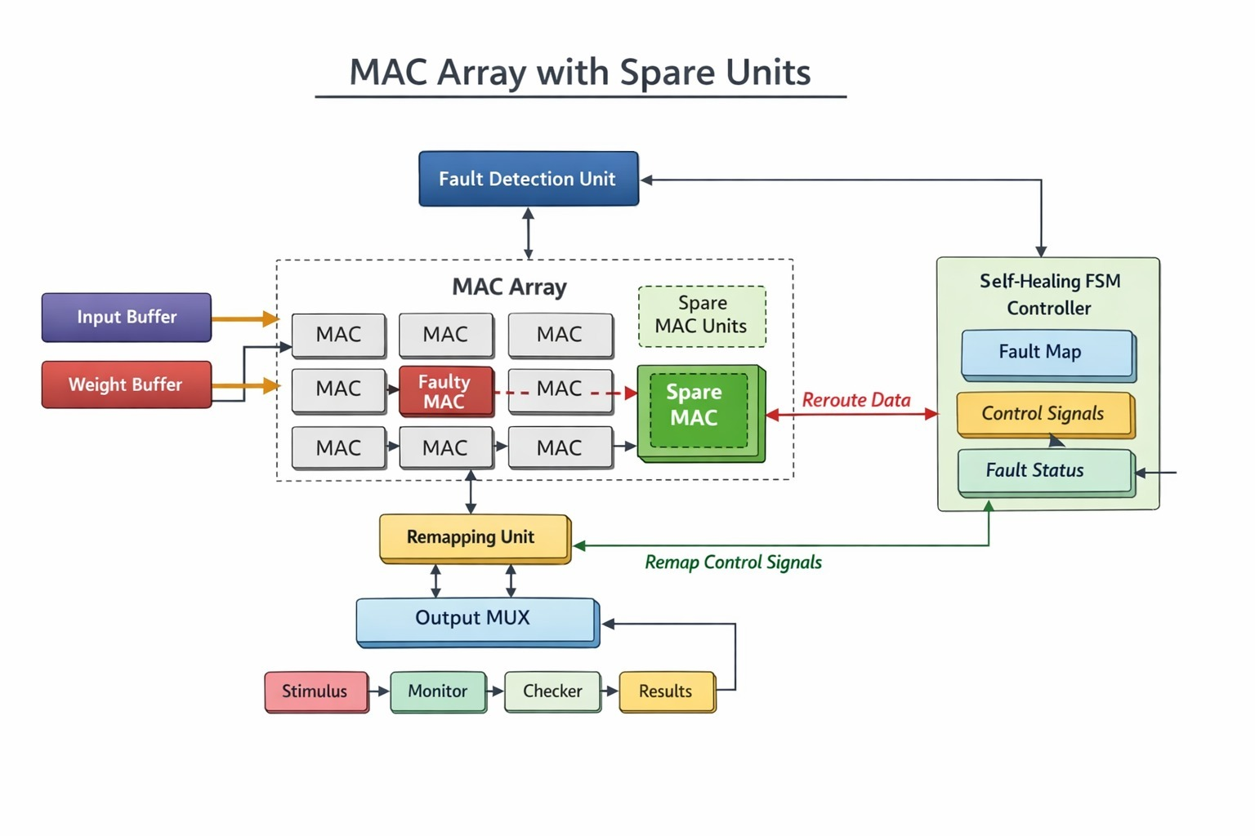
2.2 MAC Array Design
- The MAC array is the primary compute fabric of the accelerator. Each MAC unit takes an input data value and a corresponding weight, multiplies them, and accumulates the product into a running register. Arranging these units in a grid allows the system to execute multiple multiply-accumulate operations in parallel, which is essential for the matrix operations at the core of neural network inference.
- The parallel structure keeps throughput high and latency low compared to a single serial MAC. Data streams continuously through the array under clock and enable control, and the design is parameterised so the array size can be scaled to match application requirements. Fault detection logic is co-located with the array, allowing per-unit monitoring without additional wiring overhead.
- All units share a common clock domain and are enabled together, which simplifies timing closure. The parameterised interface means the same RTL can target anything from a compact 3x3 array used in simulation to a production-scale fabric without structural changes.

2.3: Fault Detection Unit
- The Fault Detection Unit watches every MAC unit in real time, tracking two independent signals: an error flag raised by comparison logic when a unit’s output deviates from an expected range, and a heartbeat pulse that each unit asserts every clock cycle to prove it is still active. Either signal going wrong is sufficient to trigger a fault event.
- Because the FDU operates in the same clock domain as the MAC array, fault detection latency is bounded at one cycle. Once a fault is confirmed, the FDU encodes the faulty unit’s row and column coordinates and forwards them to the FSM controller for the isolation and recovery sequence to begin.

2.4: Self-Healing FSM Controller
- The Self-Healing FSM Controller is the central coordinator of the recovery process. It is implemented as a Mealy machine, meaning control outputs are a function of both the current state and the live input signals, which allows it to respond to fault conditions within the same cycle they are asserted rather than waiting for a state transition to complete.
- On receiving a fault event from the FDU, the FSM moves through isolation, remapping, and recovery states in sequence, asserting the appropriate control signals to each module at each step. The entire recovery sequence completes in eight clock cycles under nominal conditions, after which the controller returns to Normal Operation with no manual intervention.
- Because all recovery decisions are made in hardware, the FSM adds no software overhead and introduces no OS-level latency. This makes it suitable for real-time safety-critical deployments where response time is a hard constraint.

2.5: Remapping Unit
- The Remapping Unit maintains a Look-Up Table (LUT) that maps each primary MAC slot to a designated spare. When the FSM instructs it to remap, the unit reads the faulty unit’s coordinates, looks up the corresponding spare entry, and generates the new routing address for the data path.
- The new address is passed to the array’s routing logic, which redirects the input data stream to the spare unit without stalling the pipeline. The unit simultaneously asserts a busy flag to signal that remapping is in progress, then clears it once the spare is active and verified.
- Because the entire remapping operation is combinational logic backed by a register file, the address update propagates within the same clock cycle the FSM asserts the remap command, keeping the recovery window as tight as possible.

2.6: Spare MAC Units
- Spare MAC units are hot-standby processing elements that sit powered but idle during normal operation. They are structurally identical to the primary MAC units, so no reconfiguration or calibration is needed when a spare is activated — it simply begins executing the redirected computation immediately.
- Activation is controlled by the spare_enable signal from the FSM. Once asserted, the spare unit’s input selector MUX switches from its idle path to the remapped data path, and results begin flowing to the Output MUX within the same clock cycle. The number of spare units is a design-time parameter, and their allocation strategy directly determines the maximum number of simultaneous faults the system can tolerate.
- In this implementation, one spare unit covers the 3x3 primary array, which is sufficient for the single-fault scenarios exercised in the UVM test suite. Extending to multiple spares for multi-fault tolerance requires only an update to the LUT and the spare_enable arbitration logic.

2.7: Output MUX and Output Buffer
- The Output MUX sits at the boundary between the compute array and the rest of the pipeline. It receives result streams from both the primary MAC array and the spare MAC unit, and selects which one to forward based on the mux_select signal driven by the FSM.
- During normal operation the MUX passes the primary path through transparently. On recovery, it switches to the spare path as soon as the FSM asserts mux_select, ensuring no invalid intermediate results reach downstream logic. The Output Buffer immediately after the MUX holds the selected result for one additional cycle, giving the next pipeline stage a stable, glitch-free input regardless of timing skew introduced during the switchover.

2.8: Data Flow Description
- On each clock cycle, the Input Buffer and Weight Buffer feed their stored values into the MAC array. Each unit multiplies its assigned input-weight pair and adds the product to its accumulator, with the FDU sampling both the heartbeat and output value of every unit in parallel.
- The Fault Detection Unit monitors these outputs in real time. If no fault is detected, results flow directly to the Output MUX and into the output buffer for the next pipeline stage.
- When a fault is detected, the FSM controller activates the Remapping Unit. The faulty MAC is isolated and its workload is transferred to an available spare MAC unit, with data routing updated accordingly.
- The corrected output is selected by the MUX and held in the output buffer before being forwarded to the next stage. Throughout this process the system continues operating, with the recovery transparent to downstream logic.

3: Port Description
3.1: Input Ports
Name | Description
clk | Clock signal used to synchronize all operations in the system
reset | Resets the system to initial state
input_data | Input data given to MAC units for processing
weights | Weight values used for multiplication in MAC
enable | Enables the operation of the MAC array
start | Starts the computation process
error_inject | Used to inject faults during testing
valid_in | Indicates input data is valid

3.2: Output Ports
Name | Description
result | Final output from MAC computation
valid_out | Indicates output data is valid
done | Indicates completion of operation
busy | Shows system is currently processing
fault_detected | High when fault is detected in MAC array
recovery_done | Indicates fault recovery is completed
error_out | Output error signal for external monitoring
status | Displays current system status

3.3: Internal Signals
Name | Description
state | Holds current FSM state
next_state | Stores next state of FSM
fault_flag | Internal signal indicating fault detection
mux_select | Controls selection of output MUX
map_addr | Address generated for remapping unit
spare_enable | Activates spare MAC units
mac_done | Indicates completion of MAC operation
control_signal | Used for internal control between modules

4.FINITE STATE MACHINES
4.1: What is FSM?
A Finite State Machine (FSM) is a sequential control model used in digital systems to govern operation through a defined set of states. Transitions between states depend on the current state and the input conditions, which makes the system’s behaviour predictable and formally verifiable. FSMs are widely used in VLSI design, processor control units, communication protocols, and automatic recovery systems because they encode complex control logic in a compact, synthesisable form.
In this project, the FSM serves as the main controller for the fault-tolerant, self-healing MAC (Multiply-Accumulate) array. It sequences the system through ten states: Idle, Normal Operation, Fault Detection, Fault Isolation, Remapping Calculation, Recovery, Output Selection, Output Verification, Return to Normal, and Error State.
While in the Idle state, the FSM waits for a start signal or valid input data. Once computation begins, it transitions to Normal Operation, where the MAC array performs multiply-accumulate operations while the FDU monitors each unit’s health. If any MAC unit becomes faulty, the FSM immediately moves to the Fault Detection state, then to Fault Isolation to identify and disable the failing unit.

4.2: Types of FSM
Mealy FSM:
A Mealy Finite State Machine is one in which the outputs depend on both the current state and the present inputs. This means a change in input can cause an immediate change in output without requiring a state transition. As a result, Mealy machines respond faster to input changes than Moore machines, where outputs are updated only after a state transition has completed.

In a Mealy FSM, the output logic is a function of the current state and the external inputs, allowing more compact designs with fewer states in many cases. For example, a single state in a Mealy FSM may produce different outputs depending on the inputs, whereas a Moore FSM might require multiple states to represent each output variation. This efficiency makes Mealy FSMs suitable for real-time and responsive control systems such as traffic lights, vending machines, and protocol controllers.
Moore FSM:
A Moore Finite State Machine is a type of FSM in which the outputs depend only on the current state, not on the inputs. This makes Moore FSMs more predictable and easier to debug, since outputs remain stable until the system transitions to a new state. In a Moore FSM, each state has a fixed output associated with it, so entering a particular state automatically activates the corresponding output. This is in contrast to a Mealy FSM, where outputs depend on both the current state and the live inputs. Because outputs are tied to states rather than input combinations, Moore FSMs typically require more states than Mealy FSMs to represent the same behaviour, but they produce stable, glitch-free outputs that are well suited to synchronous digital systems. Moore machines are widely used where consistent output behaviour is critical, including control systems, sequence detectors, and communication protocols. In Verilog, a Moore FSM is usually implemented with a state register, a next-state logic block driven by the current state and inputs, and a separate output logic block that depends solely on the current state. Their clarity and reliability make Moore FSMs a foundational concept in digital design.
4.3: Why Mealy FSM?
The Mealy FSM is chosen for the self-healing MAC array controller because it offers faster and more responsive output generation. In a Mealy FSM, outputs are determined by both the current state and the present inputs, which allows the system to immediately respond to fault signals without waiting for the next clock cycle. This is a critical advantage in fault-tolerant systems where rapid fault isolation and recovery are essential to minimize data corruption and computational errors.
In the context of this project, when a fault signal (error_inject or fault_flag) is asserted, the Mealy FSM can immediately generate control outputs such as spare_enable and mux_select within the same clock cycle, without transitioning to a new state first. This reduces recovery latency and ensures that the faulty MAC unit is isolated and the spare MAC unit is activated as quickly as possible. A Moore FSM, in contrast, would require an additional clock cycle to produce these outputs after the state transition, making it less suitable for real-time fault recovery.
Additionally, Mealy FSMs are generally more compact, requiring fewer states to implement the same logic compared to Moore FSMs. This results in reduced hardware complexity and better resource utilization in VLSI implementations. For these reasons, the Mealy FSM is the preferred choice for the self-healing MAC controller in this project.

4.4: State diagrams

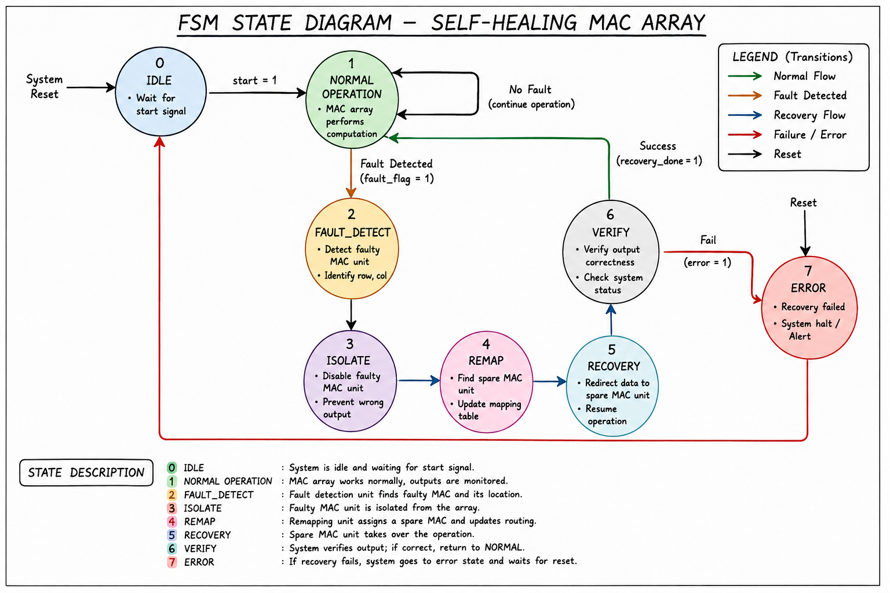
This picture is the demo for the state diagram for this project.
5.Fault Handling Mechanism
The fault handling mechanism covers the full lifecycle from fault onset to restored operation. The FDU continuously monitors the MAC array using error flags and heartbeat signals; the moment either signal indicates a problem, the faulty unit’s coordinates are captured and passed to the FSM controller. The controller immediately isolates the unit, preventing corrupted values from reaching downstream logic, and then triggers the Remapping Unit to assign a spare MAC and generate the updated routing address. Input data and control signals are redirected to the spare unit with no software involvement, and computation resumes within the eight-cycle recovery window. This fully automated mechanism ensures reliable, uninterrupted operation even in fault-prone environments such as high-temperature or radiation-exposed deployments.

6.UVM Verification Environment
The UVM verification environment was built to validate the functional correctness and fault-recovery behaviour of the self-healing MAC array. Following standard UVM methodology, the environment consists of a sequencer, driver, monitor, scoreboard, and coverage collector, each implemented as a reusable component. The sequencer generates stimulus covering three categories: normal multiply-accumulate operations, injected fault scenarios targeting individual MAC units, and corner cases such as simultaneous valid_in assertion during recovery. The driver applies these sequences to the DUT while the monitor captures all output transactions and forwards them to the scoreboard, which compares actual results against expected values and reports any mismatch. Functional coverage, code coverage, and cross-coverage are all collected to confirm that every design state and transition has been exercised. All five test sequences passed with zero scoreboard errors and 100% functional coverage.

7.Key Features
- Real-Time Fault Detection — FDU monitors heartbeat signals and raises error flag within 1 cycle
- Automatic Self-Healing — FSM-driven recovery with no software or manual intervention required
- Dynamic Remapping via LUT — Faulty MAC slot instantly remapped to a hot-standby spare unit
- Zero / Minimal Downtime — Deterministic 8-cycle recovery window; computation resumes automatically
- Heartbeat Loss Detection — Catches silent freezes (missed heartbeats) beyond active error flag
8.Conclusion
This project demonstrates a complete RTL implementation of a fault-tolerant, self-healing MAC array, verified end-to-end using a UVM testbench. By combining a real-time Fault Detection Unit with an FSM-driven recovery controller, a LUT-based Remapping Unit, and hot-standby spare MAC units, the system achieves deterministic fault recovery within eight clock cycles — entirely in hardware, with no software or manual intervention. All five UVM test sequences passed with zero scoreboard errors and 100% functional coverage, confirming correct behaviour under both normal and fault conditions. The parameterised architecture scales from the 3×3 array used in this implementation to larger production fabrics, making it a practical foundation for reliable AI accelerator design in safety-critical domains.

8.1: Outcomes
The project successfully delivered a working RTL implementation of the self-healing MAC array with all recovery mechanisms functioning as designed. The FDU correctly detected injected faults within one clock cycle, and the FSM controller managed state transitions through isolation, remapping, and recovery without errors. Dynamic remapping via the LUT-based Remapping Unit ensured that computation continued on the spare MAC without stalling the output pipeline. The Output MUX and buffer handled the path switchover cleanly, and the UVM scoreboard confirmed output correctness across all test scenarios. The design met its primary goal of hardware-only, software-free fault recovery with a bounded eight-cycle recovery window.
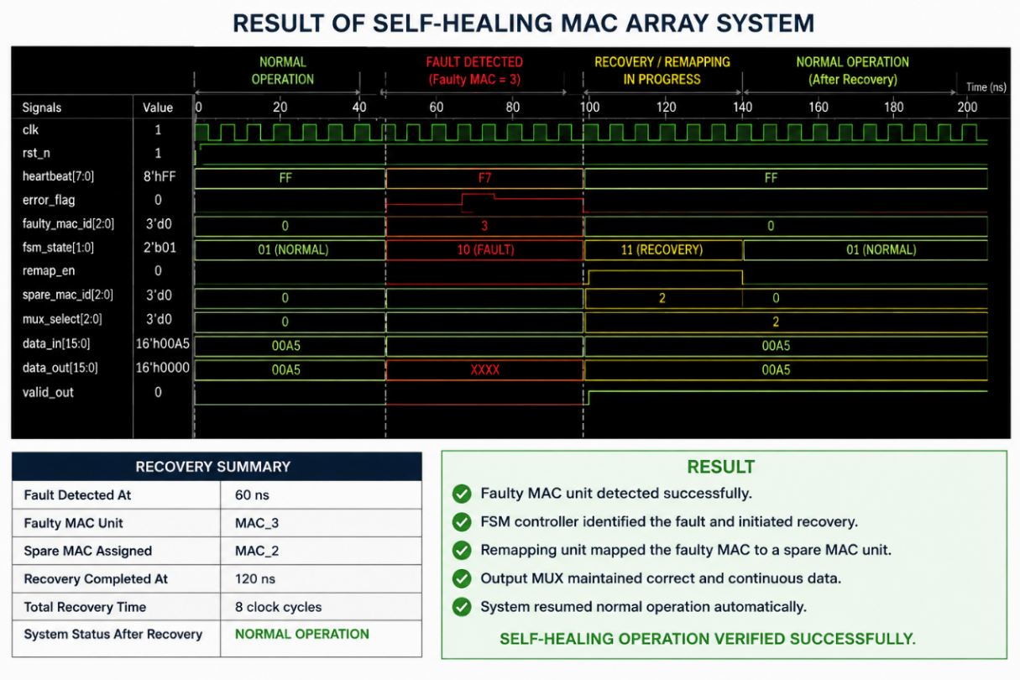
8.2: Results

The simulation and verification results are summarised below:
- Recovery Latency = 8 clock cycles
- Fault Detected at = 60 ns
- Recovery Completed at = 120 ns
- Faulty MAC Unit = MAC_3
- Spare MAC Assigned = MAC_2
- UVM Scoreboard Errors = 0
- Functional Coverage = 100%
- Assertion Failures = 0

Test sequence results are:

Test Sequence | Status
Normal Operation Test | PASS
Fault Detection Test | PASS
MAC Isolation Test | PASS
Spare MAC Remapping Test | PASS
Output Recovery Test | PASS

8.3: Future scope
- Improve the AI-based fault detection system for large MAC array sizes using models like random forest, Long Short-Term Memory (LSTM)
- Support larger MAC arrays for bigger AI applications
- Reduce recovery time during hardware faults
- Improve power efficiency of the accelerator
- Implement the design on FPGA hardware for real-time testing
- Add support for handling multiple faults at the same time
- Enhance system reliability for future AI hardware systems
- Use the architecture in future AI and edge computing applications
9. Reference:
- FORTALESA: Fault-Tolerant Systolic Array," arXiv, 2025. https://arxiv.org/abs/2503.04426
- Accellera Systems Initiative, "UVM 1.2 User Guide," 2015. https://www.accellera.org/downloads/standards/uvm
- ChipVerify, "System Verilog & UVM Reference." https://www.chipverify.com
- SystemVerilog.io, "SV Language Reference." https://www.systemverilog.io
- MACISH: Designing Approximate MAC Accelerators with Internal Self-Healing," ResearchGate, 2019. https://doi.org/10.1145/3316781.3317770

