SORTING MANIPULATOR

21AIE213 - Robotic Operating System and Robot Simulation

A PROJECT REPORT

***Submitted by***

BL.EN. U4AIE21126 Suryamritha M

BL.EN. U4AIE21128 TVNL Harshitha

BL.EN. U4AIE21139 Varshini Balaji

**BACHELOR OF TECHNOLOGY**

IN

COMPUTER SCIENCE AND ENGINEERING (Artificial Intelligence)



AMRITA SCHOOL OF COMPUTING, BANGALORE

AMRITA VISHWA VIDYAPEETHAM

BANGALORE 560 035

June – 2023

CONTENTS:

1. PROBLEM STATEMENT
   1. Problem Statemen
   2. Approach
2. IMPLEMENTATION
   1. Implementation
   2. Flow Chart
3. RESULT

**1.PROBLEM STATEMENT**

Design and implement a sorting robotic arm to sort the objects based on the color. The manipulator should be build from scratch. The input of the system can be locations of the objects and color based destination points. The system should be tested with minimum of three different colors. The type of sensors can be team’s choice but the reason to use the sensor should be clear in the report and the presentation.

**Approach used:**

We are building a 4-DOF manipulator/arm for sorting the objects based on color. Source or initial point and the destination points are given as input. In our project we are considering robotic manipulator as robotic arm. So, we modified cougerbot with modification in torso and wrist parts along with the tip. We are using Inverse Kinematics, in order for the robot’s end effector to move to a particular goal point.

**Spatial manipulator:**

A manipulator is called a spatial manipulator if at least one of the links of the mechanism possesses a general spatial motion

**2.IMPLEMENTATION**

1. Create a package named ‘cougerbot’ in src of ros workspace.
2. Create config, launch and urdf folders inside the package.
3. Create and edit controller, launch and urdf files in respective folders.

* Urdf file is to create links and joints and properties of the links and joints.
* In controllers.yaml file, we specify all the joints of the manipulator

1. Create nodes to spawn the bot and the other node(first_node.py) to assign the co-ordinates to the manipulator .
2. Create python files to give all the co-ordinates of numbers and to spawn the bot.
3. We create a launch file to launch these 2 nodes at atime. One node is gazebo empty world and the spawn_node which spawns the manipulator.
4. Now run launch file and co-ordinates node to run in gazebo. (Follow the below commands)
5. ros2 launch cougerbot cougerbot_launch.xml
6. ros2 run cougerbot cougerbot_node

**FLOW CHART:**

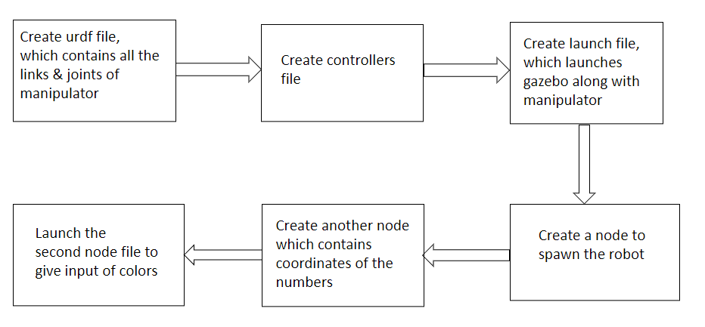

**3.RESULT**

We are placing 3 objects:

1. Sphere with green color
2. Cube with Red color
3. Cylinder with Blue color

In RVIZ:

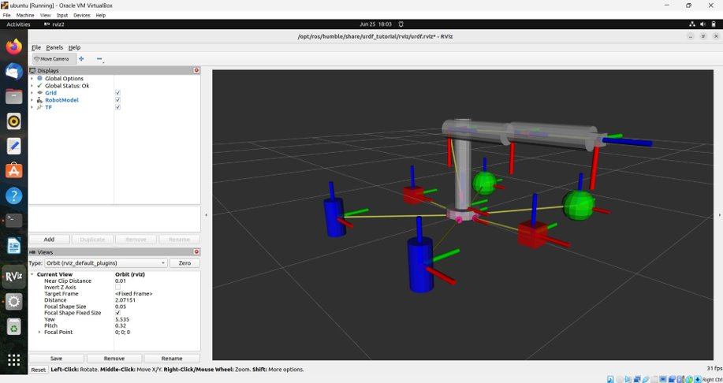

Test Case-1:

Moving cube object

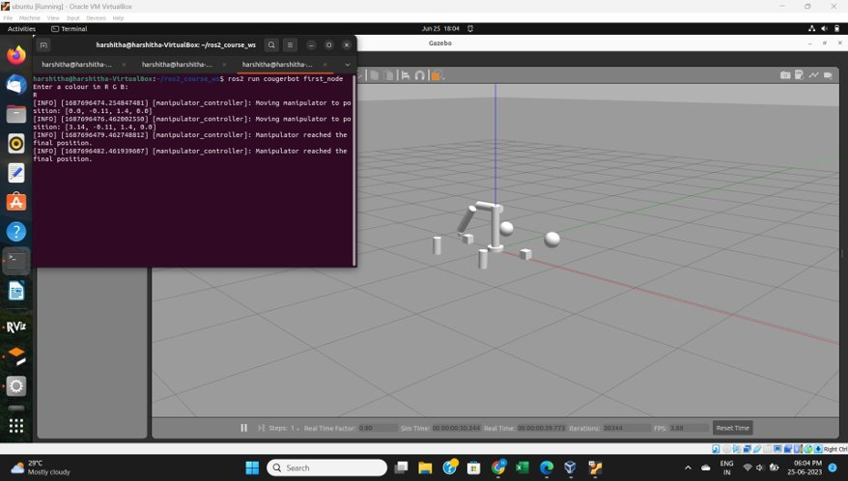

Test case-II:

Moving circle object

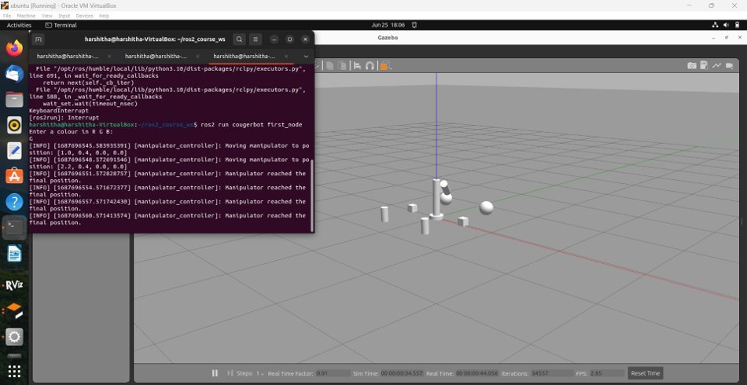

Test case-III:

Moving Cylinder object

