SOCIETE GENERAL DATA ANALYSIS AND VISUALIZATION PROCESS

PORTFOLIO_ID:

* Under financial services portfolio **defined** as, a grouping of financial assets such as stocks, bonds and cash equivalents, as well as their funds counterparts, including mutual, exchange-traded and closed funds. Portfolios are held directly by investors and/or managed by financial professionals.
* **No** missing data.
* All data are **unique**.
* Total data : **9366.**

DESK_ID:

* Desk_id is an id given to the **finance manager** who handles the respective portfolio.
* **Presence** of missing data.
* **Presence** of repeated data.
* Total missing data : **3665**.
* Total data present : **5701**.
* Filled missing data with ‘**no_desk_id**’.
* Number of times data repeated: 10,9,8,7,6,5,4,3,2.
* **Maximum Repeated data** : [TOP 3]

|  |  |
| --- | --- |
| DESK_ID | NO OF TIMES REPEATED |
| DSK00005869  DSK00006011  DSK00005951  DSK00005895  DSK00005724  DSK00005718  DSK00005754  DSK00006030  DSK00005905  DSK00005789  DSK00005727 | 10  10  9  9  9  9  9  8  8  8  8 |

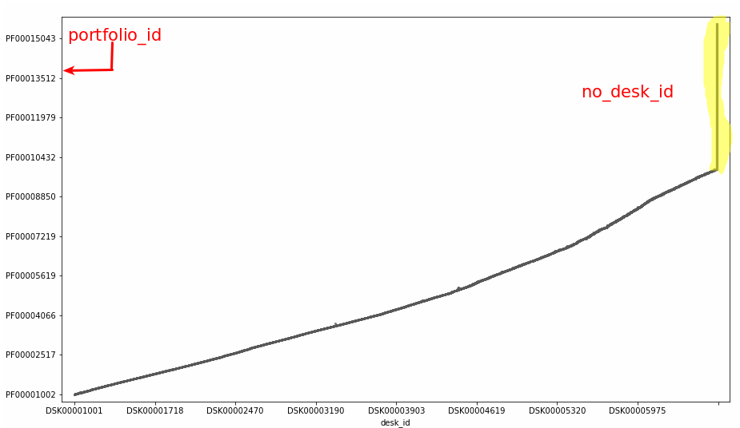

OFFICE_ID:

* Office_id is an id which denotes the **location of the office**. [where the office is located]
* **No** missing data
* **Presence** of repeated data.
* Only **two office id** : OFF00001001, OFF00001002.
* Mostly OFF00001001 **covers overall** deskID.
* Most of the **desk ID** which lies on **both** the office ID.
* Only the desk_ID from **DSK00001500 – DSK00002500[Approx]** which lies only on OFF00001001.
* **Empty desk Id** also lies on both the office ID.

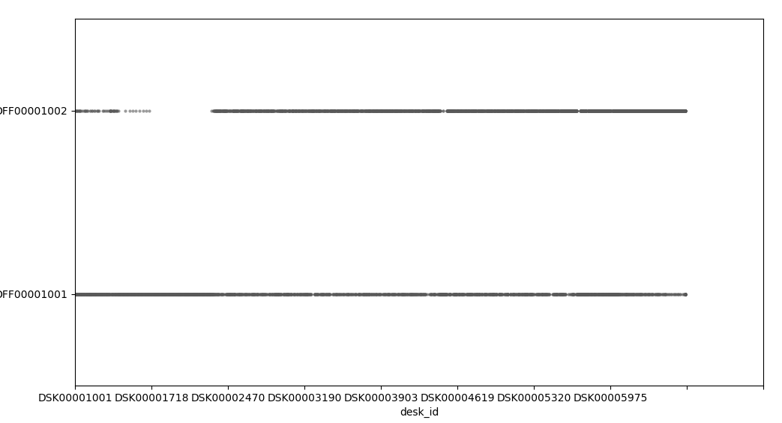

PF_CATEGORY:

* PF_category which denotes, on which type of financial service does the portfolio ID related to.
* Total pf_category : 5 🡪 A,B,C,D,E.

**Pf_category and Office_id:**

* Office_id 1 🡪 A,D,E
* Office_id2 🡪 B,C
* B 🡪 PF00009568 🡪 DSK00006395
* E 🡪 PF00005076 🡪 DSK00004479
* E 🡪 PF00005075 🡪 DSK00004478

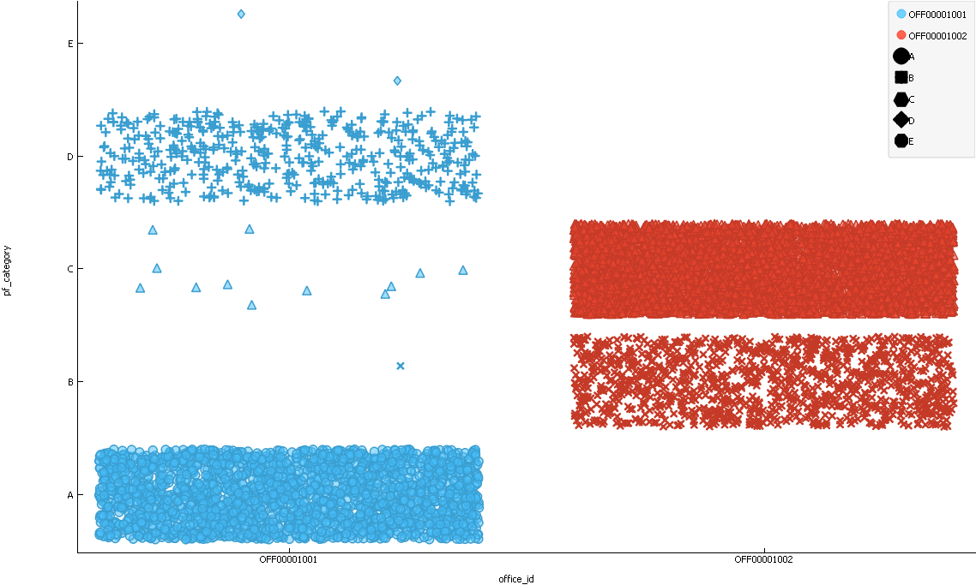

**Pf_category and Sold:**

* B 🡪 PF00013397 🡪 No Desk ID 🡪 OFF00001002 🡪 N 🡪 GBP 🡪ER(-) 🡪LR(+)

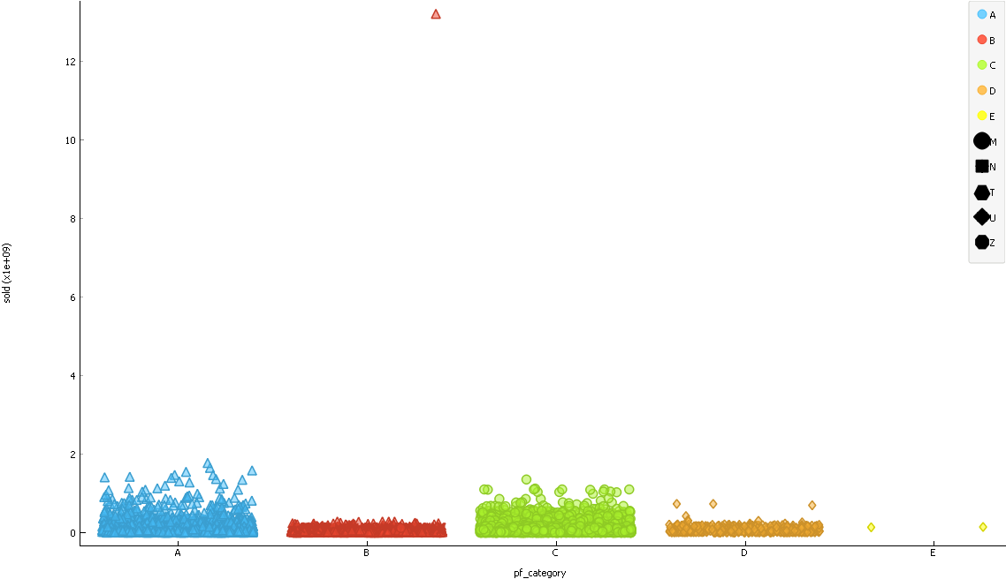

PF_CATEGORY AND COUNTRY_CODE:

* M 🡪 A,B,C
* N 🡪 A,B
* T 🡪 A,B
* U 🡪 B
* Z 🡪 A,B,D,E
* More than one country which comes under a single country code.

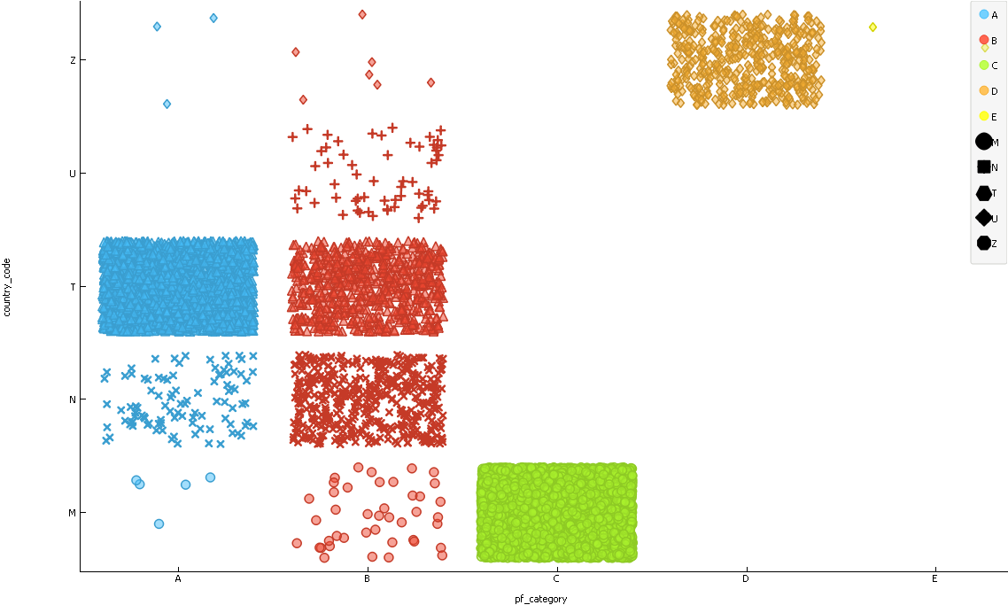

PF_CATEGORY AND EURIBOR RATE:

* Euribor_rate for the Pf_category D,E is low.

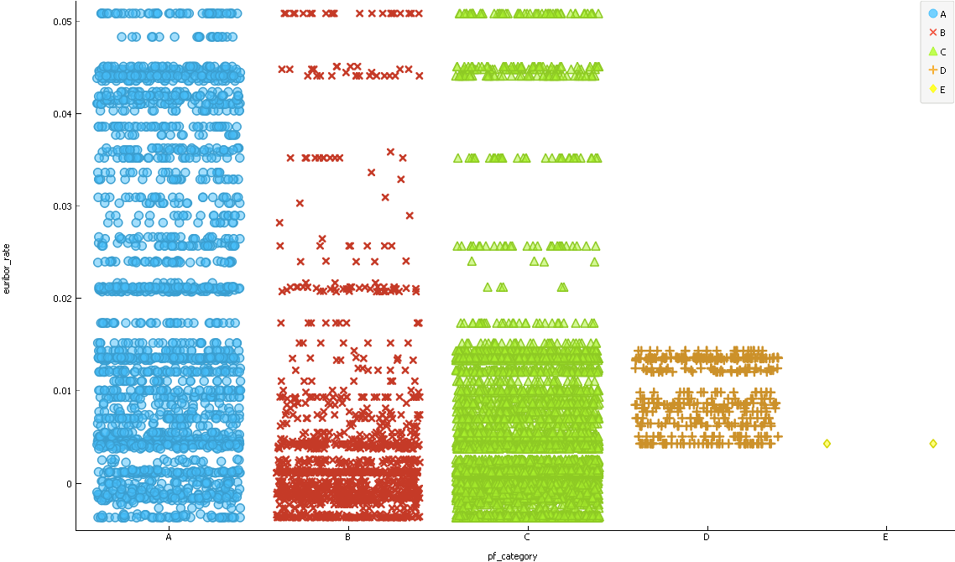

PF_CATEGORY WITH CURRENCY:

A 🡪 No JPY

B 🡪 All Currency

C 🡪 CHF

D 🡪 EUR

E 🡪 EUR

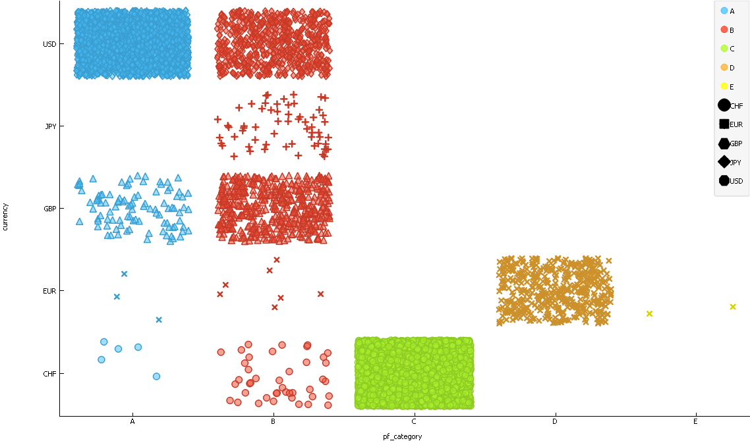

PF_CATEGORY WITH LIBOR_RATE

A,B,C has Libor_rate

D,E 🡪 empty [EUR]

EUR in A,B,C are not empty and with positive values.

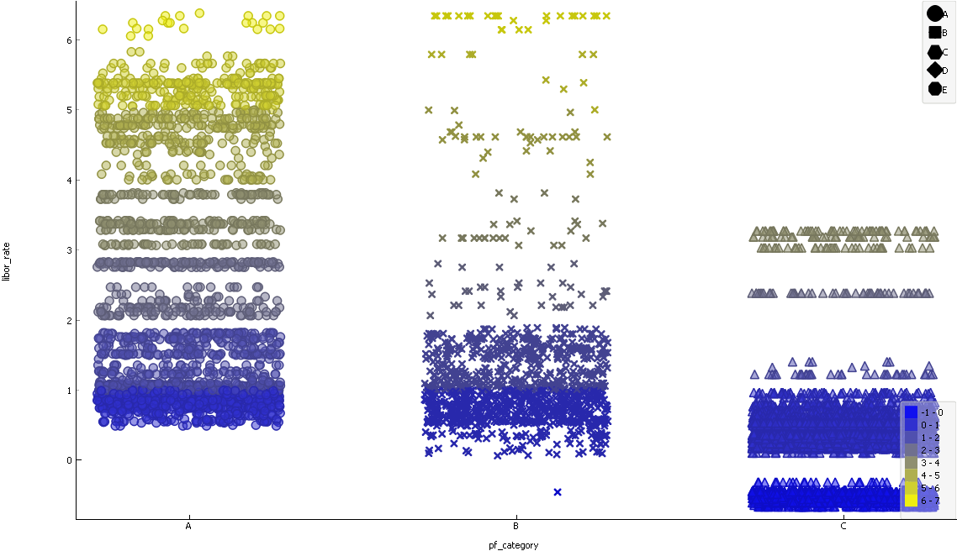

PF_CATEGORY and BOUGHT:

B 🡪 PF00013397

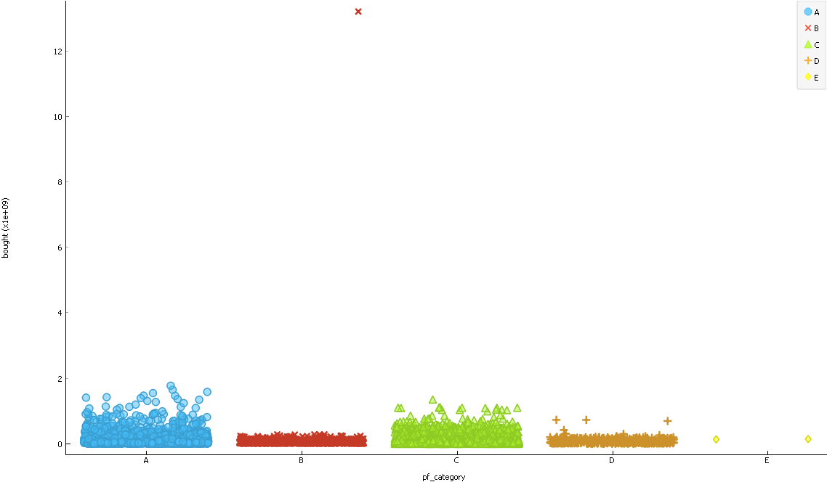

PF_CATEGORY AND RETURN:

C 🡪 High.

PF00003547 🡪 OF2 🡪 ER(+) 🡪 M 🡪 CHF.

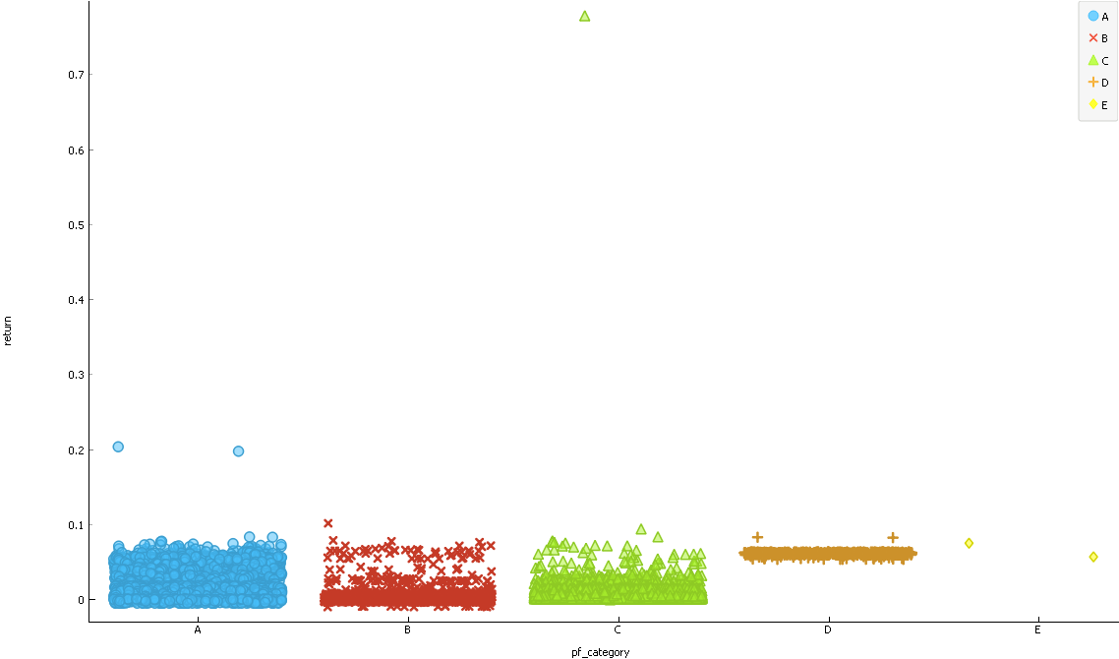

Currency and Country_code:

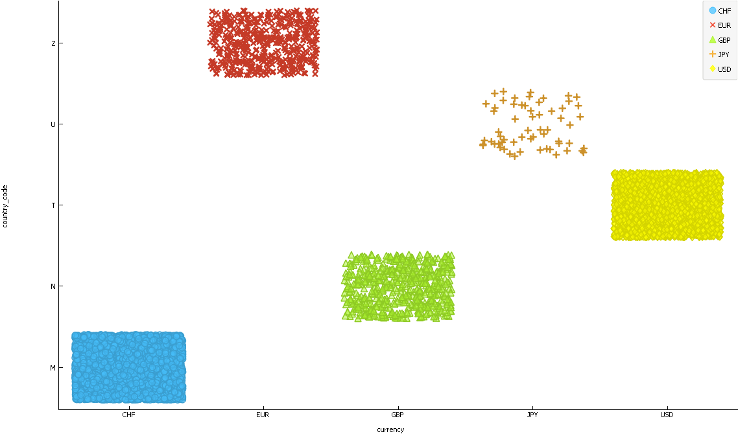

Currency and Return:

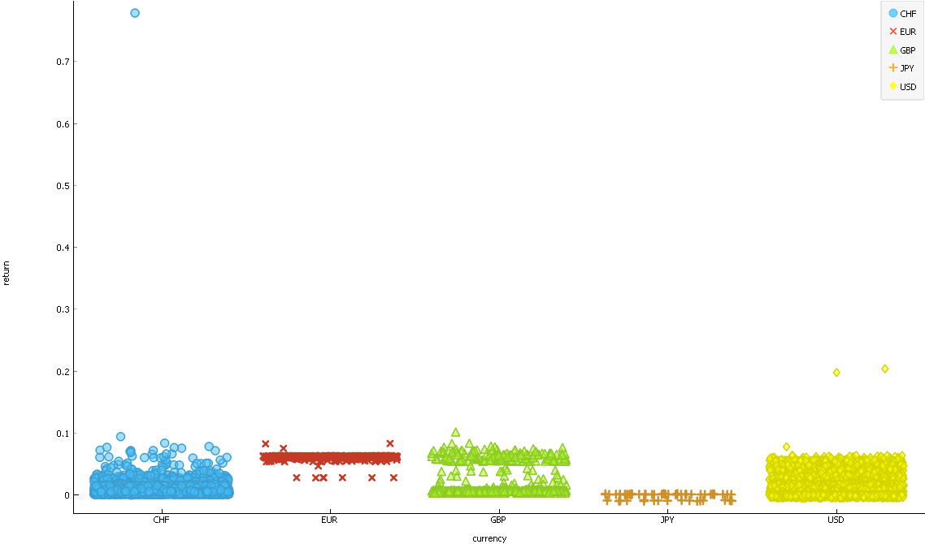

Country_code and Return

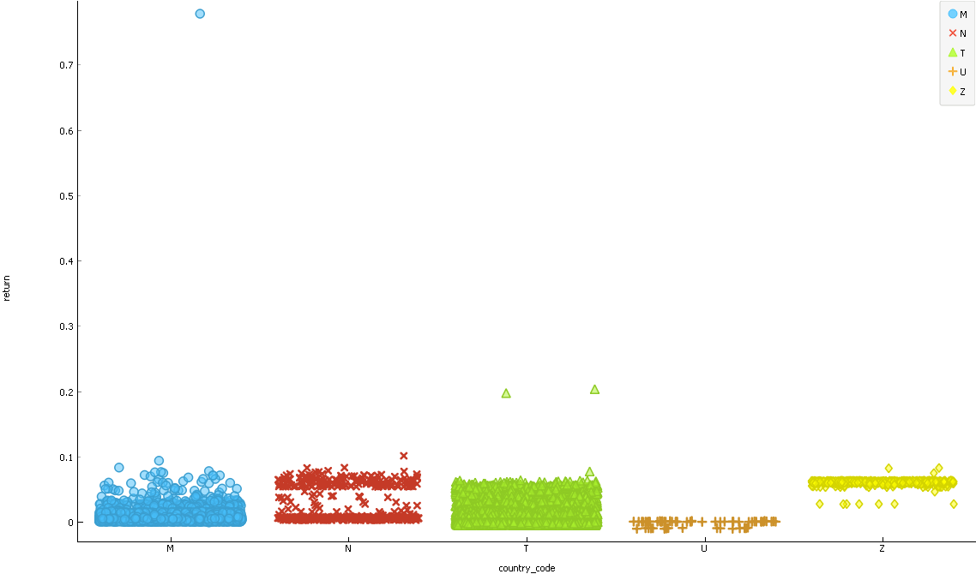

PF_Category and Return:



Return and office_id:

