**Software Requirements Specification**

For

Salus : Health care application

Version 1.0 approved

Prepared by:

1. Varshini Jayasankar - PES2UG20CS567
2. Sanjana S - PES2UG20CS549
3. Sharath K - PES2UG20CS552
4. Kushala - PES2UG20CS541

PES UNIVERSITY

11 SEPTEMBER 2022

**Table of Contents**

Table of Contents........................................................................................... ii

Revision History............................................................................................. ii

1. **Introduction**.............................................................................................. 1
   1. Purpose.................................................................................................. 1
   2. Intended Audience and Reading Suggestions........................................... 1
   3. Product Scope........................................................................................ 1
   4. References............................................................................................. 1
2. **Overall Description**.................................................................................. 2
   1. Product Perspective................................................................................ 2
   2. Product Functions................................................................................... 2
   3. User Classes and Characteristics............................................................. 2
   4. Operating Environment........................................................................... 2
   5. Design and Implementation Constraints................................................... 2
3. **External Interface Requirements**........................................................... 3
   1. User Interfaces....................................................................................... 3
   2. Software Interfaces................................................................................. 3
   3. Communications Interfaces..................................................................... 3
   4. Hardware Interface…………………………………………………………….3
4. **Analysis Model** ........................................................................................ 4
   1. Use Case Diagram .................................................................................... 4
5. **System Features** ……………………......................................................... 4
   1. Student Features.................................................................................... 4
   2. Faculty features…………….................................................................. 4
   3. Administrative Features…………….................................................................. 4
6. **Other Nonfunctional Requirements**....................................................... 4
   1. Performance Requirements...................................................................... 4
   2. Safety Requirements............................................................................... 5

6.3 Security Requirements............................................................................ 5

**INTRODUCTION(PES2UG20CS567)**

## 1.1

## **Purpose**

This health care application helps patients to look up doctors and view their profiles, schedule the appointments, order medicines, keep track of their physical activities and also keep track of the medical necessities.Doctors can treat their patients remotely and can accept/postpone the appointments of their patients.

## 1.2

## **Intended Audience**

This document aims at describing all the requirements of this particular software effectively. It is intended to be read and understood by the application developers, the testing team, the project managers for effective implementation of the necessary features.

The rest of the SRS document consists of the product functions, the external user interface requirements, the priorities of the features being implemented, the operating environment used, the system features, etc. It also consists of the non- functional requirements of the software .It also consists a use case diagram and a clear documentation of the features that are being implemented in the project.

It is of great help to all the stakeholders involved in the project. It can also be used as a reference to the developers in the future.

1.3

## **Product Scope**

This software-based application aims to provide online facilities of health care to the customers. This application helps the customers to keep track of their health despite their busy and hectic schedules. The customers can schedule appointments to their convenience, depending on the availability of the doctor.

It primarily has two users:

1.The customer/patient: They can login using the registered username and password through the login screen. They can search for different doctors based on their specialization, book appointments, order medicines and can even customize their workout plan and diet.

2.Then doctors: They can accept/reject appointments from their patients. They can also keep track of their schedule. They have to login through the login screen.

1.4

## **References**

1. <https://www.google.com/>
2. <https://ieeexplore.ieee.org/document/278253>
3. https://techexactly.com/blogs/healthcare-application-development-guide-types-features-challenges

# OVERALL DESCRIPTION(PES2UG20CS549)

## 2.1

## **Product Perspective**

The application provides an interface for two kinds of users, namely, patients and doctors.

The patients are provided with the following features:

* **Fitness tracker:** Monitors various health related activities such as menstrual cycle, diet plan and workout routine.
* **Book appointment:** The patients will be provided with the data regarding the doctors available and their specializations. Further, a NLP feature will map the symptoms of the patients to the appropriate doctors based on keyword search.
* **Order medicines online:** Order medicines and healthcare items online and get it delivered to the user’s convenience.
* **Payment:** Payment page the appointments and the ordered medications.
* **Medications remainder:** A page which keeps a track of medications given and sends reminders regarding right medicines to be taken at the right time.
* **Emergency SOS:** This crucial feature will automate the ambulance service on detecting the nearest hospital on a tap. It reduces the response time between the initiation of a call and getting help, thus reducing fatality.

The doctor will be able to:

* Enter available slots for the day.
* Accept the appointment.
* Decline the appointment.
* Reschedule the appointment.

The various tools (functional stack) that have been used in developing the software are as follows:

**Front End/User Interface**

Flutter Flow: Flutter flow is used for designing the cross-platform application which is scalable and easy to use.

**Backend**

Firebase: Server and a database solution for recording data.

## 2.2

## **Product Functions**

The various features provided by the application are listed below:

1. Login screen which allows patients and doctors to manage their profiles and allows new users to register.
2. Health page highlighting various health facts which will be updated on a timely basis.
3. Fitness tracker to track menstrual cycle, diet plans and workout schedule.
4. Schedule appointments with doctors given the profile of doctors.
5. Order medicines and other healthcare items.
6. Payment page for paying for appointments and medications.
7. Remainder for medications.
8. Automated call to the nearest hospital for an ambulance facility in case of an emergency.

## 2.3

## **User Classes and Characteristics**

The various user classes that will be using this product are:

1. **Patients:**

The application is developed for facilitating users by providing end to end services for healthcare from common facts to personalized features like booking appointment and tracking heath.

1. **Doctors:**

The application allows the doctors to maintain their schedule and accept, schedule or cancel appointments that have been made.

## 2.4

## **Operating Environment**

The application will facilitate a cross-platform environment which supports Android as well as iOS.

## 2.5

## **Design and Implementation Constraints**

1. Application is limited to smart phones.
2. The user can interact with the application only in English.

## 2.6

## **User Documentation**

## Documentation will be provided in the later phase of the project based on the interface developed.

## 2.7

## **Assumptions and Dependencies**

The user uses a smartphone and has internet connectivity to access the functionalities of the application.

**EXTERNAL INTERFACE REQUIREMENTS**

**(PES2UG20CS552)**

3.1

### **User Interfaces**

The Health care system is a simple, intuitive and user friendly interface.

There are two user interfaces:

**Patient Interface:**

Patients will be provided a registration page to gain access to the health care services. Upon opening the app, the user will have quick options for app services for booking doctor appointments, to track fitness,to manage his/her appointments, to visit profiles which include his/her medical reports, appointments,payment history etc. and ordering medicines with a medicine remainder.

**Doctor Interface:**

After the registration, the Doctor will have an interface with options to accept patient appointments, to view appointments and patient’s details, to update his availability etc.

Sample Screenshots:

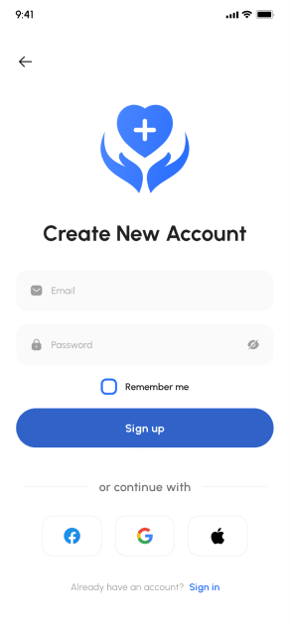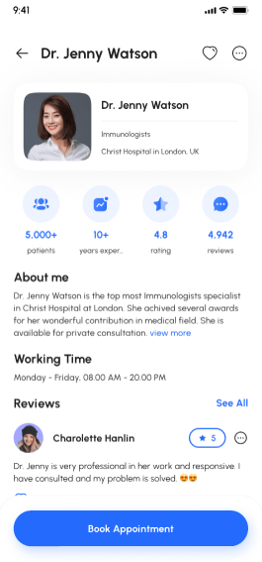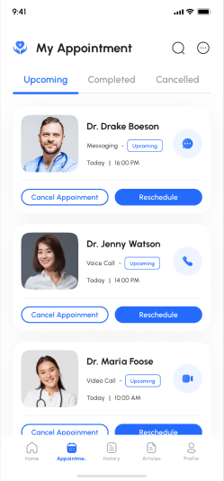

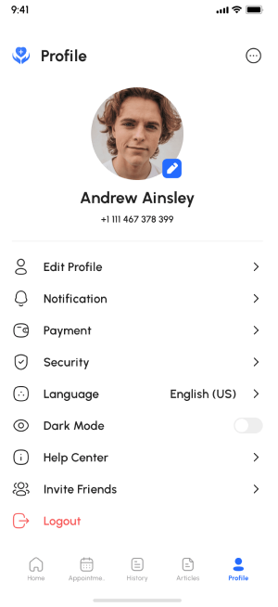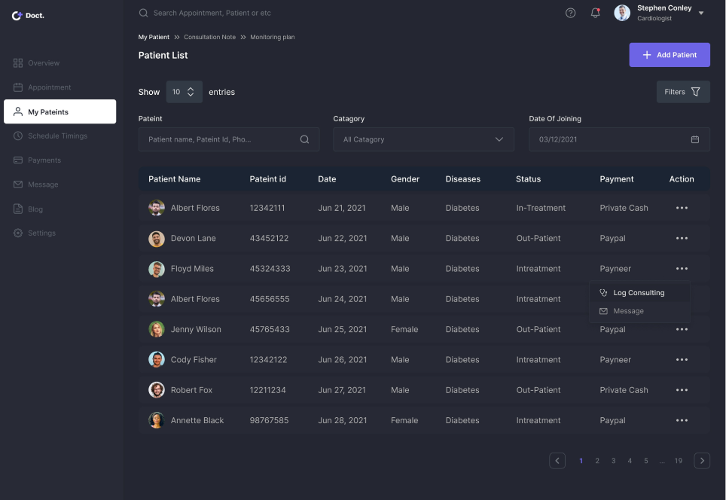

**To show the ease of interaction with system sees the use case diagram of the system:**

* In the use case diagram, it is clearly shown how the doctor and patient are interacting with each other. He/she can further go to a home page which gives them various tabs to navigate.
* The admin will have access to the registration module where they register the patients and doctors
* Each tab will provide special functionality to the user.

3.2

### **Software Interfaces**

Software can run on any android (version above 6.0) and ios devices

3.3

**Communications Interfaces**

Connections to the system will be through TCP/ IP gateways.

3.4

**Hardware interface**

* RAM: minimum 4Gb
* Hard Disk: 64 Gb

**ANALYSIS MODEL(PES2UG20CS552)**

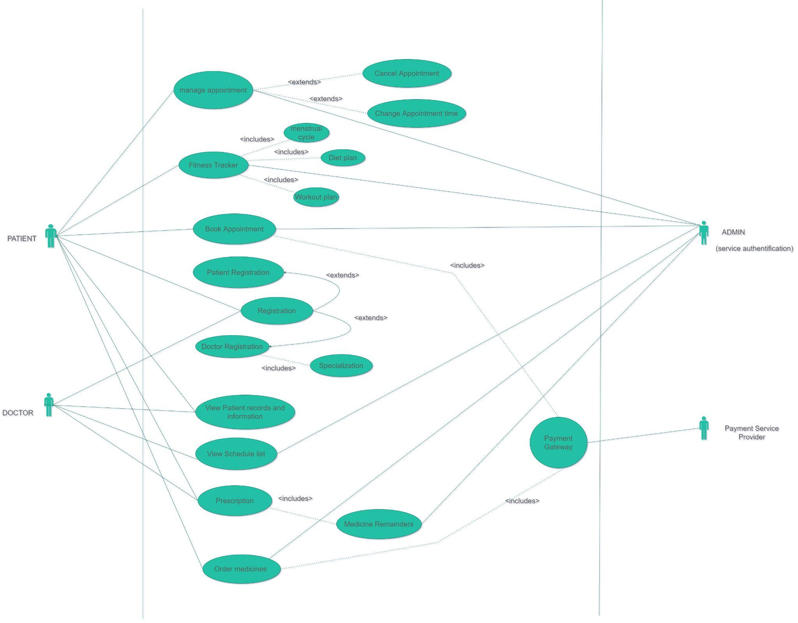

**SYSTEM FEATURES(PES2UG20CS549)**

The conference hall booking system has the following users:

1. Patients
2. Doctors

**Patient Features**

5.1.1 Description and Priority

Patients will be able to:

* View profiles of doctors
* Book appointments
* Order medications
* Make an emergency call for ambulance

These are high priority features.

5.1.2 Stimulus/response sequence

| STIMULUS | RESPONSE |
| --- | --- |
| Patients login to access their profile | Login page is displayed which requests user-id and password, if the patient is a new user, the window is redirected to a sign-up page. |
| Patient logs in | User-id and password is verified, patient is provided with a home page, which contains facts about health and options to access required functionalities. |
| Patient clicks on “Book appointment” | Application provides a list of profiles of doctors and options to select a time slot for appointment. |
| Patient enters symptoms in “Book appointment” window | Application searches for best fit doctors based on symptoms and provides results as a list of doctors’ profiles. |
| Patient clicks on “Order medicines” | Displays a list of medicines that the patient can search for and select to add to cart. |
| Patient clicks on “Reminder” | Lists the medicines and the timings to be consumed. |
| Patient clicks on “Emergency SOS” | Application asks for another confirmation through a click for emergency after which nearest hospitals are detected and ambulance facility is provided by one of those hospitals. |

5.1.3 Functional requirements

1. Database for login credentials of patients.
2. Database for appointment details.
3. Database for medication record.

**Doctor Features**

5.1.1 Description and Priority

Doctors will be able to:

* Update their schedule
* Accept an appointment
* Cancel an appointment
* Reschedule an appointment

This is a high priority feature.

5.1.2 Stimulus/response sequence

| STIMULUS | RESPONSE |
| --- | --- |
| Doctor accesses the application | Login page is displayed which requests user-id and password. If profile not created, the user is redirected to the sign up page. |
| Doctor logs in | User-id and password is verified |
| Doctor clicks on “Schedule appointments” | Application allows the doctor to enter time slot, accept, delete or reschedule an appointment. |

5.1.3 Functional requirements

1. Database for doctors’ login credentials.
2. Database for doctors’ profiles.
3. Database for appointments.

# OTHER NONFUNCTIONAL REQUIREMENTS

# (PES2UG20CS567)

6.1

**Performance Requirements**

The system must be capable of supporting:

1. Insights on the on-demand doctors .
2. Doctors are suggested based on symptoms searched.
3. Flexibility for doctors in scheduling their appointments with patients
4. A simple,user-friendly UI which provides convenience at critical times.
5. System runs smooth 24/7 provided good internet.

6.2

**Safety Requirements**

Maintainability and reliability of the system is ensured very thoroughly. All the records and appointments are kept in the databases along with backups and the system can restore in case of failure. This reconstructs a more current state by reapplying or redoing the operations of committed transactions from the backed up log, up to the time of failure.

6.3

**Security Requirements**

The security of the system is maintained by providing a login interface to the user. If a user forgets the password it will be restored with high security and with the consent of the user. Payments are done through a trusted 3rd party service, to ensure a secure transaction