Exercise 1 – Create Your First React Application
Aim
To create a React application named myfirstreact and display the heading "Welcome to the First Session of React" on the web page.
Software Required
- Node.js
- npm
- Visual Studio Code
- Google Chrome / Microsoft Edge
Prerequisites
- Install Node.js (npm is installed automatically with it).
- Install Visual Studio Code.
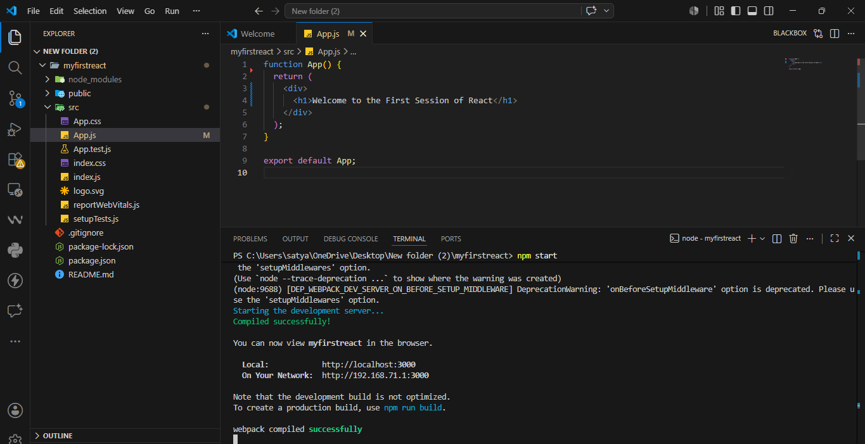

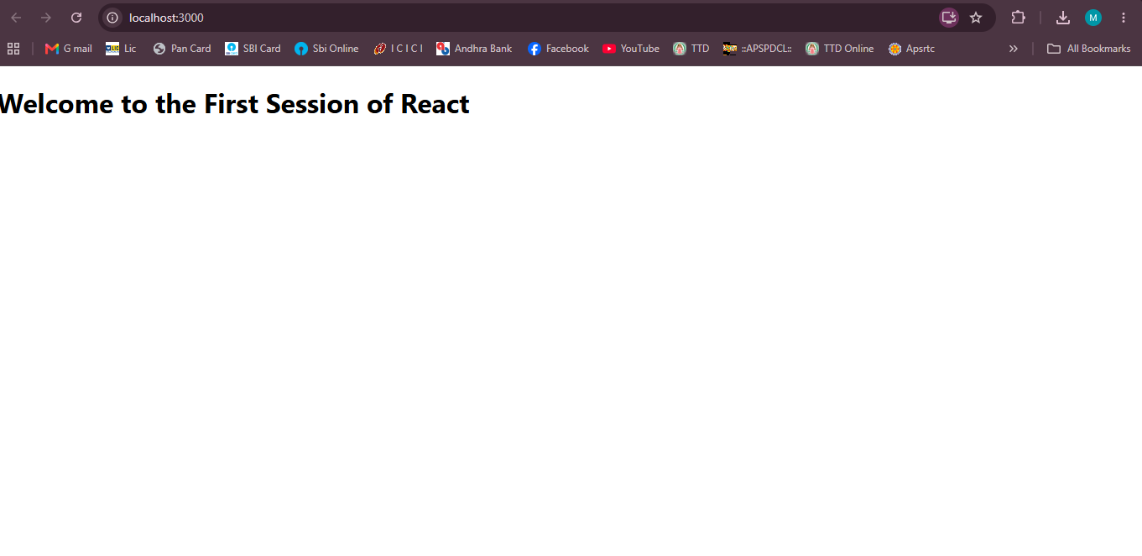

Exercise 2 – React Components (Student Management Portal)
Aim
To create a React application named StudentApp, create three class components (Home, About, and Contact), and render all the components on a single page.
Software Required
- Node.js
- npm
- Visual Studio Code
- Google Chrome / Microsoft Edge
Prerequisites
- Install Node.js
- Install Visual Studio Code
- Basic knowledge of React Components
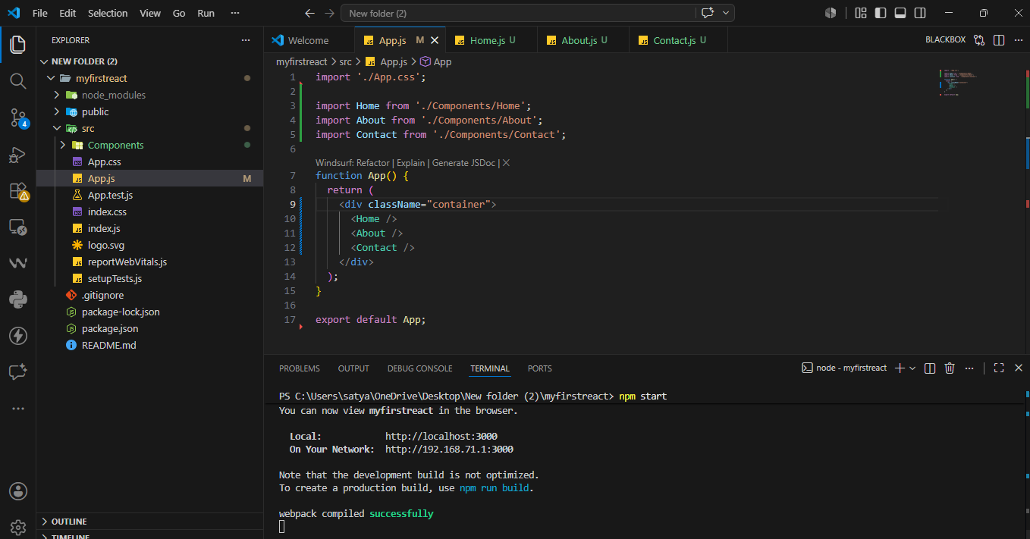
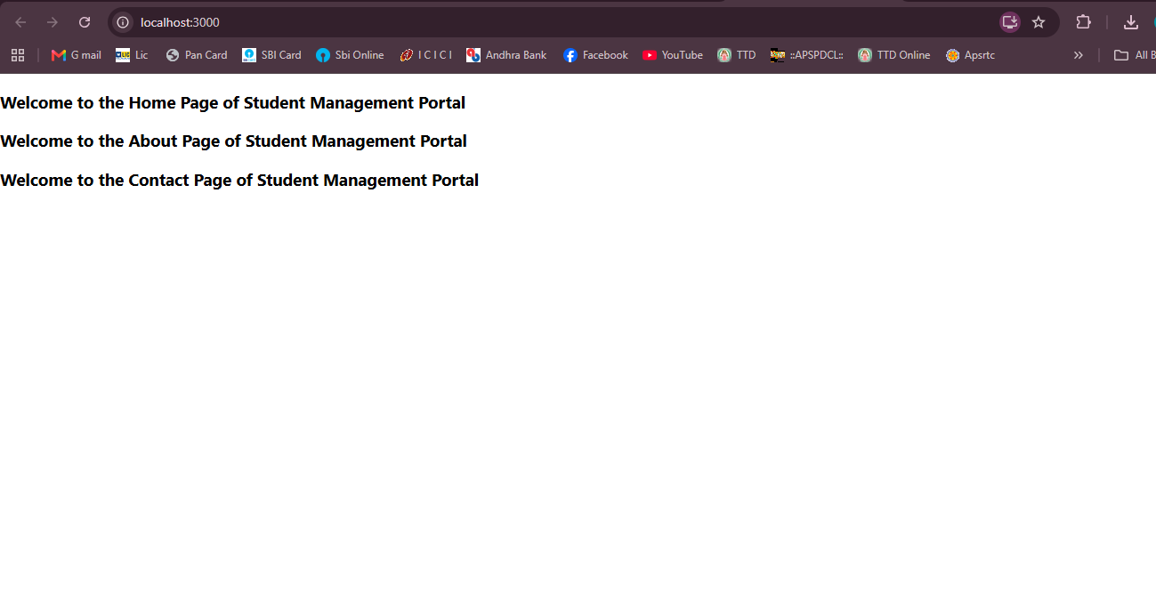
Exercise 3 – Functional Component (Score Calculator)
Aim
To create a React application named scorecalculatorapp using a functional component named CalculateScore that accepts Name, School, Total, and Goal as props, calculates the average score, and displays the student details with CSS styling.
Software Required
- Node.js
- npm
- Visual Studio Code
- Google Chrome / Microsoft Edge
Prerequisites
- Install Node.js
- Install Visual Studio Code
- Basic knowledge of React Functional Components
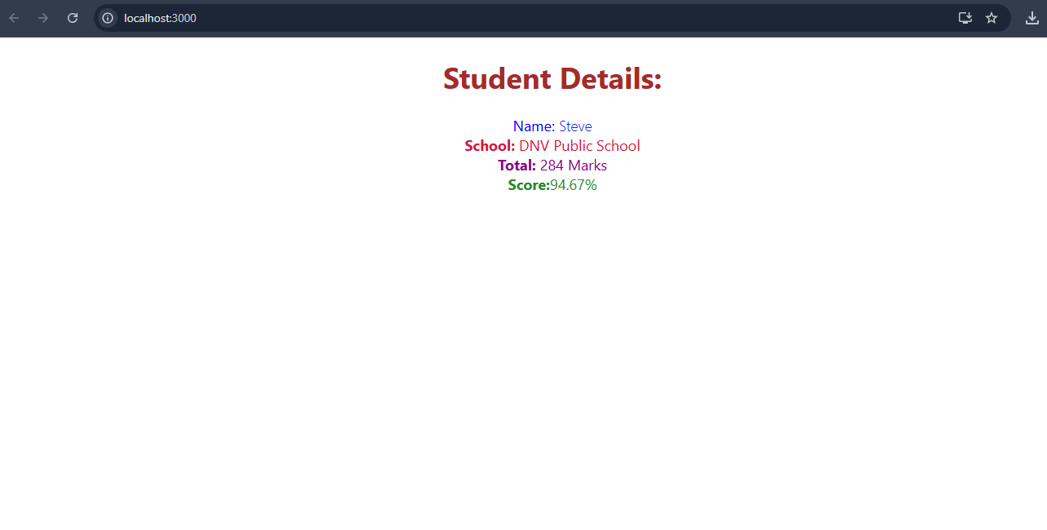
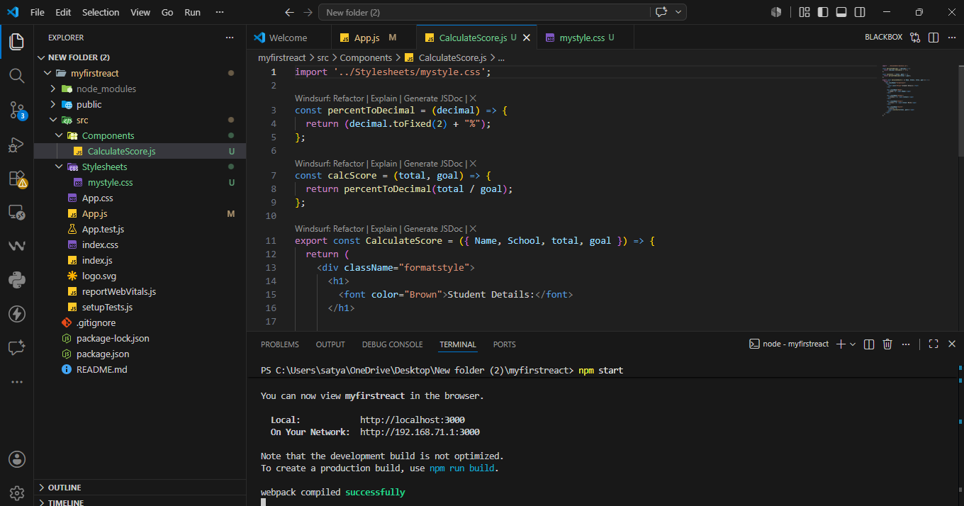
Exercise 4 – React Component Lifecycle (componentDidMount & componentDidCatch)

Aim
To create a React application named blogapp that fetches posts from an online API using the componentDidMount() lifecycle method and handles runtime errors using componentDidCatch().
Software Required
- Node.js
- npm
- Visual Studio Code
- Google Chrome / Microsoft Edge
Prerequisites
- Install Node.js
- Install Visual Studio Code
- Internet connection (for Fetch API)

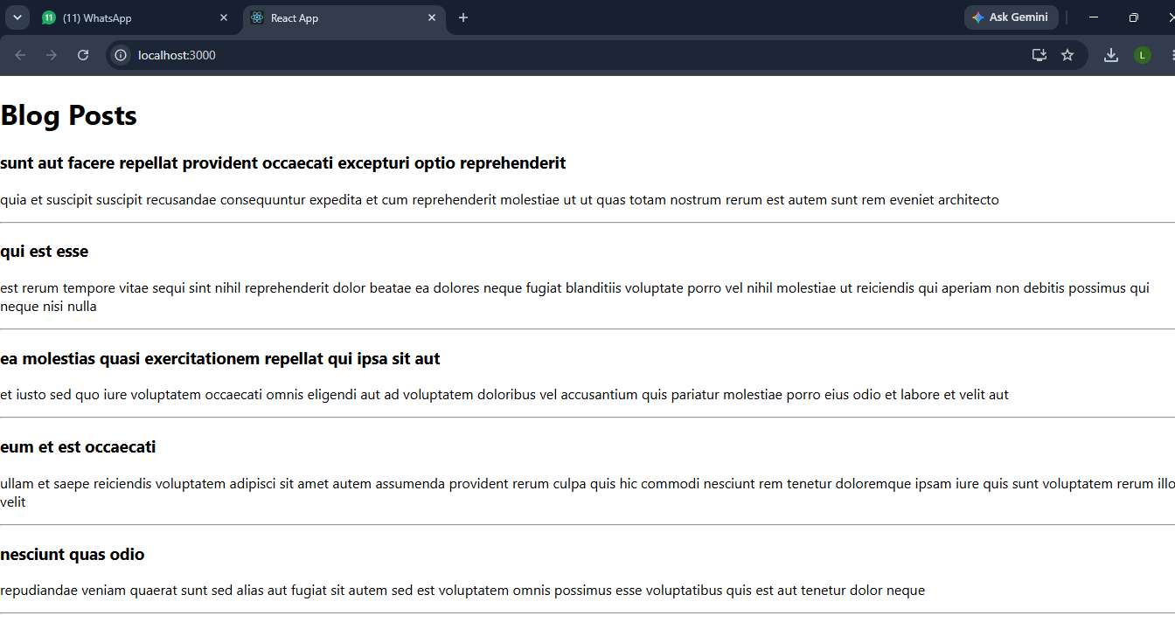
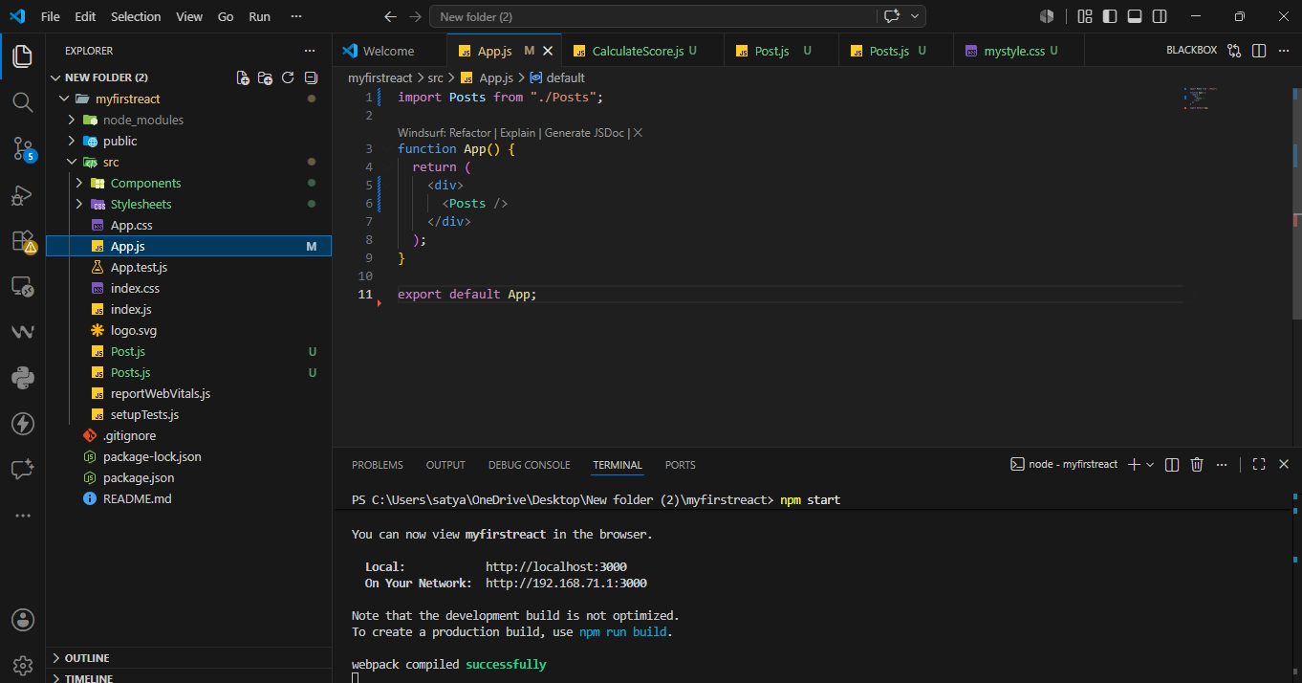
Exercise 5 – Styling React Components using CSS Modules
Aim
To style React components using CSS Modules and inline styles, and display the cohort details with different heading colors based on the cohort status.
Software Required
- Node.js
- npm
- Visual Studio Code
- Google Chrome / Microsoft Edge
Prerequisites
- Install Node.js
- Install Visual Studio Code
- Download and extract the provided React application (cohorttracker.zip).
Exercise 6 – React Router (Trainers App)
Aim
To create a React application named TrainersApp that uses React Router for navigation between pages and displays trainer details using URL parameters (useParams).
Software Required
- Node.js
- npm
- Visual Studio Code
- Google Chrome / Microsoft Edge
Prerequisites
- Install Node.js
- Install Visual Studio Code
- Basic knowledge of React Router.
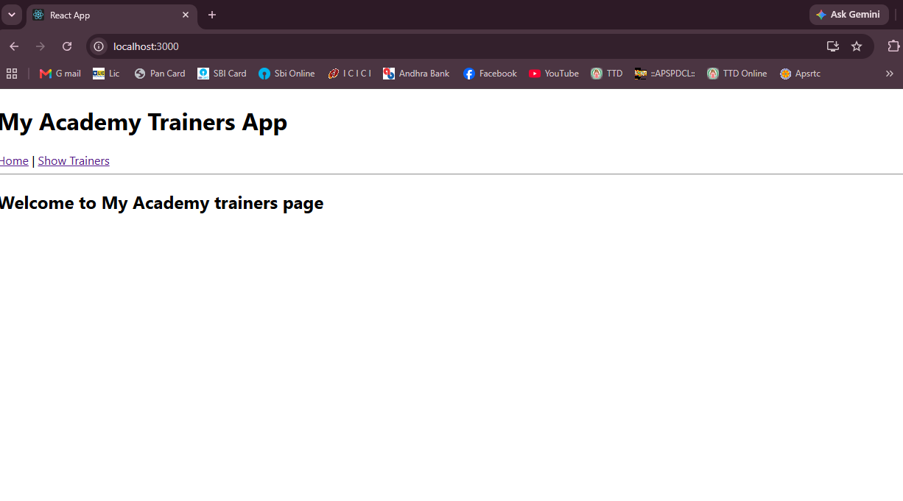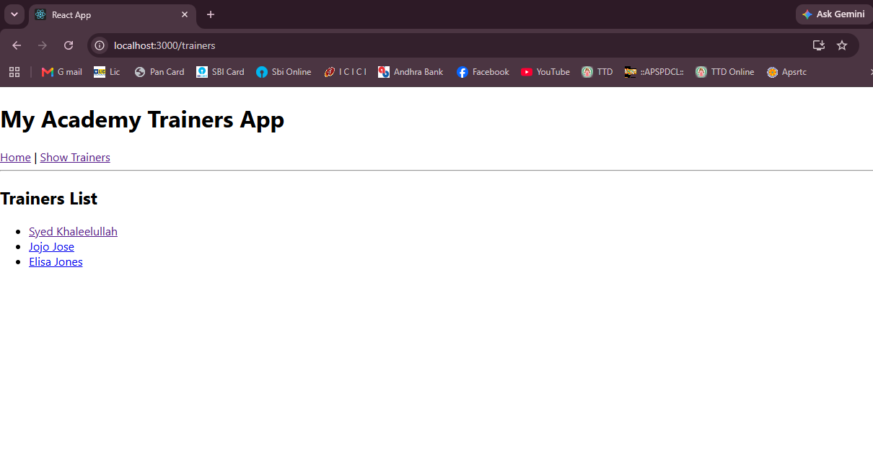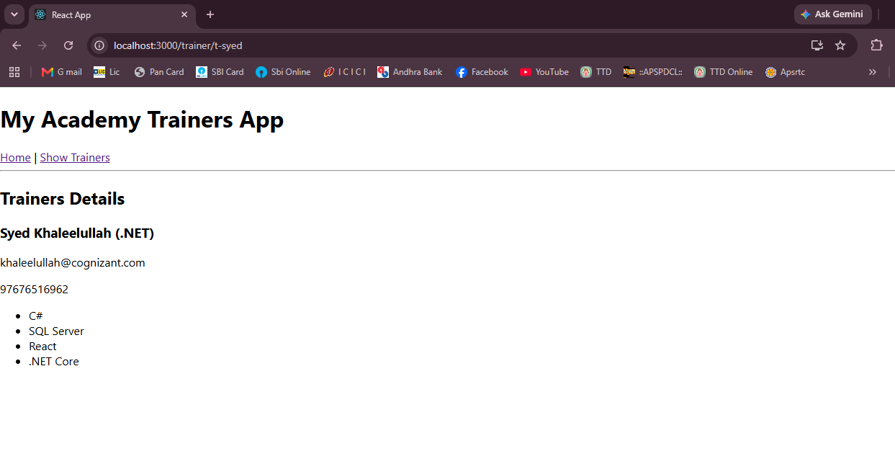
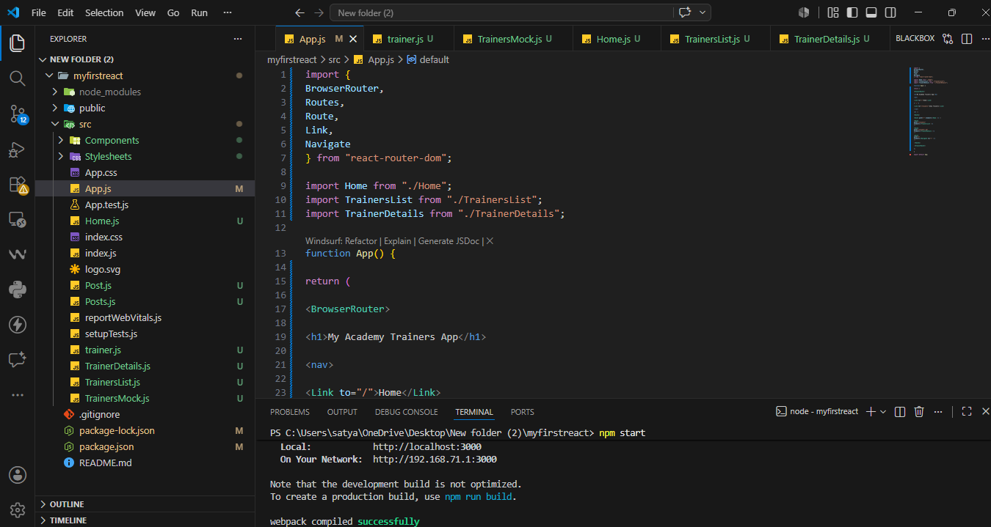
Exercise 7 – React Props (Shopping Cart)
Aim
To create a React application named shoppingapp that demonstrates the use of Props by passing an array of shopping cart items from a parent component (OnlineShopping) to a child component (Cart) and displaying them in a table.
Software Required
- Node.js
- npm
- Visual Studio Code
- Google Chrome / Microsoft Edge
Prerequisites
- Install Node.js
- Install Visual Studio Code
- Basic knowledge of React Props.

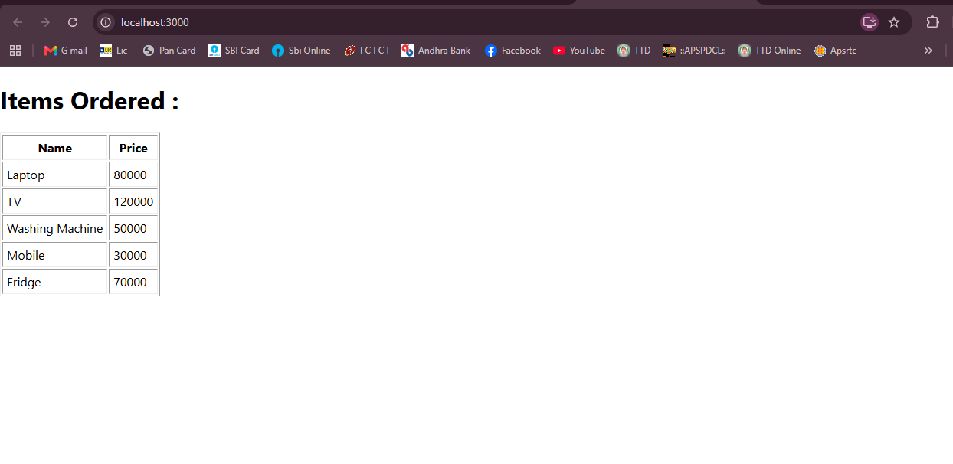
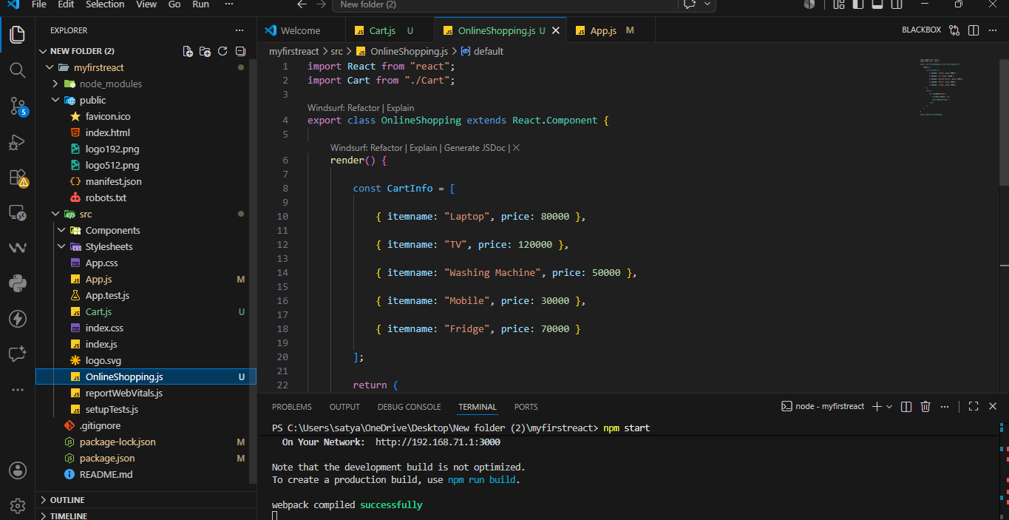
Exercise 8 – React State (Counter App)
Aim
To create a React application named counterapp that demonstrates the use of the React State object by maintaining the count of people entering and exiting a mall using two buttons.
Software Required
- Node.js
- npm
- Visual Studio Code
- Google Chrome / Microsoft Edge
Prerequisites
- Install Node.js
- Install Visual Studio Code
- Basic knowledge of React State.
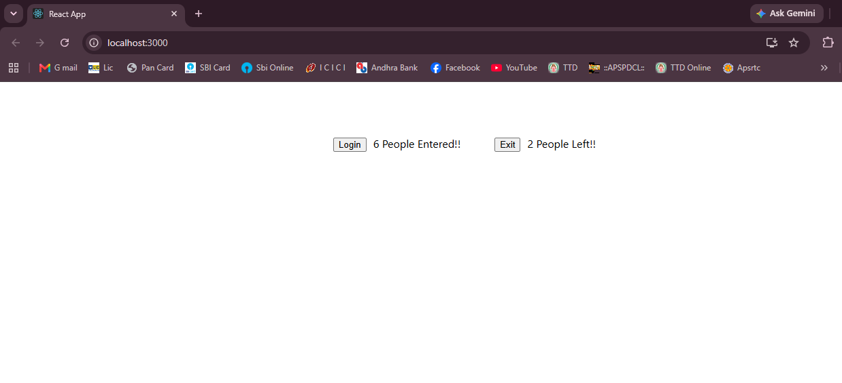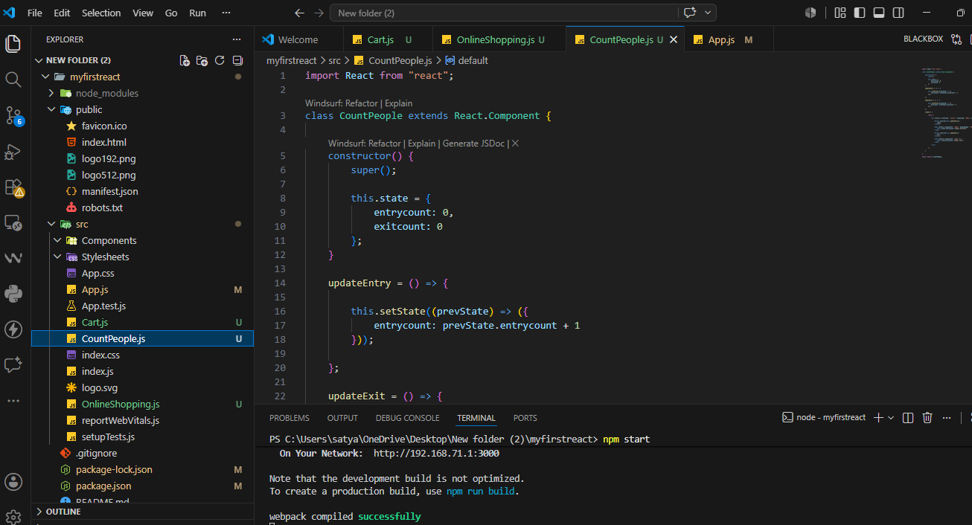
Exercise 9 – ES6 Features in React (Cricket App)
Aim
To create a React application named cricketapp that demonstrates various ES6 features such as map(), arrow functions, destructuring, and the spread operator to display cricket player details.
Software Required
- Node.js
- npm
- Visual Studio Code
- Google Chrome / Microsoft Edge
Prerequisites
- Install Node.js
- Install Visual Studio Code
- Basic knowledge of ES6 features and React.


