1)Insert Record}

db.book.insertMany(

[

{"book_title":"mean web development",

"author":"Amos Q. Haviv",

"publication":" Packt Publishing Ltd",

"edition":"1.0.0",

"year_of_publication":"2014",

"ISBN_No":77754,

"type_of_book":"textbook",

},

{

"book_title":"Big Data Anaylatics",

"author":"Seema Acharya",

"publication":" Packt Publishing Ltd",

"edition":"2.0.0",

"year_of_publication":"2019",

"ISBN_No":77712,

"type_of_book":"textbook",

},

{

"book_title":"Machine Learning",

"author":"Tom Mitchell",

"publication":" O'Reilly Media",

"edition":"3.0.0",

"year_of_publication":"2016",

"ISBN_No":75766,

"type_of_book":"textbook",

},

{

"book_title":"Java",

"author":"Ketty Sierra",

"publication":" Packt Publishing Ltd",

"edition":"5.0.0",

"year_of_publication":"2016",

"ISBN_No":77754,

"type_of_book":"textbook",

},

{

"book_title":"Java",

"author":"Andrew Troelsen",

"publication":" WP publishers",

"edition":"4.0.0",

"year_of_publication":"2001",

"ISBN_No":87416,

"type_of_book":"textbook",

}

]);

2) Find the book whose title is java

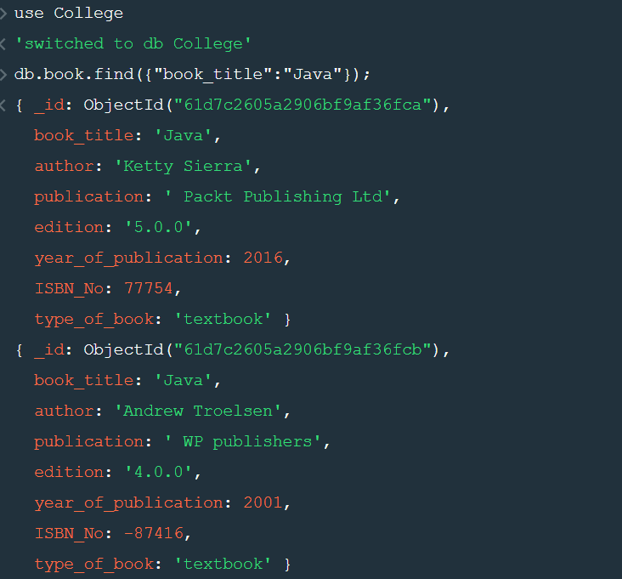

3) Find the book whose year of publication is greater than 2015

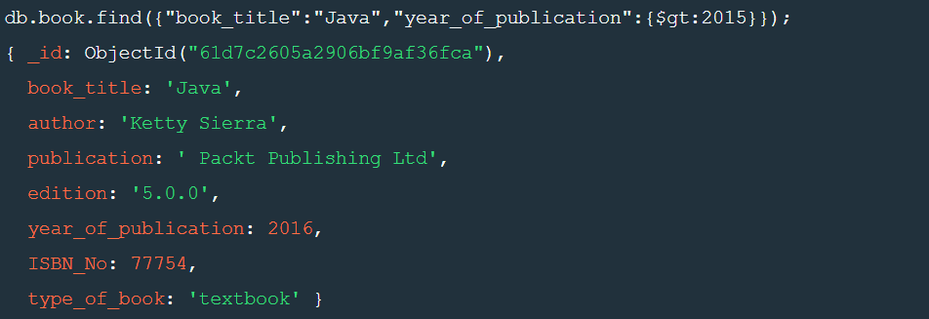

4) Find the author who published more than one book

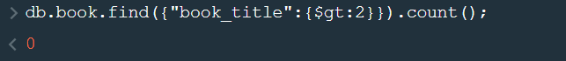

5) Find the book which its edition is greater than 3 and less than 4

