SALES ANALYSIS AND PREDICTION

WEEK 4 – DATA ANALYST CAPSTONE PROJECT

Project Report

Project Description:
Exploratory Data Analysis, Sales Prediction Using Regression, and Power BI Dashboard Development.

Tools Used:

- Microsoft Excel
- Python (Pandas, Matplotlib, Scikit-learn)
- Power BI

Submitted as: Data Analyst Course – Week 4 Capstone Project

1. INTRODUCTION

Sales analysis is an important process for understanding business performance and identifying opportunities for growth.

The main objective of this project is to analyse sales data, identify important business insights, and develop a regression model to predict sales.

This project uses Python for data cleaning and analysis, Excel for data organisation, and Power BI for interactive data visualisation.

Project Objectives

1. To clean and prepare the sales dataset.
2. To perform Exploratory Data Analysis (EDA).
3. To identify sales trends and patterns.
4. To build a regression model for sales prediction.
5. To create an interactive Power BI dashboard.
6. To provide useful business recommendations.

2. DATASET DESCRIPTION

The dataset used in this project contains sales-related information. It is used to analyse business performance and build a model to predict sales.

Dataset Details

- Dataset Name: Sales Dataset
- File Format: Excel (.xlsx)
- Original File: dataset.xlsx
- Cleaned File: sales_analysis_cleaned.xlsx

Data Preparation

The following steps were performed using Python:

1. Loaded the sales dataset.
2. Checked for missing values.
3. Checked and handled duplicate records.
4. Cleaned the dataset.
5. Prepared the data for analysis and model building.

The cleaned dataset was saved in Excel format for further analysis.

3. EXPLORATORY DATA ANALYSIS (EDA)

Exploratory Data Analysis was performed using Python to understand the sales dataset and identify important patterns.

Tools and Libraries Used

- Pandas – Data manipulation and analysis.
- NumPy – Numerical calculations.
- Matplotlib – Data visualisation.
- Seaborn – Statistical visualisation.

Analysis Performed

1. Calculated descriptive statistics.
2. Analysed sales by country.
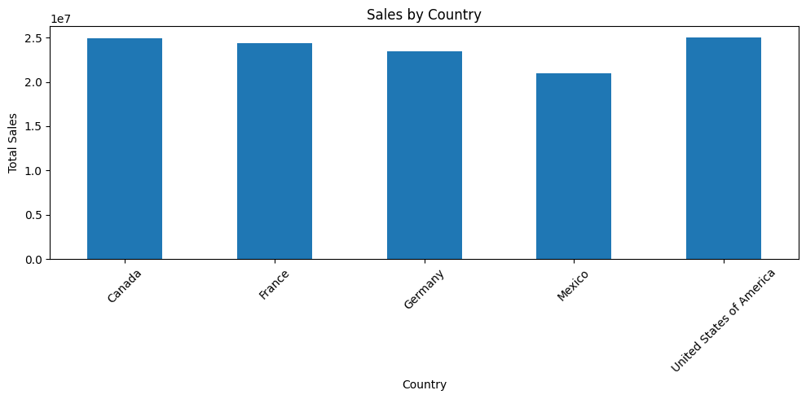
3. Analysed sales by product.
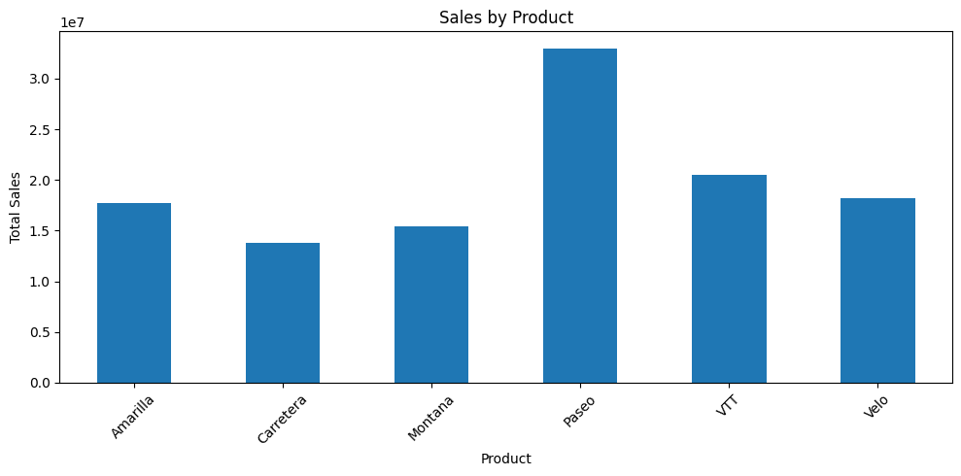
4. Examined monthly sales trends.
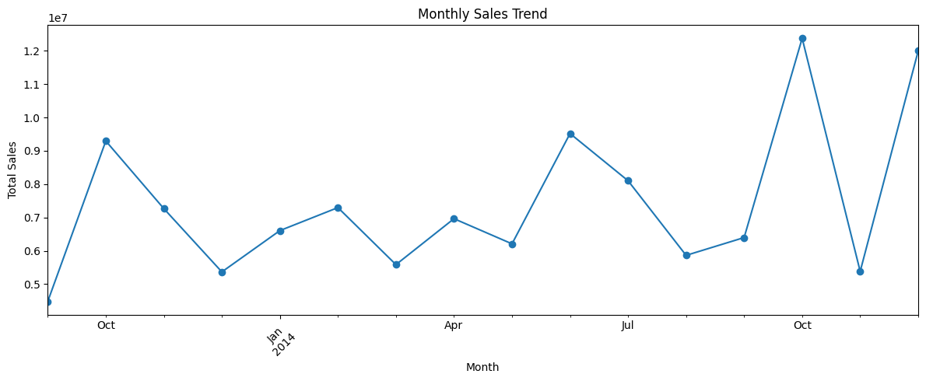
5. Compared profit across countries.
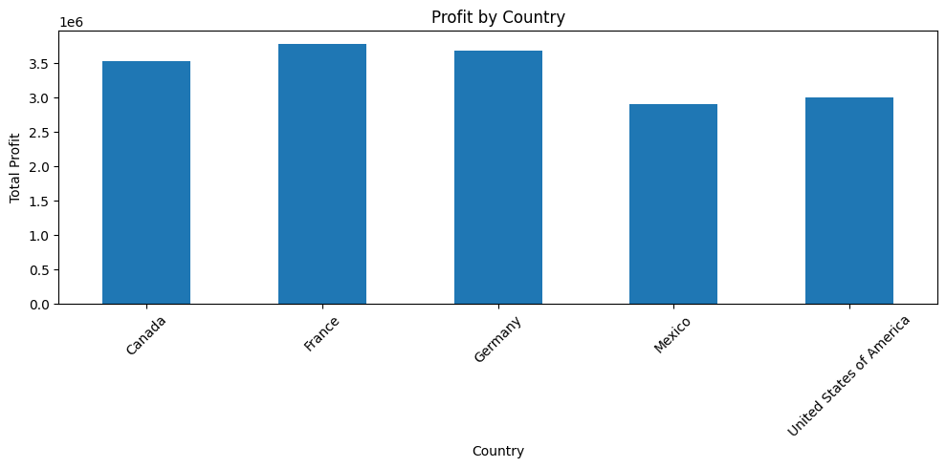
6. Identified patterns and variations in sales.

Key Observations

The analysis helped identify differences in sales performance across countries, products and time periods.

The visualisations provided useful insights into business performance and helped identify areas requiring improvement.

4. SALES PREDICTION USING LINEAR REGRESSION.

The Linear Regression model was developed to predict sales using selected input features such as Units Sold, Manufacturing Price, Sale Price, Discounts, Month Number and Year.
4.1 Actual vs Predicted Sales.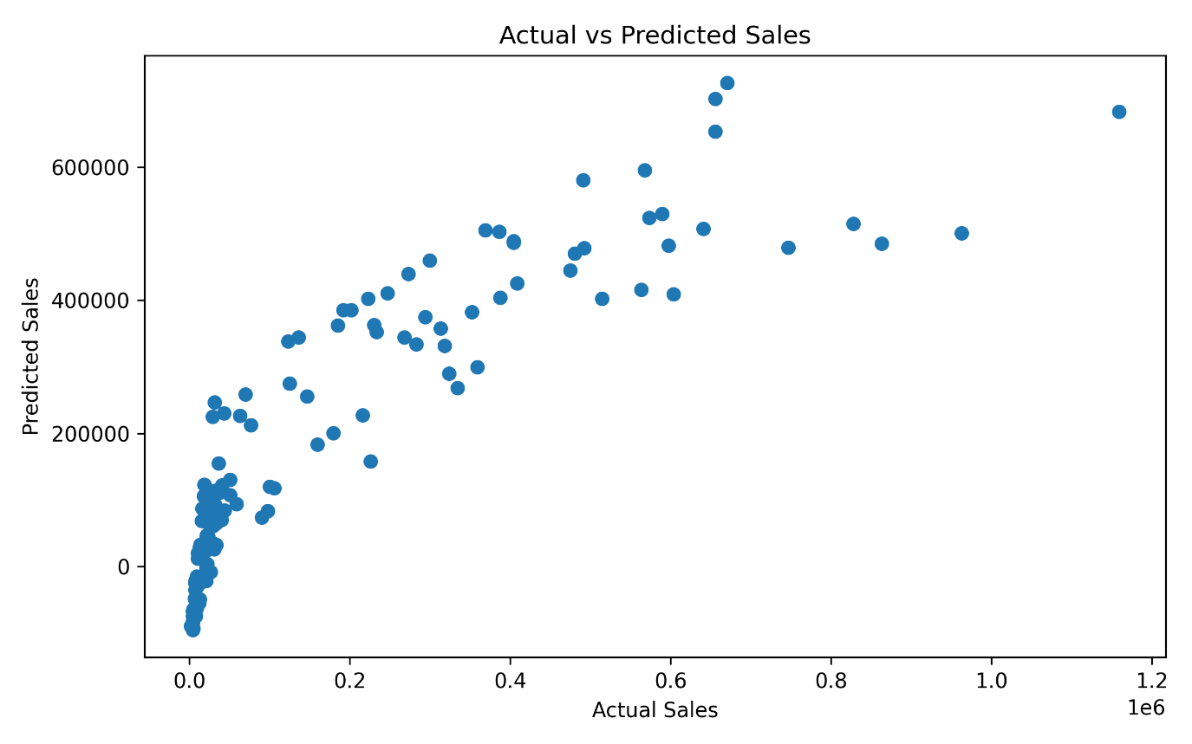
4.2 Model Evaluation

The Linear Regression model was evaluated using Mean Absolute Error (MAE), Mean Squared Error (MSE), Root Mean Squared Error (RMSE), and R² Score.
The model achieved an MAE of 82,876.54, an MSE of 13,051,783,059.06, and an RMSE of 114,244.40. The R² Score was 0.7643, indicating that the model explains approximately 76.43% of the variation in sales.
Overall, the model shows a reasonable ability to predict sales, although some prediction errors remain.
4.3 Findings of Regression Model
The Linear Regression model was successfully developed to predict sales based on the selected input features.
The following findings were observed:
- The model achieved an R² Score of 0.7643, indicating that it explains approximately 76.43% of the variation in sales.
- The Actual vs Predicted Sales graph shows a general positive relationship between actual sales and predicted sales.
- The MAE and RMSE values indicate that some differences exist between actual and predicted sales.
- The model provides reasonably good predictions, although prediction errors are present for certain observations.
- Linear Regression can be useful for understanding sales patterns and supporting business decisions.
Overall, the model demonstrates a reasonable ability to predict sales and provides a foundation for further sales analysis.
5. POWER BI DASHBOARD DEVELOPMENT
5.1 Introduction
Power BI was used to create an interactive dashboard for analysing and visualising sales data. The dashboard helps understand sales performance, identify trends, compare products and countries, and support data-driven business decisions.
The cleaned sales dataset was used as the source for creating meaningful visualisations.
5.2 Dashboard Objectives
- To analyse overall sales performance.
- To compare sales across different countries.
- To identify top-performing products.
- To understand monthly sales trends.
- To present important business insights through interactive visualisations.
5.3 Dashboard Visualisations
The Power BI dashboard presents sales information through charts, graphs, and other visual elements. These visualisations help users understand sales patterns and compare business performance.
5.4 Dashboard Insights
The dashboard provides a clear overview of sales performance across different products, countries, and time periods. It helps identify areas of strong performance and opportunities for business improvement.
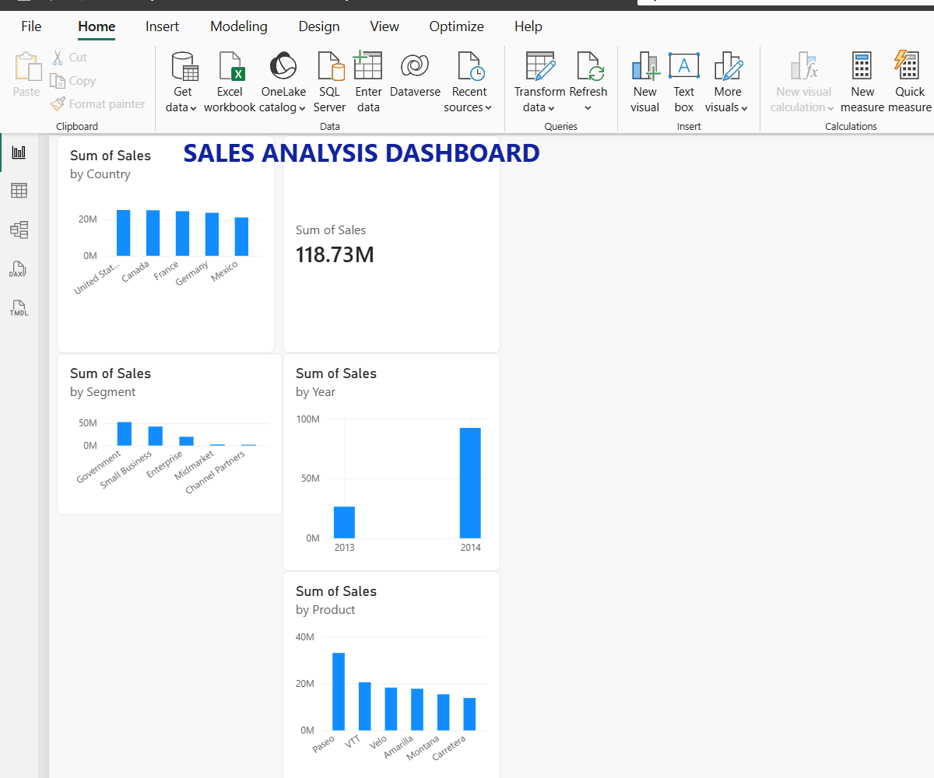

6. FINDINGS AND BUSINESS RECOMMENDATIONS
6.1 Key Findings
The sales analysis and prediction project provided useful insights into business performance.
- Sales performance varies across different countries and products.
- Monthly sales analysis helps identify changes in sales trends over time.
- The analysis highlights differences in product and country performance.
- The Linear Regression model achieved an R² Score of 0.7643, explaining approximately 76.43% of the variation in sales.
- The Power BI dashboard provides an interactive way to understand and monitor sales performance.
6.2 Business Recommendations
Based on the analysis, the following recommendations are suggested:
- Focus on improving the performance of products with lower sales.
- Identify successful sales strategies in high-performing countries and apply them to other markets.
- Monitor monthly sales trends to support better business planning.
- Use sales predictions to support inventory and sales planning.
- Regularly update the dashboard to monitor business performance.
- Improve the prediction model further by exploring additional features and suitable machine learning techniques.

7. CONCLUSION
- The Sales Analysis and Prediction project successfully demonstrated the use of data analysis, visualisation, and machine learning techniques to understand business sales performance.
- The project involved data cleaning, Exploratory Data Analysis (EDA), sales trend analysis, and Linear Regression modelling using Python.
- The Linear Regression model achieved an R² Score of 0.7643, indicating that it explains approximately 76.43% of the variation in sales.
- Power BI was used to develop an interactive dashboard that presents important sales information through visualisations.
- Overall, this project provided practical experience in handling real-world datasets, analysing business performance, building predictive models, and presenting insights to support data-driven decision-making.
8. REFERENCES
- Python Documentation – https://docs.python.org/3/
- Pandas Documentation – https://pandas.pydata.org/docs/
- NumPy Documentation – https://numpy.org/doc/
- Matplotlib Documentation – https://matplotlib.org/stable/
- Scikit-learn Documentation – https://scikit-learn.org/stable/
- Microsoft Power BI Documentation – https://learn.microsoft.com/en-us/power-bi/

