CHAPTER – 1 INTRODUCTION
The Employee Leave Management System (ELMS) is a modern web-based application developed to automate and simplify the leave management process in organizations. In many companies, leave requests are still handled manually using paper forms, emails, or spreadsheets. These traditional methods are time-consuming, prone to human errors, and make it difficult to maintain accurate leave records. Employees often experience delays in receiving approval for their leave requests, while managers and administrators face challenges in tracking leave balances, maintaining employee records, and preparing reports. As organizations continue to grow, the need for an efficient and automated leave management system has become increasingly important.
The Employee Leave Management System addresses these challenges by providing a centralized platform that streamlines the entire leave management process. It allows employees to apply for leave online, check their leave balance, view leave history, and monitor the status of their requests. Managers can review leave applications submitted by their team members and approve or reject them based on organizational policies. Administrators can manage employee details, departments, leave types, and monitor all leave-related activities through a dedicated dashboard. This role-based approach improves communication, transparency, and accountability across the organization.
The application is developed using React.js for the frontend, providing a responsive and user-friendly interface, and Java Spring Boot for the backend, ensuring a secure and scalable server-side application. Spring Security with JWT (JSON Web Token) authentication is implemented to provide secure login and role-based access control. Spring Data JPA is used to simplify database operations, while MySQL serves as the relational database for storing employee information, leave records, leave balances, and other organizational data securely.
Overall, the Employee Leave Management System provides a secure, reliable, and efficient solution for managing employee leave. The project demonstrates how modern web technologies can be effectively used to solve real-world organizational challenges and support digital transformation in human resource management.

Summary of Project

The Employee Leave Management System (ELMS) was successfully designed and developed as a role-based web application to automate leave management within an organization. The project provides separate dashboards for Admin, Manager, and Employee, enabling each user to perform their responsibilities efficiently. Employees can apply for leave and monitor its status, managers can approve or reject leave requests, and administrators can manage employees, leave types, and organizational records.

The application was implemented using React.js, Java Spring Boot, Spring Security, JWT authentication, and MySQL, ensuring a secure, responsive, and scalable system. The project successfully integrates frontend and backend components through REST APIs and stores all information in a centralized database for easy access and management.

The completed system reduces paperwork, minimizes manual errors, speeds up the leave approval process, and improves transparency between employees and management. It also enhances data security through role-based authentication and provides an organized approach to maintaining leave records. Overall, the project demonstrates the practical application of modern web technologies in solving real-world organizational problems and provides a reliable foundation for future enhancements such as attendance management, payroll integration, mobile application support, analytics, and cloud deployment.

Background of project

The rapid growth of organizations and the increasing number of employees have made leave management an important part of human resource administration. In many organizations, leave requests are still handled through manual processes such as paper forms, emails, or spreadsheets. These methods are often slow, difficult to maintain, and prone to human errors. They also make it challenging to track leave balances, maintain accurate records, and ensure timely approval of leave requests. As a result, organizations face reduced efficiency, increased administrative workload, and a lack of transparency in the leave management process.

To overcome these challenges, the Employee Leave Management System (ELMS) was developed as a digital solution to automate and streamline leave management. The system provides a centralized platform where employees can submit leave requests, managers can review and approve or reject applications, and administrators can manage employee information, leave policies, and records efficiently. By replacing manual processes with automation, the system improves communication, enhances transparency, reduces paperwork, and ensures accurate record management.

The project is developed using modern web technologies such as React.js, Java Spring Boot, Spring Security, JWT Authentication, and MySQL, providing a secure, scalable, and user-friendly solution. The Employee Leave Management System not only simplifies leave management but also supports organizations in improving productivity, reducing administrative effort, and creating a more efficient and organized work environment..

Existing System

In many organizations, the existing leave management process is carried out using manual methods such as paper application forms, emails, or spreadsheets. Employees submit leave requests to their managers or the HR department, where the requests are verified and processed manually. This approach requires significant paperwork, consumes time, and increases the chances of errors in maintaining leave records. It also makes it difficult to track leave balances, monitor the status of leave requests, and generate accurate reports.

As the number of employees increases, managing leave manually becomes more complicated and inefficient. Employees often experience delays in receiving approval, while managers and administrators spend extra time verifying records and updating leave information. The absence of a centralized system also reduces transparency and makes communication between employees, managers, and HR less effective.

Limitations of the Existing System:

* Manual leave application and approval process.
* Time-consuming and paper-based record management.
* High risk of human errors and data duplication.
* Delays in leave approval and communication.
* Difficulty in tracking leave balances and leave history.
* Lack of transparency and real-time updates.
* Poor security and inefficient record maintenance.
* Increased administrative workload.

These limitations highlight the need for an automated Employee Leave Management System that provides a faster, more secure, and efficient way to manage employee leave requests and organizational records.

Proposed System

The Employee Leave Management System (ELMS) is a web-based application designed to automate and simplify the leave management process in an organization. The proposed system provides a centralized platform where employees can apply for leave online, managers can review and approve or reject leave requests, and administrators can manage employee records, leave types, and organizational data efficiently. This eliminates the need for manual paperwork and ensures that all leave-related information is stored securely in a centralized database.

The system is developed using React.js for the frontend and Java Spring Boot for the backend. Spring Security with JWT (JSON Web Token) authentication provides secure login and role-based access for Admin, Manager, and Employee. Spring Data JPA is used for database operations, while MySQL stores employee information, leave records, and leave balances. The system also provides real-time status updates, allowing employees to track their leave requests throughout the approval process.

Advantages of the Proposed System:

* Automates the leave application and approval process.
* Secure login with JWT-based authentication.
* Separate dashboards for Admin, Manager, and Employee.
* Real-time tracking of leave requests and approvals.
* Accurate leave balance and leave history management.
* Centralized database for secure record storage.
* Reduces paperwork and minimizes human errors.
* Faster approval process and improved transparency.
* Easy management of employees, leave types, and reports.
* Scalable system that supports future enhancements such as attendance integration, payroll management, email notifications, mobile applications, and cloud deployment.

CHAPTER – 3

SOFTWARE AND HARDWARE REQUIREMENTS

Software Requirements
    - Frontend: React.js
    - Backend: Springboot
    - Database: MySQL
    - Operating System: Windows 11
    - IDE: VS Code, GitHub
    - Deployment: Vercel

Hardware requirements

    - Processor : Intel CORE i7
    - RAM : 16GB
    - Hard Disk : 512GB SSD

CHAPTER – 4
SYSTEM DESIGN

System Architecture

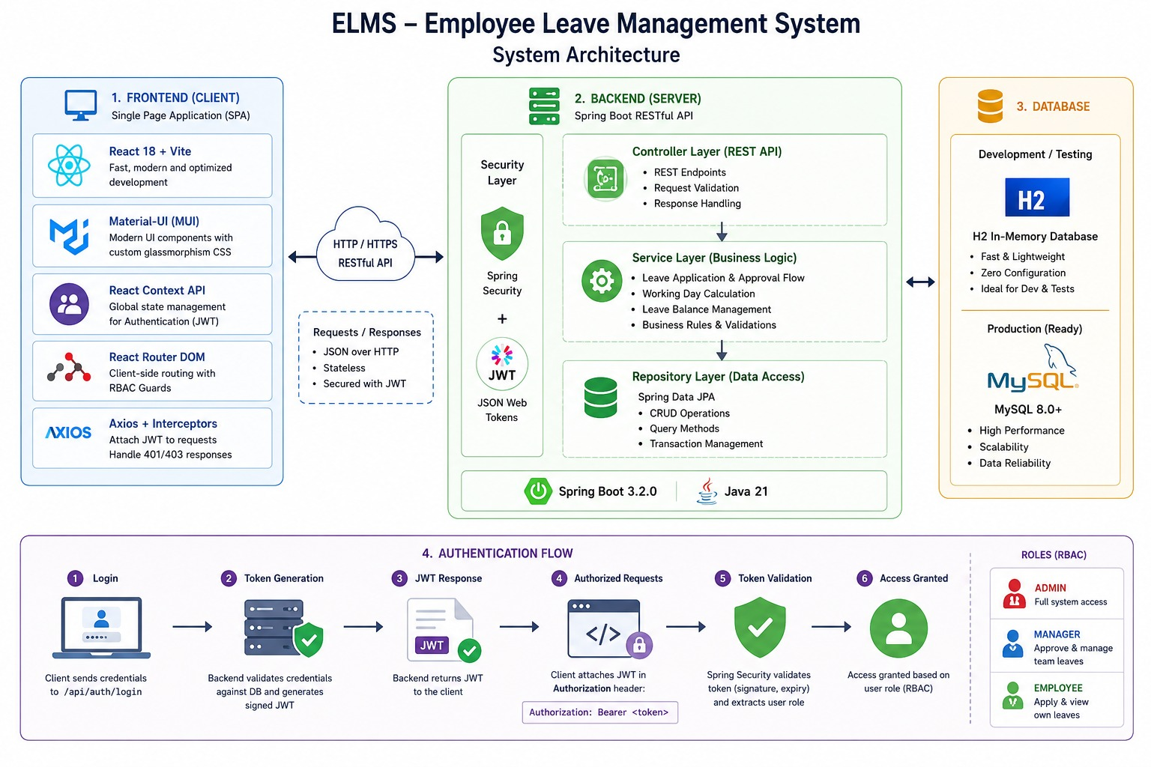

Fig.1: System Architecture

The system architecture diagram visually maps out the structure and interconnections of the "EMPLOYEE LEAVE MANAGEMENT SYSTEM" application, offering a streamlined representation of its core components.

Data Flow Diagram

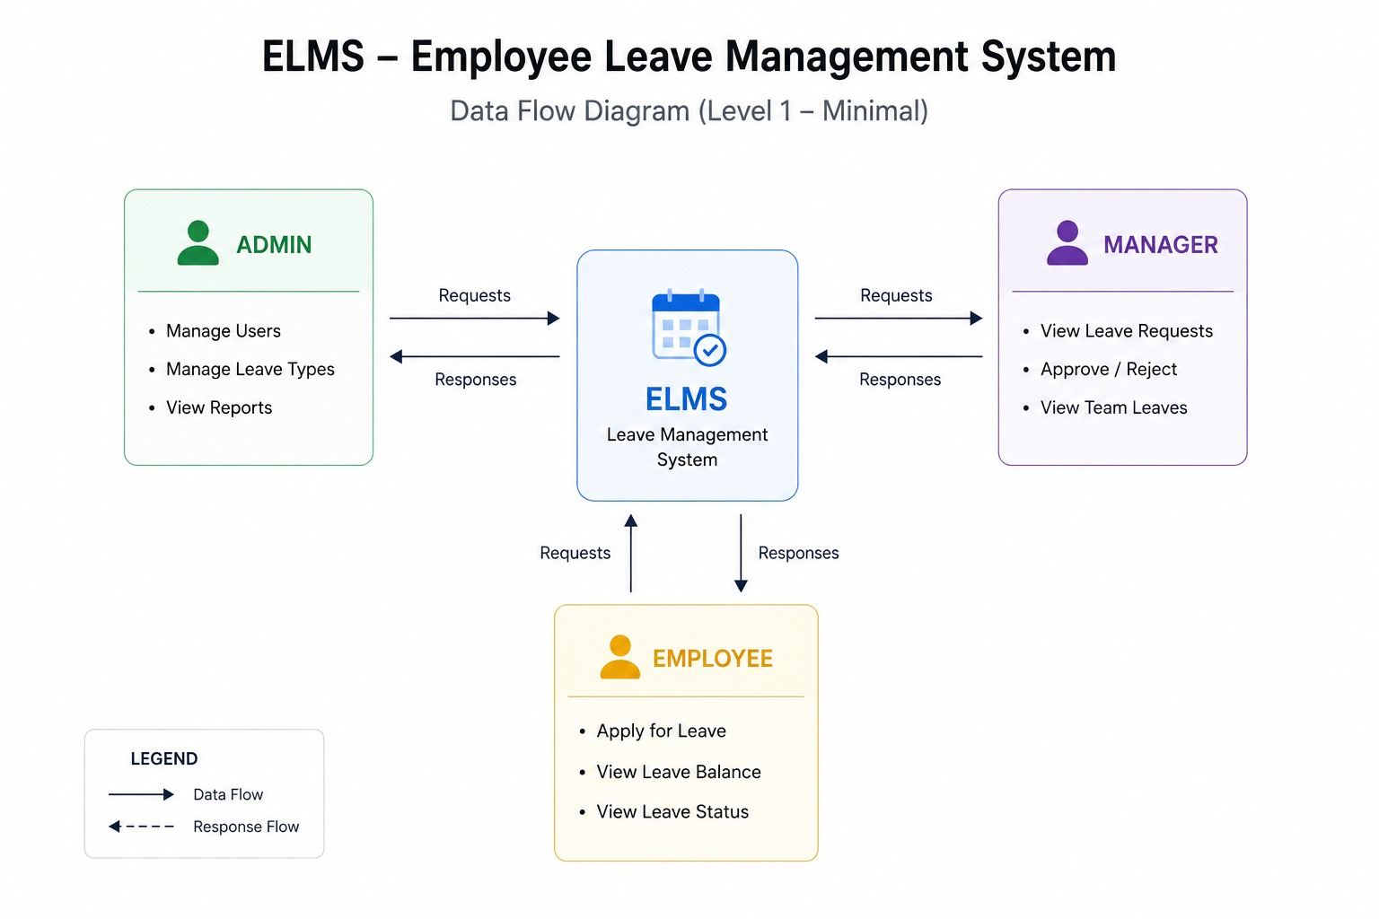

Fig. 2: Data Flow Diagram
The data flow diagram succinctly visualizes how information flows within "EMPLOYEE LEAVE MANAGEMENT SYSTEM" aiding system comprehension efficient.

Screen Shots:
Home page
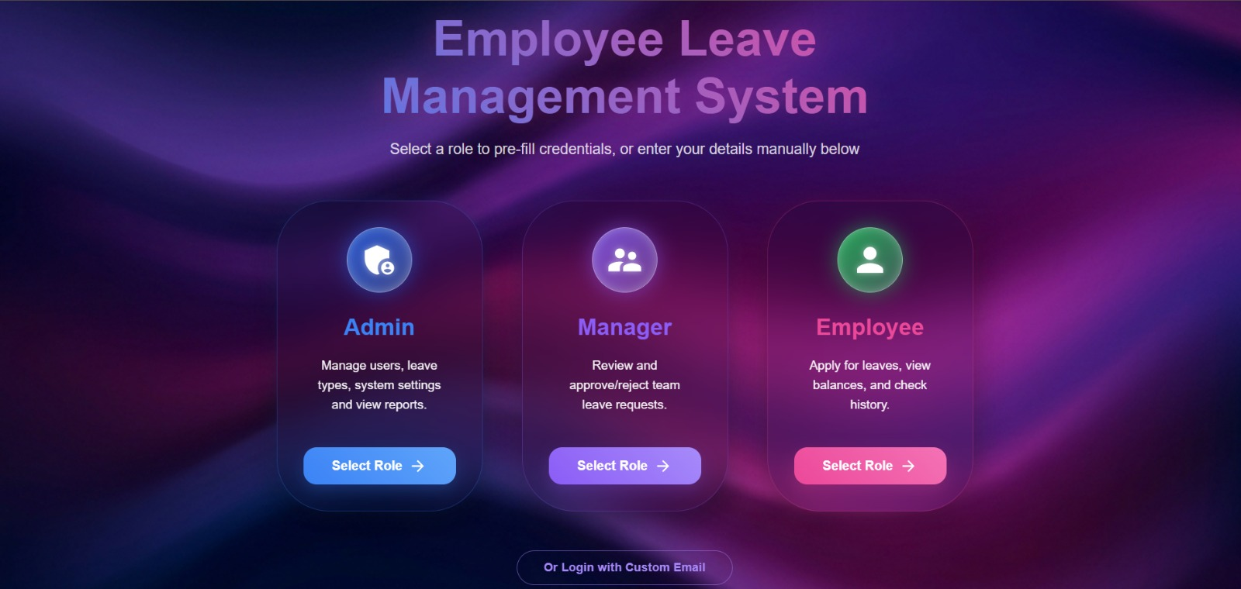

Fig.3: Home Page

SigninPage

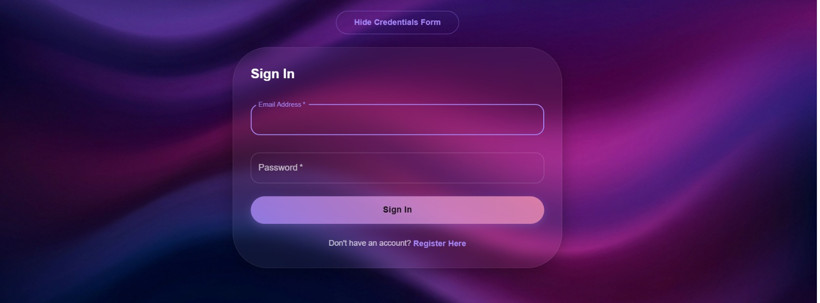

Fig.4: Sign-in Page

Admin dashboard:

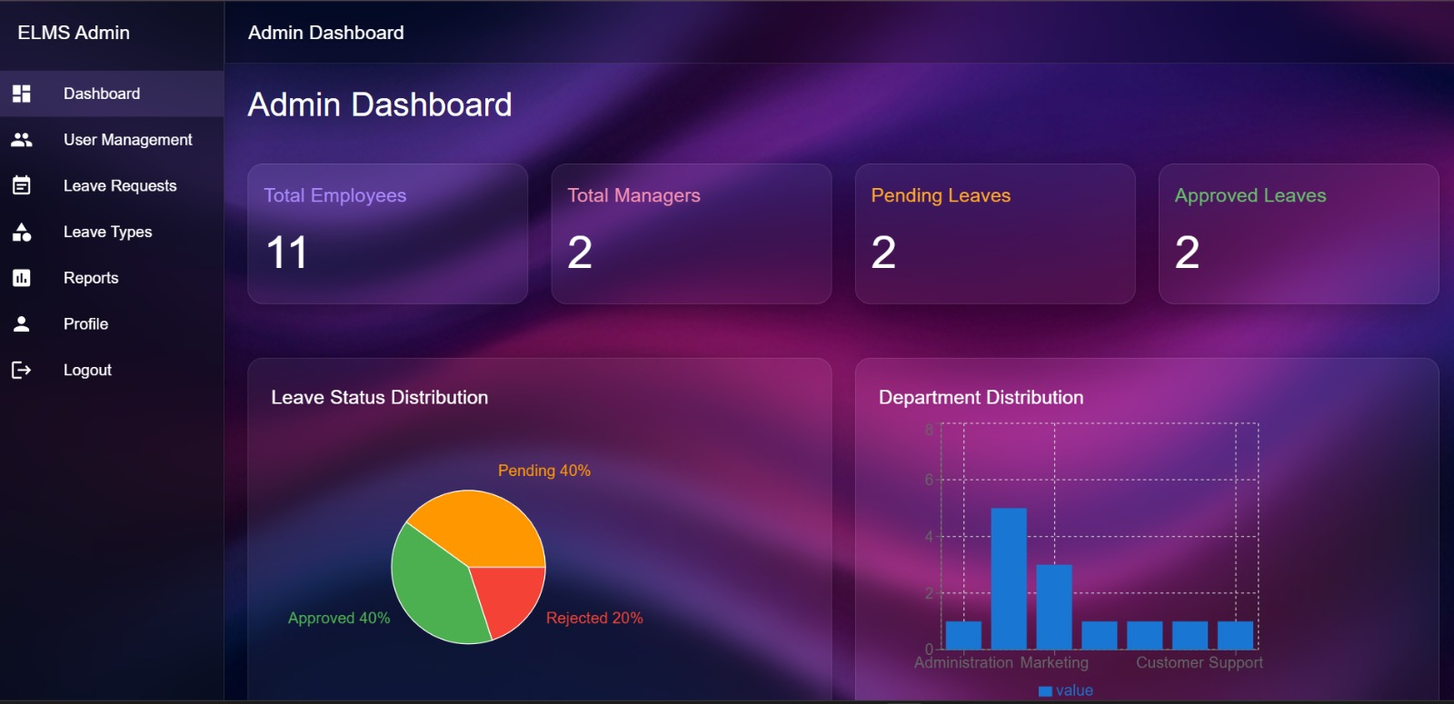

Fig.5: Admin Dashboard

Manager dashboard:
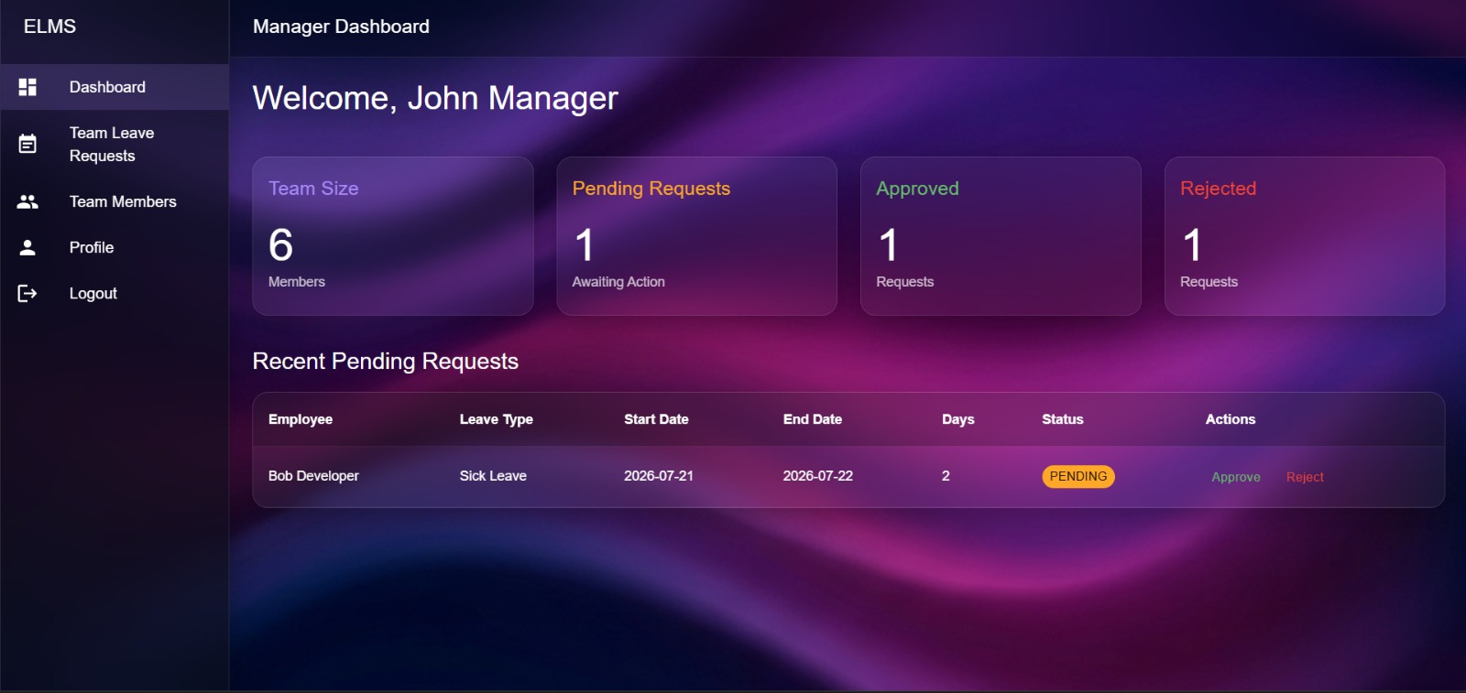

Fig.6: Manager Dashboard

Employee dashboard:
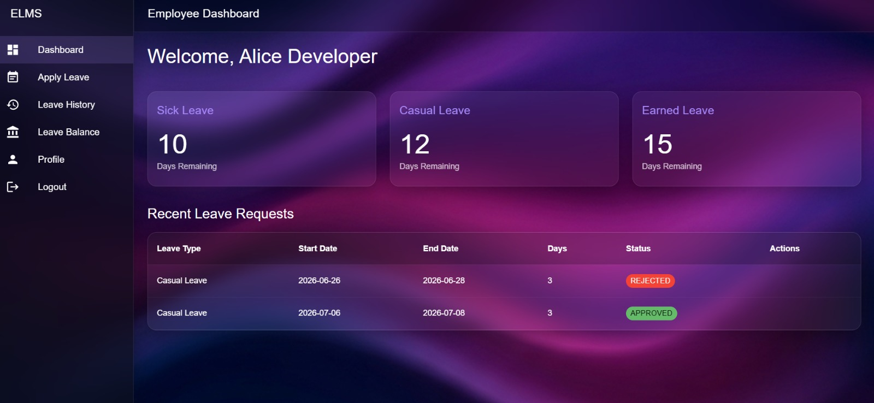

Fig.7: Employee Dashboard

CHAPTER – 6 CONCLUSION

The Employee Leave Management System (ELMS) successfully provides a modern, secure, and efficient solution for managing employee leave in an organization. The project replaces the traditional manual leave management process with a centralized web-based application, making leave requests, approvals, and record maintenance faster and more accurate. By automating these activities, the system reduces paperwork, minimizes human errors, and improves overall organizational efficiency.

The application offers separate dashboards for Admin, Manager, and Employee, ensuring that each user can perform their responsibilities through role-based access control. Employees can easily apply for leave, check their leave balance, and track the status of their requests. Managers can review and approve or reject leave applications, while administrators can manage employees, leave types, and organizational records effectively. The implementation of Spring Security and JWT authentication ensures secure access to the system and protects sensitive organizational data.

Overall, the Employee Leave Management System improves productivity, enhances transparency, and simplifies the leave management process for employees and management alike. It serves as a strong foundation for future enhancements such as attendance management, payroll integration, mobile applications, advanced analytics, and cloud deployment, making it a valuable solution for organizations.

CHAPTER – 7 FUTURE SCOPE

The Employee Leave Management System (ELMS) can be further enhanced by adding advanced features that improve efficiency, security, and user experience. Future versions of the system can integrate with attendance and payroll management systems, enabling automatic updates of employee attendance and salary calculations based on approved leave records.

The system can also include email and SMS notifications to inform employees and managers about leave requests, approvals, rejections, and reminders in real time. A mobile application for Android and iOS can be developed to allow users to access the system anytime and anywhere. Integration with Google Calendar or Microsoft Outlook can help employees keep track of approved leaves and company holidays.

Future enhancements may include Artificial Intelligence (AI) and Machine Learning (ML) to analyze leave patterns, predict employee absenteeism, and assist managers in workforce planning. Advanced reporting and analytics dashboards can provide HR departments with insights into leave trends, employee attendance, and departmental performance.

To improve scalability and reliability, the system can be deployed on cloud platforms such as AWS, Microsoft Azure, or Render. Additional security features like Multi-Factor Authentication (MFA), biometric authentication, and audit logs can further protect sensitive employee information. The system can also support multi-branch and multi-company management, multilingual interfaces, document uploads for medical leave, and customizable leave policies.

Overall, these future enhancements will transform the Employee Leave Management System into a comprehensive Human Resource Management (HRM) solution capable of meeting the evolving needs of organizations while improving productivity, security, and employee satisfaction. comprehensive smart financial planning platform for individuals and organizations.

