Table of Contents

Steps to install all automation components 2

1. Following are the tools and technologies used to create the functional automation solution 2

2. Following are the steps to install Java Application 2

3. Following are the steps to install Eclipse Oxygen 3

4. Following are the steps to install Cucumber plug-in 3

5. Following are the steps to download jar files 4

**Automation Components**

# Steps to install all automation components

## Following are the tools and technologies used to create the functional automation solution

1. Eclipse Oxygen integrated Maven environment
2. JDK 1.8
3. Cucumber Plugins
4. Selenium, Cucumber, Junit jar dependencies

## Following are the steps to install Java Application

1. For Windows: To install the remaining applications, first find out if you have a 32 or 64-bit operating system. This is very important to know as different files are required for each.
2. Download the latest version of Java from “<https://www.oracle.com/java/technologies/javase/javase-jdk8-downloads.html>” and select Java depending on your operating system choose the correct file:



1. Follow the instructions to download java and run the .exe to install Java on your machine. Once installed, then set environment variables to point to the correct installation directories.
2. Setting up the path for windows: Installed Java in c:\Program Files\java\jdk directory

* Right-click on ‘This PC’ and select 'Properties'.
* Click on the 'Environment variables' button under the 'Advanced System settings' tab.
* Altered the 'Path' variable so that it also contains the path to the Java executable. Example, if the path is currently set to 'C:\WINDOWS\SYSTEM32', then change your path to read 'C:\WINDOWS\SYSTEM32; c:\Program Files\java\jdk\bin'.

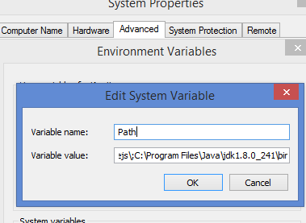

## Following are the steps to install Eclipse Oxygen

1. Click on the below link to process installation

<https://www.eclipse.org/downloads/packages/release/oxygen/3a>

1. Click Eclipse IDE Java EE Developers 64bit depends on the system configuration.

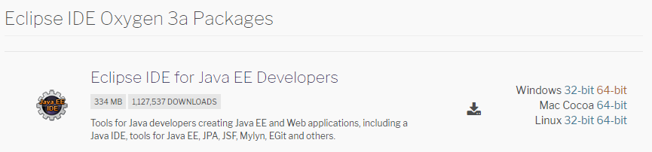

1. Download eclipse-jee-oxygen-3a-win32-x86_64



1. Extract the zip and run the eclipse application.

## Following are the steps to install Cucumber plug-in

1. Launch the Eclipse

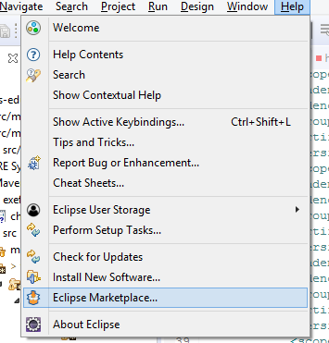

1. Install Cucumber Eclipse Plugin 1.0 and Natural 0.7.6

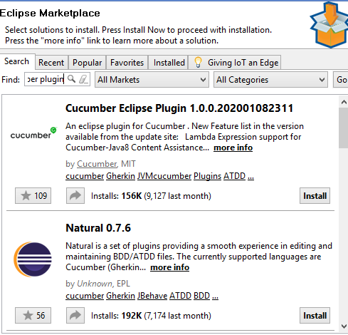

## Following are the steps to download jar files

1. In Eclipse Oxygen, for maven projects we need to add the Selenium, Cucumber, Junit jar dependencies in pom.xml file

* Selenium
* Click <https://mvnrepository.com/search?q=selenium+jars> to add selenium jars dependencies.
* 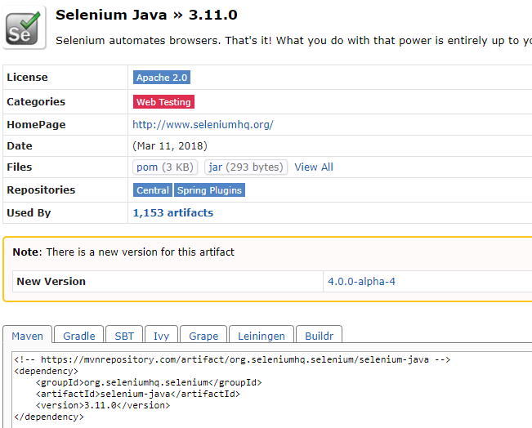
* Junit
* Click to <https://mvnrepository.com/artifact/junit/junit> add junit jars

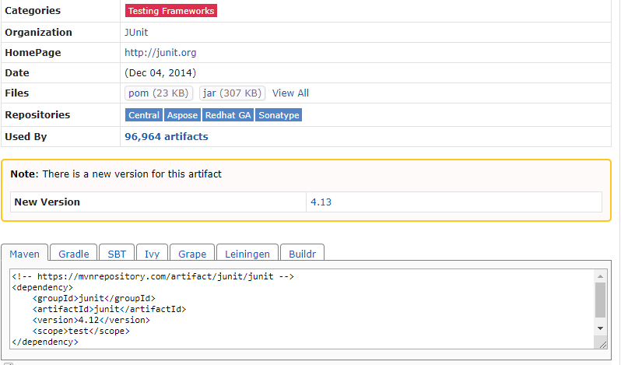

* Cucumber

