**Automation Test scripts Execution**

# Steps to execute automation test scripts execution

## Following are the steps to create Maven Project

1. To create Maven project, navigate to File>New>Maven Project:

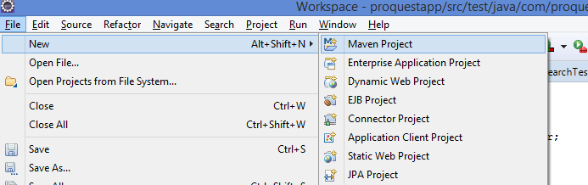

1. Click Next and proceed

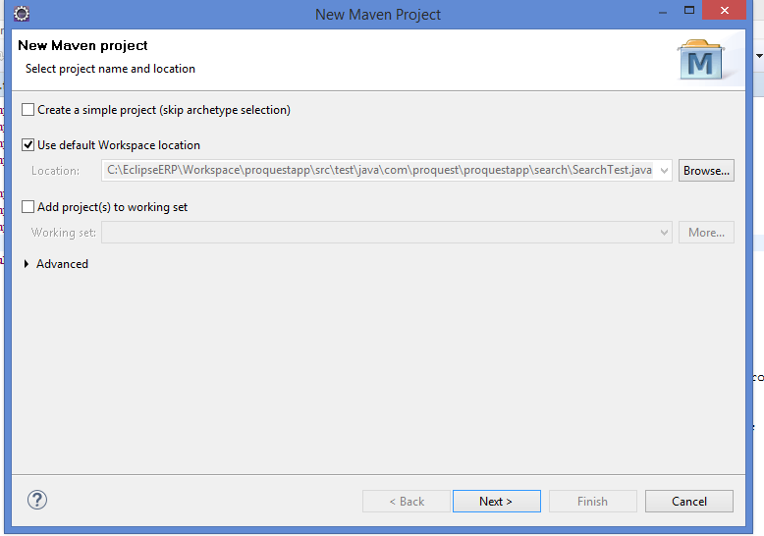

1. Enter Group ID and Artifact IDand click finish.

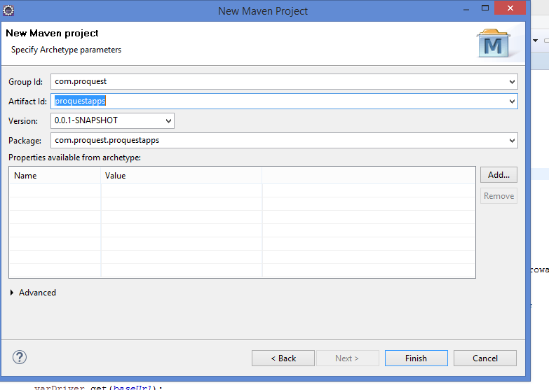

1. After few seconds, the project will be created under Project Explorer

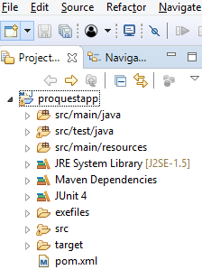

## Following are dependencies in pom.xml

1. In Eclipse Oxygen, for maven projects we need to add the Selenium, Cucumber, Junit jar dependencies in pom.xml file
2. Pom.xml for ProQuest project

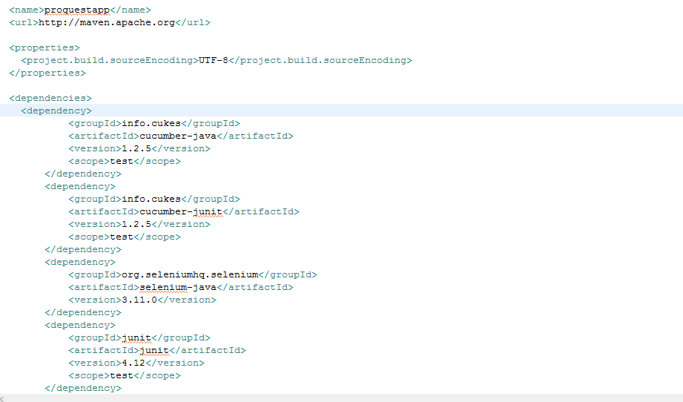

* Selenium
* Click <https://mvnrepository.com/search?q=selenium+jars> to add selenium jars dependencies.

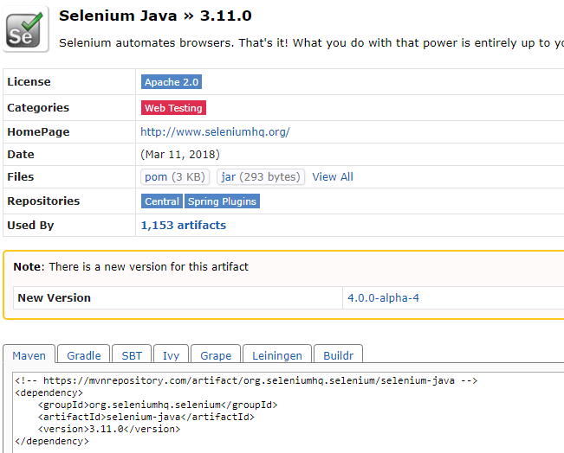

* Junit
* Click to <https://mvnrepository.com/artifact/junit/junit> add junit jars

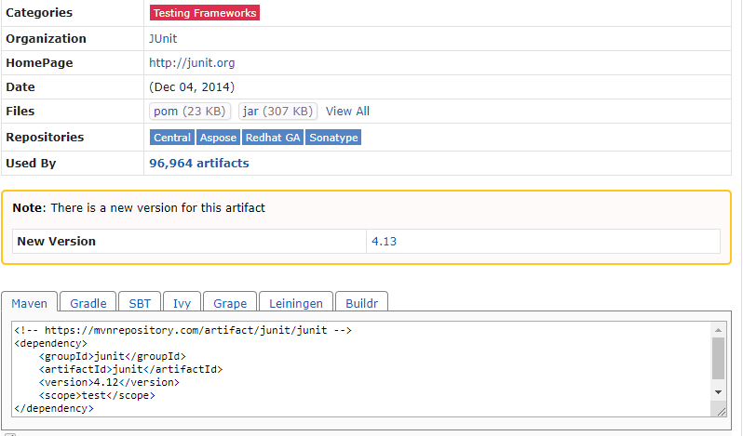

* Cucumber

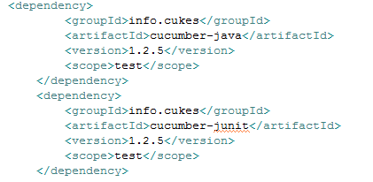

## Following are the steps to add Runner class, step definition and feature file

1. TestMain.java Class

* Right click com.proquest.proquestapp package and add class to it with name of ProquestMain.java. It is the main runner class.
* Write @RunWith(Cucumber.class) annotation, it is a Junit annotation which will help to run the cucumber feature file.

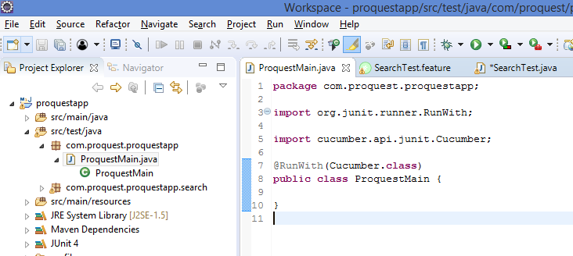

1. Feature.file

* Right Click on ‘src/test/java’ to create a new package ‘com.proquest.proquestapp.search’ for the project feature as a good practice.

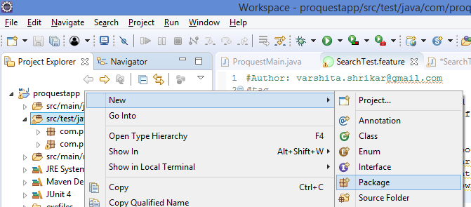

* Right click the new package created and add a feature file, name as ‘search.feature’

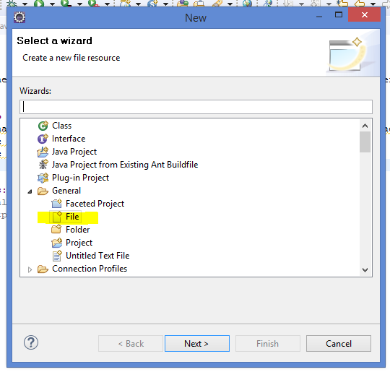

* It should be added as shown below



1. Step Definition class

* Right click the new package created and add a step definition class, name as ‘SearchTest.java’

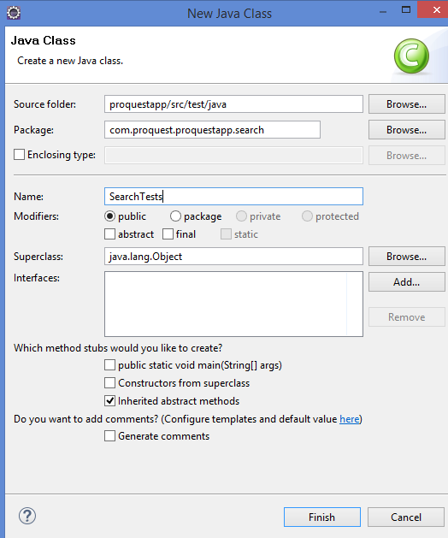

1. It should be added as shown below



## Writing Feature file with Gherkin Language

1. Feature file includes the format of Gherkin language which is business readable created for behaviour descriptions of the requirements. It makes sure that the end to end process workflow is captured.

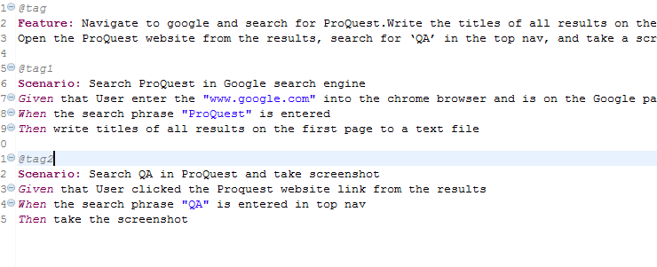

1. Right click and run the feature file as Cucumber Feature.

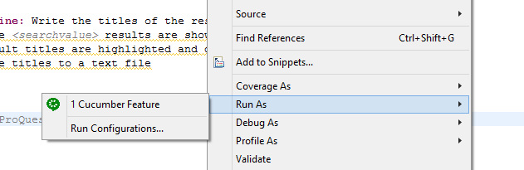

1. You can implement missing steps with the snippets which is generated after running feature file.

## Writing Step definition

1. Import WebDriver and elements

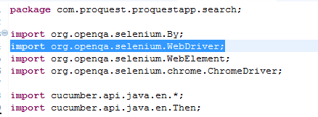

1. Copy the snippets generated and paste in to SearchTest class.
2. Write code in the methods as below

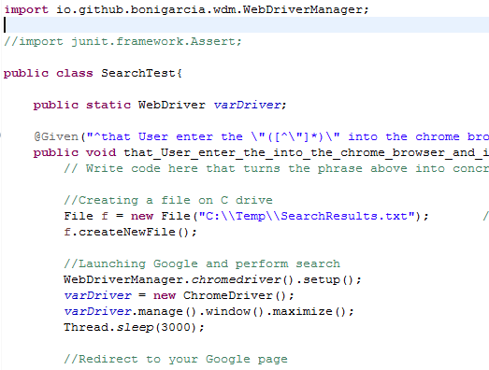

1. Download chrome driver jar and set the property

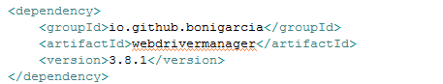

1. Run the runner class file to execute all the automated test scripts.

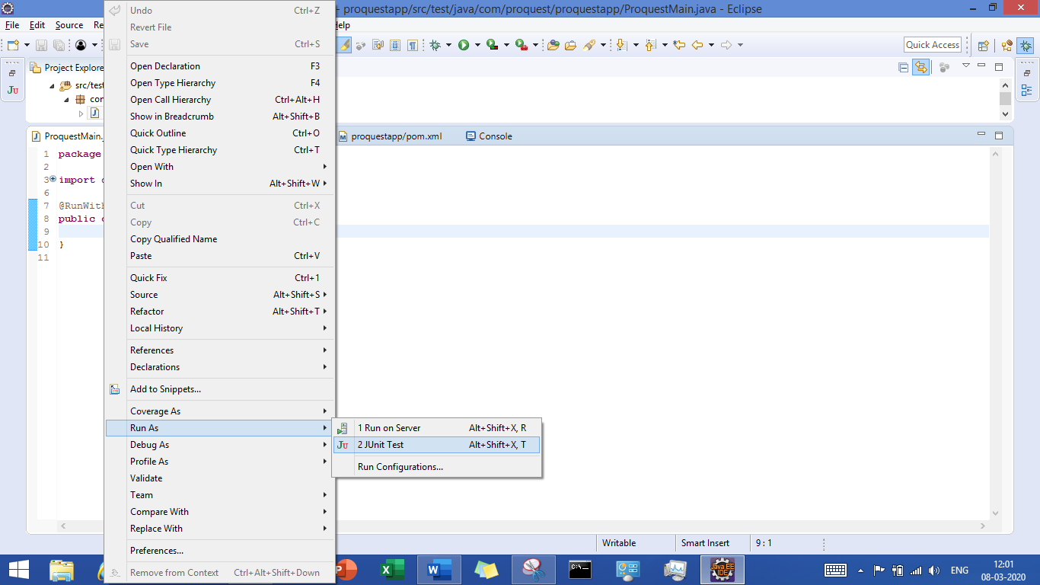

1. We can view the test results as follows

