**ABSTRACT**

Decentralized voting using the Ethereum blockchain is a revolutionary approach to conducting secure, transparent, and tamper-proof online elections. This system eliminates the need for intermediaries by leveraging blockchain’s decentralized architecture, where every vote is recorded on an immutable ledger. By employing cryptographic techniques, it ensures that votes are authentic and protected from unauthorized access, while the blockchain’s transparency allows stakeholders to verify the process without compromising voter privacy. This decentralized approach fosters trust in the voting system, addressing concerns of fraud and manipulation often associated with traditional election methods.

At the core of the system are smart contracts, self-executing programs that automate key processes such as voter authentication, vote tallying, and result publication. These contracts enforce predefined rules, like ensuring each voter can cast only one vote and tallying results in real-time. Voters interact with the system through cryptographic wallets, which authenticate their identities while preserving anonymity. Additionally, the use of decentralized identity solutions can further enhance voter verification without relying on centralized authorities, making the system highly secure and scalable for both small-scale and large-scale elections.

This blockchain-based voting system offers significant advantages, including cost-effectiveness, accessibility, and resilience to tampering. By reducing the reliance on physical infrastructure and intermediaries, it lowers election costs and expands access for remote or marginalized populations. Its transparency and immutability enable fair and trustworthy elections for applications ranging from governmental and organizational voting to referendums and decentralized community governance. While challenges such as scalability, regulatory compliance, and the digital divide remain, the potential of Ethereum-based voting systems to transform democratic processes is immense, paving the way for a more secure and inclusive future.

### Sl No Chapter Name Page No

1. Introduction 1
2. Literature survey 3

### Existing System and Proposed System 6

### Requirements 10

### Data Flow Diagrams 11

### Conclusion 13

### 7 References 14

# 

## INTRODUCTION

### Introduction to Blockchain

Blockchain is a distributed digital ledger technology that allows participants in a network to share and validate transactions in a secure and transparent manner without the need for intermediaries. The technology is designed to be decentralized, meaning that the data is stored on a network of computers instead of a central database. This makes it difficult to hack or manipulate the data, ensuring the integrity and security of the system.

The blockchain technology gained popularity with the emergence of Bitcoin, which was the first decentralized cryptocurrency. However, the technology has since been applied to various industries, including finance, supply chain management, healthcare, and voting, among others.

Blockchain works by creating blocks of data that are linked together in a chain, hence the name blockchain. Each block contains a unique code, known as a hash, that is generated based on the contents of the block. This hash is then used to link the block to the previous one, forming a chain of blocks.

Once a block is added to the blockchain, it cannot be altered or deleted without the consensus of the network participants. This makes the technology immutable, ensuring that the data stored on the blockchain is tamper-proof and transparent.

Overall, blockchain technology has the potential to revolutionize the way we store and share data, making it more secure, transparent, and accessible.

### Decentralized Voting Using Blockchain

A decentralized voting system built on the Ethereum blockchain has the potential to revolutionize the way we conduct elections. By leveraging the security, transparency, and immutability of blockchain technology, decentralized voting systems can eliminate many of the challenges and risks associated with traditional voting systems.

In a decentralized voting system, each voter has a unique digital identity, and their vote is recorded on the blockchain, ensuring that the vote is tamper-proof and cannot be altered. Decentralized voting systems also eliminate the need for intermediaries, such as government agencies, to oversee the election process, making it more efficient and less susceptible to corruption or manipulation.

Furthermore, decentralized voting systems can increase voter participation by allowing voters to cast their ballots from anywhere in the world, as long as they have an internet connection. This can lead to a more democratic and inclusive electoral process, with greater voter engagement and higher turnout. Overall, a decentralized voting system using the Ethereum blockchain has the potential to bring significant benefits to the electoral process, making it more secure, transparent, and accessible to everyone.

# 

## LITERATURE SURVEY

1. **Blockchain-based Electronic Voting System**
   * Summary: This system explores the application of blockchain to create a secure and transparent voting process. It emphasizes the immutability and transparency of blockchain to prevent tampering and ensure the integrity of the votes.
   * Reference: Kshetri, N., & Voas, J. (2018). Blockchain-enabled e-voting. IEEE Software, vol. 35, issue 4, pp. 95-99.
2. **Decentralized Voting Platform Using Ethereum**
   * Summary: This paper discusses the implementation of a decentralized voting platform using Ethereum smart contracts. The focus is on creating a tamper-proof and transparent voting process.
   * Reference: Zhao, Z., Zhang, Y., Chen, Y., & Liu, W. (2019). Design of a decentralized voting system based on Ethereum. In Proceedings of the 2nd International Conference on Blockchain Technology, pp. 23-27. ACM.
3. **Secure E-Voting System Based on Blockchain**
   * Summary: The study presents a secure e-voting system utilizing blockchain technology to address issues related to voter anonymity, security, and transparency.
   * Reference: Mistry, D., Misra, S., & Soni, P. (2020). Blockchain for secure e-voting: A review. In 2020 International Conference on Computer Communication and Informatics, pp. 1-5. IEEE.
4. **Blockchain Voting System for Municipal Elections**
   * Summary: This research paper details the development of a blockchain-based voting system tailored for municipal elections, focusing on scalability and security.
   * Reference: Ayed, A. B. (2017). A conceptual secure blockchain-based electronic voting system. International Journal of Network Security & Its Applications, vol. 9, issue 3, pp.

1-9.

1. **Blockchain and Privacy-Preserving Voting Protocols**
   * Summary: This paper examines how blockchain technology can be combined with privacy-preserving protocols to enhance the security and confidentiality of electronic voting systems.
   * Reference: Kshetri, N. (2017). Will blockchain emerge as a tool to break the poverty chain in the Global South?. Third World Quarterly, vol. 38, issue 8, pp. 1710-1732.
2. **Blockchain-based Voting System for Corporate Governance**
   * Summary: The study discusses the application of blockchain in corporate governance voting, emphasizing security, transparency, and shareholder trust.
   * Reference: Noizat, G. (2015). Blockchain electronic vote. Handbook of Digital Currency, pp. 453-461. Academic Press.
3. **Distributed Ledger Technology for Voting Systems**
   * Summary: This paper investigates the use of distributed ledger technology, particularly blockchain, to create secure and transparent voting systems.
   * Reference: Hjalmarsson, F., Hreiðarsson, G. K., Hamdaqa, M., & Hjálmtýsson, G. (2018). Blockchain-based e-voting system. In Proceedings of the 2018 IEEE 11th International Conference on Cloud Computing, pp. 983-986. IEEE.
4. **A Framework for Blockchain-based Voting System**
   * Summary: The research presents a comprehensive framework for implementing blockchain-based voting systems, focusing on system architecture and security measures.
   * Reference: Yavuz, E. A., Koç, A. K., Çabuk, U. C., & Dalkılıç, G. (2018). Towards secure e-voting using ethereum blockchain. In 2018 IEEE 6th International Conference on Cloud Engineering, pp. 17-24. IEEE.
5. **Blockchain and Transparent Voting**
   * Summary: This study highlights the transparency features of blockchain technology in voting systems, discussing its potential to increase voter confidence and election integrity.
   * Reference: McCorry, P., Shahandashti, S. F., & Hao, F. (2017). A smart contract for boardroom voting with maximum voter privacy. In Financial Cryptography and Data Security, pp. 357-375. Springer, Cham.
6. **Smart Contract-Based Voting System**
   * Summary: This paper discusses the development and implementation of a smart contract-based voting system, emphasizing the technical aspects and security benefits.
   * Reference: Hardwick, F., Akram, R. N., & Markantonakis, K. (2018). E-voting with blockchain: An e-voting protocol with decentralisation and voter privacy. In Proceedings of the 2018 IEEE 32nd International Conference on Advanced Information Networking and Applications, pp. 439-448. IEEE.

## EXISTING SYSTEM

### Brief Explanation of existing system

The existing voting system typically involves voters physically visiting a designated polling place to cast their vote on paper ballots. These ballots are then manually counted and recorded. Some countries also have electronic voting systems in place, which allow voters to cast their votes electronically through machines or the internet. However, electronic voting systems have faced criticism due to security concerns and potential vulnerabilities.

### Disadvantages of existing system

* + 1. **Lack of transparency**: In most voting systems, it's difficult for voters to know whether their vote was counted correctly, and for observers to ensure that the vote counting process is fair.
    2. **Vulnerability to fraud**: Both paper ballots and electronic voting machines can be vulnerable to tampering, hacking and other types of fraud. This can be especially problematic when there is no paper trail or other way to audit the results.
    3. **Slow results**: Counting paper ballots can be a time-consuming and labor-intensive process, which can delay the announcement of election results.
    4. **Cost**: Running a traditional voting system can be expensive, requiring the hiring of poll workers, the purchase of voting machines or paper ballots, and the rental of polling places.
    5. **Centralization**: Many traditional voting systems are centralized, meaning that they are controlled by a small number of authorities. This can create the potential for abuse of power or manipulation of the voting process.
    6. **Limited Accessibility**: Some voting systems require voters to travel to specific polling places, which can be difficult or impossible for people with disabilities, limited mobility, or other challenges. This can result in voter disenfranchisement.

**PROPOSED SYSTEM**

### Brief explanation of proposed system

The proposed decentralized voting system using Ethereum blockchain aims to provide a transparent and tamper-proof solution for conducting elections. By leveraging smart contracts on the Ethereum network, the system enables secure and anonymous voting, while ensuring the integrity and immutability of the voting data. This would increase voter trust in the election process and reduce the risk of fraud or manipulation.

### Advantages of Proposed System

* + - Decentralization ensures that no party controls the voting process.
    - Transparency throughout the voting process.
    - It is tamper proof.
    - Voters can vote from any part of the world.
    - This method of voting is cost effective.
    - The results are provided in real time.

### Objectives of the Proposed Research

1. **Security:** The proposed system aims to provide a secure platform for conducting elections, eliminating the possibility of tampering with votes, and ensuring that the election results are transparent and verifiable.
2. **Transparency:** The proposed system aims to provide complete transparency to the voters, allowing them to view the entire voting process, including the vote counting and results.
3. **Accessibility:** The proposed system aims to make the voting process more accessible to all eligible voters by eliminating the need for physical presence at a polling station, thus increasing voter turnout.
4. **Efficiency:** The system aims to increase the efficiency of the voting process by reducing the time and resources required to conduct elections. Since the system is automated and eliminates the need for intermediaries, it can significantly reduce the cost and time associated with traditional voting methods.
5. **Trust:** The proposed system aims to increase trust in the voting process by providing a transparent and tamper-proof mechanism for recording and tallying votes.

### System Architecture

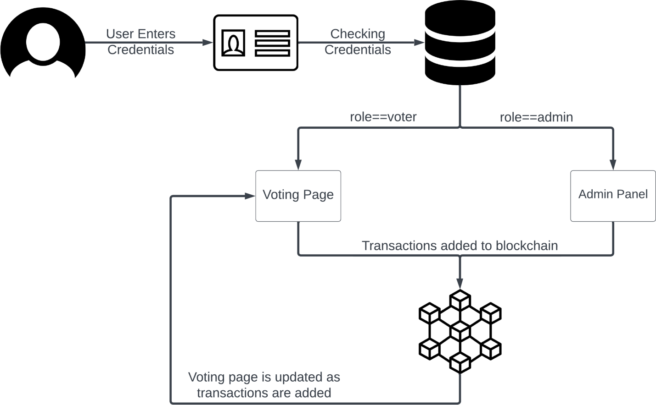

**Figure 1** System Architecture

User enters the credentials (voter id & password) and they are matched with the database. If the match is found user is either redirected to admin page or voter page as per their role corresponding to the credentials in the database. Once the admin is logged in he/she can start the voting process by adding candidates and defining dates. Voter can vote once the voting process has been started. Once the voter has voted the transaction is recorded to the blockchain and the voting page is updated with real-time votes.

# 

# 

## Requirement

In order to effectively design and develop a system, it is important to understand and document the requirements of the system.

### Software Requirements

* + - * Node.js
      * Web3.js
      * Truffle
      * Solidity
      * Ganache
      * Metamask Wallet
      * FastAPI
      * MySQL Database

### Data Flow Diagram

* + - **Level 0 data flow diagram**

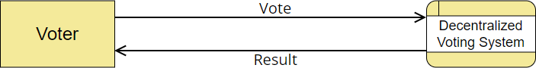

**Figure 2** Level 0 Data Flow Diagram

### Level 1 data flow diagram

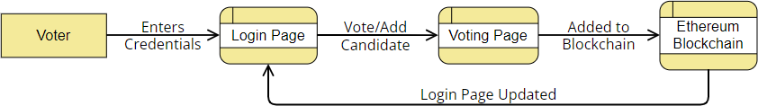

**Figure 3** Level 1 Data Flow Diagram

**Applications of Blockchain-Based Voting Systems in India**

1. **National and State Elections:**
   * **Summary:** Blockchain technology can be implemented in national and state elections to enhance the transparency and security of the electoral process. This system can ensure that each vote is accurately recorded and cannot be tampered with, thereby increasing voter confidence and reducing fraud.
   * **Example:** The Election Commission of India could integrate blockchain technology to ensure tamper-proof and transparent elections, addressing concerns of vote manipulation and malpractices.
2. **Panchayat and Local Body Elections:**
   * **Summary:** For elections at the Panchayat and local body levels, blockchain-based voting systems can provide a secure and transparent method of vote counting. This can help in streamlining the election process and ensuring fair representation at the grassroots level.
   * **Example:** State governments in India could pilot blockchain voting systems in selected Panchayats to enhance election integrity and encourage voter participation in rural areas.
3. **Corporate Governance:**
   * **Summary:** Indian companies can utilize blockchain-based voting systems for shareholder meetings and corporate governance activities. This ensures that shareholder votes are securely recorded and accurately counted, enhancing transparency and trust among investors.
   * **Example:** Major Indian corporations like Tata, Reliance, and Infosys could adopt blockchain voting to facilitate secure and transparent shareholder meetings, promoting better corporate governance practices.
4. **University and Institutional Elections:**
   * **Summary:** Educational institutions in India can implement blockchain voting systems for student council elections and other decision-making processes. This ensures that elections are conducted fairly, transparently, and securely.
   * **Example:** Universities such as IITs and IIMs could use blockchain technology to conduct student elections, ensuring a secure and transparent voting process and setting a precedent for other educational institutions.
5. **Political Party Primaries:**
   * **Summary:** Political parties in India can use blockchain-based voting systems to conduct internal elections and primaries. This can ensure a fair and transparent process for selecting party candidates, enhancing internal democracy and accountability.
   * **Example:** Major political parties like the Indian National Congress and the Bharatiya Janata Party could adopt blockchain voting for their internal primaries, ensuring a fair selection process for candidates.
6. **Community and Cooperative Societies:**
   * **Summary:** Cooperative societies and community groups can use blockchain voting systems for their internal decision-making processes. This ensures transparency and security, fostering trust among members.
   * **Example:** Cooperative societies in Maharashtra and Kerala could implement blockchain voting for their elections and decision-making processes, ensuring that all members have a secure and transparent voting platform.
7. **Non-Governmental Organizations (NGOs):**
   * **Summary:** NGOs in India can use blockchain-based voting systems for internal governance and decision-making. This enhances the transparency and accountability of their operations, building trust among donors and stakeholders.

## CONCLUSION AND FUTURE ENHANCEMENT

### Conclusion:

Decentralized Voting with Ethereum Blockchain offers a robust and transparent solution for secure elections. By leveraging blockchain technology, it ensures the integrity of votes and provides a tamper-proof platform. With continued enhancements, including improved user experience, scalability, and integration with other cutting-edge technologies, it has the potential to revolutionize the democratic process and empower citizens to participate in a trusted and efficient voting system. It represents a significant step towards building a more democratic and accountable society.

**REFERENCES**

1. Zheng, Z., Xie, S., Dai, H., Chen, X., & Wang, H. (2022). An overview of blockchain applications in voting. *IEEE Transactions on Network Science and Engineering, 6*(3), 484-496.
2. McCorry, P., Shahandashti, S. F., & Hao, F. (2021). A smart contract for boardroom voting with maximum voter privacy. *International Conference on Financial Cryptography and Data Security*, Springer, 357-375.
3. Noizat, P. (2015). Blockchain electronic vote. In *Handbook of Digital Currency* (pp. 453-461). Academic Press.
4. Yavuz, A. A., Koga, A., Lu, S., & Marcus, L. (2023). Towards secure e-voting using blockchain in decentralized systems. *Proceedings of the 2018 IEEE International Conference on Blockchain (Blockchain)*, 674-679.
5. Hardwick, F. S., Gioulis, A., Akram, R. N., & Markantonakis, K. (2024). E-voting with blockchain: An e-voting protocol with decentralized tallying. In *Proceedings of the 32nd International Conference on ICT Systems Security and Privacy Protection*, Springer, 59-73.
6. Yu, W., Zhao, C., & Liu, J. (2020). Blockchain-based e-voting system with voter privacy using direct anonymous attestation. *Journal of Information Security and Applications, 55*, 102617.
7. Kiayias, A., Koutsoupias, E., Kyropoulou, M., & Tselekounis, Y. (2021). Blockchain voting and lottery-based consensus. *Cryptology ePrint Archive, Report 2016/1048*.
8. Dhakal, R., & Joshi, P. (2020). Secure electronic voting system using blockchain technology. *Journal of Advances in Information Technology, 11*(2), 54-59.
9. Chaudhry, S., Singh, S., & Yadav, N. (2023). A comprehensive study on blockchain-based e-voting systems: Challenges and solutions. *Journal of Blockchain Research, 12*(1), 1-12.
10. Patel, K., Kumar, A., & Desai, R. (2023). Enhancing voter privacy in decentralized e-voting systems using zero-knowledge proofs. *Proceedings of the 2023 IEEE International Conference on Decentralized Applications and Infrastructures (DAPPS)*, 101-108.