**RECOSENSE ASSIGNMENT**

**1. Admin Page**

This is a User Admin page with has complete access to all the posts and User login and Registrations to the blog.

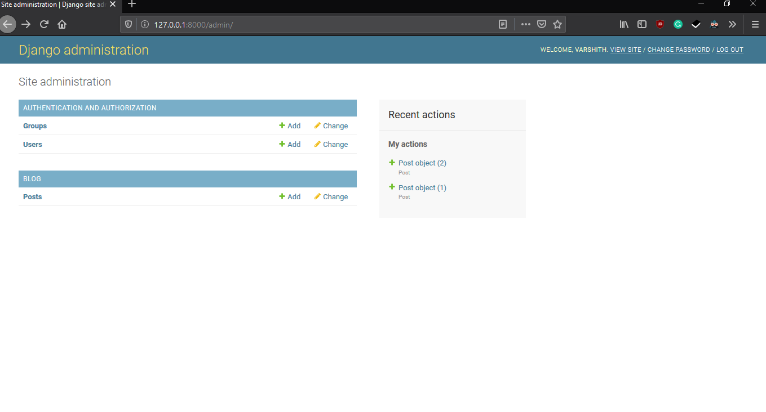

**2. Login Page**

User can login and start using the blog or new user can register.

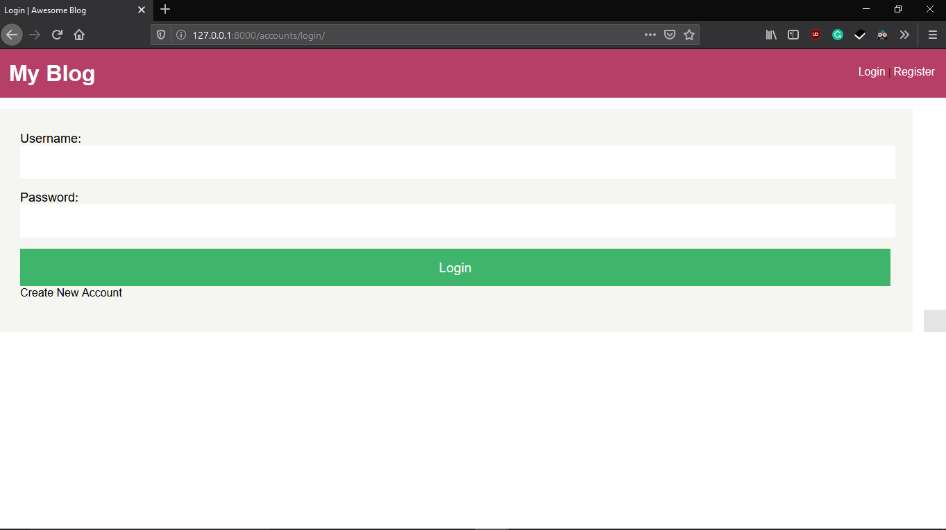

**3. Home Page**

This page of the blog displays all the posts published by the User. A User can publish a new post via the “+ New Post” Option. A User can also Logout from this blog via home page.

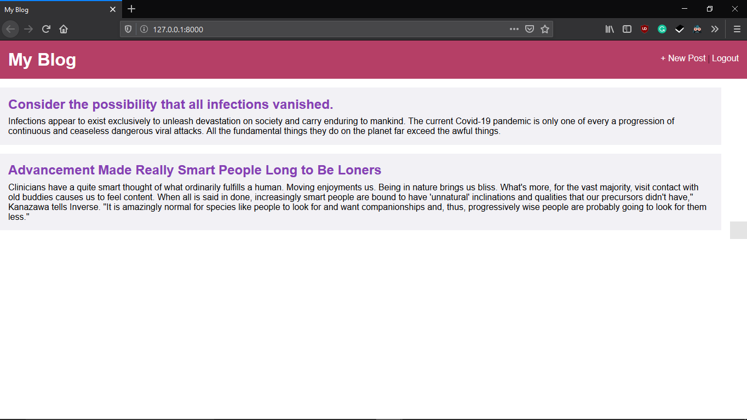

**4. Post Publish Page**

This page is used to publish a new post to the blog. The content is displayed on home page.

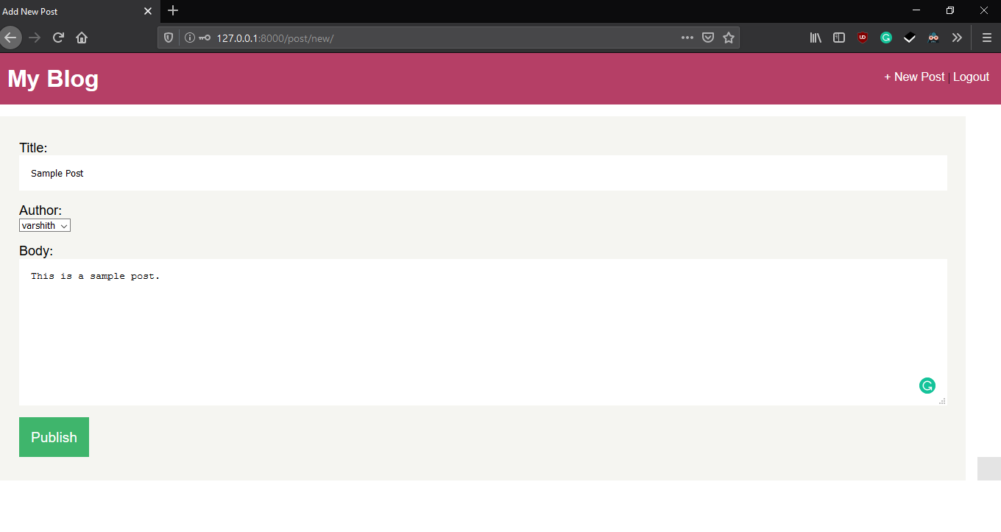

**5. Post Content Page**

This page of the blog is used to for editing the post, for deleting the post and to view the complete content of the post.

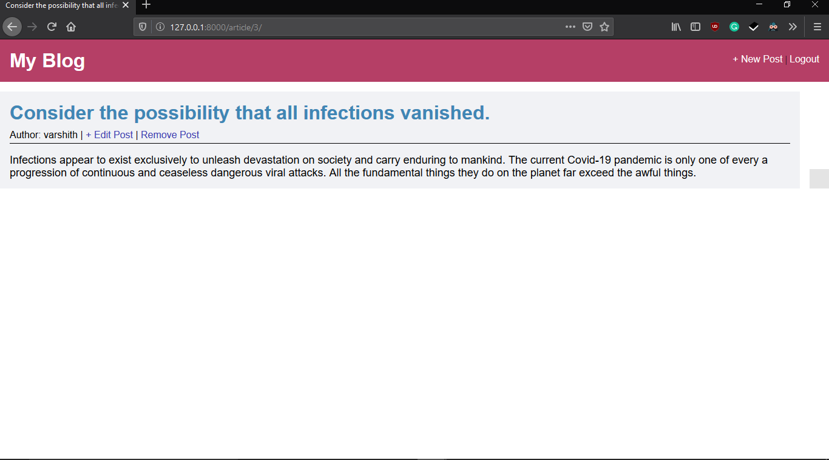

GitHub (code) - <https://github.com/Varshith-Y/Blog>