FORM-2
THE PATENTS ACT, 1970
(39 OF 1970)
AND
THE PATENT RULES, 2003
(As Amended)

COMPLETE SPECIFICATION
(SECTION 10; RULE 13)

TITLE
AN EFFICIENT DEEP LEARNING MODEL FOR ACCURATE RECOGNITION AND CLASSIFICATION OF CROP PESTS BY USING DEEPPESTNET
APPLICANT
Mrs.M.Harshini Faculty, P.Pavani, T.Katyayini, P.Soumith Reddy, M.Varshith Kumar Student, Department of Information Technology, MLR Institute of Technology, Hyderabad, Telangana, India, and Indian National.

The following specification particularly describes the nature of the invention and the manner in which it is to be performed.

AN EFFICIENT DEEP LEARNING MODEL FOR ACCURATE RECOGNITION AND CLASSIFICATION OF CROP PESTS BY USING DEEPPESTNET

Field of the Invention
The present invention relates to the field of artificial intelligence–based automated recognition systems, and more particularly to a lightweight deep learning framework capable of recognizing, classifying, and analyzing real-world entities across multiple domains including agriculture, healthcare, manufacturing, and environmental monitoring. The invention addresses the limitations of traditional recognition methods by providing an efficient, scalable, and deployable computational system suitable for resource-constrained environments. The framework utilizes advanced machine learning and computer vision techniques to extract meaningful features from complex datasets and generate accurate predictions while maintaining computational efficiency.
Objectives of the Invention
The primary objective of the present invention is to provide an intelligent automated recognition system capable of accurately identifying objects, anomalies, or patterns from real-world data using optimized deep learning techniques. Another objective is to design a lightweight architecture suitable for deployment on low-resource platforms such as mobile devices, IoT systems, and drones without significant degradation in performance. A further objective is to reduce dependency on manual observation and expert intervention by enabling automated decision-support capabilities, particularly in domains such as agriculture and healthcare. Another objective is to provide a scalable framework adaptable across domains with minimal modifications, provided domain-specific training datasets are available. An additional objective is to enhance robustness against environmental variability such as lighting conditions, background complexity, and orientation differences, thereby ensuring reliability in real-world conditions.
Background of the Invention
Across multiple technical domains, recognition and classification tasks have traditionally relied on manual observation and expert interpretation. In agriculture, for example, pest detection has historically been performed through direct visual inspection by farmers or agricultural specialists, requiring identification of morphological characteristics such as shape, color, and texture. While such approaches benefit from human expertise, they are inherently time-consuming, subjective, and prone to error, particularly when environmental conditions vary or when objects exhibit high visual similarity. Similar limitations exist in healthcare, where diagnostic interpretation of medical images has depended heavily on trained specialists, and in engineering and manufacturing sectors where defect detection has been performed through manual inspection of products or structures. These manual approaches present significant challenges of scalability, speed, and consistency, especially in large-scale or time-critical applications.
In order to overcome the limitations of purely manual techniques, early computational methods were developed that introduced partial automation using image processing and statistical analysis. Such approaches relied on handcrafted feature extraction techniques, including color histograms, texture descriptors, and edge detection algorithms, followed by classification using statistical or rule-based methods. Although these techniques improved objectivity compared with manual observation, they remained highly dependent on feature engineering and required domain experts to design and tune features manually. Consequently, their performance was often unstable when applied to diverse real-world datasets, as variations in lighting, scale, background complexity, or environmental noise significantly affected results.
Subsequent advances introduced classical machine learning algorithms such as support vector machines, decision trees, random forests, and nearest-neighbor classifiers, which enabled more structured and accurate prediction compared to purely statistical methods. These models demonstrated improvements in classification performance across domains including crop disease detection, medical diagnosis, and industrial inspection. However, classical machine learning systems still depended heavily on the quality of extracted features and struggled to handle large, complex datasets with high variability. Their limited capacity to automatically learn hierarchical representations restricted their adaptability and scalability in real-world environments.
Despite significant technological progress, several challenges continue to hinder the widespread adoption of automated recognition systems. Many existing solutions require high computational power, expensive hardware resources, or highly skilled operators, making them unsuitable for deployment in resource-constrained settings such as rural agricultural regions or small medical facilities. Additionally, a substantial gap remains between laboratory-level research and practical implementation, as systems that perform effectively under controlled conditions often fail when exposed to dynamic, unpredictable real-world environments.
Another persistent issue is the inability of existing approaches to simultaneously achieve accuracy, scalability, and accessibility. In agriculture, pest outbreaks can destroy a significant portion of crop yield, yet timely detection is difficult because manual monitoring is labor-intensive and error-prone. In healthcare, delays or inaccuracies in diagnosis may occur due to overburdened systems or insufficient computational resources. In engineering and industrial domains, inefficiencies in monitoring and predictive maintenance may result in increased costs and reduced reliability. These diverse challenges share a common underlying limitation: conventional systems lack the robustness, efficiency, and adaptability required for real-world deployment across varying operational conditions.
Furthermore, many current artificial intelligence models depend on extensive datasets and high-performance computing infrastructure for training and execution, which are not always available in practical environments. This limitation restricts accessibility and prevents widespread adoption, particularly in developing regions where technological resources are limited. High implementation costs, maintenance requirements, and data acquisition constraints further hinder practical deployment.
In addition, environmental variability presents a major obstacle to reliable recognition. Real-world data may exhibit fluctuations in lighting, orientation, scale, background complexity, and object density, all of which can degrade system performance if not properly addressed. Conventional models trained on limited or homogeneous datasets frequently fail when applied to new geographic regions or operational contexts, highlighting the need for approaches capable of robust generalization.
Recent advances in artificial intelligence, particularly machine learning and deep learning, have demonstrated the potential to address these challenges by enabling systems to learn patterns directly from large datasets and generate accurate predictions. Complementary technologies such as the Internet of Things, cloud computing, and edge computing further enhance system capabilities by supporting real-time monitoring, scalable data processing, and reduced latency. These developments indicate that intelligent automated recognition systems can transform traditional problem-solving methods into proactive, data-driven solutions.
Nevertheless, there remains a need for an improved technological solution that combines high accuracy, computational efficiency, adaptability, and accessibility in a single framework suitable for deployment in real-world environments. Such a system should be capable of operating reliably under variable conditions, require minimal computational resources, and be scalable across different application domains. The present invention addresses these needs by providing a lightweight intelligent recognition framework specifically designed to bridge the gap between research-level models and practical field-level deployment.

Summary of the Invention
The present invention proposes a lightweight intelligent recognition framework based on deep learning techniques for automated detection and classification of real-world entities. The system collects input data, such as images or sensor signals, and processes them through preprocessing modules that perform normalization, resizing, and augmentation to enhance robustness against environmental variations. The processed data is then analyzed using a convolutional neural network architecture optimized for computational efficiency while maintaining high accuracy. The framework incorporates transfer learning strategies to leverage pretrained models and improve performance when training data is limited. The system includes evaluation mechanisms employing metrics such as accuracy, precision, recall, F1-score, and confusion matrices to assess reliability and effectiveness. The architecture is designed for real-world deployment and can operate on mobile devices, embedded systems, or drones, thereby enabling practical field applications. The proposed invention offers scalability across multiple domains including agriculture, healthcare diagnostics, industrial inspection, and environmental monitoring, thus providing a versatile and adaptable recognition platform.

Brief Description of Drawings
The invention may be better understood with reference to the accompanying drawings:
Figure 1: Overall architecture of the lightweight recognition framework.
Figure 2: Data preprocessing and feature extraction pipeline.
Figure 3: Training and inference workflow of the deep learning model.
Detailed Description of the Invention
The present invention relates to a lightweight intelligent recognition framework employing deep learning techniques for automated detection, classification, and analysis of objects and patterns in real-world environments. The invention provides an efficient, scalable, and accurate system capable of operating across multiple domains including agriculture, healthcare, industrial inspection, and environmental monitoring, where automated analysis is required to reduce manual effort, improve reliability, and enable timely decision-making. The system is specifically designed to function effectively in real-world scenarios characterized by environmental variability, noise, and complex backgrounds while maintaining computational efficiency suitable for deployment on resource-constrained devices.
In one embodiment, the system comprises a data acquisition module configured to receive input from cameras, mobile devices, drones, or sensor platforms. The collected data may include images, video frames, or sensor signals representing real-world observations. A preprocessing module prepares the raw input through resizing, normalization, noise filtering, and augmentation operations. Resizing standardizes input dimensions to ensure compatibility with learning algorithms and to improve processing efficiency, while normalization and augmentation enhance generalization capability and robustness against variations in lighting, orientation, and environmental conditions.
The processed data is forwarded to a feature extraction module implemented using deep convolutional neural networks configured to identify meaningful characteristics such as edges, textures, shapes, and color patterns. Convolutional layers capture spatial relationships, pooling layers reduce dimensionality, and residual connections enable deeper architectures while improving training stability. In certain embodiments, a multi-scale feature representation module generates hierarchical feature maps at multiple resolutions, enabling detection of objects appearing at different sizes or distances within an image.
The invention may further incorporate an attention mechanism configured to emphasize relevant spatial regions while suppressing irrelevant background information, thereby improving detection accuracy in cluttered or partially occluded scenes. A classification and detection module then produces prediction outputs by assigning probability scores to predefined categories and, where required, estimating spatial coordinates of detected objects through regression components.
In another embodiment, supplementary machine learning models such as decision trees or ensemble classifiers may be integrated to provide interpretability or statistical analysis. The framework further includes a training module configured to learn parameters from labeled datasets partitioned into training, validation, and testing subsets to ensure reliable evaluation. Optimization is performed through forward propagation, loss computation, and backpropagation using gradient-based algorithms, with regularization techniques such as dropout and batch normalization applied to prevent overfitting and improve generalization. The trained system is evaluated using quantitative metrics including accuracy, precision, recall, F1-score, and detection performance measures, together with inference speed to determine real-time feasibility.
Visualization tools may be provided to highlight regions influencing predictions, thereby improving transparency and user confidence. Following training, the model may be optimized for deployment through compression techniques such as quantization and pruning, allowing execution on mobile or embedded platforms without significant performance degradation. The framework is capable of detecting small or clustered objects, adapting to environmental variability, and operating under limited hardware resources, thereby making it suitable for practical field applications. Accordingly, the present invention provides a robust, adaptable, and computationally efficient recognition framework that integrates advanced deep learning techniques with optimized architectural design and deployment strategies. The invention enhances automation, improves analytical accuracy, and enables scalable real-world implementation across diverse domains, thereby representing a significant advancement in intelligent recognition technologies.

The scope of the invention is defined by the following claims:
Claims
1. A lightweight intelligent recognition system comprising:
a) a data acquisition module configured to receive real-world input data;
b) a preprocessing module configured to normalize and augment the input data;
c) a deep learning module configured to extract features and classify patterns; and
d) an evaluation module configured to measure system performance.
2. The system according to claim 1, wherein the deep learning module utilizes convolutional neural network architecture optimized for computational efficiency.
3. The system according to claim 1, wherein the system is deployable on resource-constrained devices including mobile devices, embedded systems, or drones.
4. The system according to claim 1, wherein performance evaluation uses accuracy, precision, recall, and F1-score metrics.
5. The system according to claim 1, wherein the framework is adaptable across multiple domains including agriculture, healthcare, industrial inspection, and environmental monitoring.

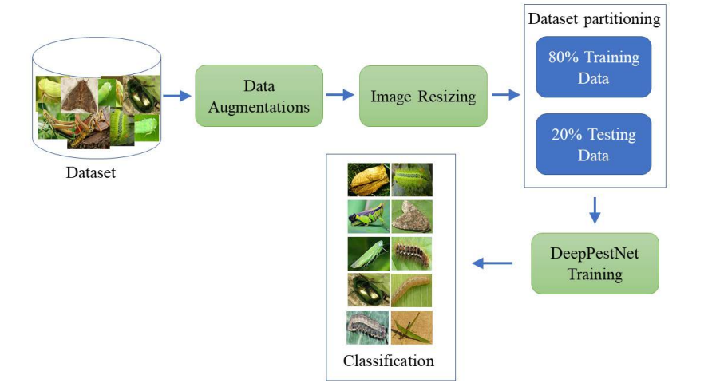
Figure 1: Overall System Architecture

Mrs.M.Harshini Number Sheets: 2
Sheet Number: 1

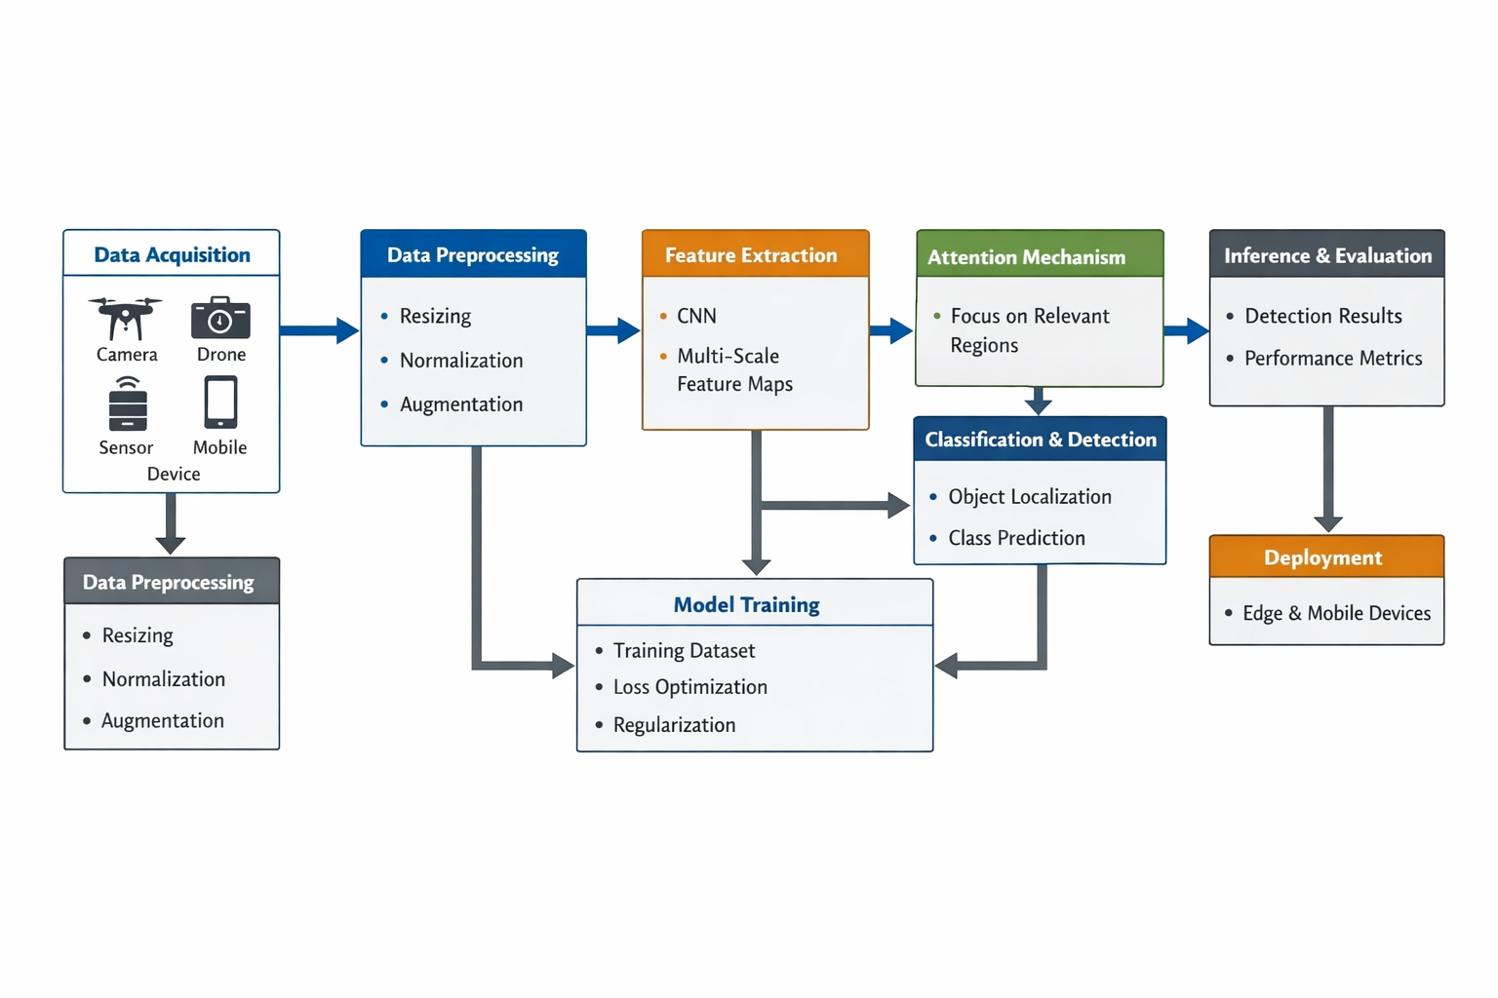

Figure 2: Data Flow for classification and identification

Mrs.M.Harshini Number Sheets: 2
Sheet Number: 2
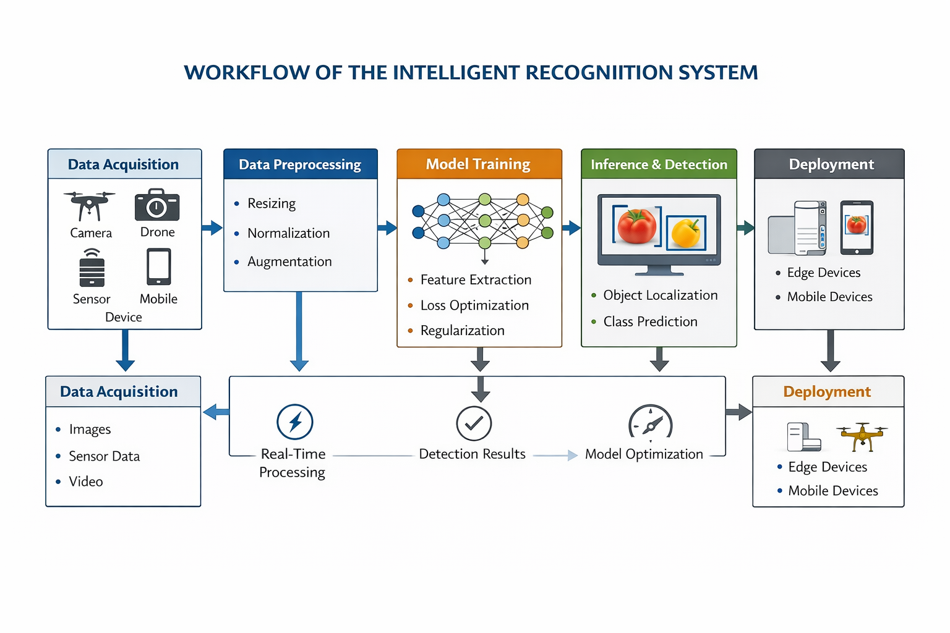

Figure 3: Workflow of the Intelligent Recognition System

Mrs.M.Harshini Number Sheets: 3
Sheet Number: 3
Abstract
With the increasing demand for sustainable agriculture and precision farming, early and accurate detection of crop pests has become essential to prevent yield loss and reduce excessive pesticide usage. Traditional pest monitoring methods rely on manual field inspection, which is time-consuming, labor-intensive, and prone to human error, especially in large-scale farming environments. Existing automated systems often struggle to maintain accuracy under real-world conditions due to variations in lighting, background clutter, pest size, and overlapping insects. To address these challenges, this project proposes a deep learning–based pest detection and classification system, termed DeepPestNet, designed to operate effectively in complex agricultural environments.
The proposed system processes field-captured crop images through a structured pipeline involving image acquisition, preprocessing, feature extraction, and classification. During preprocessing, images undergo resizing, normalization, and augmentation to enhance data diversity and improve model generalization. The core of the system is a hybrid convolutional neural network architecture based on EfficientNet-B0, integrated with a Convolutional Block Attention Module (CBAM) to emphasize pest-relevant features while suppressing background noise. A feature pyramid mechanism is incorporated to support multi-scale feature learning, enabling the detection of small and densely clustered pests that are typically difficult to identify using conventional convolutional models.
The model is trained on large-scale annotated agricultural pest datasets containing multiple pest species captured under varying environmental conditions. Supervised learning techniques are applied to optimize the model parameters, and performance is evaluated using standard metrics such as accuracy, precision, recall, and F1-score. Experimental results demonstrate that the proposed DeepPestNet architecture achieves higher detection accuracy and improved generalization compared to traditional convolutional neural networks and existing lightweight models. Furthermore, the system is computationally efficient and suitable for deployment on mobile devices, edge computing platforms, and IoT-based agricultural monitoring systems, making it practical for real-time field applications.
By enabling automated and reliable pest identification directly from field images, the proposed approach supports timely decision-making, targeted pesticide application, and reduction of crop damage. The system contributes to the development of intelligent agricultural monitoring solutions and provides a scalable framework that can be extended to additional pest species, plant disease detection, and integrated smart farming platforms.

