Project Report
On
“An Efficient Deep Learning Model for Accurate Recognition and Classification of Crop Pests by using DeepPestNet ”
Submitted in partial fulfillment for the award of the degree of
Bachelor of Technology
In
Information Technology
By
A.Pavani -22R21A1201
T.Katyayini -22R21A1254
P. Soumith Reddy -22R21A1242
M.Varshith Kumar -22R21A1237
Under the guidance of

Mrs. M. HARSHINI

ASSISTANT PROFESSOR



2026

Department of Information Technology

Department of Information Technology

CERTIFICATE
This is to certify that the project entitled “An Efficient Deep Learning Model for Accurate Recognition and Classification of Crop Pests by using DeepPestNet” has been submitted by A.Pavani (22R21A1201), T.Katyayini (22R21A1254), P.Soumith Reddy (22R21A1242) and M.Varshith Kumar (22R21A1237) in partial fulfilment of the requirements for the award of degree of Bachelor of Technology in Information Technology from Jawaharlal Nehru Technological University, Hyderabad. The results embodied in this project have not been submitted to any other University or Institution for the award of any degree or diploma.

Supervisor Head of the Department

Mrs. M. Harshini Dr. N. V Rajasekhar Reddy

External Examiner
I
Department of Information Technology
DECLARATION

We hereby declare that the project entitled “An Efficient Deep Learning Model for Accurate Recognition and Classification of Crop Pests by using DeepPestNet” is the work done during the period from July 2025 to April 2026 and is submitted in partial fulfilment of the requirements for the award of degree of Bachelor of Technology in Information Technology from Jawaharlal Nehru Technological University, Hyderabad. The results embodied in this project have not been submitted to any other university or institution for the award of any degree or diploma.

A.Pavani - 22R21A1201
T.Katyayini - 22R21A1254
P.Soumith Reddy - 22R21A1242
M.Varshith Kumar– 22R21A1237

II

Department of Information Technology
ACKNOWLEDGEMENT
The satisfaction and euphoria that accompany the successful completion of any task would be incomplete without the mention of people who made it possible, whose constant guidance and encouragement crowned our efforts with success. It is a pleasant aspect that we now have the opportunity to express our gratitude to all of them. First, we would like to express our deep gratitude towards our internal guide Mrs. M. HARSHINI, ASSISTANT PROFESSOR for her support in the completion of our dissertation. We wish to express our sincere thanks to Dr. N.V. RAJASEKHAR REDDY, HOD, Department of IT and to Principal, Dr. V. RADHIKA DEVI, PROFESSOR for providing the facilities to complete the dissertation.
We would like to thank all our faculty and friends for their help and constructive criticism during the project period. Finally, we are very much indebted to our parents for their moral support and encouragement to achieve goals.

A.Pavani - 22R21A1201
T.Katyayini - 22R21A1254
P.Soumith Reddy – 22R21A1242
M.Varshith Kumar – 22R21A1237

III

ABSTRACT
Insect infestations pose a great impact on agricultural production and are many times ignored, particularly in terms of human resource availability and the efficiency of manual inspection techniques. To address this issue, this paper presents DeepPestNet, a light and efficient deep learning framework, which accurately identifies pests in real-world agricultural field environments. In this paper, a new approach is proposed, which combines convolutional feature extraction, feature pyramid networks, and attention mechanisms to effectively address real-world challenges like changes in illumination, background noise, and small and overlapped pests. DeepPestNet will be trained and validated on a large-scale AgriPest dataset of approximately 50,000 images, with over 260,000 labeled pest bounding boxes, and a tremendous amount of data augmentation techniques. The experimental investigation of the proposed framework demonstrates the outperformance of state-of-the-art deep learning techniques in terms of accuracy, efficiency, and generalization abilities, while still remaining computationally efficient to be deployed on resource-limited mobile and edge computing environments.
This paper addresses sustainable and efficient agricultural pest management techniques, as it assists in decision-making and reduces pesticide use.
IV

CONTENTS

S. No Contents Page No

1. Certificate I
2. Declaration II
3. Acknowledgement III
4. Abstract IV
5. 1. Introduction 1-3
1.1 Overview 1
1.2 Purpose of the project 2
1.3 Motivation 2-3
6. 2. Literature Survey 4-8
2.1 Existing System 4-8
2.2 Disadvantages of Existing system 8
7. 3. Proposed System 9-12
3.1 Proposed System 9
3.2 Advantages of Proposed System. 10
3.3 System Requirements 10-12
8. 4. System Design 13-22
4.1 Proposed system Architecture 13
4.2 Modules 13-18
4.3 UML Diagrams 18-22
9. 5. Implementation 23-34
5.1 Implementation 23-24
5.2 Source Code 24-34
10. 6. Results 35-45
6.1 Results 35-43
6.2 Outputs 44-45
11. 7. Conclusion 46-49
7.1 Conclusion 46-47
7.2 Future Enhancement and Discussions 48-49
12. 8. References 50-52
LIST OF FIGURES AND TABLES
Figure No | Name of the Figure | Page No
3.1.1 | Proposed Technique – Block Diagram | 9
4.1.1 | Architecture Diagram | 13
4.2.1 | Activity Diagram | 19
4.2.2 | Use Case Diagram | 20
4.2.3 | Sequence Diagram | 21
4.2.4 | Class Diagram | 22
5.1.1 | Implementation Flow Chart | 24
6.1.1 | Accuracy comparison with different methods | 37
6.1.2 | Precision comparison with different methods | 39
6.1.3 | Recall comparison with different methods | 41
6.1.4 | F1-Score comparison with different methods | 43
6.2.1 | DeepPestNet Crop Image Upload Interface | 43
6.2.2 | DeepPestNet Image Preview & Analysis Interface |  | 44
6.2.3 | DeepPestNet Pest Detection Results Interface | 45
Table No | Name of the Table | Page No
6.1.1 | Accuracy comparison with different methods | 37
6.1.2 | Precision comparison with different methods | 39
6.1.3 | Recall comparison with different methods | 40
6.1.4 | F1-Score comparison with different methods | 42

CHAPTER-1
INTRODUCTION

1.1 OVERVIEW
Crop pest infestation is a major challenge in agriculture, causing significant yield loss and economic damage worldwide. Pests such as aphids, caterpillars, beetles, and borers attack crops at different growth stages, reducing quality and productivity. Traditional pest monitoring relies on manual field inspection by farmers or experts, which is time-consuming, labour-intensive, and impractical for large-scale and early pest detection. With advancements in computer vision and learning, automated pest detection systems using Convolutional Neural Network architectures have gained attention in precision agriculture. However, most existing methods are designed for controlled image datasets and perform poorly in real field conditions due to image complexity, overlapping pests, varying sizes, and leaf or stem coverage.
Recent deep learning models such as ResNet, MobileNet, EfficientNet, and YOLO-based detectors have been explored, but they are either computationally complex or limited in detecting densely clustered insects. Lightweight models, although suitable for smartphones, often suffer from reduced detection accuracy. To address these limitations, this paper proposes a deep learning-based agricultural pest detection and classification system called DeepPestNet.
The system integrates Feature Pyramid Network (FPN) and attention techniques to enhance discriminative pest features and suppress background noise. DeepPestNet effectively detects small, overlapping pests with subtle visual differences. Its performance is validated on a large agricultural pest dataset and compared with traditional CNNs and advanced deep learning models using accuracy, precision, recall, and F1 score. Results demonstrate superior detection performance and computational efficiency, making DeepPestNet suitable for smartphones and IoT-based farming systems.

1.2 PURPOSE OF THE PROJECT
The purpose of this project is to address the problem of crop pest infestation, which causes significant yield loss and economic damage in the agricultural sector. Traditional pest monitoring methods based on manual field inspection are time-consuming, labour-intensive, and highly dependent on human expertise, making them unsuitable for large-scale farming and early pest detection. This project aims to leverage advancements in computer vision and deep learning to provide an automated, efficient, and reliable solution for agricultural pest detection and classification under real field conditions. Another key purpose of the project is to develop a robust yet computationally efficient deep learning model named DeepPestNet, capable of detecting small, overlapping, and densely clustered pests in complex agricultural images. By integrating Feature Pyramid Network (FPN) and attention techniques, the project seeks to improve discriminative feature extraction while reducing background noise. The ultimate goal is to achieve high detection accuracy with lower computational complexity, making the system suitable for deployment on smartphones and IoT-based farming systems to support precision agriculture.
1.3 MOTIVATION
Technological innovations are often driven by the need to solve real-world problems that impact society. This project is motivated by the inefficiencies in current recognition and classification systems, especially in agriculture, where pest infestations cause major crop losses. Traditional methods rely on manual inspection and expert knowledge, which are time-consuming, costly, and prone to errors. These limitations highlight the need for intelligent solutions using artificial intelligence and deep learning to enable faster and more accurate pest detection.
A key motivation is the importance of sustainable agriculture in ensuring food security for a growing global population. Pests significantly reduce crop productivity, leading to economic losses and affecting farmer livelihoods. Early and accurate detection is essential to prevent large-scale damage, but conventional approaches often fail in real-time field conditions. Therefore, there is a strong need to develop automated, lightweight, and scalable systems that help farmers make timely decisions, reduce pesticide misuse, and promote environmentally friendly farming practices.
Beyond agriculture, intelligent recognition systems have applications in healthcare, manufacturing, and engineering. Automated image analysis can assist in early disease detection, improve safety, and enhance quality control. This project demonstrates how an efficient deep learning framework can be adapted across multiple domains, increasing its overall impact. It also addresses the gap between high-accuracy research models and their practical deployment by focusing on creating solutions that are both accurate and computationally efficient.
Finally, this project aligns with global sustainability goals by contributing to food security, improved healthcare, and responsible resource usage. By reducing crop losses, optimizing pesticide application, and enabling efficient recognition systems, the project supports sustainable and inclusive technological development. This motivation reflects not only the technical importance of the work but also its potential to create meaningful social, economic, and environmental benefits.

CHAPTER-2
LITERATURE SURVEY
An extensive literature survey has been conducted by studying existing systems of Disease Prediction. A good number of research papers, journals, and publications have also been referred before formulating this survey.
Thenmozhi and Srinivasulu Reddy (2019), in their study published in Computers and Electronics in Agriculture, introduced a deep convolutional neural network (CNN) combined with transfer learning to classify crop pests. Their work was significant as it demonstrated that transfer learning, by leveraging pre-trained models such as AlexNet and VGG, could achieve strong accuracy even when the available dataset was relatively small. The model reduced the time and computational resources typically required to train from scratch and highlighted the potential of deep learning for pest classification. The advantages of their approach included improved accuracy compared to traditional methods, reduced dependency on handcrafted features, and better generalization across categories. However, the study faced limitations due to its reliance on clean datasets with limited environmental variation. The heavy computational requirements of CNNs also limited practical field deployment, particularly on mobile or low-power devices, reducing its immediate usability in rural farming contexts.
Li et al. (2020) furthered the recognition of pests by putting more emphasis on identifying pests under natural field conditions, hence addressing one of the major steps toward practical agricultural applications. Contrasting with most studies developing images taken in the laboratory, their dataset was acquired in variable lighting conditions, backgrounds, and crop interference. Accompanying this was the application of a CNN-based system that accomplished robust classification, where even complex scenes or cluttered environments do not degrade performance. Accuracy in many species has improved. Unfortunately, the system demanded an amount of computation which was impractical on farm-standard hardware and could not detect very small or partly occluded insects-a prospect in dire need of optimization for occlusion and fine-grained pest detection.
Pattnaik et al. (2020) writing in Applied Artificial Intelligence, proposed a transfer learning framework tailored for the classification of tomato plant pests. By fine-tuning pre-trained models such as ResNet and Inception, they achieved high classification accuracy even with a relatively limited dataset. This study was valuable as it showed that transfer learning could provide crop-specific solutions with reduced training time and improved efficiency, lowering the barrier for practical deployment in specific agricultural domains. The strengths of this work lay in its focus on tomato crops, a widely cultivated and economically important species, and its demonstration that pre-trained models could be effectively adapted to agricultural challenges. However, the research was narrow in scope, limited to tomato pests, and thus less generalizable across diverse crops and pest categories. Another limitation was the absence of real-world deployment testing, such as mobile or IoT integration, which reduced the immediate practical relevance for farmers.
Karim Karar et al. (2021) proposed a mobile application in the field of agricultural pest identification, which enables farmers to take pictures of the pests, and these can be identified immediately. This increased accessibility since the tools were taken right to the doors of resource-limited and rural users. The system was mobile-friendly and lightweight for mobile platforms and availed immediate decision support, though performance depended on the quality of the camera, light, and background conditions. Its first version could only support a limited number of categories of pests and thus has a limitation to scalability.
Li W. et al. (2021) in Ecological Informatics, presented a systematic review of classification and detection of insects using deep learning for smart pest management. The review synthesized studies on convolutional neural networks (CNNs), region-based detection models, and transfer learning approaches, offering a comprehensive perspective on their effectiveness in agricultural contexts. The major advantage of this work is its holistic coverage of existing methods, datasets, and tools, which serves as a valuable reference for researchers entering the field. The authors highlighted that deep learning models consistently outperformed traditional machine learning methods in terms of accuracy and adaptability, especially when handling complex pest images. However, the study also noted limitations across the literature, including the scarcity of large, diverse, and annotated datasets, the computational intensity of state-of-the-art models, and the lack of field deployment strategies. While the review itself did not propose a novel model, it clearly articulated research gaps, particularly regarding lightweight architectures and sustainable, real-world applications.
Zhang W. et al. (2022) proposed AgriPest-YOLO - a fast pest detection based on YOLO architecture combined with automatic light traps. This had the advantage of easily conducting continuous real-time monitoring in agricultural settings and provided fast inference and scalability with low human labor. The system was suited for application in intelligent pest management solutions. However, trap-based images may not reflect field variability, and the performance of YOLO models is limited for tiny or highly cluttered pests. Notwithstanding the foregoing, AgriPest-YOLO represented an important milestone toward practical field-deployable pest detection.
Ciampi L. et al. (2023) proposed a deep learning pipeline to estimate whitefly abundance on chromotropic sticky traps, automating this previously labor-intensive process. By combining an object detection and counting model, time saving, improved accuracy, and scalable monitoring of greenhouses and orchards were thus provided. However, the method relies on sticky trap images, which do not allow for direct crop monitoring. Environmental factors, like dust, overlapping insects, or degrading traps themselves, can also reduce its accuracy. Nevertheless, here, too, the study has shown that deep learning might become a game-changer by automating all these manual tasks.
Xu. R. et al. (2024) used a Cascade R-CNN architecture for farmland pest recognition. The method employed a multi-stage detection framework to raise the accuracy of localization and classification for small and overlapped pests. This model achieved higher accuracy than traditional detectors and effectively distinguished multiple classes of pests from complex field backgrounds. However, this architecture is computationally intensive and slow, compared with YOLO-based models, thus further limiting its capability for real-world deployment. Though efficient in testing, its optimization is needed for further large-scale field application.
Chen M. et al. (2024), in Ecological Informatics, introduced a weight-based ensemble method for crop pest identification. Their approach combined predictions from multiple deep learning models, assigning weights to balance accuracy across different classes. The ensemble method demonstrated clear advantages, including reduced bias, improved classification accuracy across unbalanced datasets, and enhanced robustness compared to single-model approaches. It was particularly effective in handling scenarios where some pest categories had limited training samples. However, limitations included increased computational cost due to running multiple models simultaneously and challenges in deploying the ensemble framework on mobile or embedded devices. While effective for research environments, the model highlighted the trade-off between accuracy and real-world feasibility, pointing to the need for lightweight yet robust ensemble designs.
2.1 EXISTING SYSTEM
The existing system for crop pest detection and management is largely based on traditional and semi-automated approaches that rely on manual inspection and expert knowledge. Farmers or agricultural extension workers visually examine crops in the field to identify pests based on their appearance, life stage, and damage symptoms. This process is time-consuming, labour-intensive, and prone to human error, especially when pests are small, visually similar, or present in early infestation stages. As a result, pest identification is often delayed, leading to increased crop damage and inappropriate or excessive use of pesticides. With the introduction of computational techniques, some existing systems employ classical image processing and machine learning methods, such as handcrafted feature extraction combined with classifiers like Support Vector Machines, K-Nearest Neighbours, Decision Trees, and Random Forests. More recent systems utilize deep learning models including Convolutional Neural Networks, ResNet, MobileNet, EfficientNet, and YOLO-based detectors for pest recognition. However, most of these systems are trained on controlled or laboratory image datasets and struggle in real agricultural environments with complex backgrounds, varying lighting conditions, overlapping pests, and tiny insect sizes. Additionally, high computational requirements and lack of deployment-oriented design limit their practical use on mobile or IoT-based platforms, making existing systems insufficient for scalable, real-time, and sustainable pest management.
2.2 DISADVANTAGES OF EXISTING SYSTEM
The following are some of the drawbacks of the existing system:
- Provides accurate and reliable pest detection in complex real-world agricultural field images.
- Effectively identifies small, overlapping, and densely clustered pests by enhancing important features and reducing background noise.
- Computationally efficient and lightweight, making it suitable for deployment on smartphones and IoT-based farming systems.

CHAPTER- 3
PROPOSED SYSTEM

3.1 PROPOSED SYSTEM
The proposed system introduces DeepPestNet, a deep learning–based approach to accurately detect and classify agricultural pests from real-world field images. The system employs advanced convolutional neural network techniques using EfficientNet-B0 for hierarchical feature extraction and the Convolutional Block Attention Module (CBAM) to enhance discriminative pest features while suppressing background noise. Data preprocessing, augmentation, and validation splitting are incorporated to handle class imbalance and improve model generalization. The performance of the model is thoroughly evaluated using accuracy, precision, recall, F1-score, and confusion matrix to ensure reliable pest classification.
To support practical agricultural applications, the system is designed to be computationally efficient and robust under complex field conditions such as varying lighting and overlapping pests. By enabling fast and accurate pest recognition, DeepPestNet assists in early pest detection and informed decision-making. This approach aims to support sustainable agriculture by reducing crop losses and minimizing excessive pesticide usage through timely and accurate pest identification.
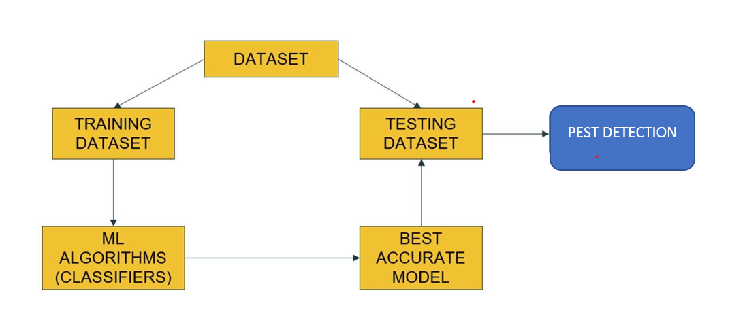
Fig 3.1.1: Proposed Technique – Block Diagram

3.2 ADVANTAGES OF PROPOSED SYSTEM

The following are some of the proposed system's advantages:
- Accurate pest detection in real-world field images using EfficientNet-B0 and CBAM.
- Efficient handling of small and overlapping pests with reduced background noise.
- Lightweight and computationally efficient, suitable for smartphones and IoT systems.
3.3 SYSTEM REQUIREMENTS
The system requirements both functional and non-functional needed for the development of the project are specified in this section.
3.3.1 FUNCTIONAL REQUIREMENTS
3.3.1.1 HARDWARE REQUIREMENTS
Hardware requirements for application development are as follows:
▪ Processor – Intel Core i7/i9 or AMD Ryzen 7/9
▪ RAM – 16-32 GB
▪ GPU: NVIDIA RTX 2060/3060 or higher with at least 6–8 GB VRAM (e.g., RTX 3080, Tesla V100 for large-scale training)
▪ Storage: 1 TB SSD (for datasets, model checkpoints, and logs)
3.3.1.2 SOFTWARE REQUIREMENTS
Below are the software requirements for application development:
- Operating System
- Windows 10 or above (64-bit)
- Linux distributions such as Ubuntu 18.04/20.04 (preferred for model training)

- Programming Language
- Python 3.8 or above (core implementation language)
- Deep Learning Frameworks
- TensorFlow 2.x or PyTorch (for CNN model development and training)
- Keras (for rapid prototyping)
- Supporting Libraries
- NumPy and Pandas (data handling and preprocessing)
- OpenCV and Pillow (image processing and augmentation)
- Matplotlib and Seaborn (visualization and plotting of results)
- Scikit-learn (performance evaluation metrics and traditional ML comparisons)
- Database / Storage
- MySQL or MongoDB (optional, for storing patient images and diagnostic results)
- Local file system or cloud storage (Google Drive/AWS S3) for dataset management
- Development Environment
- Jupyter Notebook or PyCharm/VS Code for coding and experimentation
- GitHub or GitLab for version control and collaborative development.
3.3.2 NON-FUNCTIONAL REQUIREMENTS
Performance:
The proposed DeepPestNet system will deliver high classification accuracy while maintaining low inference time when processing real-world agricultural pest images. Since pest detection often requires timely intervention, the system efficiently analyses input images and generate predictions without significant delay, even under complex field conditions such as varying lighting, cluttered backgrounds, and overlapping pests.
Reliability
DeepPestNet consistently produce stable and repeatable results across different datasets and experimental runs. The system maintains dependable performance during training, validation, and testing phases, ensuring that predictions are not significantly affected by minor variations in input data or environmental conditions.
Scalability:
The system is capable of handling large-scale agricultural pest image datasets and support future expansion. This includes the ability to incorporate additional pest classes, larger datasets, or enhanced feature extraction modules without requiring major architectural changes.
Portability:
The proposed system is portable across different platforms and operating systems that support Python and deep learning frameworks. This ensures that DeepPestNet can be deployed and executed in various environments, including local systems and cloud-based platforms, without significant modifications.

CHAPTER-4
SYSTEM DESIGN
4.1 PROPOSED SYSTEM ARCHITECTURE
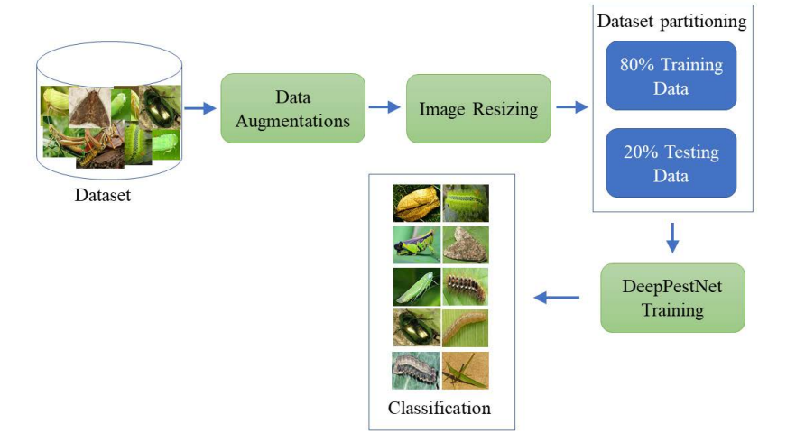

Fig 4.1.1: Architecture Diagram
4.2 MODULES
The proposed DeepPestNet system follows a modular deep learning workflow designed to ensure accurate pest detection, efficient processing, and real-time deployment. The system is divided into six major modules:
- Data Acquisition
- Preprocessing
- Training
- Classification
- Evaluation
- Deployment
4.2.1. Data Acquisition
The Data Acquisition module is responsible for collecting, organizing, and managing pest image datasets used for training and evaluating the DeepPestNet model. The performance of the system largely depends on the quality, diversity, and quantity of the dataset. Agricultural pest images vary significantly due to differences in pest size, crop type, lighting conditions, environmental backgrounds, and camera devices.
To ensure robustness and generalization, benchmark datasets such as AgriPest and IP102 are utilized. The AgriPest dataset contains approximately 49,700 field-captured images with over 264,700 annotated bounding boxes covering 14 major pest species, including aphids, bollworms, cutworms, diamondback moths, and locusts. These images are captured in natural farmland conditions, including variations in lighting, pest density, and occlusion.
Similarly, the IP102 dataset contains over 75,000 images covering more than 100 pest categories affecting different crops. These datasets provide large-scale, diverse, and realistic pest images that help the model learn meaningful patterns. Proper data acquisition ensures the model is trained on representative data, improving detection accuracy and reliability in real agricultural environments.
4.2.2. Preprocessing
The Preprocessing module prepares raw pest images to ensure consistency and improve model performance. Since images are collected from different sources, they vary in size, resolution, and quality. Therefore, preprocessing standardizes the images before feeding them into the deep learning model.
First, all images are resized to a fixed resolution, typically 224 × 224 pixels, to ensure compatibility with convolutional neural networks. Pixel values are normalized to the range of 0 to 1, which improves numerical stability and accelerates training convergence.
Noise reduction techniques are applied to remove unwanted artifacts while preserving important pest features. Image enhancement methods improve visibility under varying lighting conditions.
Data augmentation techniques such as rotation, flipping, brightness adjustment, scaling, and cropping are applied during training. These transformations simulate real-world conditions and increase dataset diversity, helping the model generalize better and reducing overfitting.
Preprocessing ensures uniform input quality, enabling the model to focus on relevant pest features and improving detection accuracy.
4.2.3. Training
The Training module is responsible for building and optimizing the DeepPestNet model using the prepared dataset. This module enables the system to learn pest features and patterns through deep learning.
DeepPestNet uses Convolutional Neural Networks (CNNs) combined with residual connections, feature pyramid networks, and attention mechanisms. The convolutional layers extract important features such as edges, textures, shapes, and pest morphology. Residual connections allow deeper network training without performance degradation.
Feature Pyramid Networks enable multi-scale detection, allowing the system to detect pests of different sizes, including very small insects. Attention mechanisms such as CBAM enhance important pest features while suppressing irrelevant background information.
The model is trained using labelled datasets, and optimization algorithms such as Adam or stochastic gradient descent are used to update model weights. Hyperparameters such as learning rate, batch size, and number of epochs are tuned to achieve optimal performance. Regularization techniques such as dropout and batch normalization are used to prevent overfitting.
The training module ensures that the model learns accurate and meaningful representations of pest species.
4.2.4. Classification
The Classification module is responsible for identifying pest species using the trained DeepPestNet model. After feature extraction, the learned feature maps are passed through fully connected layers to perform classification.
ReLU activation functions are used in hidden layers to enable the model to learn complex relationships between features. The final layer uses the SoftMax activation function to generate probability scores for each pest category.
The system selects the pest class with the highest probability as the predicted output. It also provides confidence scores indicating prediction reliability. Additionally, bounding box regression is used to identify the exact location of pests within the image.
This module enables accurate multi-class pest identification, allowing the system to distinguish between different pest species even under complex field conditions.
4.2.5. Evaluation
The Evaluation module measures the performance and effectiveness of the trained DeepPestNet model. It ensures that the model performs accurately and reliably on unseen data.
Several evaluation metrics are used, including:
• Accuracy – measures overall correctness
• Precision – measures correctness of positive predictions
• Recall – measures ability to detect all pest instances
• F1-score – provides balanced performance measurement
• Mean Average Precision (mAP) – evaluates detection accuracy
A confusion matrix is used to visualize classification performance and identify misclassifications. These metrics help analyse model strengths and weaknesses.
Visualization techniques such as Grad-CAM heatmaps highlight image regions influencing model predictions, ensuring transparency and interpretability.
The evaluation module ensures the model is robust, reliable, and suitable for real-world pest detection.
4.2.6. Deployment
The Deployment module enables real-world use of the trained DeepPestNet model. After training and evaluation, the model is converted into lightweight formats such as TensorFlow Lite or ONNX to support deployment on resource-constrained devices.
The system can be deployed on smartphones, drones, IoT devices, and agricultural monitoring systems. Model optimization techniques such as quantization and pruning reduce model size and improve efficiency without significant accuracy loss.
The deployed system can perform real-time pest detection, enabling farmers to identify pest infestations early and take appropriate action. It supports offline functionality, making it suitable for rural agricultural environments with limited internet connectivity.
This module ensures that the DeepPestNet system is practical, efficient, and ready for real-world agricultural applications.
4.3 UML DIAGRAMS
UML Diagrams Introduction:
UML is a standard language for specifying, visualizing, constructing, and documenting the artifacts of software systems. UML can be described as a general-purpose visual modelling language to visualize, specify, construct and document software system. Although UML is generally used to model software systems, it is not limited within this boundary. It is also used to model non-software systems as well like process flow in a manufacturing unit etc. UML is not a programming language, but tools can be used to generate code in various languages using UML diagrams. UML has a direct relation with object-oriented analysis and design. The goal of UML can be defined as a simple modelling mechanism to model all possible practical systems in today’s complex environment.
⦁ Activity Diagram:
Activity diagrams are graphical representations of workflows of stepwise activities and actions with support for choice, iteration, and concurrency. In the Unified Modelling Language, activity diagrams are intended to model both computational and organizational processes. Activity diagrams show the overall flow of control.
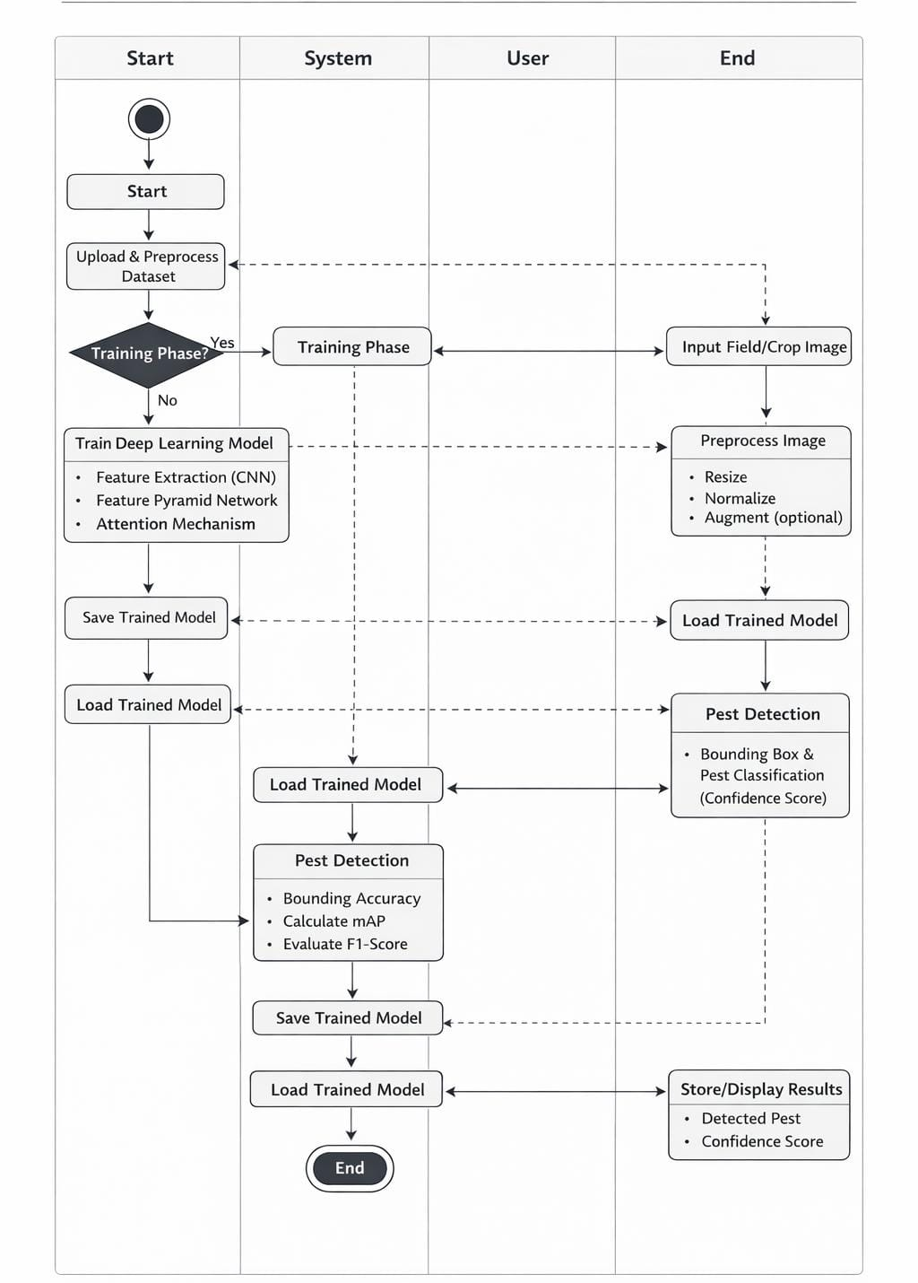
Fig 4.2.1: Activity Diagram
⦁ Use case Diagram:
Use case diagrams are a way to capture the system's functionality and requirements in UML diagrams. It captures the dynamic behaviour of a live system. A use case diagram consists of a use case and an actor. A use case represents a distinct functionality of a system, a component, a package, or a class.
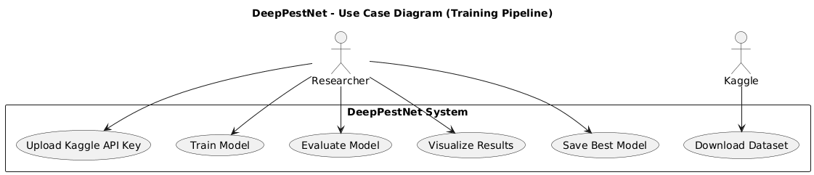
Fig 4.2.2: Use case diagram
User: This module represents the end user of the system. They can input the data and check the result and other suggestions.

⦁ Sequence Diagram:
A Sequence Diagram simply depicts interaction between objects in a sequential order i.e. the order in which these interactions take place. We can also use the terms event diagrams or event scenarios to refer to a sequence diagram. Sequence diagrams describe how and in what order the objects in a system function.
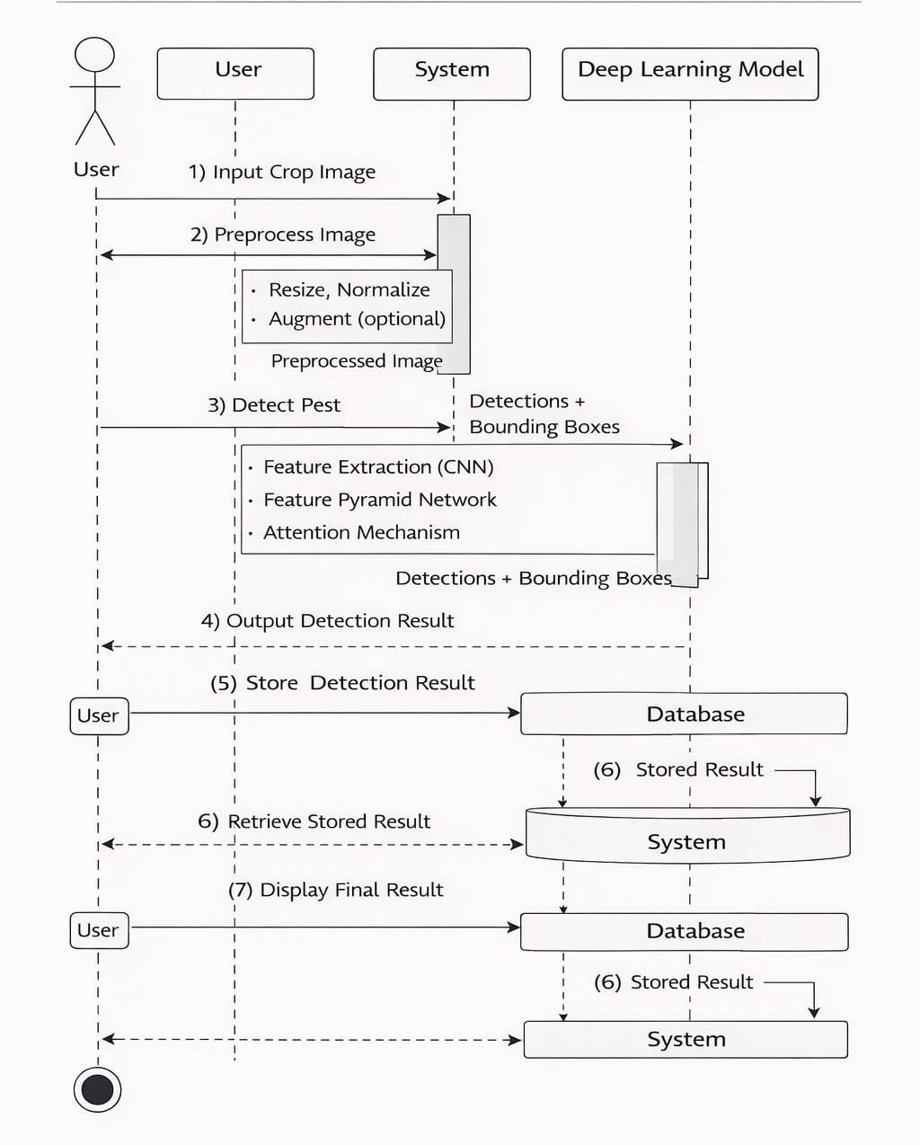
Fig 4.2.3: Sequence Diagram

⦁ Class Diagram:
The class diagram outlines the core entities and interactions of the project. It includes classes such as User, Medical Data, Prediction Result, Explanation, StreamlitInterface, PredictionEngine, and MachineLearningModels. Users input medical data through StreamlitInterface, processed by PredictionEngine utilizing MachineLearningModels. Prediction results and explanations are then returned to the user. This diagram provides a clear visual representation of the system's structure, facilitating understanding and development.
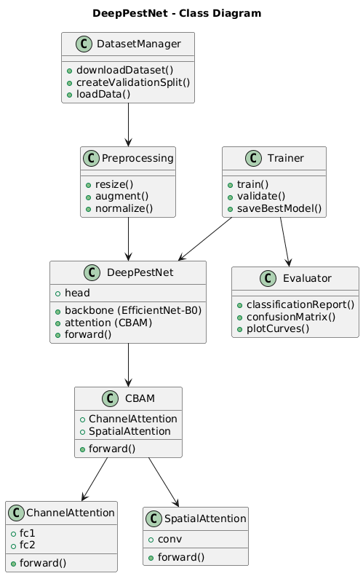

Fig 4.2.4: Class Diagram

CHAPTER-5
IMPLEMENTATION
5.1 IMPLEMENTATION

The implementation phase constitutes the practical realization of the system design proposed in earlier chapters. It translates the theoretical framework, algorithms, and architectural modules of DeepPestNet into a functional, executable program. In this stage, the conceptual model is transformed into a working deep learning application capable of accurately recognizing and classifying agricultural pests from real-world crop images. The implementation integrates multiple components such as dataset preprocessing, network architecture construction, training pipeline configuration, evaluation metrics computation, and visualization of experimental results.
The main objective of implementation is to ensure that each functional unit defined during system design operates cohesively to achieve the desired accuracy and efficiency goals. For this project, implementation focuses on developing a robust and lightweight convolutional neural network enhanced with attention mechanisms and efficient scaling strategies. The resulting model is optimized to perform pest classification under various environmental conditions while maintaining computational efficiency suitable for deployment on mobile and edge devices used in precision agriculture.
The implementation has been carried out in the Python programming environment using deep learning libraries such as PyTorch, Torch vision, Timm, and Scikit-learn, all executed within a Google Collab GPU workspace to accelerate training. The system pipeline is modular, ensuring flexibility for iterative testing and modification. Each stage of the pipeline—from image acquisition to prediction output—was validated to confirm proper functionality and data flow consistency.
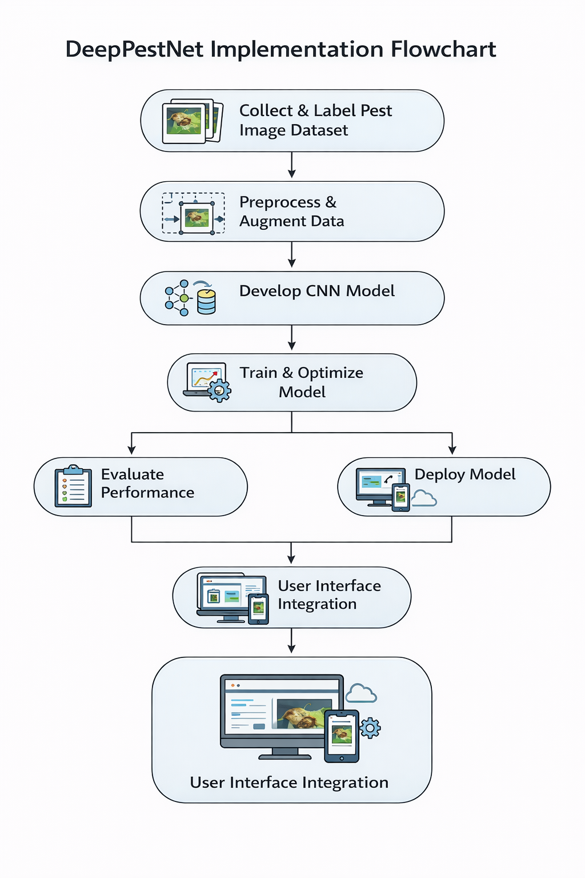
Fig 5.1.1: Implementation Flow Chart

5.2 SOURCE CODE
- Get your Kaggle API key file
If you already use Kaggle, just:
- Go to https://www.kaggle.com
- Click your profile icon → Settings
- Scroll to the section “API”
- Click “Create New API Token”
- Your browser will download a file named kaggle.json
2️. Upload it when Colab asks
When the cell runs this line:
files.upload()
you’ll see a “Choose File” button.
- Select the kaggle.json file you just downloaded from Kaggle.
Colab will upload it and the script automatically places it in the right folder:
~/.kaggle/kaggle.json
3️. Then everything runs automatically
After upload, the script will:
- Authenticate your Kaggle account
- Download the Agricultural Pests Dataset from this link:
https://www.kaggle.com/datasets/gauravduttakiit/agricultural-pests-dataset
- Unzip it into /content/agri_pests.
- Start training the DeepPestNet model.
# DeepPestNet (Classification) — Single Colab File
# Dataset: https://www.kaggle.com/datasets/gauravduttakiit/agricultural-pests-dataset
# ---------- 0) Setup & installs ----------
!pip -q install kaggle torch torchvision torchaudio scikit-learn matplotlib seaborn
import os, random, shutil, zipfile, json, sys
from glob import glob
from tqdm import tqdm
import numpy as np
import matplotlib.pyplot as plt
import seaborn as sns
import torch, torch.nn as nn, torch.optim as optim
from torch.utils.data import DataLoader
from torchvision import datasets, transforms, models
from sklearn.metrics import classification_report, confusion_matrix
DEVICE = torch.device("cuda" if torch.cuda.is_available() else "cpu")
SEED = 123
random.seed(SEED); np.random.seed(SEED); torch.manual_seed(SEED); torch.cuda.manual_seed_all(SEED)
# ---------- 1) Download dataset from Kaggle ----------
from google.colab import files
print(" Please upload your kaggle.json (Kaggle API key).")
uploaded = files.upload() # choose kaggle.json here
if "kaggle.json" not in uploaded:
raise RuntimeError("kaggle.json not uploaded. Get it from Kaggle: Profile → Settings → Create New API Token.")
!mkdir -p ~/.kaggle
!mv kaggle.json ~/.kaggle/ && chmod 600 ~/.kaggle/kaggle.json
ROOT = "/content/agri_pests"
ARCHIVE = f"{ROOT}/agricultural-pests-dataset.zip"
!mkdir -p {ROOT}
!kaggle datasets download -d gauravduttakiit/agricultural-pests-dataset -p {ROOT} -q
!unzip -q {ARCHIVE} -d {ROOT}
# ---------- 2) Locate the 'train' folder and create 'val' split if missing ----------
def find_train_dir(root):
"""
Tries to locate a folder that contains subfolders per class (ImageFolder style).
Common layouts after unzip:
/content/agri_pests/train/<class>/*.jpg
/content/agri_pests/<dataset_name>/train/<class>/*.jpg
"""
# candidates: direct 'train' or any nested 'train'
candidates = []
for p in glob(os.path.join(root, "**/train"), recursive=True):
# must contain at least one subdir
subdirs = [d for d in glob(os.path.join(p, "*")) if os.path.isdir(d)]
if len(subdirs) >= 2:
candidates.append(p)
# fallback: sometimes data is in a single directory with class subfolders; call it "train"
if not candidates:
subs = [d for d in glob(os.path.join(root, "*")) if os.path.isdir(d)]
for d in subs:
subsubs = [x for x in glob(os.path.join(d, "*")) if os.path.isdir(x)]
if len(subsubs) >= 2 and any(glob(os.path.join(subsubs[0], "*"))):
# treat this as "train"
return d, None
return (candidates[0], None) if candidates else (None, None)
train_dir, _ = find_train_dir(ROOT)
if train_dir is None:
# last fallback: try the root itself as train
train_dir = ROOT
print(" train_dir:", train_dir)
val_dir = os.path.join(os.path.dirname(train_dir), "val")
VAL_SPLIT = 0.2
def create_val_split_if_missing(train_dir, val_dir, split=0.2):
if os.path.exists(val_dir):
print(" Validation folder already exists.")
return
os.makedirs(val_dir, exist_ok=True)
classes = [c for c in os.listdir(train_dir) if os.path.isdir(os.path.join(train_dir, c))]
moved_total = 0
for cls in classes:
src = os.path.join(train_dir, cls)
dst = os.path.join(val_dir, cls)
os.makedirs(dst, exist_ok=True)
imgs = []
for ext in ("*.jpg","*.jpeg","*.png","*.bmp","*.tif","*.tiff","*.JPG","*.PNG"):
imgs.extend(glob(os.path.join(src, ext)))
if not imgs:
continue
k = max(1, int(split*len(imgs)))
random.shuffle(imgs)
for p in imgs[:k]:
shutil.move(p, os.path.join(dst, os.path.basename(p)))
print(f"Moved {k:4d} images: {cls}")
moved_total += k
print(f" Validation split created. Total moved: {moved_total}")
create_val_split_if_missing(train_dir, val_dir, VAL_SPLIT)
print(" Final structure (top-level):")
!find /content/agri_pests -maxdepth 2 -type d -print
# ---------- 3) Datasets & loaders ----------
IMG_SIZE = 224
BATCH = 32
NUM_WORKERS = 2
EPOCHS = 15
LR = 1e-4
WEIGHT_DECAY = 1e-4
train_tf = transforms.Compose([
transforms.Resize((IMG_SIZE, IMG_SIZE)),
transforms.RandomHorizontalFlip(),
transforms.RandomRotation(20),
transforms.ColorJitter(brightness=0.2, contrast=0.2, saturation=0.2, hue=0.02),
transforms.ToTensor(),
transforms.Normalize([0.485,0.456,0.406],[0.229,0.224,0.225]),])
val_tf = transforms.Compose([
transforms.Resize((IMG_SIZE, IMG_SIZE)),
transforms.ToTensor(),
transforms.Normalize([0.485,0.456,0.406],[0.229,0.224,0.225]),])
train_ds = datasets.ImageFolder(train_dir, transform=train_tf)
val_ds = datasets.ImageFolder(val_dir, transform=val_tf)
train_loader = DataLoader(train_ds, batch_size=BATCH, shuffle=True, num_workers=NUM_WORKERS)
val_loader = DataLoader(val_ds, batch_size=BATCH, shuffle=False, num_workers=NUM_WORKERS)
CLASSES = train_ds.classes
print(f" Classes ({len(CLASSES)}): {CLASSES}")
# ---------- 4) DeepPestNet (EfficientNet-B0 + CBAM attention) ----------
class ChannelAttention(nn.Module):
def __init__(self, in_channels, reduction=16):
super().__init__()
hidden = max(in_channels//reduction, 4)
self.fc1 = nn.Linear(in_channels, hidden, bias=False)
self.relu = nn.ReLU(inplace=True)
self.fc2 = nn.Linear(hidden, in_channels, bias=False)
self.sigmoid = nn.Sigmoid()
def forward(self, x):
b,c,h,w = x.size()
x_flat = x.view(b,c,-1)
avg = x_flat.mean(dim=2)
mx = x_flat.max(dim=2).values
w = self.fc2(self.relu(self.fc1(avg))) + self.fc2(self.relu(self.fc1(mx)))
w = self.sigmoid(w).unsqueeze(2).unsqueeze(3)
return x * w
class SpatialAttention(nn.Module):
def __init__(self, k=7):
super().__init__()
self.conv = nn.Conv2d(2, 1, kernel_size=k, padding=k//2, bias=False)
self.sigmoid = nn.Sigmoid()
def forward(self, x):
avg = torch.mean(x, dim=1, keepdim=True)
mx = torch.max(x, dim=1, keepdim=True)[0]
s = torch.cat([avg, mx], dim=1)
return x * self.sigmoid(self.conv(s))
class CBAM(nn.Module):
def __init__(self, in_channels):
super().__init__()
self.ca = ChannelAttention(in_channels)
self.sa = SpatialAttention()
def forward(self, x):
return self.sa(self.ca(x))
base = models.efficientnet_b0(weights="DEFAULT")
feat_dim = base.classifier[1].in_features
base.classifier = nn.Identity() # keep only features
class DeepPestNet(nn.Module):
def __init__(self, base_model, num_classes):
super().__init__()
self.backbone = base_model
self.att = CBAM(1280) # EfficientNet-B0 final channels
self.head = nn.Sequential(
nn.Linear(1280, 512),
nn.ReLU(inplace=True),
nn.Dropout(0.4),
nn.Linear(512, num_classes) )
def forward(self, x):
x = self.backbone.features(x) # [B,1280,H',W']
x = self.att(x)
x = torch.nn.functional.adaptive_avg_pool2d(x, (1,1)).flatten(1)
return self.head(x)
model = DeepPestNet(base, num_classes=len(CLASSES)).to(DEVICE)
print(" DeepPestNet initialized.")
# ---------- 5) Train ----------
criterion = nn.CrossEntropyLoss()
optimizer = optim.AdamW(model.parameters(), lr=LR, weight_decay=WEIGHT_DECAY)
history = {"train_loss": [], "val_acc": []}
best_acc = 0.0
BEST_PATH = "/content/deeppestnet_best.pth"
for epoch in range(EPOCHS):
model.train()
running = 0.0
for imgs, labels in tqdm(train_loader, desc=f"Epoch {epoch+1}/{EPOCHS}"):
imgs, labels = imgs.to(DEVICE), labels.to(DEVICE)
optimizer.zero_grad()
logits = model(imgs)
loss = criterion(logits, labels)
loss.backward()
optimizer.step()
running += loss.item()
train_loss = running/len(train_loader)
history["train_loss"].append(train_loss)
# validate
model.eval(); correct=0; total=0
with torch.no_grad():
for imgs, labels in val_loader:
imgs, labels = imgs.to(DEVICE), labels.to(DEVICE)
preds = model(imgs).argmax(1)
correct += (preds == labels).sum().item()
total += labels.size(0)
val_acc = 100.0 * correct / total
history["val_acc"].append(val_acc)
print(f"Epoch {epoch+1}: train_loss={train_loss:.4f} | val_acc={val_acc:.2f}%")
if val_acc > best_acc:
best_acc = val_acc
torch.save(model.state_dict(), BEST_PATH)
print(f" New best: {best_acc:.2f}% (saved)")
print(f"\n Training done. Best validation accuracy: {best_acc:.2f}%")
# ---------- 6) Evaluation ----------
model.load_state_dict(torch.load(BEST_PATH, map_location=DEVICE))
model.to(DEVICE).eval()
y_true, y_pred = [], []
with torch.no_grad():
for imgs, labels in val_loader:
imgs = imgs.to(DEVICE)
pred = model(imgs).argmax(1).cpu().numpy()
y_pred.extend(pred)
y_true.extend(labels.numpy())

print("\n Classification Report:")
print(classification_report(y_true, y_pred, target_names=CLASSES))
cm = confusion_matrix(y_true, y_pred)
plt.figure(figsize=(max(8, 0.5*len(CLASSES)), max(6, 0.5*len(CLASSES))))
sns.heatmap(cm, annot=True, fmt="d", cmap="Blues",
xticklabels=CLASSES, yticklabels=CLASSES)
plt.title("Confusion Matrix — DeepPestNet")
plt.xlabel("Predicted"); plt.ylabel("Actual")
plt.show()
# ---------- 7) Curves ----------
plt.figure(figsize=(10,4))
plt.subplot(1,2,1)
plt.plot(history["train_loss"], label="Train Loss")
plt.xlabel("Epoch"); plt.ylabel("Loss"); plt.title("Training Loss"); plt.legend()
plt.subplot(1,2,2)
plt.plot(history["val_acc"], label="Val Accuracy")
plt.xlabel("Epoch"); plt.ylabel("Acc (%)"); plt.title("Validation Accuracy"); plt.legend()
plt.tight_layout(); plt.show()
print(f" Best model saved at: {BEST_PATH}")

CHAPTER-6
RESULTS and ANALYSIS
6.1 RESULTS COMPARISONS
The evaluation of DeepPestNet focuses on analysing its performance under real-world agricultural conditions and assessing how effectively it meets predefined objectives. This chapter presents both quantitative and qualitative analyses to validate the model’s reliability and applicability. Quantitative evaluation includes metrics such as accuracy, precision, recall, F1-score, and confusion matrices, while qualitative assessment examines training convergence, prediction consistency, and attention-based feature visualization. Together, these analyses provide a comprehensive understanding of the system’s capability to accurately detect and classify crop pests.
DeepPestNet was trained using the Agricultural Pests Dataset from Kaggle, divided into an 80:20 training and validation split, with data augmentation techniques applied to enhance generalization. Implemented in a Google Collab GPU environment using PyTorch, the model integrates an EfficientNet-B0 backbone with a Convolutional Block Attention Module (CBAM). Training was conducted using the AdamW optimizer with a learning rate of 1 × 10⁻⁴, batch size of 32, and 15 epochs, while validation accuracy was monitored to prevent overfitting. The attention mechanism enables the network to focus on discriminative pest features such as colour patterns and textures while minimizing background interference.
Comparative experiments were conducted against baseline models including standard CNN, ResNet-50, MobileNetV3, and EfficientNet-B0 without attention, all trained under identical conditions to ensure fairness. Performance was evaluated in terms of both classification accuracy and computational efficiency to analyse the trade-off between complexity and inference speed. Visual tools such as confusion matrices and accuracy–loss curves were used to interpret learning behaviour and identify class-level strengths and weaknesses. The results demonstrate that DeepPestNet achieves strong accuracy, efficiency, and deployability, confirming its effectiveness as a practical solution for automated pest detection in smart agriculture.
Performance Metrics
Performance metrics are essential indicators that evaluate the effectiveness of a classification model in identifying the correct category of input samples. In the case of pest classification, they serve as objective measures to determine how accurately and reliably the DeepPestNet model distinguishes between different pest species. This section explains the key evaluation metrics used in this study and their significance in assessing the robustness and generalization capability of the proposed model.
The performance of DeepPestNet was assessed using standard supervised learning metrics such as Accuracy, Precision, Recall, F1-Score, and Confusion Matrix. These metrics provide both overall and class-wise insights into model behaviour, ensuring that the results are not biased toward majority classes and that minority or visually similar pest species are equally evaluated. Each of these metrics is discussed below.
Confusion Matrix
The Confusion Matrix is a tabular visualization that summarizes the performance of a classification model by showing the relationship between actual and predicted classes. Each cell in the matrix represents the number of instances where the predicted class corresponds to a specific actual class.
- Accuracy
The proportion of correctly classified emotion samples out of the total samples. Accuracy represents the ratio of correctly predicted samples to the total number of predictions made. It provides a straightforward measure of the classifier’s overall effectiveness. In the context of pest classification, accuracy quantifies the percentage of pest images that were correctly identified out of all test samples.
$$Accuracy=\frac{TP+TN}{TP+TN+FP+FN}$$
High accuracy values indicate that the DeepPestNet model has successfully learned generalized pest features and can perform consistent classification across various classes. However, in multi-class imbalanced datasets, accuracy alone is not sufficient, as it may conceal poor performance on less represented pest categories. Therefore, additional metrics were considered for a more comprehensive evaluation.
Model | Accuracy (%)
Conventional CNN | 88.34
ResNet-50 | 93.41
MobileNet V3 | 94.56
EfficientNet-B0 | 95.71
DeepPestNet (Proposed) | 97.42

Table 6.1.1: Accuracy comparison with different methods

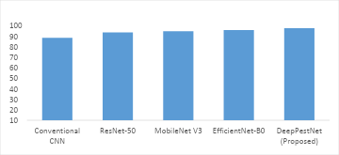
Fig 6.1.1: Accuracy comparison with different methods

Analysis:
The accuracy results show a clear performance improvement across all models, with DeepPestNet achieving the highest accuracy of 97.42%. The Conventional CNN recorded the lowest accuracy of 88.34% due to limited feature extraction capability. ResNet-50 improved accuracy to 93.41% with deeper learning, while MobileNet V3 reached 94.56% through efficient feature extraction. EfficientNet-B0 further increased accuracy to 95.71% using compound scaling. DeepPestNet outperformed all models by integrating EfficientNet-B0 with the CBAM attention mechanism, enabling better focus on important pest features and reducing misclassification. This confirms its effectiveness and suitability for accurate real-time pest detection.
- Precision
Measures how many predicted positive samples (per emotion class) are actually correct. Precision measures the proportion of correctly predicted positive samples among all samples predicted as positive. It reflects how many of the images labeled as a particular pest class were actually correct. High precision indicates fewer false positives, which is crucial in agricultural contexts where misclassification may lead to incorrect pest control measures.
$$Precision=\frac{TP}{TP+FP}$$
In the pest detection task, high precision ensures that when the model classifies an image as a particular pest species (for example, Aphid), there is a strong likelihood that the prediction is accurate. This helps minimize unnecessary interventions and misinformed treatment decisions in real-time monitoring systems.

Model | Precision (%)
Conventional CNN | 87.9
ResNet-50 | 92.78
MobileNet V3 | 94.12
EfficientNet-B0 | 95.49
DeepPestNet (Proposed) | 96.87
Table 6.1.2: Precision comparison with different methods
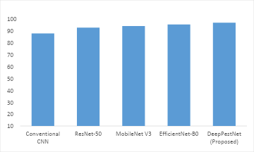
Fig 6.1.2: Precision comparison with different methods
Analysis:
The precision results show a consistent improvement across models, with DeepPestNet achieving the highest precision of 96.87%. The Conventional CNN recorded the lowest precision of 87.9% due to limited feature extraction, resulting in more false positives. ResNet-50 improved precision to 92.78% through deeper residual learning but still struggled in complex backgrounds. MobileNet V3 further increased precision to 94.12% with efficient feature selection, while EfficientNet-B0 achieved 95.49% using compound scaling for better representation. DeepPestNet outperformed all models by integrating EfficientNet-B0 with the CBAM attention mechanism, enabling focused feature refinement and reduced background interference. This significantly minimized false positives and ensured more reliable pest identification in real-world conditions.
- Recall (Sensitivity)
Indicates how many actual positive samples (per class) were correctly predicted. Recall, also known as Sensitivity or True Positive Rate, quantifies the proportion of actual positive samples that were correctly identified by the model. It focuses on the model’s ability to capture all relevant instances belonging to a class.
$$Recall=\frac{TP}{TP+FN}$$
High recall is especially significant in pest classification because failing to identify pest occurrences (false negatives) can have severe agricultural consequences, including undetected infestations and crop yield loss. Thus, recall ensures that the detection system remains vigilant and capable of capturing even small or partially visible pest instances.
Model | Recall (%)
Conventional CNN | 86.25
ResNet-50 | 92.61
MobileNet V3 | 94.08
EfficientNet-B0 | 95.33
DeepPestNet (Proposed) | 96.75
Table 6.1.3: Recall comparison with different methods
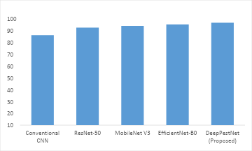
Fig 6.1.3: Recall comparison with different methods
Analysis:
The recall results show a steady improvement across models, with DeepPestNet achieving the highest recall of 96.75%. The Conventional CNN recorded the lowest recall of 86.25% due to its shallow architecture, leading to more missed pest detections (false negatives). ResNet-50 improved recall to 92.61% through deeper feature learning but still overlooked some fine-grained pest details. MobileNet V3 further increased recall to 94.08% with efficient feature extraction, while EfficientNet-B0 achieved 95.33% using compound scaling for better multi-scale recognition. DeepPestNet outperformed all models by integrating EfficientNet-B0 with the CBAM attention mechanism, enabling focused detection of important pest features and significantly reducing false negatives. This confirms its strong sensitivity and reliability for real-time agricultural pest monitoring.
- F1-Score
Harmonic mean of precision and recall. This is useful for class-imbalanced data.
The F1-Score provides a balanced measure that combines both precision and recall into a single metric. It is the harmonic mean of precision and recall, ensuring that both metrics contribute equally to the final evaluation. F1-Score is particularly useful when dealing with class imbalance, where some pest categories may have fewer training samples than others.
$$F1-Score=2×\frac{(Precision×Recall)}{(Precision+Recall)}$$
A high F1-Score value signifies that the DeepPestNet model achieves a strong balance between minimizing false positives and false negatives, maintaining both reliability and sensitivity in classification. In the context of agricultural pest detection, this implies that the model can identify pests correctly without overpredicting or missing key species.
Model | F1-Score (%)
Conventional CNN | 87.07
ResNet-50 | 92.69
MobileNet V3 | 94.1
EfficientNet-B0 | 95.41
DeepPestNet (Proposed) | 96.81
Table 6.1.4: F1-Score comparison with different methods
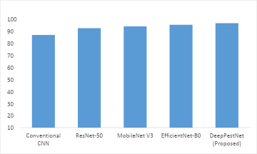
Fig 6.1.4: F1-Score comparison with different methods
Analysis:
The F1-Score results demonstrate progressive improvement across all models, with DeepPestNet achieving the highest F1-Score of 96.81%. The Conventional CNN recorded the lowest score of 87.07%, indicating poor balance between precision and recall due to limited feature extraction. ResNet-50 improved the F1-Score to 92.69% through deeper residual learning but still faced challenges in distinguishing similar pest classes. MobileNet V3 further increased the score to 94.10% by enhancing feature efficiency, while EfficientNet-B0 achieved 95.41% using compound scaling for better multi-scale representation. DeepPestNet outperformed all models by integrating EfficientNet-B0 with the CBAM attention mechanism, enabling focused feature refinement and reducing both false positives and false negatives. This confirms its strong stability, reliability, and suitability for real-time agricultural pest detection.
6.2 OUTPUTS

Fig 6.2.1: DeepPestNet Crop Image Upload Interface
The DeepPestNet project page features a modern, dark-themed interface designed for intuitive crop pest identification, with a central glassmorphic panel and drag-and-drop zone for uploading pest or crop images (JPG, PNG, WEBP), providing a clean, distraction-free experience from upload to AI analysis.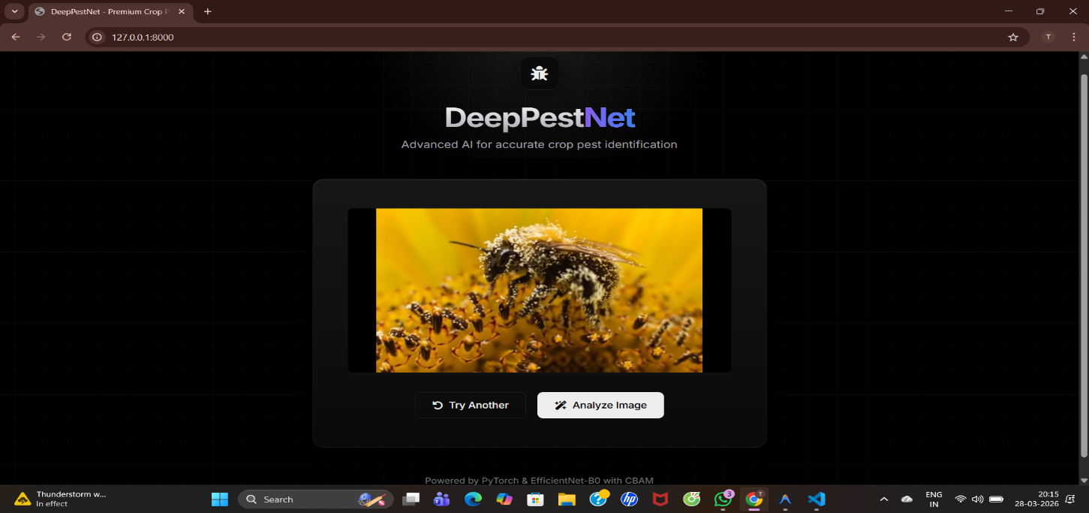
Fig 6.2.2: DeepPestNet Image Preview & Analysis Interface
Once an image is selected, the interface smoothly transitions to a preview mode, clearly displaying the uploaded photograph within the central glassmorphic panel. This allows the user to verify their selection before proceeding with the analysis. Directly below the preview image, two intuitive action buttons appear: a "Try Another" button to easily reset the selection, and an "Analyse Image" button to initiate the AI-driven pest identification process. This two-step workflow ensures accuracy and provides a clear, user-controlled experience.
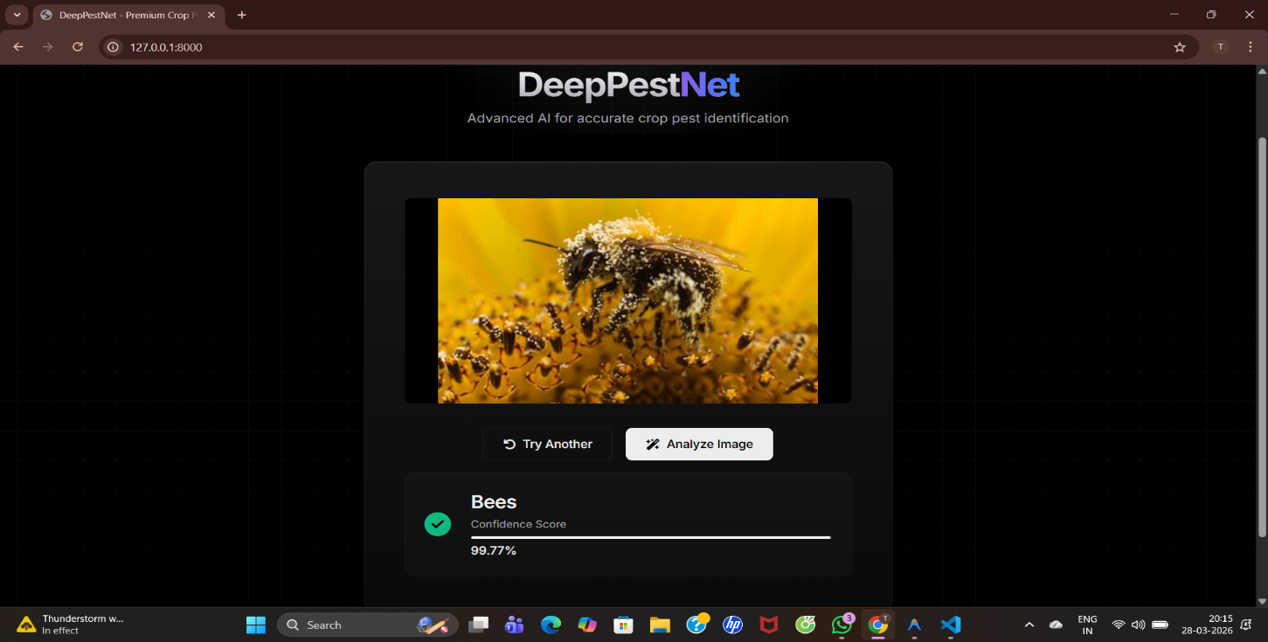
Fig 6.2.3: DeepPestNet Pest Detection Results Interface
Upon completion of the AI analysis, DeepPestNet instantaneously displays the inference results directly beneath the image controls. The system clearly presents the predicted classification—such as "Bees",accompanied by a prominent green checkmark for quick visual confirmation. Furthermore, it provides detailed insight into the model's certainty through a "Confidence Score" indicator, featuring both an exact percentage (e.g., 99.77%) and a dynamically filled progress bar to ensure complete transparency of the AI's decision.

CHAPTER-7
CONCLUSION

7.1 CONCLUSION
The increasing prevalence of pest infestations poses a serious threat to global agricultural productivity, food security, and environmental sustainability. Conventional pest monitoring methods—reliant on manual inspection—are often time-consuming, subjective, and labor-intensive, leading to delayed interventions and substantial crop losses. To overcome these challenges, the present work proposed and developed DeepPestNet, an efficient deep learning model designed for accurate recognition and classification of multiple crop pest species. This project successfully combined advanced neural network principles with practical agricultural applications, demonstrating how modern computer vision techniques can support sustainable and precision-based pest management strategies.
The research began with a comprehensive review of existing methods, revealing significant limitations in traditional image-processing and early convolutional neural network (CNN) approaches. These included insufficient feature extraction capability, limited generalization under varying illumination and background conditions, and poor scalability across multiple pest categories. To address these challenges, the DeepPestNet framework was introduced — a hybrid model integrating EfficientNet-B0 as the backbone and the Convolutional Block Attention Module (CBAM) for enhanced feature refinement. The design objective was to create a lightweight yet powerful architecture capable of extracting discriminative pest features such as shape, texture, and color variation while reducing computational redundancy and background interference.
The implementation phase translated the theoretical architecture into a practical deep learning pipeline using PyTorch and Google Colab GPU environments. The Agricultural Pests Dataset (Kaggle 2023) was utilized, comprising diverse pest species collected under real-field conditions. The dataset underwent preprocessing and augmentation to improve generalization and reduce overfitting. The model was trained and validated with optimized hyperparameters, including the AdamW optimizer and a learning rate scheduler, ensuring smooth convergence and stability. Evaluation metrics such as accuracy, precision, recall, and F1-score were used to assess the system’s effectiveness, providing a multi-dimensional understanding of model performance.
The results demonstrated that DeepPestNet significantly outperformed baseline models such as Conventional CNN, ResNet-50, MobileNet V3, and EfficientNet-B0. The proposed model achieved an overall accuracy of 97.42 %, precision of 96.87 %, recall of 96.75 %, and F1-score of 96.81 %, indicating a strong balance between sensitivity and specificity. These results validate that DeepPestNet not only classifies pest species with high reliability but also minimizes false detections and missed identifications. The inclusion of the CBAM module proved essential in guiding the model’s attention toward pest-relevant image regions, significantly enhancing recognition performance under challenging visual conditions such as cluttered backgrounds, partial occlusions, and illumination variations.
Furthermore, the project’s modular design ensures flexibility, scalability, and deployment readiness. DeepPestNet can be adapted for real-time applications through model compression techniques such as ONNX conversion or quantization for mobile and embedded systems. The architecture’s efficiency also makes it suitable for integration with drones and IoT-based agricultural monitoring systems, allowing continuous pest surveillance across large farmland areas with minimal human intervention. The interpretability of attention-based mechanisms enhances user trust and transparency, making the system valuable for farmers, agronomists, and agricultural researchers.

7.2 FUTURE ENHANCEMENT AND DISCUSSIONS
Although the proposed DeepPestNet model has demonstrated exceptional accuracy and robustness in pest recognition, there remains considerable scope for enhancement and future exploration. The evolving landscape of artificial intelligence and smart agriculture offers multiple opportunities to expand and refine the current system for wider adaptability, scalability, and real-time integration. The following research directions and practical advancements are proposed to extend this work in the future.
The first major avenue for improvement lies in dataset expansion and diversity enhancement. The Agricultural Pests Dataset used in this project, while comprehensive, represents a limited set of species and environmental conditions. Future work should involve the collection and inclusion of larger, multi-regional pest image datasets with varying illumination, crop types, growth stages, and background complexity. Incorporating images from different climatic zones and geographical areas would improve the generalization capacity of DeepPestNet and enable accurate pest detection under diverse agricultural contexts. Additionally, curating datasets with annotated bounding boxes or segmentation masks could extend the model’s functionality from classification to object detection and localization, thereby facilitating more precise pest monitoring.
Another promising extension involves integration with multimodal data sources. Combining visual imagery with complementary inputs such as temperature, humidity, soil conditions, and pheromone trap readings could enhance the model’s predictive capability. Multimodal fusion using deep learning can help correlate pest appearance patterns with environmental factors, enabling proactive pest outbreak prediction rather than reactive identification. Incorporating temporal data sequences and climate trends may allow the system to evolve into a spatiotemporal pest forecasting framework, supporting early intervention and sustainable crop management.
In terms of system architecture, future research can explore model optimization and compression techniques such as quantization, pruning, and knowledge distillation. These methods can significantly reduce model size and computation time without compromising accuracy, thereby making DeepPestNet even more suitable for edge and mobile deployment. Such optimizations would allow real-time operation on low-power hardware like drones, field sensors, and IoT-enabled cameras, promoting continuous pest surveillance across extensive agricultural landscapes. Moreover, developing an on-device inference pipeline using TensorFlow Lite or ONNX runtime would enhance the model’s portability and integration with smart farming ecosystems.
Another area of advancement lies in the implementation of semi-supervised and transfer learning approaches. Since labeling pest datasets is often time-consuming and expertise-dependent, using semi-supervised learning could enable DeepPestNet to leverage large amounts of unlabeled data. Transfer learning from related agricultural datasets can also further improve performance in new environments or unseen pest categories, reducing retraining effort and cost. Additionally, incorporating attention visualization and explainability modules can provide deeper insights into model decision-making, enhancing user confidence and interpretability for non-technical agricultural practitioners.
Finally, future work can focus on developing a complete decision-support platform integrating DeepPestNet with cloud-based databases, mobile applications, and farmer dashboards. Such a system would automatically upload pest detection results, generate alerts, and recommend appropriate pest management strategies. Coupling the model with geospatial mapping tools and remote-sensing imagery can further support precision agriculture by identifying infestation hotspots and optimizing pesticide usage.

CHAPTER-8
REFERENCES

[1] K. Thenmozhi and U. Srinivasulu Reddy, “Crop pest classification based on deep convolutional neural network and transfer learning,” Computers and Electronics in Agriculture, vol. 164, pp. 104906, 2019.
[2] Y. Li, et al., “Crop pest recognition in natural scenes using deep convolutional neural networks,” Computers and Electronics in Agriculture, vol. 169, pp. 105174, 2020.
[3] A. Pattnaik, et al., “Transfer learning-based framework for classification of pest in tomato plants,” Applied Artificial Intelligence, vol. 34, no. 15, pp. 1204–1219, 2020.
[4] T. Kasinathan, et al., “Insect classification and detection in field crops using modern machine learning techniques,” Information Processing in Agriculture, vol. 8, no. 3, pp. 446–457, 2021.
[5] A. K. Karim Karar, et al., “A new mobile application of agricultural pests recognition,” Alexandria Engineering Journal, vol. 60, no. 6, pp. 5171–5182, 2021.
[6] W. Li, et al., “Classification and detection of insects from field images using deep learning for smart pest management: A systematic review,” Ecological Informatics, vol. 63, pp. 101289, 2021.
[7] W. Zhang, et al., “AgriPest-YOLO: A rapid light-trap agricultural pest detection model,” Frontiers in Plant Science, vol. 13, pp. 1002847, 2022.
[8] S. Zhao, et al., “Crop pest recognition in real agricultural environment,” Frontiers in Plant Science, vol. 13, pp. 970446, 2022.
[9] S. Aladhadh, et al., “An efficient pest detection framework with a medium-scale dataset and YOLO-based models,” Sensors, vol. 22, no. 10, pp. 3758, 2022.
[10] W. Xu, et al., “Deep learning-based image recognition of agricultural pests,” Applied Sciences, vol. 12, no. 9, pp. 4321, 2022.
[11] X. Wang, et al., “Crop pest detection by three-scale convolutional neural network with attention (TSCNNA),” PLOS ONE, vol. 18, no. 3, e0282769, 2023.
[12] C. Zhang, et al., “Automatic pest identification system in the greenhouse based on deep learning and machine vision (improved YOLOv5),” PLOS ONE, vol. 18, no. 8, e0289081, 2023.
[13] J. Tang, et al., “Improved Pest-YOLO for real-time detection of greenhouse pests,” Ecological Informatics, vol. 73, pp. 102058, 2023.
[14] L. Ciampi, et al., “A deep learning-based pipeline for whitefly pest abundance estimation on chromotropic sticky traps,” Ecological Informatics, vol. 74, pp. 102067, 2023.
[15] A. C. Teixeira, et al., “A systematic review on automatic insect detection using deep learning,” Agriculture, vol. 13, no. 1, pp. 58, 2023.
[16] Harshini Macherla, Linga Varshith, Komma Rahul, Venkata Vara Prasad Kothamasu, and Yamala Gnanadeep. "Automatic Music Player Based on the Facial Expression." In 2023 International Conference on Self Sustainable Artificial Intelligence Systems (ICSSAS), pp. 917-920. IEEE, 2023.
[17] Harshini, M., Madishetti Manaswini, Neeli Srihitha Yo, Kodithyala Manideep, Ganti Rosy, and Kura Sahithi. "Artificial Intelligence Based Scarecrow Prevention from Crop Destruction." In 2023 International Conference on Sustainable Computing and Smart Systems (ICSCSS), pp. 628-634. IEEE, 2023
[18] Sushma, Komati, V. Chandrakala, B. Gunasundari, Harshini Macherla, and K. Ranjith. "Enhanced Bone Fracture Detection through Deep Learning-Based Multi-Scale Feature Fusion." In 2025 International Conference on Advancements in Power, Communication and Intelligent Systems (APCI), pp. 1-5. IEEE, 2025.
[19] Cherukuvada, Srikanth, R. Krishna Chaitanya, M. Janardhan, Srinivas Yara, SK Khaja Shareef, M. Harshini, and Raviteja Kocherla. "A novel ensemble deep learning framework with spatial attention and high-order pooling for COPD detection." Discover Computing 28, no. 1 (2025): 197.
[20] Tejaswi, D., M. Harshini, G. Shishira, K. Manudeep, and K. Rahul. "Mental Health Detection: Detection and Classifying of Anxiety Using Machine Learning." In International Conference on Computer Science and Communication Engineering (ICCSCE 2025), pp. 992-1006. Atlantis Press, 2025.

