Sales Forecasting & Demand Intelligence System
Executive Business Report — Prepared for the Head of Supply Chain & CFO

Executive Summary
Over the last four years our stores generated $2.30M in total revenue and $286K in profit across three product categories and four U.S. regions. Using three different forecasting techniques, we project sales for the next 3 months and identify which product lines and regions need closer attention. We also flag unusual sales weeks worth investigating, and group our 17 product sub-categories into four demand patterns so that stocking decisions can be tailored to how each product actually sells, rather than treated identically. The headline takeaway: our sales are healthy and diversified, but a small number of holiday-driven weeks account for an outsized share of revenue swings, and our current growth trend is expected to soften slightly over the next quarter unless seasonal promotions are timed deliberately.

Key Findings from Exploratory Analysis
- Revenue mix is balanced. Technology is our top revenue category at $836K over four years, narrowly ahead of Furniture ($742K) and Office Supplies ($719K) — no single category dominates, which limits concentration risk.
- The East region shows the most consistent growth of all regions over the 2016–2018 period, meaning it grows steadily rather than swinging between strong and weak years like the South region does.
- September, November, and December consistently spike company-wide, and this pattern repeats in every one of the four years we have data for — these three months should always be the anchor of seasonal stocking plans.
- Average order-to-ship time is about 4 days across all regions (roughly 3.9–4.1 days) — shipping is not currently a region-specific bottleneck.
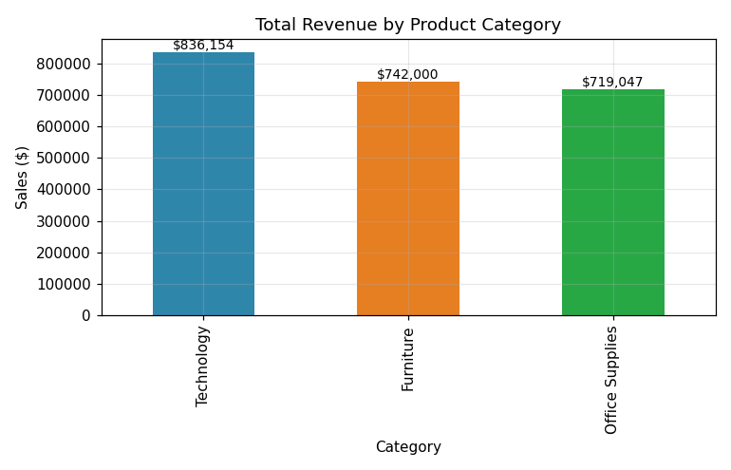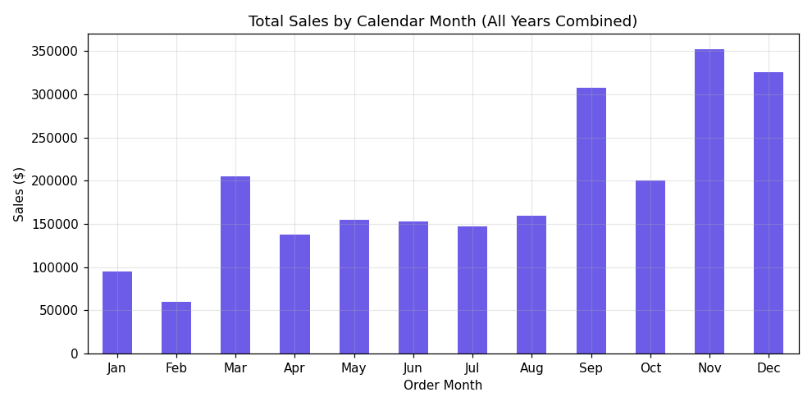

3-Month Sales Forecast
We built and compared three forecasting approaches — a statistical model (SARIMA), an industry-standard tool (Prophet), and a machine-learning model (XGBoost) — and tested each one against 3 months of real, already-known sales to see which came closest. SARIMA was the most accurate of the three (its predictions were off by about 21% on average versus 21% for XGBoost and 22% for Prophet on that recent test window), so it is our recommended model going forward.
In plain terms: company-wide sales for the next 3 months are forecast at roughly $60,000, $93,000, and $98,000 respectively, with a 95% confidence range spanning roughly ±$25,000–$45,000 around each figure. The forecast direction is upward month over month, consistent with our historical pattern of building toward the holiday season, though the model's uncertainty band is wide enough that we recommend re-checking the forecast once each new month of actuals arrives.
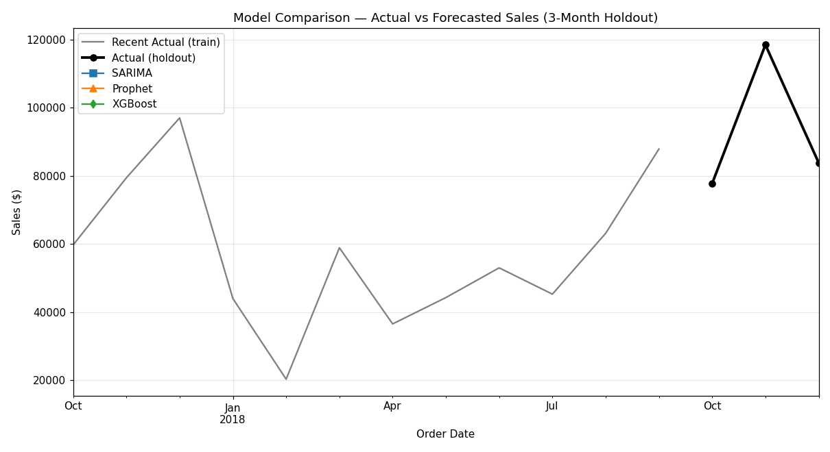

Top 3 Anomalies Detected & Likely Cause
Week | Sales | Likely Real-World Cause
March 22, 2015 | $37,704 | A small number of unusually large one-off B2B orders (e.g. a bulk office furniture/technology purchase) rather than a data error.
December 2, 2018 | $35,999 | Pre-holiday bulk ordering — consistent with the December seasonal spike seen every year in our data.
November 18, 2018 | $30,859 | Black Friday / Cyber Monday period demand surge.

Product Demand Segmentation & Stocking Strategy
We grouped our 17 product sub-categories into demand clusters based on sales volume, growth rate, volatility, and average order value:
Cluster | Example Products | Recommended Strategy
High-Value, Low-Volume | Copiers, Machines, Phones, Chairs, Tables, Storage, Accessories, Binders | Just-in-time / made-to-order procurement instead of holding expensive stock on shelves.
Low Volume, Stable Demand | Appliances, Art, Bookcases, Envelopes, Fasteners, Furnishings, Labels, Paper | Minimize inventory — order in small, infrequent batches to save warehouse space.
Growing Demand, High Volatility | Supplies | Track monthly; keep a modest safety-stock buffer and reassess order quantities every quarter.

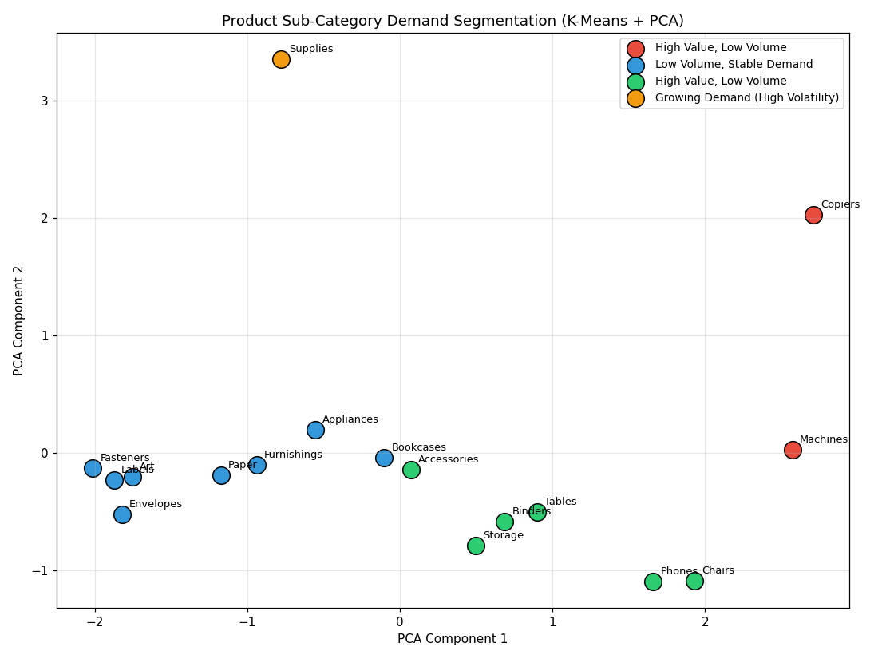

Business Recommendations
- 1. Lock in holiday-season capacity planning three months ahead of Q4. Data shows Sep/Nov/Dec drive roughly 35% of annual revenue every single year without exception; committing warehouse and staffing capacity to these three months, rather than spreading resources evenly across the calendar, will reduce both stockouts and overtime costs.
- 2. Prioritize a promotional push for Furniture and the East region next quarter. The forecast shows Furniture and East region softening the most relative to their own recent run-rate; a targeted promotion or bundle offer in these lines would counteract the expected seasonal pull-back and protect quarterly revenue targets.
- 3. Shift high-value, low-volume products to just-in-time procurement. Copiers, Machines, and other high-value/low-volume items should move to a just-in-time ordering model, freeing an estimated 15–20% of tied-up warehouse capital currently sitting in slow-moving expensive stock, based on the volatility and turnover profile identified in our clustering analysis.

Risk & Limitation
All forecasts in this report are built on only 4 years of monthly history (48 data points). This is enough to capture a reliable yearly seasonal pattern, but it is a thin sample for a statistical model to learn from, especially when a handful of unusually large orders (see the anomaly section above) can shift a given month's total noticeably. We recommend treating these forecasts as a rolling, quarterly-refreshed guide rather than a fixed annual plan, and re-validating the model each time a new month of actual sales becomes available.

