Machine Learning Unit 4
Computational Learning

Learning Set of Rules

Introduction
The target function represented as a set of if-then rules which is useful to learn simply.
There are multiple ways to learn the sets of rules, One way is to learn a decision tree,
Then translates the tree into an equivalent set of rules, i.e one rule for each leaf node in the tree.
Second Way is to use Genetic algorithm.
That Encodes each rule set as a bit string and uses genetic search operators to explore this hypothesis space.

Learning Sets of Rules
Variety of algorithms that directly learn rule sets and that differ from these algorithms in two key respects.
First, they are designed to learn sets of first-order rules That contain variables.
This is significant because first-order rules are much more expressive than propositional rules.
Second , use sequential covering algorithms
That learn one rule at a time to incrementally grow the final set of rules.

Example - First order rule sets
Consider the following two rules that jointly describe the target concept Ancestor.
Here we use predicate parent (x,y) to indicate that y is mother or father of x.
& the predicate Ancestor(x,y) to indicate that
y is an ancestor of x related by an arbitrary number of family generations.
IF Parent(x,y) THEN Ancestor(x,y)
IF Parent(x,z) AND Ancestor(z,y) THEN Ancestor(x,y)

This function is difficult to represent using decision tree or other propositional representation.

Applications of FIRST ORDER RULE Representations

- One way to see the representational power of first-order rules is to consider the general purpose programming language PROLOG. In PROLOG, programs are sets of first-order rules such as the two shown above (rules of this form are also called Horn clauses).
- In practice, learning systems based on first-order representations have been successfully applied to problems such as
  - learning which chemical bonds fragment in a mass spectrometer ,
  - learning which chemical substructures produce mutagenic activity and
  - learning to design finite element meshes to analyze stresses in physical structures .
- In each of these applications, the hypotheses that must be represented involve relational assertions that can be conveniently expressed using first-order representations, while they are very difficult to describe using propositional representations.

SEQUENTIAL COVERING ALGORITHMS
We consider a family of algorithms for learning rule sets.
  - Based on the strategy of learning one rule, removing the data it covers, then iterating this process.
  - Such algorithms are called sequential covering algorithms.
To elaborate, imagine we have a subroutine LEARN-ONE-RULE that accepts a set of positive and negative training examples as input, then outputs a single rule that covers many of the positive examples and few of the negative examples.
We require that this output rule have high accuracy, but not necessarily high coverage.
  - By high accuracy, we mean the predictions it makes should be correct.
  - By accepting low coverage, we mean it need not make predictions for every training example.

SEQUENTIAL COVERING ALGORITHMS
This procedure can be iterated as many times as desired to learn
a disjunctive set of rules that together cover any desired fraction of the positive examples.
This is called a sequential covering algorithm because it sequentially learns a set of rules that together cover the full set of positive examples.
The final set of rules can then be sorted so that more accurate rules will be considered first when a new instance must be classified.

Algorithm
- Learn one rule that covers certain number of examples
- Remove those examples covered by the rule
- Repeat on the examples left until the learned rule has the performance greater than predefined threshold.

Require that each rule has high accuracy but low coverage – High accuracy -> the correct prediction
- Accepting low coverage -> the prediction NOT necessary for every training example

Sequential Covering Algorithms(Cont..)

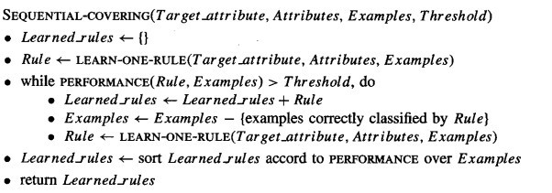
Sequential Covering Algorithms(Cont..)

- One of the most widespread approaches to learning disjunctive sets of rules.
- Problem of learning disjunctive sets of rules reduced to a sequence of simpler problems, each requiring that a single of conjunctive rule be learned.
- It performs a greedy search, formulating a sequence of rules without backtracking. Not guarantee to find a smallest or best set of rules covering training examples.

General to specific Beam search
- One effective approach to implementing LEARN-ONE-RULE is to organize the hypothesis space search in the same general fashion as the ID3 algorithm, but to follow only the most promising branch in the tree at each step
- The search begins by considering the most general rule precondition possible the empty test that matches every instance), then greedily adding the
attribute test that most improves rule performance measured over the training examples.
- Once this test has been added, the process is repeated by greedily adding a second attribute test, and so on.
- This process repeated untill the hypothesis reaches an acceptable level of performance.

General to specific Beam search
- This approach to implementing LEARN-ONE-RULE performs a general- to_specific search through the space of possible rules in search of a rule with high accuracy, though perhaps incomplete coverage of the data.
- As in decision tree learning, there are many ways to define a measure to select the "best" descendant. (low entropy)
- The general-to-specific search suggested above for the LEARN-ONE-RULE algorithm is a greedy depth-first search with no backtracking.
- With greedy search , there is a danger that a suboptimal choice will be made at any step.
  - To reduce this risk, we can extend the algorithm to perform a beam search.

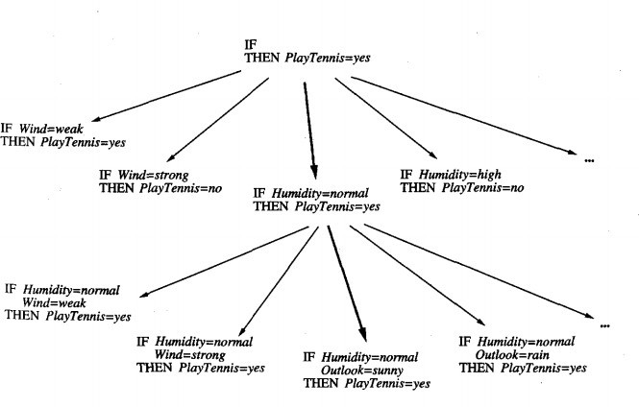

General to specific Beam search
- A search in which the algorithm maintains a list of the k best candidates at each step, rather than a single best candidate.
- On each search step, descendants are generated for each of these k best candidates and the resulting set is again reduced to the k best candidates.
- Beam search keeps track of the most promising alternatives to the current top-rated hypothesis,
- This general to specific beam search algorithm is used by the CN2 program described by Clark and Niblett

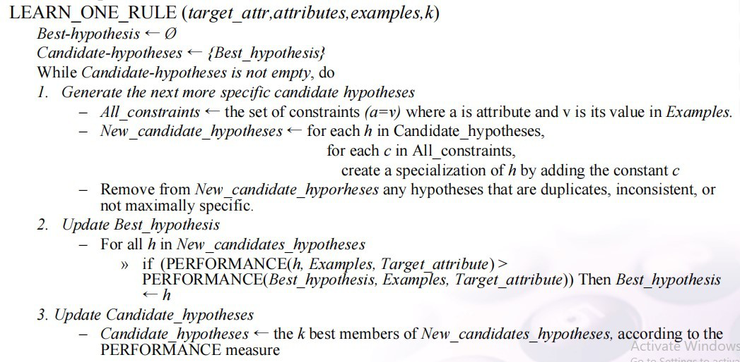

General to specific beam search
- Return a rule of the form “IF Best-hypothesis THEN prediction”
- where predication is the most frequent value of target_attr among those examples that match Best_x0002_hypothesis

– PERFORMANCE(h, examples, target_attribute) h_examples ← the subset of examples that match h
Return - Entropy(h_examples), where entropy is with respect to Target_attribute

Variations
- The SEQUENTIAL-COVERING algorithm, together with the LEARN-ONE-RULE algorithm, learns a set of if-then rules that covers the training examples.
- Many variations on this approach
- For example, in some cases it might be desirable to have the program learn only rules that cover positive examples and to include a "default" that assigns a negative classification to instances not covered by any rule.
- This approach might be desirable, say, if one is attempting
- to learn a target concept such as "pregnant women who are likely to have twins." In this case, the fraction of positive examples in the entire population is small, so the rule set will be morecompact and intelligible to humans if it identifies only classes of positive examples, with the default classification of all other examples as negative

- This approach also corresponds to the "negation-as-failure" strategy of PROLOG, in which any expression that cannot be proven to be true is by default assumed to be false.
- In order to learn such rules that predict just a single target value, the LEARN-ONE- RULE algorithm can be modified to accept an additional input argument specifying the target value of interest.
- The general-to-specific beam search is conducted just as before, changing only the PERFORMANCE subroutine that evaluates hypotheses.
- Note the definition of PERFORMANCE as negative entropy is no longer appropriate in this new setting, because it assigns a maximal score to hypotheses that cover exclusively negative examples, as well as those that cover exclusively positive examples. Using a measure that evaluates the fraction of positive examples covered by the hypothesis would be more appropriate in this case.


 is provided by a family of algorithms called AQ that predate the CN2 algorithm.
- AQ learns a disjunctive set of rules that together cover the target function.
- First, the covering algorithm of AQ differs from the SEQUENTIAL-COVERING algorithm because it explicitly seeks rules that cover a particular target value, learning a disjunctive set of rules for each target value in turn.
- Second, AQ's algorithm for learning a single rule differs from LEARN-ONE- RULE. While it conducts a general-to-specific beam search for each rule, it uses a single positive example to focus this search.
- In particular, it considers only those attributes satisfied by the positive example as it searches for progressively more specific hypotheses. Each time it learns a new rule it selects a new positive example from those that are not yet covered

Learning Rule Sets: Summary
  - Sequential or Simultaneous?
- Sequential : Learning one rule at a time, removing the covered examples and repeating the process on the remaining examples
- Simultaneous : Learning the entire set of disjucts simultaneously as part of the single search for an acceptable decision tree as in ID3
General-to-specific or Specific-to-general?
G-> S - Learn one rule S->G - Find S
Generate-and-test or Example-driven?
G&T : search thru syntactically legal hypotheses E-D : Find-S, Candidate-Elimination

LEARNING FIRST-ORDER RULES
  - We consider learning rules that contain variable in particular, learning first-order Horn theories.
  - Our motivation for considering such rules is,
They are much more expressive than propositional rules.

  - Inductive learning of first-order rules or theories is often referred to as 

Example - Propositional Representation
  - Propositional representations are variable free.
Consider the task of learning simple target concept Daughter (x, y), defined over pairs of people x and y.
The value of Daughter(x, y) is True when x is the daughter of y, and False otherwise.
The given dataset (Training example) contains people, each described with the attributes, such as
Name, mother, father, male, female and target value Daughter. IF (Father = Bob) AND (Name = Bob) AND (Female = True) THEN Daughter = True
This rule is specific and can be useful for future prediction.

The problem with propositional representations is,
  - Propositional representations have no general way to describe the essential relations among the values of the attributes.

A program using first-order representations could learn the following general rule:
IF Father(y,x) ∧ Female(y), THEN Daughter(x,y)

where x and y are variables that can be bound to any person.

Learn First Order Rules

  - First order logic is much more expressive than propositional logic – i.e. it allows a finer-grain of specification and reasoning when representing knowledge.
  - First order rule learners can generalise over relational concepts (which propositional learners cannot)
  - In addition, first order rule learners can also acquire recursive rules, e.g.:
IF Parent(x, y) THEN Ancestor(x, y)
IF Parent(x,z)∧Ancestor(z, y) THEN Ancestor(x, y)

Note, that variables may be introduced in the rule preconditions that do not occur in the postconditions (z in this case)

Terminology
- All expressions in first order logic are composed of:
- constants – e.g. bob, 23, a
- variables – e.g. X,Y,Z
- predicate symbols – e.g. f emale, f ather
  - predicates take on the values True or False only
- function symbols – e.g. age
  - functions can take on any constant as a value
– connectives – e.g. ∧, ∨, ¬, → (or ←)
– quantifiers – e.g. ∀, ∃

Terminology
  - A is
    - any constant – e.g. bob
    - any variable – e.g X
    - any function applied to any term – e.g. age(bob)
  - A  is
Any predicate or negated predicate applied to any terms
    - e.g. female(sue),¬father(X,Y)

    - A  is a literal that contains no variables
      - e.g. female(sue)
    - A   is a literal that does not contain a negated predicate
      - e.g.female(sue)


    - A  is a literal that contains a negated predicate
      - e.g ¬f ather(X,Y)

Learning First-Order Rules
  - A clause is any disjunction of literals M1 ∨ ···∨Mn whose variables are universally quantified
  - A Horn clause is any clause containing exactly one positive literal
Since  

and    (read ← B as “if B then A”) then a Horn clause can be equivalently written:
Note: the equivalent form in Prolog: H :- L1, ..., Ln.

Learning Sets of First-Order Rules: FOIL
  - Two methods are considered

we consider a program called FOIL, an approach very similar to the SEQUENTIAL-COVERING and LEARN-ONE-RULE algorithms.
  - The FOIL program is the extension to first-order representations.
  - The hypotheses learned by FOIL are sets of first-order rules, where each rule is similar to a Horn clause with two exceptions.

FOIL
  - FOIL learns first order rules which are similar to Horn clauses with 
    - literals may not contain function symbols (reduces complexity of hypothesis space)
    - literals in body of clause may be negated (hence, more expressive than Horn clauses)




FOIL learns one rule at time and removes positive examples covered by the learned rule before attempting to learn a further rule.


    - only tries to learn rules that predict when the target literal is true – propositional version sought rules that predicted both true and false values of target attribute
    - performs a simple hill-climbing search (beam search of width one)

FOIL
FOIL searches its hypothesis space via 
-   at each iteration adds a new rule to an overall disjunctive hypothesis. (i.e.rule1 ∨ rule2 ∨ rule3 )
This loop may be viewed as a
  - Starting with the empty disjunctive hypothesis which covers no positive instances
  - Stopping when the hypothesis is general enough to cover all positive examples.
 works out the detail of each specific rule, adding conjunctive constraints to the rule precondition on each iteration.

This loop may be viewed as a
  - starting with the most general precondition (empty)
  - stopping when the hypothesis is specific enough to exclude all negative examples

FOIL - Algorithm
FOIL(Target predicate,Predicates,Examples)
- Pos ← positive Examples, Neg ← negative Examples, Learned rules ← {}
- 
Learn a NewRule
  - NewRule ← most general rule possible (no preconditions)
  - NewRuleNeg ← Neg
Add a new literal to specialize NewRule
- Candidate literals ← generate candidates based on Predicates
- Best literal ←
argmaxL∈Candidate literals Foil Gain(L,NewRule)
- add Best literal to NewRule preconditions
- NewRuleNeg ← subset of NewRuleNeg that satisfies NewRule preconditions
  - Learned rules ← Learned rules+NewRule
  - Pos ← Pos − {members of Pos covered by NewRule}
- Return Learned rules

FOIL - in detail

- The principal differences between FOIL and SEQUENTIAL-COVERING + LEARN-ONE- RULE are:
  - In its inner loop search to generate each new rule, FOIL needs to cope with variables in the rule preconditions
  - The performance measure used in FOIL is not the entropy measure used in LEARN-ONE-RULE since
- the performances of distinct bindings of rule variables need to be distinguished
– FOIL only tries to discover rules that cover positive examples

FOIL: Specialising the Current Rule
- Suppose we are learning a rule of the form:
- Then candidate specialisations add a new literal of the form:  , where
Q is any predicate in the rule or training data.
at least one of the vi in the created literal must already exist as a variable in the rule
- Equal(xj, xk), where x j and xk are variables already present in the rule; or
- The negation of either of the above forms of literals

FOIL - Example
- Suppose we are trying to learn granddaughter(X,Y), given instances described by the predicates father and female:
- FOIL starts with the most general rule:

- The above procedure generates candidate additional literals:
equal(X,Y), female(X), female(Y), father(X,Y), father(Y,X), father(X,Z), father(Z,X), father(Y,Z), father(Z,Y)
- plus the negations of each of these








FOIL - Example
- Suppose FOIL now chooses father(Y,Z) as most promising:
granddaughter(X,Y) ← father(Y,Z)
- New candidate literals to specialise this rule include those from above, plus equal(Z,X), equal(Z,Y), f emale(Z), f emale(Y), f ather(Z,W), f ather(W,Z)
Plus their negations
If FOIL next selects , then  the rule
  - granddaughter(X,Y) ← f ather(Y,Z)∧ f ather(Z,X)∧ f emale(Y) is generated.
Assuming this rule covers only positive examples, no more specialisations for the current rule are sought.
- If more positive examples remain, search for another rule begins.

FOIL: Performance Evaluation
- How do we decide which is the best literal to add when specialising a rule?
- To do this FOIL considers each possible binding of variables in the candidate rule specialisation to constants in the training examples.
For example, suppose we have the training data:







and we also assume (“closed world assumption”) that any literals
- involving  granddaughter, father, and female
- involving bill, joan, joe, and tom
- not in the   are false. E.g. ¬granddaughter(bill,tom) is also true

FOIL: Performance Evaluation
Given the initial rule: granddaughter(X,Y) ←
- FOIL considers all possible bindings of X and Y to the constants
- Note that only
{X/bill,Y/ joan} is a positive binding
(i.e. corresponds to a positive training example).

FOIL: Summary
- FOIL alg learning to first order rule learning.
-  which acquires a disjunction of Horn clause-like rules which together cover the positive examples
-   which constructs individual rules by progressive specialisation of a rule through adding new literals selected according to the FOIL-gain measure until no negative examples are covered
- The literals introduced in the rule preconditions are drawn from the attributes used in describing the training examples
  - Variables used in new literals may be those occurring already in the rule pre-/ post conditions, or they may be new
  - If the new literal is allowed to use the target predicate then recursive rules may be learned
In this case special care must be taken to avoid learning rule sets that produce infinite recursion

FOIL: Summary



- FOIL
– otherwise some other strategy must be adopted
Quinlan proposed use of a minimum description length measure to stop rule extension
when the description length of rules exceeds that of the training data they explain.



