Machine Learning Unit 4
Computational Learning
Sample Complexity for Infinite Hypotheses Space The Mistake Bound Model of Learning

Sample Complexity for Infinite Hypotheses space

Sample complexity for PAC learning grows as the logorithm of the size of the hypothesis space.
There are two drawbacks to characterizing sample complexity in terms of |H|.
-> It can lead to quite weak bounds that the bound on delta can be significantly greater than 1 for large |H|.
-> Second, for infinite hypothesis spaces we can not apply the equation.

m 1 (ln H
≥
ϵ
+ ln(
1 ))
δ

VC Dimension

- We consider a second measure of the complexity of H, called Vapnik- Chervonenkis dimension of H or VC dimension or VC(H).
- In many cases, sample complexity bounds based on VC(H) than equation.
- This allow us to characterize the sample complexity of many infinite hypothesis spaces.

Shattering
- The VC dimension measures the complexity of the hypothesis space H, by the number of distinct instances from X that can be completely discriminated using H.
- Let us discuss more precise,
A set of instances S is shattered by hypothesis space H if and only if for every dichotomy(labeled class) of S there exists some hypothesis in H consistent with this dichotomy (labeled class).

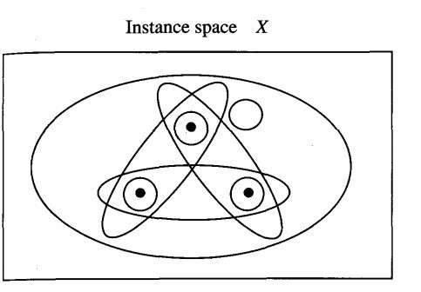
Shattering a set of Instances
  consider subset of 3 instances S from X (Instance space) . Each hypothesis h from H identify some concept on S. i.e h partitions S into the two subsets.

There could be 2S possible concepts.

We say H shatters S if every possible concept of S can be represented by Some hypothesis from H.

Shattering Definition:

The              to
represent target concepts defined over these instances.
If a set of instances is not shattered by a hypothesis space, then
there must be some concept (dichotomy) that can be defined over the instances, but that cannot be represented by the hypothesis space.

Shattering Example
- Consider a hypothesis for the 2-class problem.
- A set of 𝑁 points (instances) can be labeled as + or − in 2 N ways.
- If for every such labeling a function can be found in H consistent with this labeling, we set that the set of instances is shattered by H.
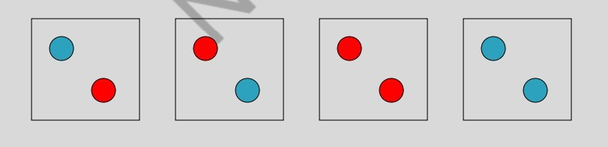

VC Dimension or VC(H)
The Vapnik-Chervonenkis dimension, VC(H). of hypothesis space H defined over instance space X is the size of the largest finite subset of X shattered by H. If arbitrarily large finite subsets of X can be shattered then VC(H) =  .
Briefly,
An unbiased hypothesis space H is one that shatters the instance space X. What if H cannot shatter X, but can shatter some large subset S of X ?
Intuitively, it seems reasonable to say that the larger the subset of X that can be shattered, the more expressive H. The VC dimension of H is precisely this measure.

If there exists at least one subset of X of size d that can be shattered then VC(H) ≥ d.
- If no subset of size d can be shattered, then VC(H) < d

Example,
For a single intervals on the real line, all sets of 2 instances can be shattered, but no set of 3 instances can, so VC(H) = 2

Since there are 2 m partitions of m instances, in order for H to shatter instances: |H| ≥ 2 m . Since |H| ≥ 2 m, to shatter m instances, VC(H) ≤ log2|H|

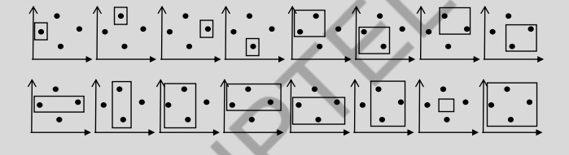
- Consider axis-parallel rectangles in the real-plane, i.e. conjunctions of intervals on two real-valued features. Some 4 instances can be shattered.

Some 4 instances cannot be shattered:

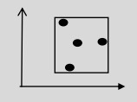

- No five instances can be shattered since there can be at most 4 distinct extreme points (min and max on each of the 2 dimensions) and these 4 cannot be included without including any possible 5th point.

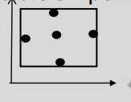
Therefore VC(H) = 4
  - Generalizes to axis-parallel hyper-rectangles (conjunctions of intervals in n dimensions): VC(H)=2n

Upper Bound on Sample Complexity with VC
- Using VC dimension as a measure of expressiveness, the following number of examples have been shown to be sufficient for PAC Learning

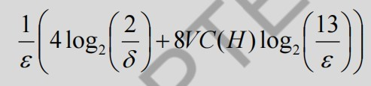

- Compared to the previous result using ln|H|, this bound has some extra constants and an extra log2(1/ε) factor. Since VC(H) ≤ log2|H|, this can provide a tighter upper bound on the number of examples needed for PAC learning

Lower Bound on Sample Complexity
- There is also a general lower bound on the minimum number of examples necessary for PAC learning (Ehrenfeucht, et al., 1989):
- Consider any concept class C such that 𝑉𝐶 (𝐻) > 2 , any learner 𝐿 and any 0 < 𝜀 < 1/8 , 0 < 𝛿 < 1/100 .
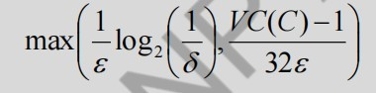
Then there exists a distribution D and target concept in C such that if L observes fewer than:

examples, then with probability at least δ, L outputs a hypothesis having error greater than ε.

Different learning settings that have been studied vary by how the training examples are generated noise in the data , the definition of success assumptions made by the learner and the measure according to which the learner is evaluated.
trainig examples: passive or active noisy or error free
target concept must be learned exactly, or only probably and approximately) the distribution of instances and whether C belongs to H
number of training examples, number of mistakes, total time

The mistake bound model of learning, in which the learner is evaluated by the total number of mistakes it makes before it converges to the correct hypothesis.
For example, if the system is to learn to predict which credit card purchases should be approved and which are fraudulent, based on data collected during use.
Then we are interested in minimizing the total number of mistakes it will make before converging to the correct target function. Here the total number of mistakes can be even more important than the total number of training examples.

- This mistake bound learning problem may be studied in various specific settings. For example, we might count the number of mistakes made before PAC learning the target concept.
In the examples below, we consider instead the number of mistakes made before learning the target concept exactly. Learning the target concept exactly means converging to a hypothesis such that

for all x h(x) = c(x).

- Find-S, which incrementally computes the maximally specific hypothesis consistent with the training examples.

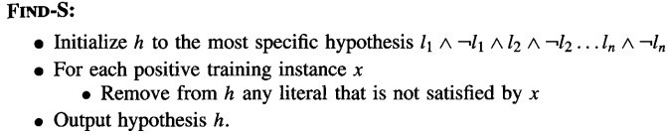

- Find-S converges hypothesis that makes no errors, for provided the concept belongs to H and given noise free training data .
- Find-S begins with the most specific hypothesis, then incrementally generalizes this hypothesis. This cover all observed positive training examples.
- Hypothesis that consists of unsatisfied literals deleted to make the hypothesis genaralize.

To calculate the number of mistakes it will make, we need only count the number of mistakes it will make misclassifying truly positive examples as negative.

- Consider first positive example encountered by Find-S.
- This certainly makes a mistake classifying this example because the initial hypothesis is specific (labels every instance negative).
- Half of 2n terms in its initial hypothesis will be eliminated (unsatisfied literals). n literals remains in the hypothesis.
- For each subsequent positive example that is mistakenly classified by the current hypothesis, at least one more of the remaining n terms must be eliminated from the hypothesis.
- Therefore, the total number of mistakes can be at most n + 1

- Consider an algorithm that learns by maintaining a description of the version space, incrementally refining the version space as each new training example is encountered.
- To analyze the number of mistakes made while learning
we must first specify precisely how the learner will make predictions given a new instance x.
Let us assume this prediction is made by taking a majority vote among the hypotheses in the current version space.
If the majority of version space hypotheses classify the new instance as positive, then this prediction is output by the learner.
Otherwise a negative prediction is output.

This combination of learning the version space, together with using a majority vote to make subsequent predictions, is often called the HALVING algorithm.
- What is the maximum number of mistakes that can be made by the HALVING algorithm, for an arbitrary finite H, before it exactly learns the target concept?
To derive the mistake bound, note that the only time the HALVING algorithm can make a mistake is when the majority of hypotheses in its current version space incorrectly classify the new example.
- In this case, once the correct classification is revealed to the learner, the version space will be reduced to at most half its current size.

- Given that each mistake reduces the size of the version space by at least half, and given that the initial version space contains only | H| members, the maximum number of mistakes possible before the version space contains just one member is log2 | H |. In fact one can show the bound is [log2|H| ]
- Consider, for example, the case in which |H| = 7. The first mistake must reduce |H| to at most 3, and the second mistake will then reduce it to 1.

- Hence [log2 IH|] is a worst-case bound.

W orst-case mistake bounds for two specific algorithms: FIND-S and CANDIDATE-ELIMINA
What is the optimal mistake bound for an arbitrary concept class C, assuming H = C.
By optimal mistake bound we mean the lowest worst-case mistake bound over all possible learning algorithms.
To be more precise, for any learning algorithm A and any target concept c, let MA(c) denote the maximum over all possible sequences of training examples of the number of mistakes made by A to exactly learn c.

let M _{A} (C) = max_{c} _{belongsto} _{C} M _{A} (C)

We showed M _{Find-S} (C) = n + 1
We also showed M _{Halving} (C) <= log2|C|)
We define the optimal mistake bound for a concept class C below.
Definition: Let C be an arbitrary nonempty concept class. The optimal mistake bound for C, denoted Opt (C), is the minimum over all possible learning algorithms A of M_{A} (C).
opt(c) = min A belongsto learning algorithms M A (C)
Opt(c) - no of mistakes made for the hardest concept in C.
M _{A} (C) - Maximum number of mistakes made by A to learn exactly the concept c. A - Algorithm (find-s or halving) C - Concept class

Thank You

