Phase 2: Solution Design & Architecture

Prepared by: Yaramala Varshitha

# Problem Statement

Once requirements are gathered in Phase 1, the next challenge is translating them into a clear, scalable, and secure solution design. Without a well-defined architecture, projects risk poor user experience, data inconsistencies, security gaps, and difficulty in scaling. Phase 2 aims to establish the blueprint for the Experience Cloud implementation by defining site structure, navigation, security, and data models.

# Objectives

The main objectives of Phase 2 include:

* - Define a scalable and secure site structure aligned with business goals.
* - Establish navigation flows for different user personas.
* - Design the Salesforce data model integration with the Experience Cloud site.
* - Determine templates, reusable components, and theme strategies.
* - Align the technical design with stakeholder expectations and industry best practices.

# Solution Architecture Design

Key activities in this stage include:

* - Define the overall site architecture including portals, pages, and components.
* - Establish data flow between Salesforce CRM objects and the site.
* - Identify reusable Lightning Components and Lightning Web Components (LWCs).
* - Plan security layers: profiles, roles, permission sets, and sharing settings.
* - Document integration points with APIs, external services, or middleware.

# Design Principles

Solution design should follow these guiding principles:

* - Simplicity: Keep navigation and user flows intuitive.
* - Scalability: Plan for growth in data volume and user traffic.
* - Security: Apply the principle of least privilege in user access.
* - Reusability: Create components and templates that can be reused across pages.
* - Maintainability: Ensure the design can be updated without heavy rework.

# Stakeholder Involvement

In Phase 2, collaboration with key stakeholders is critical:

* - Business Owners: Validate that design aligns with business needs.
* - IT Architects: Ensure technical feasibility and integration with Salesforce ecosystem.
* - UX/UI Designers: Provide input for intuitive design and user experience.
* - Administrators: Offer insights into governance and maintainability.
* - Developers: Confirm component feasibility and performance considerations.

# AppExchange Exploration

During Phase 2, exploring AppExchange can reveal prebuilt solutions that enhance design:

* - Navigation and menu components.
* - Security and compliance add-ons.
* - Analytics dashboards for Experience Cloud.
* - Industry-specific accelerators and templates.

# Industry Applications

Phase 2 design varies across industries:

* - Healthcare: Designing portals with HIPAA-compliant access.
* - Education: Architecting student and faculty portals with learning modules.
* - Finance: Secure customer portals with role-based access to financial data.
* - Retail: Personalized portals with product recommendations and customer dashboards.
* - Manufacturing: Partner portals with dealer/distributor dashboards.

# Additional Considerations

* - Risk analysis for scalability and integration challenges.
* - Alignment with compliance and regulatory requirements.
* - Planning for mobile responsiveness in design.
* - Documentation of architecture decisions for governance.

# Site Architecture

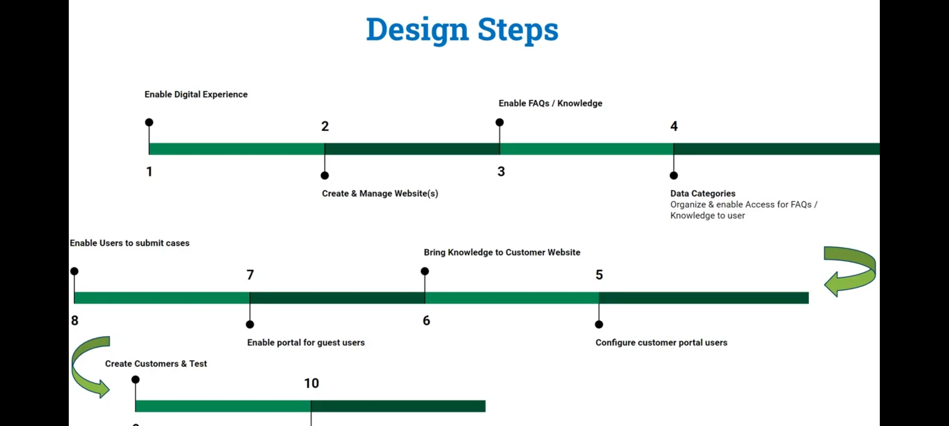

# Creating of Travel hut

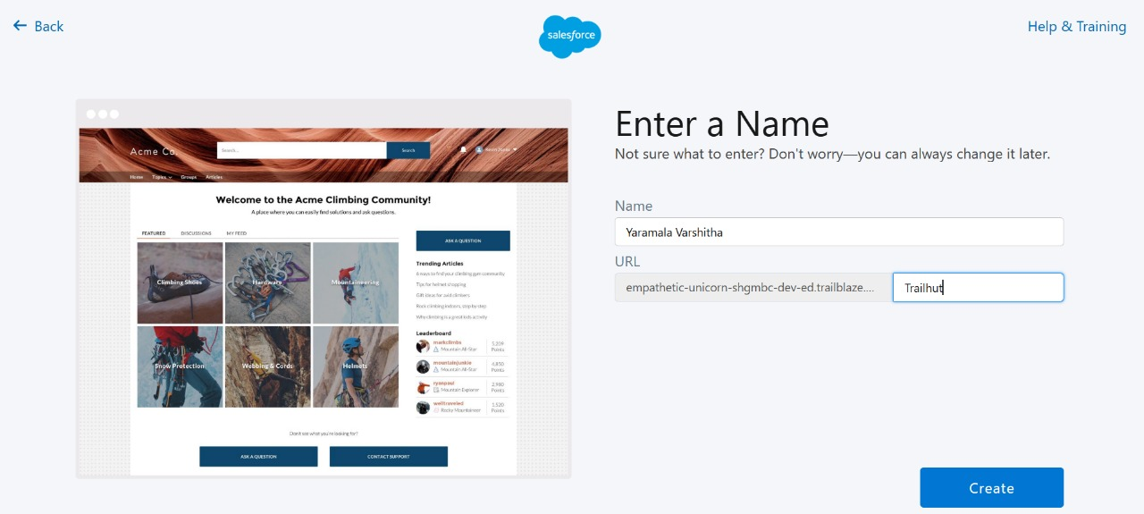

# Work Space of Travel hut



 