Phase 3: Environment Setup & Provisioning

Prepared by: Yaramala Varshitha

Phase 3 focuses on setting up the technical environment for Salesforce Experience Cloud. This includes provisioning sites, configuring domains, assigning licenses, and preparing development and testing environments. A proper setup ensures a smooth transition into design, customization, and deployment.

# Step 1: Check In – Check Out Profile

In this step, you create Check In – Check Out Profile

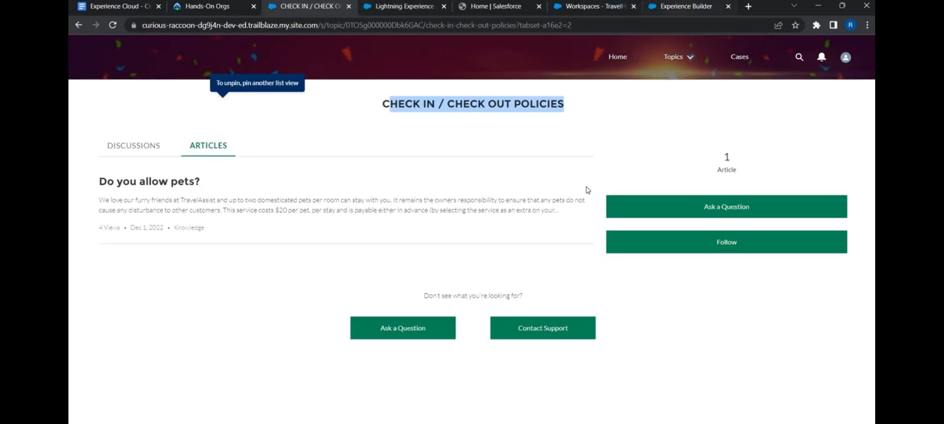

# Step 2: Creating Theme

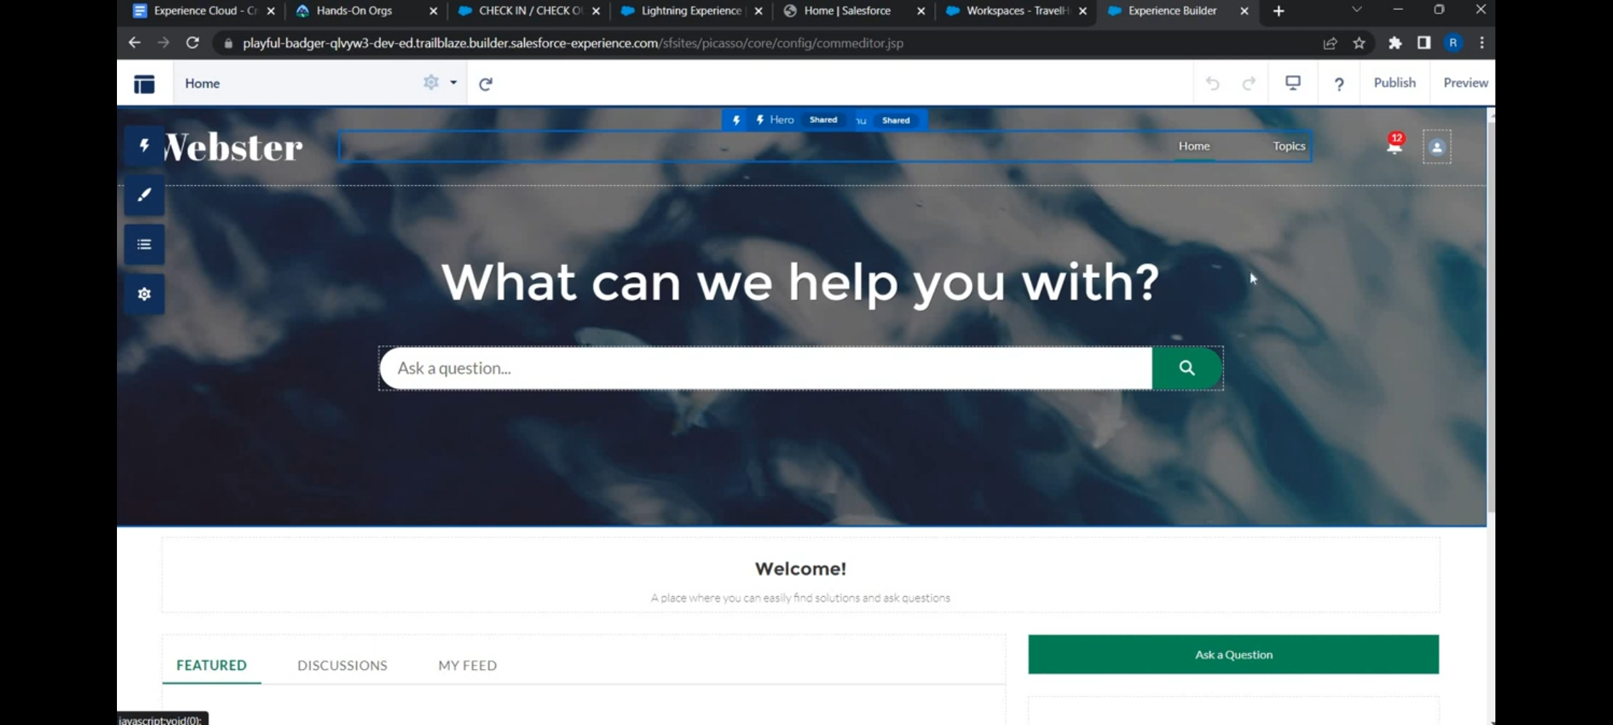

# Step 3: Object Manager as knowledge

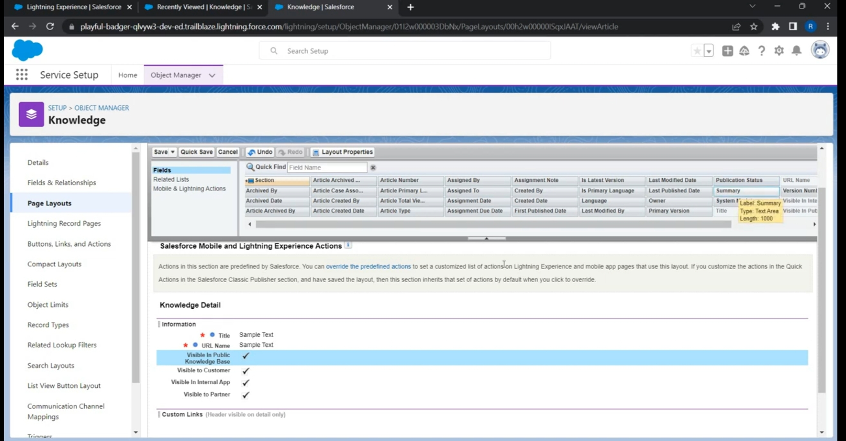

# Step 4: how do I cancel Booking?

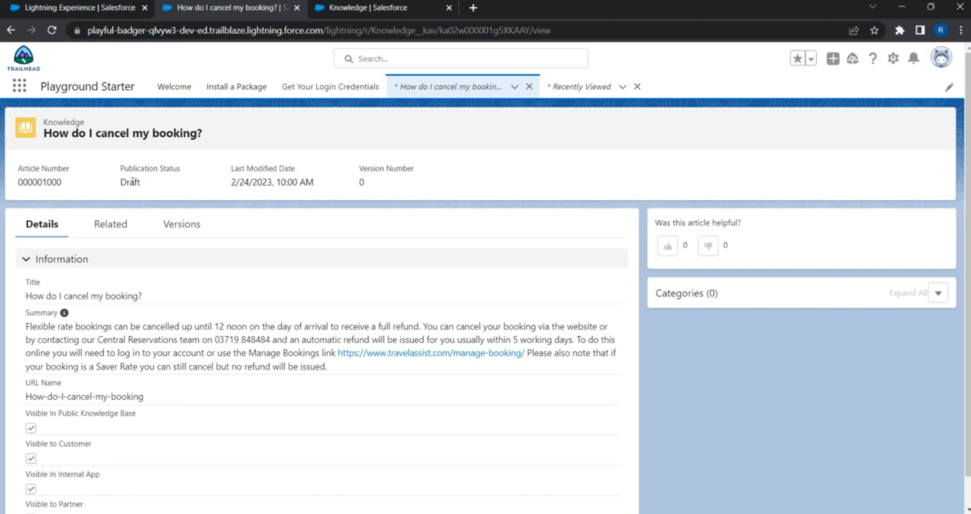

# Step 5: set Can I Amend my Booking?

