Phase 6: Component Development & Customization

Prepared by: Yaramala Varshitha

Phase 6 is dedicated to developing and customizing components within Salesforce Experience Cloud. This phase ensures that the site has the necessary functionality, combining standard components with custom-built ones where needed. Customization allows for alignment with business-specific requirements while maintaining scalability and performance.

# Step 1: Editing Customer Community User

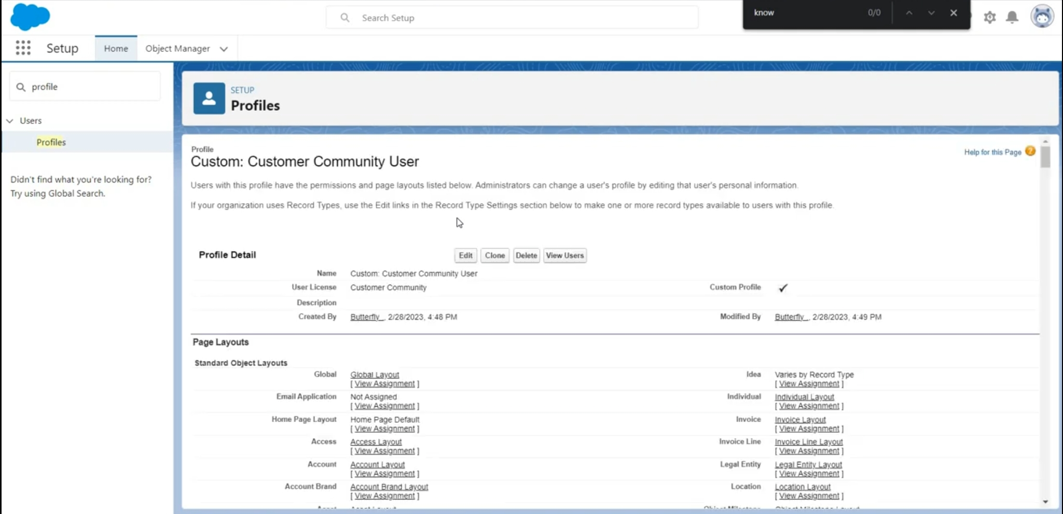

# Step 2 : Editing Check In – Check – Out Policies

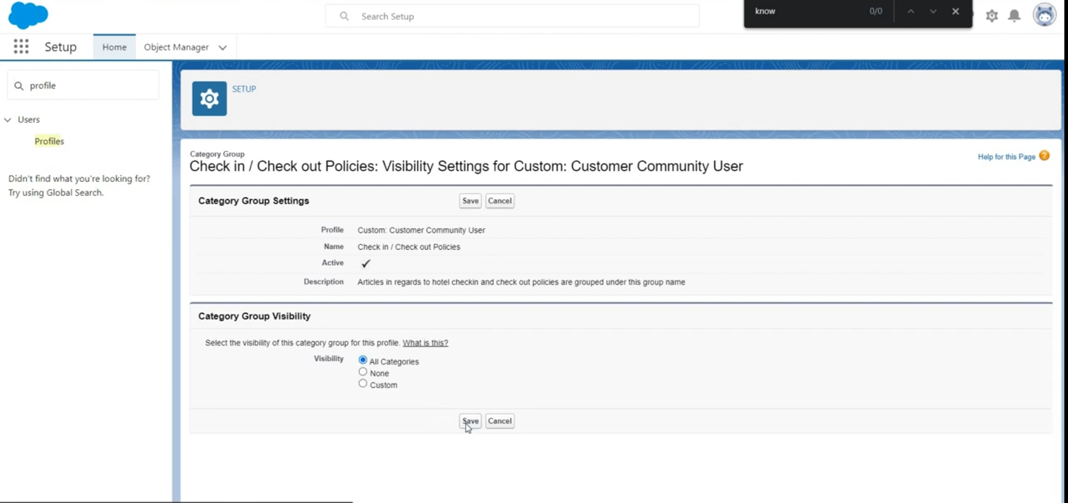

# Step 3: Editing Invoice

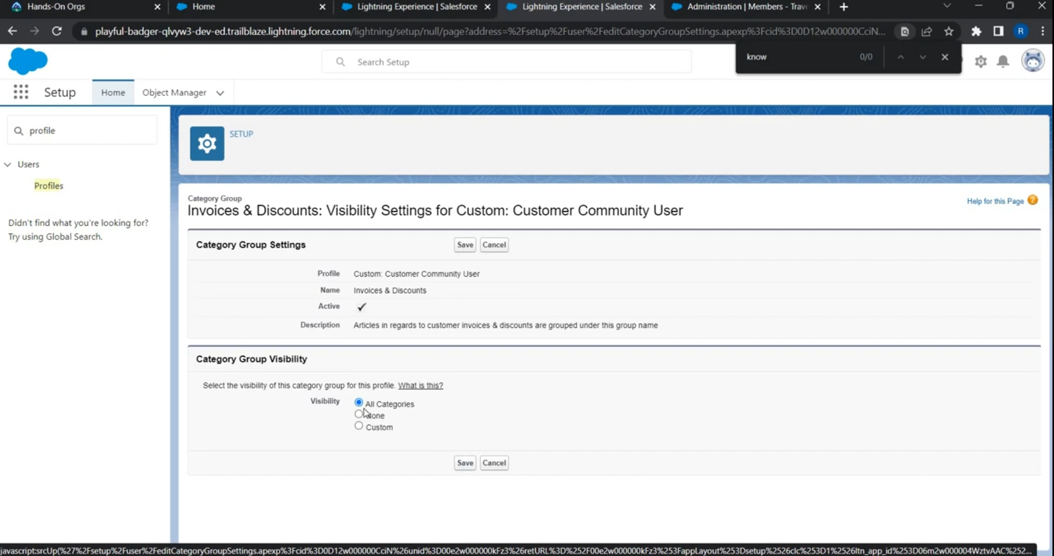

# Step 4: getting North American Portal account

