Phase 7: Security & Access Configuration

Prepared by: Yaramala Varshitha

Phase 7 focuses on configuring security and access within Salesforce Experience Cloud. This step ensures that the right users have the right level of access while protecting sensitive data. A robust security setup helps maintain trust, compliance, and overall system integrity.

# Step 1: app Launcher -> John Depp

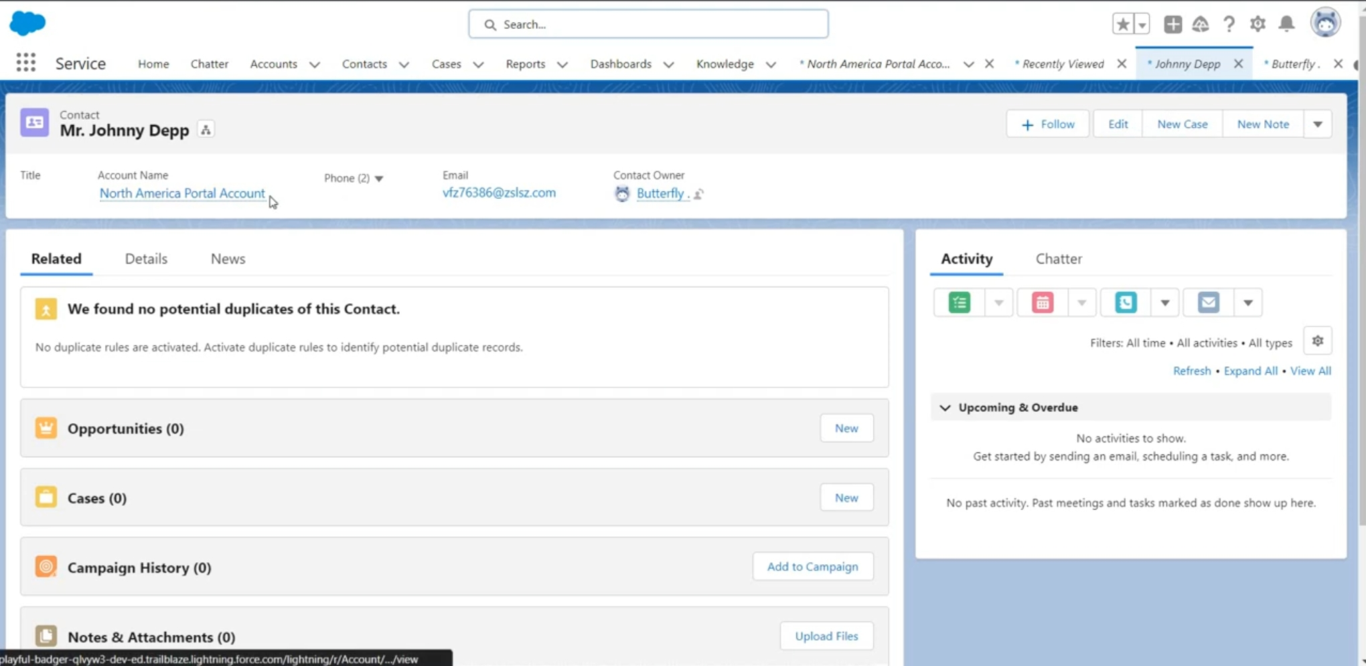

# Step 2: Editing User Account Page

# Step 3: Setting Password

# 

# Step 4: Getting Webpage

# Step 5: Editing Default Navigation

