# ASSIGNMENT-1

NAME: G. Bala Varshitha

HT.NO: 2403A52050

BATCH: AIB03

Task 1:

Write a comment: # Function to check if a string is a valid palindrome (ignoring spaces and case) and allow Copilot to complete it.

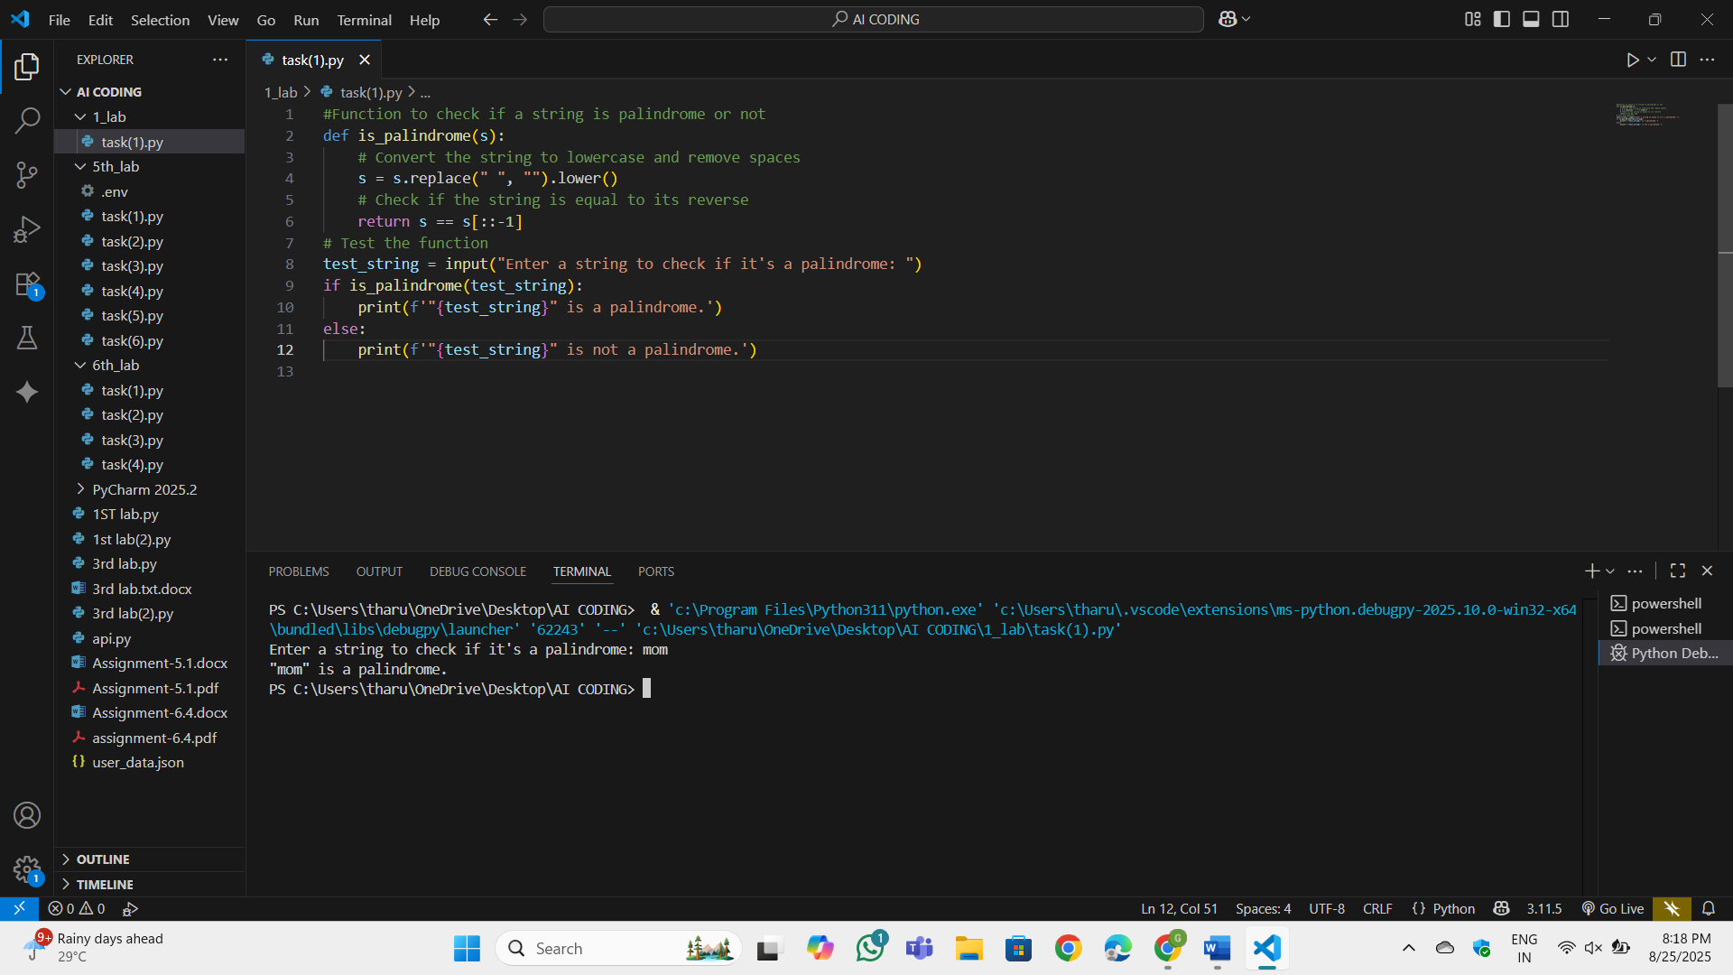

Task 2:  
● Generate a Python function that returns the Fibonacci sequence up to n terms. Prompt  
with only a function header and docstring  
Expected Output#2  
● AI completes the function logic using loop or recursion with accurate output

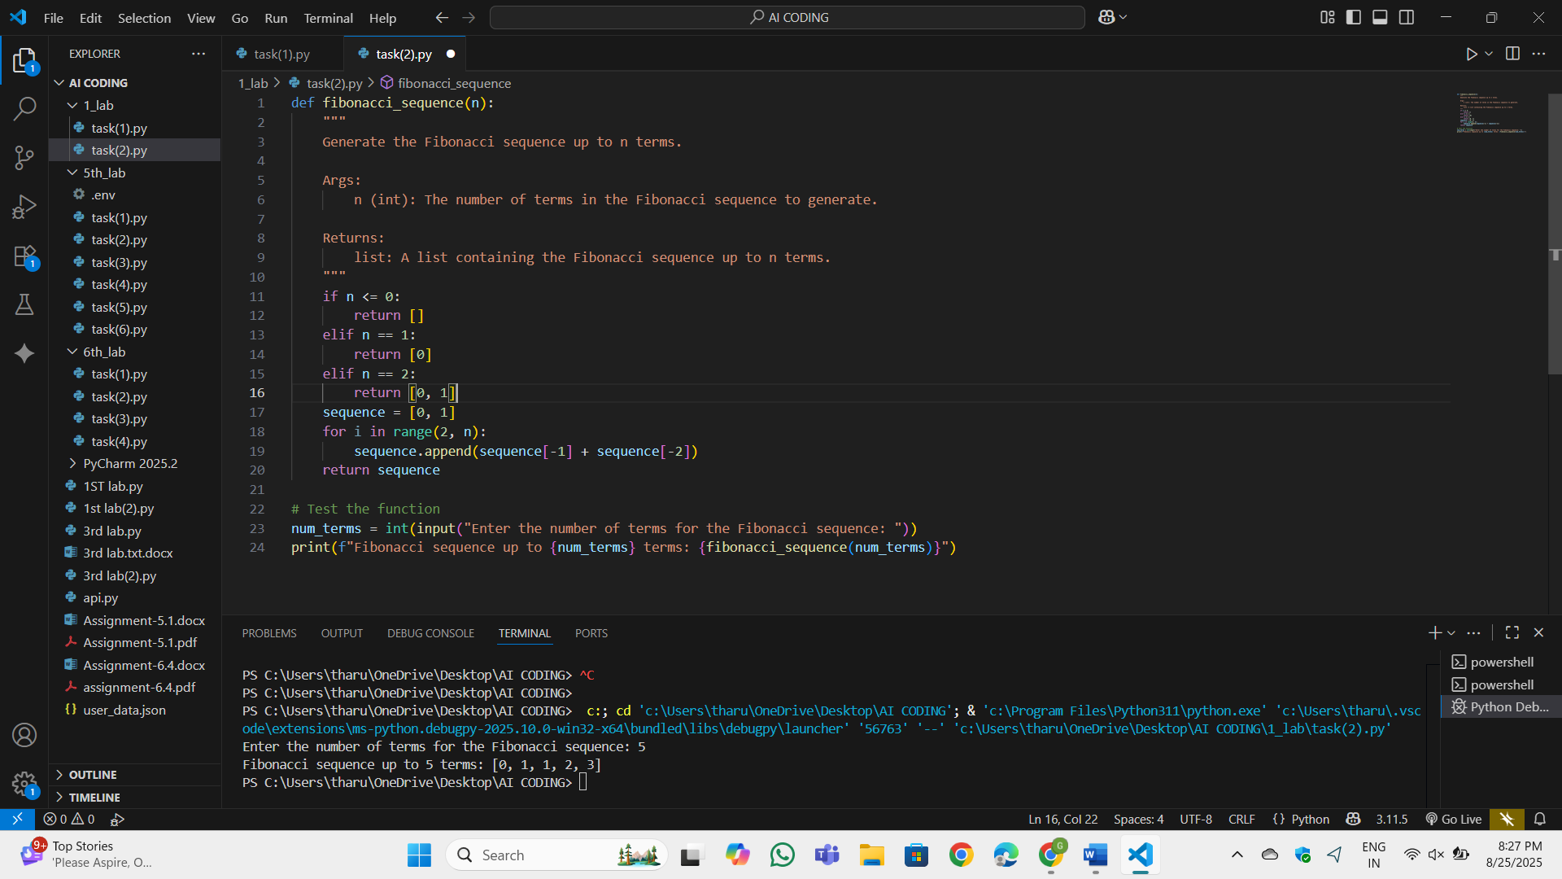

Task 3:  
● Write a comment like # Function to reverse a string and use Copilot to generate the  
function.  
Expected Output#3  
● Auto-completed reverse function

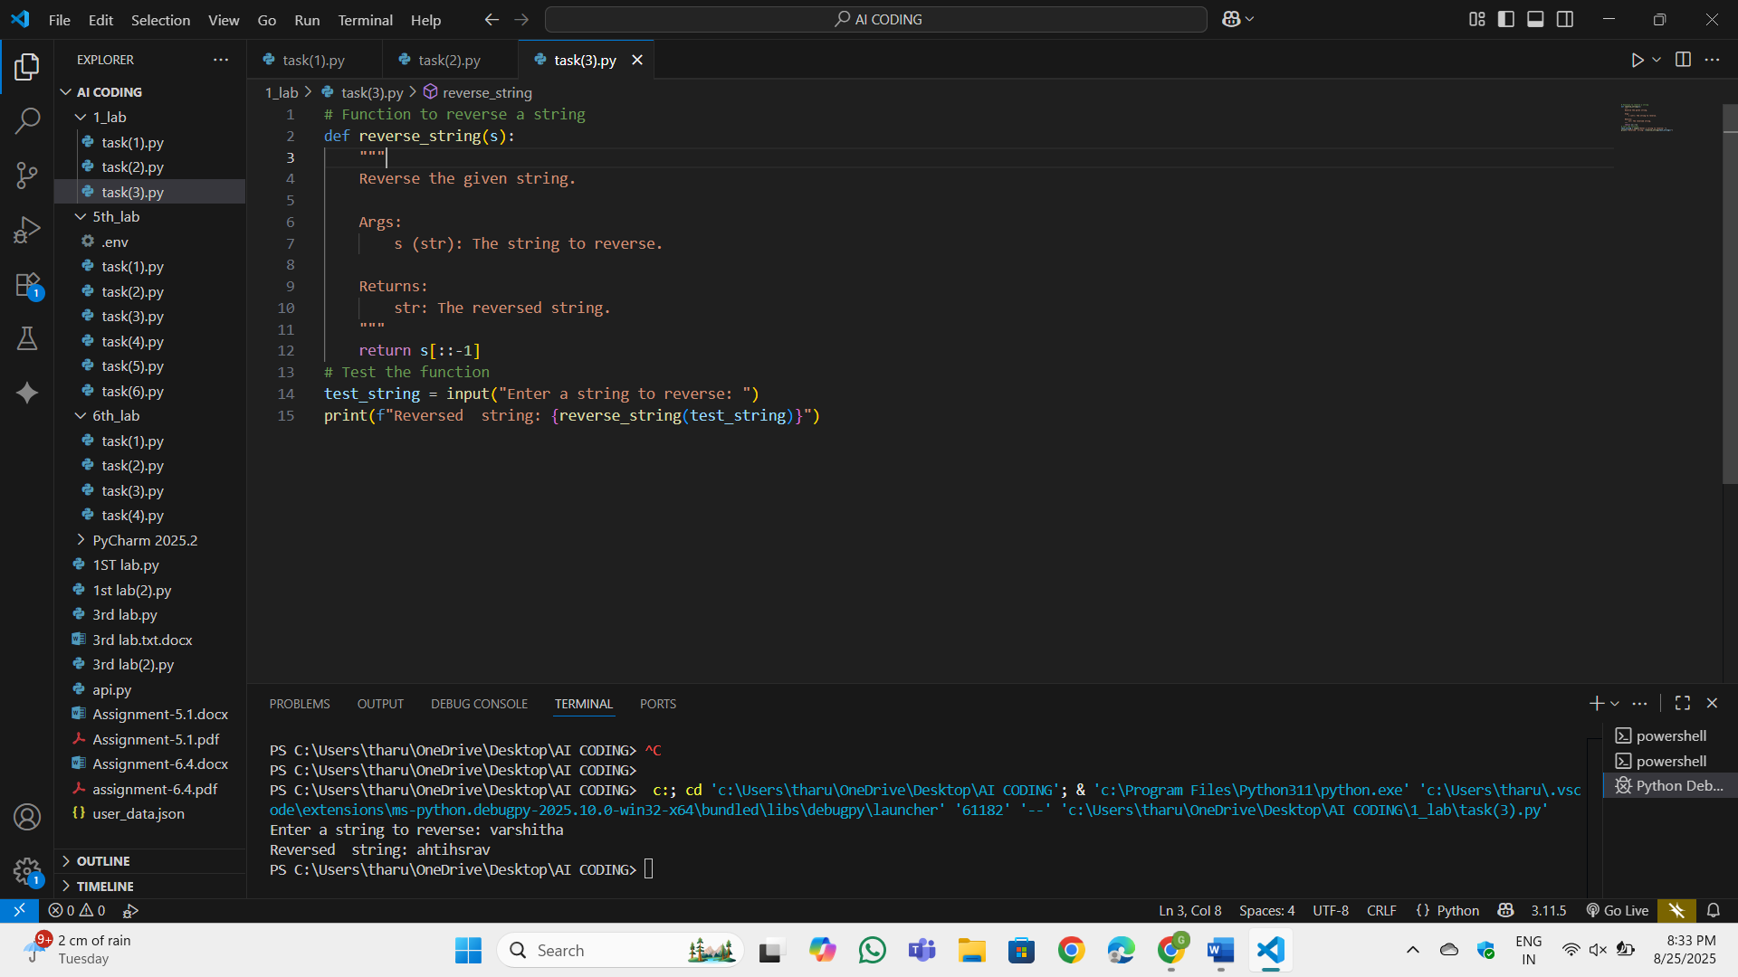

Task 4:

Generate a program that simulates a basic calculator (add, subtract, multiply, divide).  
Write the comment: # Simple calculator with 4 operations and let AI complete it.  
Expected Output#4  
● Fully working calculator with input/output and operator selection logic

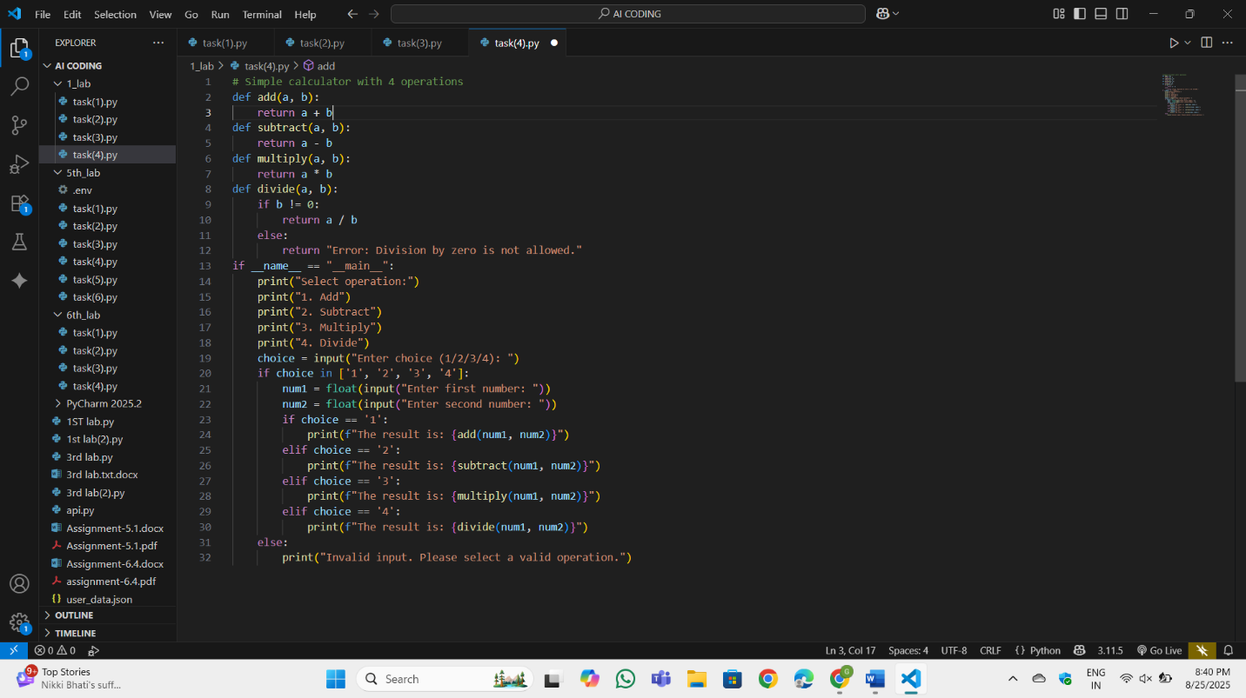

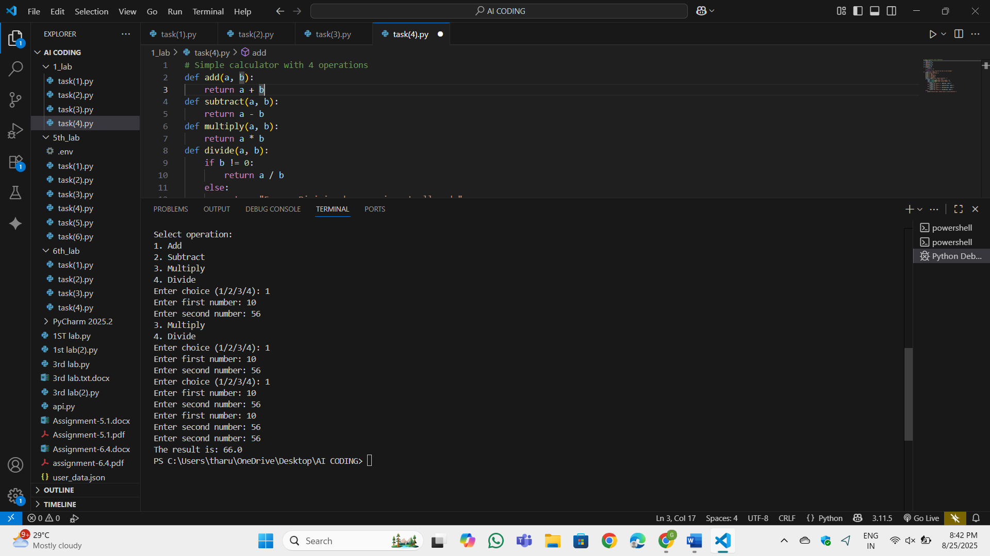

Task 5:  
● Use a comment to instruct AI to write a function that reads a file and returns the number of lines.  
Expected Output#5  
● Functional implementation using open() or with open() and readlines()

