Hybrid Power Generation with BMI Calculation and Health Monitoring System

Abstract:
This paper focuses on non-renewable energy conservation, with a particular emphasis on real-world difficulties. The system helps to generate power sustainably by utilizing solar energy, which is a renewable energy source, and integrating Piezo sensors, which produce energy in proportion to applied pressure. Furthermore, it effortlessly incorporates a health monitoring system that shows data in real-time from corresponding sensors about temperature, SpO2 levels, and heart rate. By determining an individual's fatty mass based on their weight and height, the BMI module offers useful information. This multipurpose approach is a flexible and significant breakthrough that encourages the use of renewable energy sources and provides extensive health insights.

Keywords: BMI, Health Monitoring, Piezo, Solar, Ultrasonic Sensor, renewable

Literature Survey:
Nabil Alshurafa and his team developed a paper focused on nutrition intake recognition using time-frequency decomposition in a wearable necklace equipped with a piezoelectric sensor [1]. This prototype necklace demonstrates the capability to distinguish between liquids and solids. Hongzhou Yu and Lu Liu introduced a "Remote Health Monitoring System Using ZigBee Network and GPRS Transmission Technology," enhancing healthcare through real-time data collection and transmission [2]. Xiaohui Liang, Mrinmoy Barua, Le Chen, Rongxing Lu, and Xuemin (Sherman) Shen authored "Enabling Pervasive Healthcare through Continuous Remote Health Monitoring," discussing methods for continuous remote health monitoring [3]. The IEEE PES Renewable Technologies Subcommittee provided a thorough review of hybrid renewable and alternative energy (RE/AE) power generation systems, emphasizing sustainability and addressing design and energy management challenges [4]. Another paper presented an induct-or-less switched capacitor energy harvester capable of simultaneously harvesting from solar and Piezo sources [5]. The paper explores the correlation between BMI and human walking speed through experimental research, utilizing mathematical formulations rooted in bio mechanical anthropometry. It introduces a novel algorithm based on graph theory to validate findings in practical scenarios, enabling the determination of optimal escape routes considering infrastructure, physiology, and soil conditions. The algorithm assesses walking speed and presents evacuation times based on BMI. This approach holds promise for application across civil security domains[6]. Lastly, a study explored the role of concentrating solar power (CSP) in achieving high renewable energy penetration in power systems, utilizing a stochastic two-stage generation and transmission expansion planning model [7].

Introduction:

Utilizing the evolving thesis as a reference, we have developed an innovative system that serves as a multipurpose health monitoring cum BMI calculator cum hybrid power generator. Let's look into the parameters of the implementation of different modules.

The first system consists of hybrid power generation, as the name implies, with voltage generated through solar and Piezo sources. Here utilized a 3-watt capacity solar panel, forming the solar array of a photovoltaic system, to generate and supply solar electricity. Additionally, the piezoelectric sensor, a device harnessing the piezoelectric effect, measures changes in pressure, acceleration, temperature, strain, or force by converting them into electrical charge.In addition to provide an alternative to non-renewable resources we have utilized this generated voltage to power up the entire system.

Before delving into the BMI module, let's examine the definition of BMI.
What is BMI?
The body mass index (BMI) is a metric that utilizes an individual's weight and height to assess whether they have a healthy weight. It utilizes kilograms for weight and meters for height measurement.

The following shows the BMI ranges of a healthy person:
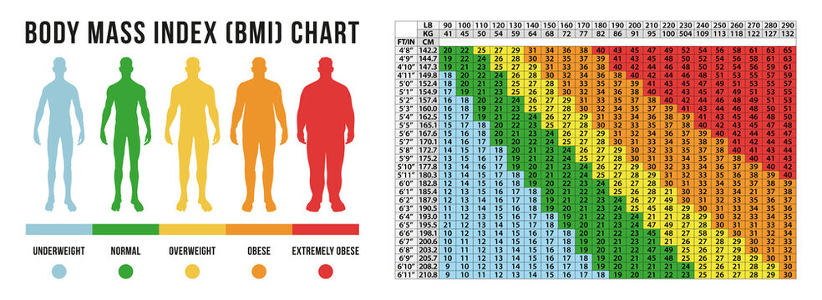
A person's BMI can be determined by considering parameters such as height and weight. While numerous sources exist in the market to calculate BMI, they often require advance knowledge of these continuous variables or involve costly hardware. To address these limitations, we have developed a BMI application that utilizes an ultrasonic sensor to measure height and a digital weight machine to measure weight. This implementation offers a more accessible and cost-effective solution for BMI calculation.
Self-health monitoring equipment has become increasingly essential, particularly in the aftermath of COVID-19. However, obtaining separate devices for each specific parameter has been the norm. In response, we have developed an integrated module capable of measuring heartbeat and SPO2 using the Max30100 sensor, alongside temperature readings via the DS18B20 sensor. These data are processed using Arduino Uno and Nano modules, with the results conveniently displayed on LCD modules.

Methodology:
In this project, we've developed and implemented an innovative solution for creating a Hybrid Power Generation and Storage System integrated with BMI calculation and Health Monitoring. As this system consists of three distinct modules, let's delve into each one to understand their functionalities. This system is designed using Arduino based controller as brain of the entire system.
Module-1:
The initial part of the system entails a hybrid power generation configuration incorporating solar and Piezo components. These elements produce voltage, which is subsequently stored in a 12V/4.5 battery through a charging circuit. This stored voltage is then utilized to charge two mobile phones via USB ports and to power the entire system. Manual switches are employed to control the charging process for the mobile phones.
Module-2:
The second component of the system is dedicated to calculating the BMI (Body Mass Index) of an individual based on their height and weight. The person's height is measured using an ultrasonic sensor, while their weight is obtained from a digital weight machine. Data from the ultrasonic sensor is processed using an Arduino-based controller, and the body weight is entered using a keypad matrix. Subsequently, this data is processed using Arduino, and the BMI value is displayed on an LCD module. Additionally, the system indicates whether the BMI value is categorized as low or high.
Module-3:
The third segment of the system focuses on health monitoring, incorporating sensors for heart rate, SpO2, and temperature. These sensor data are processed by an Arduino controller, and the real-time values are displayed on an LCD module.
The system is programmed using Embedded C language, utilizing the Arduino IDE compiler and an onboard USB programmer. Sensor pins are linked to analog pins of the Arduino, while output devices are connected to digital pins. Powering the entire system involves utilizing a 12V/4.5V battery source. Voltage regulators and filter capacitors are employed to generate a constant 5V DC supply for sensors and the LCD module, ensuring stability. Additionally, filter capacitors are utilized to eliminate noise and produce a steady voltage output.

The following block presents a diagrammatic representation of the operational model of the project system.
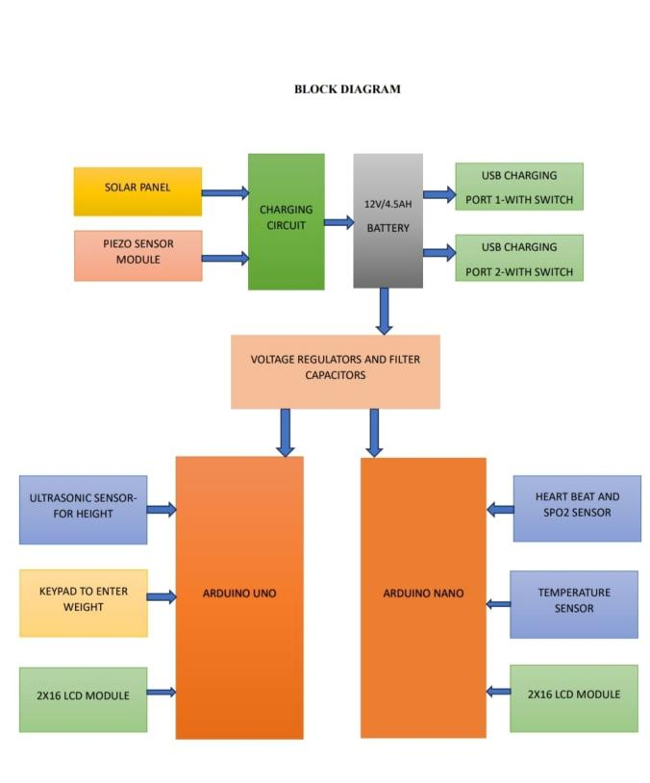
Existing System:
In the past, determining a person's Body Mass Index (BMI) often relied on software-based tools. These tools allowed users to input specific data such as height and weight, and then the software would compute the BMI accordingly. However, when it came to monitoring other vital signs like heart rate and temperature, dedicated equipment was necessary. This equipment was designed specifically for measuring these parameters accurately.Furthermore, the software applications used in these processes often required non-renewable resources for their operation. This could include electricity generated from fossil fuels or other finite sources. As a result, the reliance on such resources raised concerns about sustainability and environmental impact.
Proposed System:
In this proposed system, we've developed a hybrid solution to monitor both BMI and health parameters using an Arduino-based controller. The system employs a MAX30100 sensor module to measure the patient's heartbeat and SPO2 levels, while an LM35 sensor measures body temperature. Height is monitored with an ultrasonic sensor, complementing weight input for BMI calculation. Powering the system are piezo and solar energy sources, charging a battery to sustain operations. Additionally, a USB-based charging option is included to power 5V devices such as mobile phones or other gadgets.

P

Results and discussion :
Lets look into the working results of our system
- The hybrid power generation module incorporates solar and Piezo sources, leveraging their real-time functionality. To mitigate voltage fluctuations, a rechargeable battery serves as the buffer energy source, storing the energy generated by these two sources.




- The following figure depicts the operational mechanism of a BMI module and showcases its real-time outcomes.


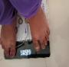



- The final module is a health monitoring system that incorporates sensors such as DS18B20 for temperature, and MAX30100 for heartbeat and SPO2 levels. It then displays the readings on an LCD screen as follows:
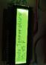
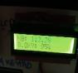
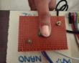
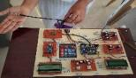

Conclusion:
Our innovative solution revolutionizes health monitoring by simultaneously assessing an individual's health status and Body Mass Index (BMI) condition through two integrated monitoring tools. The first tool calculates BMI by inputting weight via a keypad and measuring height, yielding precise BMI values. This data offers valuable insights into the individual's weight status and overall health. Complementing the BMI measurement tool is our second monitoring tool, which tracks various health parameters in real-time. Equipped with sensors for heartbeat, blood oxygen saturation (SPo2), and temperature, this tool provides a comprehensive overview of the individual's physiological condition. The gathered data is promptly displayed on an LCD module, providing immediate feedback for users and healthcare professionals alike. Operating sustainably, our system is powered by two non-renewable energy sources: Piezo and solar energy. This dual-power setup ensures reliable functionality while minimizing dependency on conventional power sources, contributing to environmental sustainability and deployment versatility. Furthermore, our system leverages IOT based technology to enhance connectivity and data monitoring capabilities. Through seamless integration with IOT platforms, users can remotely access real-time sensor data via a Blink-based cloud server. This feature empowers proactive health management, allowing users to monitor changes in health parameters and respond promptly as needed. Facilitating connectivity is a Node MCU based Wi-Fi module, that seamlessly integrates the system with the internet. This enables effortless data transmission and access to real-time health information from any location with internet connectivity. In conclusion, our innovative solution combines BMI assessment with real-time tracking of vital health parameters, revolutionizing personalized health monitoring. With sustainable power sources, advanced monitoring capabilities, and IOT connectivity, our system represents a significant advancement in health monitoring technology, empowering individuals to prioritize and manage their health effectively.

Future Scope:
Certainly! By integrating IOT technology into the system, we can leverage the capabilities of connected devices to enhance its functionality. With this enhancement, users gain the ability to monitor sensor data in real-time through a cloud server hosted on the Blink platform. This means that they can access crucial information remotely, allowing for greater flexibility and convenience. The use of a Nicodemus-based Wi-Fi module ensures seamless internet connectivity, enabling continuous data transmission and updates. Overall, this IOT based extension significantly improves the system's effectiveness and usability.
References:
[1] Alshurafa, N., et al. "Recognition of Nutrition Intake Using Time-Frequency Decomposition in a Wearable Necklace Using a Piezoelectric Sensor.", IEEE SENSORS JOURNAL, VOL. 15, NO. 7, JULY 2015

[2]. Hongzhou Yu, Lu Liu “Remote Health Monitoring System Using ZigBee Network and GPRS Transmission Technology” 978-0- 7695-4500-4/11 give this paper abstract
[3]. Xiaohui Liang, Mrinmoy Barua, Le Chen, Rongxing Lu, Xuemin(Sherman) Shen “Enabling Pervasive Healthcare through Continuous Remote Health Monitoring” 1536- 1284/12. give this paper abstract
Top of Form

[4] Special Task Force of the IEEE PES Renewable Energy Technologies Subcommittee, Energy Development and Power Generation Committee, “A Review of Hybrid Renewable/Alternative Energy Systems for Electric Power Generation:” Configurations, Control, and Applications, IEEE TRANSACTIONS ON SUSTAINABLE ENERGY, VOL. 2, NO. 4, OCTOBER 2011
[5] Abhishekh Devaraj, Mohamed Megahed, Yutao Liu, Ashwin Ramachandran, and Tejasvi Anand, Member, IEEE, “A Switched Capacitor Multiple Input Single Output Energy Harvester (Solar + Piezo) Achieving 74.6% Efficiency With Simultaneous MPPT”, IEEE TRANSACTIONS ON CIRCUITS AND SYSTEMS–I: REGULAR PAPERS, VOL. 66, NO. 12, DECEMBER 2019
[6]. WASHINGTON VELÁSQUEZ 1,2, (Student Member, IEEE), MANUEL S. ALVAREZ-ALVARADO2, (Student Member, IEEE), AND JOAQUÍN SALVACHÚA1, “Body Mass Index in Human Walking on Different Types of Soil Using Graph Theory”, Received May 28, 2018, accepted August 6, 2018, date of publication August 30, 2018, date of current version September 21, 2018.

[7] Ershun Du, Student Member, IEEE, Ning Zhang, Senior Member, IEEE, Bri-Mathias Hodge, Senior Member, IEEE, Qin Wang, Member, IEEE, Chongqing Kang, Fellow, IEEE, Benjamin Kroposki, Fellow, IEEE, and Qing Xia, Senior Member, IEEE, “The Role of Concentrating Solar Power Toward High Renewable Energy Penetrated Power Systems”, IEEE TRANSACTIONS ON POWER SYSTEMS, VOL. 33, NO. 6, NOVEMBER 2018
Top of Form

