**SNAPSHOT OF C PROGRAM:**

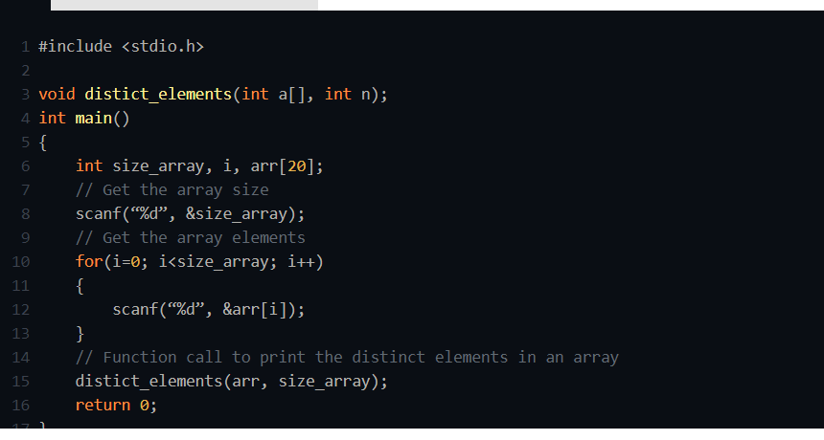

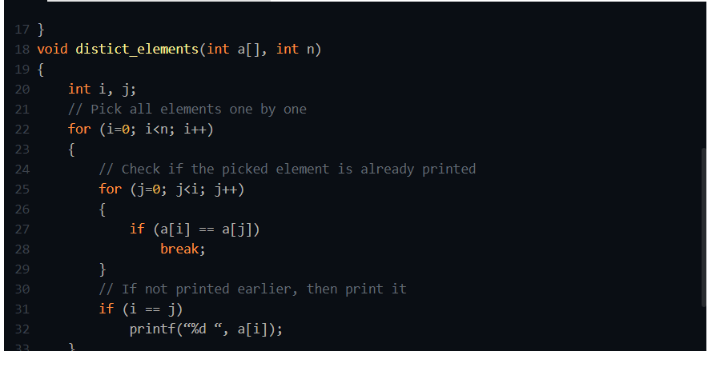

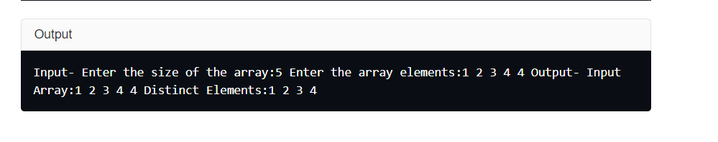

**ALOGRITHM:**

**STEP1:** Declare and input the array elements.

**STEP2:** Traverse the array from the beginning.

**STEP3:** Check if the current element is found in the array again.

**STEP4:** if it is found, then do not print the element.

**STEP5:** Else, print that element and continue.

**FLOWCHART:**

