**DAILY ONLINE ACTIVITIES SUMMARY**

|  |  |  |  |  |  |  |  |  |
| --- | --- | --- | --- | --- | --- | --- | --- | --- |
| **Date:** | **03-06-2020** | | | | | **Name:** | **Varshitha** | |
| **Sem & Sec** | **6th - B** | | | | | **USN:** | **4AL17CS106** | |
| **Online Test Summary** | | | | | | | | |
| **Subject** | | **PAP Assignment Test-1** | | | | | | |
| **Max. Marks** | | **20** | | **Score** | | | **16** | |
| **Certification Course Summary** | | | | | | | | |
| **Course** | **Deep learning with Python** | | | | | | | |
| **Certificate Provider** | | | **Great Learning** | | **Duration** | | | **3hrs** |
| **Coding Challenges** | | | | | | | | |
| **Problem Statements:**  1.Write a python program to generate prime number in an interval  2. Write a Java Program to Implement Circular Doubly Linked List.  3.Write a python program for list of length 3 containing integers, find out which is larger, first or last one and set all | | | | | | | | |
| **Status: executed** | | | | | | | | |
| **Uploaded the report in Github** | | | | | **Yes** | | | |
| **If yes Repository name** | | | | | https://github.com/Varshitha019/Daily-Online-Coding.git | | | |
| **Uploaded the report in slack** | | | | | **Yes** | | | |

Online Test Details: (Attach the snapshot and briefly write the report for the same)

Assignment Test of PAP

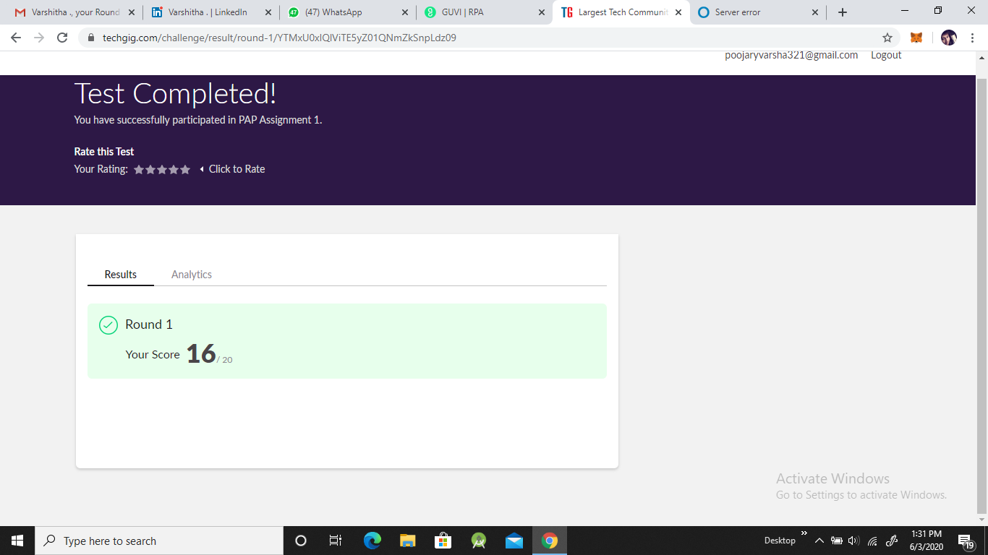

Certification Course Details: (Attach the snapshot and briefly write the report for the same)

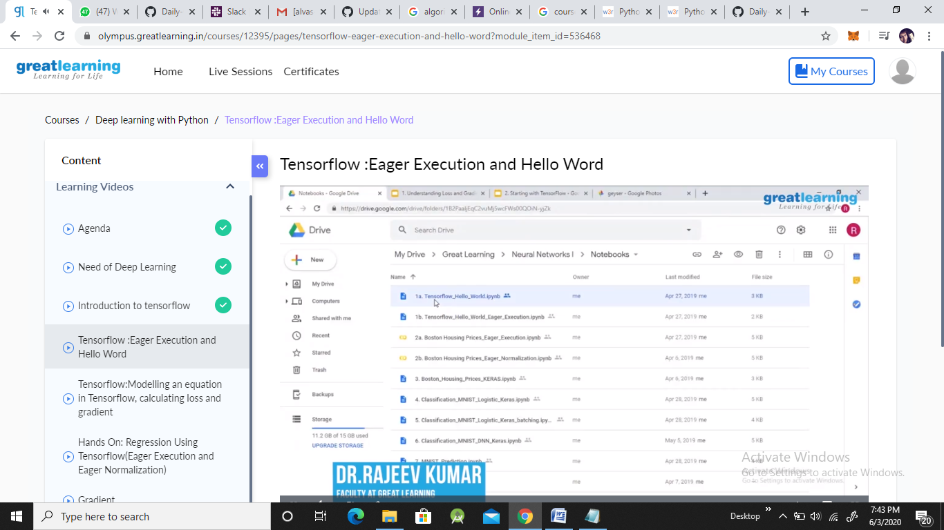

**Coding Challenges Details: (Attach the snapshot and briefly write the report for the same)**

**Problem statements are available in the Github** : https://github.com/Varshitha019/Daily-Online-Coding.git

**OUTPUT SCREEN-SHOTS:** **Program 1**

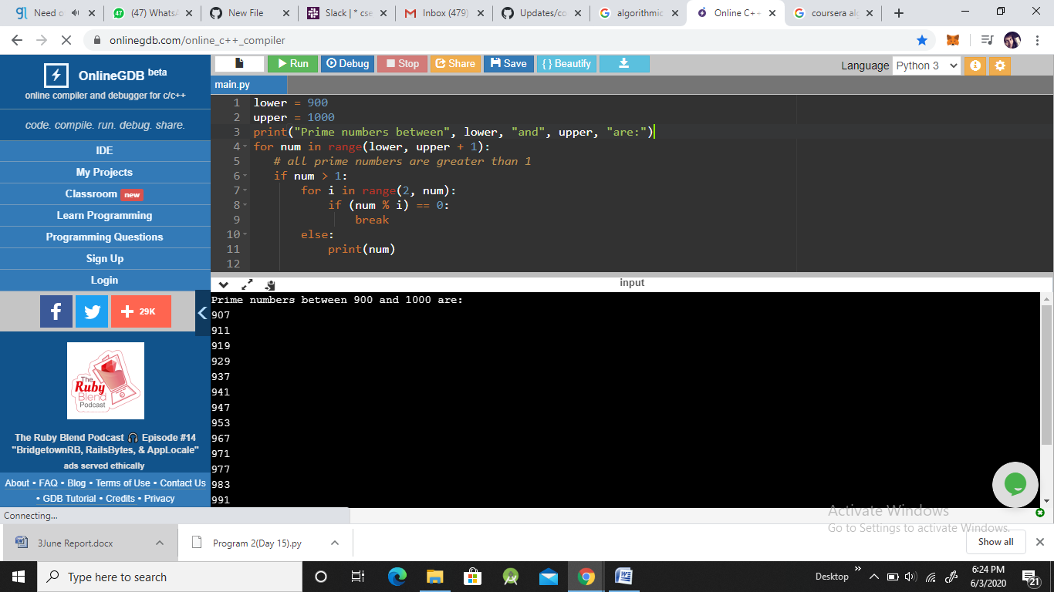

**Program 2:**

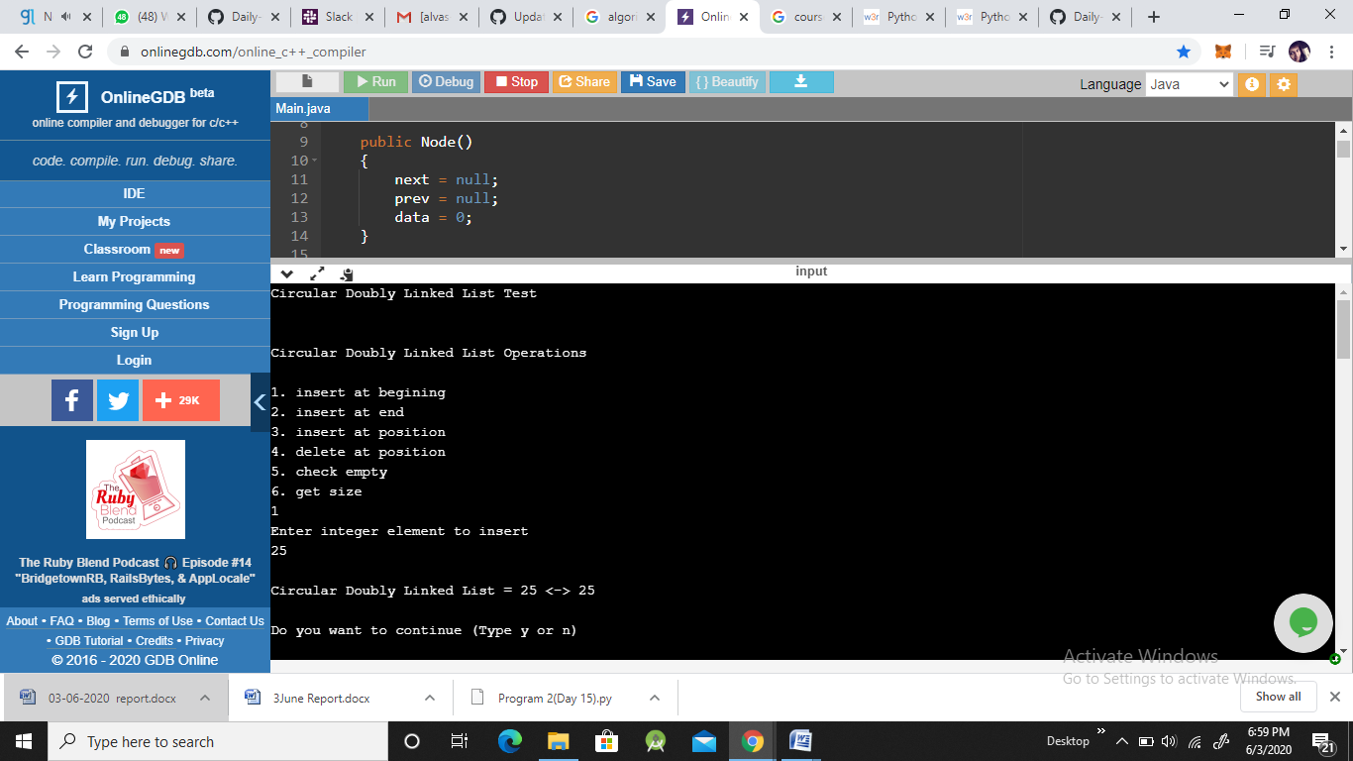

**Program 3:**

