**DAILY ONLINE ACTIVITIES SUMMARY**

|  |  |  |  |  |  |  |  |  |
| --- | --- | --- | --- | --- | --- | --- | --- | --- |
| **Date:** | **14-06-2020** | | | | | **Name:** | **Varshitha** | |
| **Sem & Sec** | **6th - B** | | | | | **USN:** | **4AL17CS106** | |
| **Online Test Summary** | | | | | | | | |
| **Subject** | | **--** | | | | | | |
| **Max. Marks** | | **--** | | **Score** | | | **--** | |
| **Certification Course Summary** | | | | | | | | |
| **Course** | **Blockchain Essentials** | | | | | | | |
| **Certificate Provider** | | | **IBM** | | **Duration** | | | **3hrs** |
| **Coding Challenges** | | | | | | | | |
| **Problem Statements: 1 C, 1 java.** | | | | | | | | |
| **Status: Executed** | | | | | | | | |
| **Uploaded the report in Github** | | | | | **Yes** | | | |
| **If yes Repository name** | | | | | https://github.com/Varshitha019/Daily-Online-Coding.git | | | |
| **Uploaded the report in slack** | | | | | **Yes** | | | |

Certification Course Details: (Attach the snapshot and briefly write the report for the same)

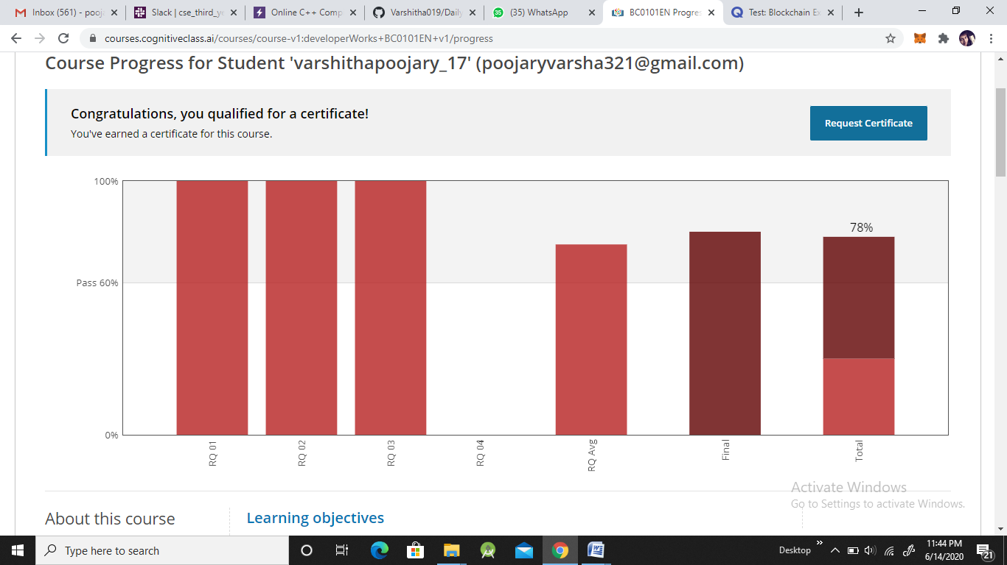

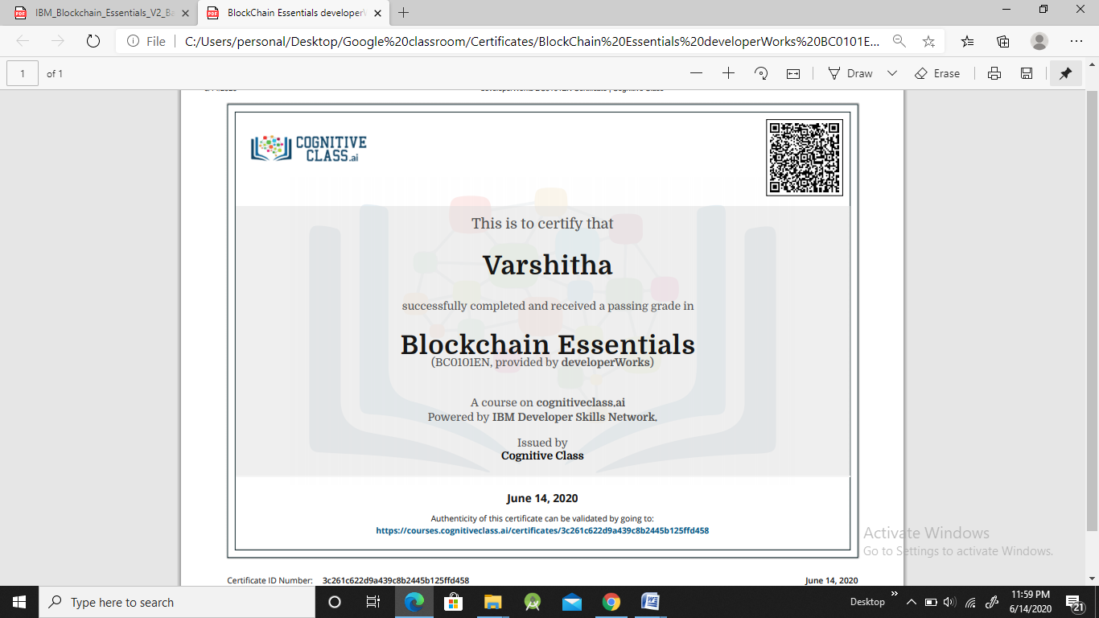

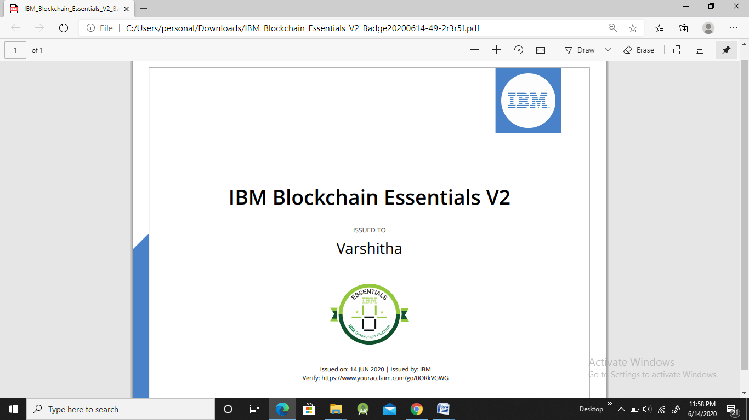

**Coding Challenges Details: (Attach the snapshot and briefly write the report for the same)**

**Problem statements are available in the Github** :

**OUTPUT SCREEN-SHOTS:**

**Program 1**

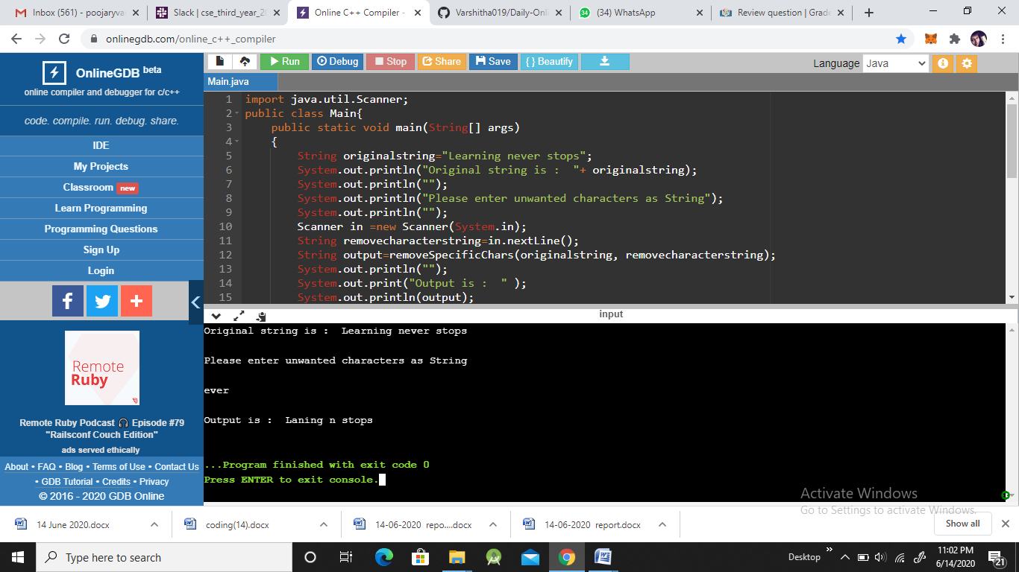

**Program 2:**

